MStar Sensor Tool v3.1.1.6
- First of all, check out a copy of sensor tool (Mst_Sensor) from the link below to you local disk.
SVN link: \\proj\tng\Mst_Sensor
Mst_Sensor v3.1.1.6 supports both MMI S1 project and XMMI v1.00 branch.

For MMI S1 project
How to edit and update sensor table
How to edit and update display table
For XMMI v1.00 branch (M188/MS3 project)
How to edit and update sensor table
How to edit and update display table
For BB2 Type A and Type C projects
How to edit and update sensor table
How to edit and update display table

- For S1 project
  - How to edit and update sensor table
The flow diagram is shown below.
Sensor table (*.DAT)
Edit table by using Mst_Sensor
New sensor table (*.DAT)
Update table by using updateSenDrv.bat
Re-download Mobile F/W (mmi_s1.bin)
Check quality
    - Edit table by using Mst_Sensor
Select you sensor table (*.DAT) from […] and then click [Edit Table]
Note: The sentab.inf is required for editing table
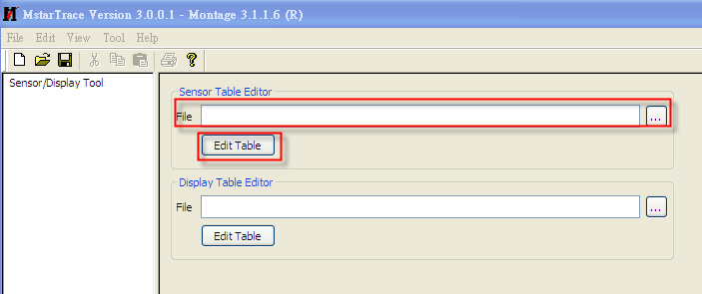
After edit finished, you save the results into your table (*.DAT). Now you have a new sensor table. All you have to do is to update the old table of mmi_s1.bin with the new one.

    - Update table by using updateSenDrv.bat
Use the following command under Mst_Sensor folder
Ex, Your new sensor table: OV2650_YUV.DAT, Mobile F/W: mmi_s1.bin, and link.info
> updateSenDrv.bat mmi_s1.bin link.info OV2650_YUV.DAT

After command executed, your mmi_s1.bin has already been updated to new sensor table.
Please re-download mmi_s1.bin to check the quality.

  - How to edit and update display table
The flow diagram is shown below.
Display table (*.DAT)
Edit table by using PQ Tool
New display table (*.DAT)
Update table by using updateLcmDrv.bat
Re-download Mobile F/W (mmi_s1.bin)
Check quality
    - Edit table by using PQ Tool
Please refer to PQ Tool user’s guide.

    - Edit table by using Mst_Sensor [Optional]
Select you display table (*.DAT) from […] and then click [Edit Table]
Note: The displaytab.inf is required for editing table
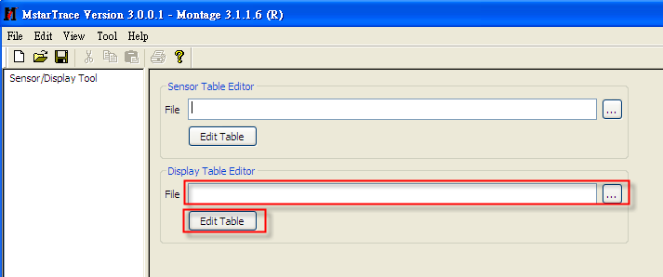
After edit finished, you save the results into your table (*.DAT). Now you have a new display table. All you have to do is to update the old table of mmi_s1.bin with the new one.

    - Update table by using updateLcmDrv.bat
Use the following command under Mst_Sensor folder

Ex, Your new display table: T24QT6882.DAT, Mobile F/W: mmi_s1.bin, and link.info
> updateLcmDrv.bat mmi_s1.bin link.info T24QT6882.DAT

After command executed, your mmi_s1.bin has already been updated to new display table.
Please re-download mmi_s1.bin to check the quality.
- For XMMI v1.00 branch (M188/MS3 project)
  - How to edit and update sensor table
The flow diagram is shown below.
Sensor table (*.dat)
Edit table by using Mst_Sensor
New sensor table (*.dat)
Transfer table format (*.dat→*.txt) by
using senDat2Txt.bat
Re-download Mobile F/W (xmmi_m188.bin)
Check quality
Overwrite file (*.txt) and rebuild code

    - Edit table by using Mst_Sensor
Select you sensor table (*.dat) from […] and then click [Edit Table]
Note: The sentab.inf is required for editing table

After edit finished, you save the results into your table (*.dat). Now you have a new sensor table. All you have to do is to update the old table of xmmi_m188.bin with the new one.

    - Transfer table format (*.dat→*.txt) by using senDat2Txt.bat
Before you update to the new table, you need to transfer the table file from the raw format (*.dat) to the txt format (*.txt) first.

Note: Tool will prevent users from using an invalid table, which is a table without dram download address embedded in table header (first 4 bytes). Otherwise, you will see a message window pop up as below when attempting to transfer format with an invalid table.
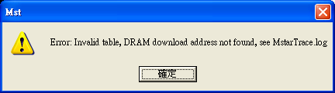

To transfer table format, use the following command under Mst_Sensor folder

Ex, Your new sensor table: ov2650_yuv_pri.dat
> senDat2Txt.bat ov2650_yuv_pri.dat

An “ov2650_yuv_pri.txt”, new sensor table in txt format, will be outputted after command executed.

    - Overwrite file (*.txt) and rebuild code
To update your sensor table, please follow the following steps.

        - Overwrite the file (ov2650_yuv_pri.txt) in your source folders -
proj\sc\driver\ema\msmdrv\inc\sensor
proj\xmmi_m188\out (To avoid the unclean build)

Note: we use the following naming convention to distinguish between primary and secondary sensor.
Primary sensor table <sensor>_pri.txt
Secondary sensor table <sensor>_sec.txt

So far, there are four sets of sensor table you can find in the \msmdrv\inc\sensor\ folder, including ov2650, ov3640, and siv100b. Each of them has two tables provided for use as primary or secondary sensor. For example, if you use ov3640 as primary sensor and siv100b as secondary sensor, then the corresponding tables are ov3640_pri.txt and siv100b_sec.txt respectively.

To decide which sensor to use as primary/secondary sensor, please define the following compile option in options.mak.

# Description=Option to select primary camera sensor driver.
# Pre_Condition_On= N/A
# Pre_Condition_Off= N/A
# Option_Selection= __PRI_SENSOR_SIV100B__, __PRI_SENSOR_OV3640__, __PRI_SENSOR_OV2650__
PP_OPT_TARGET+= __PRI_SENSOR_ OV3640__

# Description=Option to select secondary camera sensor driver.
# Pre_Condition_On= N/A
# Pre_Condition_Off= N/A
# Option_Selection= __SEC_SENSOR_SIV100B__, __SEC_SENSOR_OV3640__, __SEC_SENSOR_OV2650__
PP_OPT_TARGET+= __SEC_SENSOR_SIV100B__

To update sensor table, please overwrite the corresponding TXT files according to how the compile option is defined.

        - Rebuild code to generate a new xmmi_m188.bin
        - Re-download xmmi_m188.bin to check the quality

  - How to edit and update display table
The flow diagram is shown below.
Display table (*.dat)
Edit table by using PQ Tool
New display table (*.dat)
Transfer table format (*.dat→*.txt) by
using lcmDat2Txt.bat
Re-download Mobile F/W (xmmi_m188.bin)
Check quality
Overwrite file (*.txt) and rebuild code

    - Edit table by using PQ Tool
Please refer to PQ Tool user’s guide.

    - Edit table by using Mst_Sensor [Optional]
Select you display table (*.dat) from […] and then click [Edit Table]
Note: The displaytab.inf is required for editing table
After edit finished, you save the results into your table (*.dat). Now you have a new display table. All you have to do is to update the old table of xmmi_m188.bin with the new one.
    - Transfer table format (*.dat→*.txt) by using lcmDat2Txt.bat
Before you update to the new table, you need to transfer the table file from the raw format (*.dat) to the txt format (*.txt) first.

Note: Tool will prevent users from using an invalid table, which is a table without dram download address embedded in table header (first 4 bytes). Otherwise, you will see a message window pop up as below when attempting to transfer format with an invalid table.

To transfer table format, use the following command under Mst_Sensor folder

Ex, Your new display table: t24qtT6882.dat
> lcmDat2Txt.bat t24qt6882.dat

A “t24qt6882.txt”, new display table in txt format, will be outputted after command executed.

    - Overwrite file (*.txt) and rebuild code
To update your display table, please follow the following steps.

        - Overwrite the file (t24qt6882.txt) in your source folders -
proj\sc\driver\ema\msmdrv\inc\display
proj\xmmi_m188\out (To avoid the unclean build)

So far, there are two sets of sensor table you can find in the \msmdrv\inc\display\ folder, including t24qt6882, and default table (normal quality applied).

To decide which display to use, please define the following compile option in options.mak.

# Description=Option to select panel driver.
# Pre_Condition_On= N/A
# Pre_Condition_Off= N/A
# Option_Selection= __PANEL_T24QT6882__
PP_OPT_TARGET+= __PANEL_T24QT6882__

If the above mentioned compile option is undefined, then the default is Panel = default_display.txt (normal quality applied).

To update display table, please overwrite the corresponding TXT files according to how the compile option is defined.

        - Rebuild code to generate a new xmmi_m188.bin
        - Re-download xmmi_m188.bin to check the quality

- For BB2 Type-A and Type-C projects
  - How to edit and update sensor table
For Type-A project, it’s identical to XMMI v1.00 branch (M188/MS3 project)
For Type-C project, everything is the same as XMMI v1.00 branch (M188/MS3 project), except that “3.1.2 Transfer table format (*.dat→*.txt) by using senDat2Txt.bat”.
Please use MST command. Ex, mst –transfer siv100b_pri_tc.dat siv100b_pri_tc.txt
Command Input file Output file
Sensor table (*.dat)
Edit table by using Mst_Sensor
New sensor table (*.dat)
Transfer table format (*.dat→*.txt) by
using mst –transfer *.dat *.txt
Re-download F/W (xmmi_cinta_v2.bin)
Check quality
Overwrite file (*.txt) and rebuild code

  - How to edit and update display table
It’s identical to XMMI v1.00 branch (M188/MS3 project)

