MStar CUSVerifier Tool

CUSVerifier

User Guide

Preliminary Version 0.1
Table of Contents
1. Revision History 4
2. Reference Document 5
3. Introduction 6
3.1. Overview 6
4. Environment Setup 7
4.1. CUSVerifier: A Tool to Check CUS file 7
4.2. Open Solution 7
4.3. The Result of CUS File 8
5. The Information of Image, String Table, and Melody 10
5.1 Image and Melody Result 10
5.2 String Table Result 11
5.3 Setting View 11
6. Replace The Image File 13
Appendix 14

Revision History
Document | Description | Date
mobile_emmi_CUSVerifier_ugd_v01.doc | The user guide of the CUSVerfier | 2011/01/03

Reference Document
Document | Description | Date
N/A

Introduction

CUSVerifier is a tool used to analyze a CUS file built from the application of XRG, so users can use this application to check the correctness of a CUS file. For example, if users want to check an image named “START_BUTTON” built into a CUS file, they just need to import the CUS file to the CUSVerifier and then find the file location to check it. Furthermore, CUSVerifier also provides users to replace the original image with a new one. Therefore users can depend on this application to create a new CUS file which has different images.

Overview

The following diagram illustrates the checking procedure for a CUS file. First of all, users have to use XRG to build a CUS file and then import the CUS file to CUSVerifier. Secondly, in the CUSVerifier, users can check the correctness of the CUS file. Finally, users can replace the images and save the file in order to generate a new CUS format.

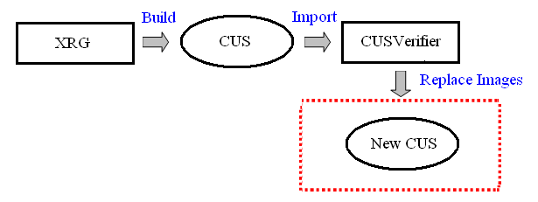
The checking procedures

So, there are four three advantages when users use this application:

- The application can be used to export the String Table, Media and Image.
- The application can also export String Table for CSV file.
- Users can use this application to find the location of the Image, String Table and Media file.
- The replacing function can be used to create a new CUS file which is not the same with original one.

Environment Setup

CUSVerifier: A Tool to Check CUS file
- CUSVerifier is a tool which can check CUS information, such as image, melody, string table, etc. CUSVerifier is also a GUI tool, which could let users maintain/replace the resource easily.
- The GUI layout of CUSVerifier includes CUS Browser Area, Image Preview, and CUS information Window message space as following figure:

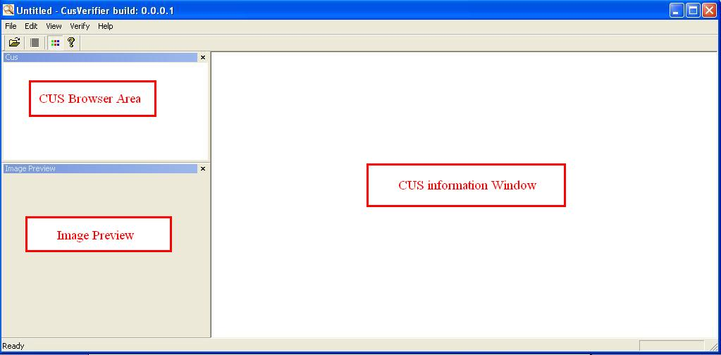
CUSVerifier Tool

Open Solution

To open a CUS file, please choose a CUS file from resource path
“\proj\build”
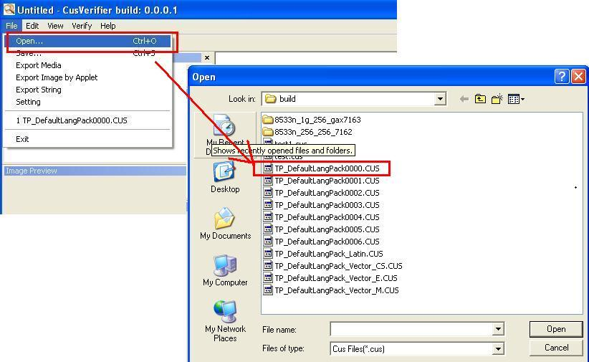
Open a CUS file

The Result of CUS File

When users open the CUS file, the following diagram is the result of a CUS file:

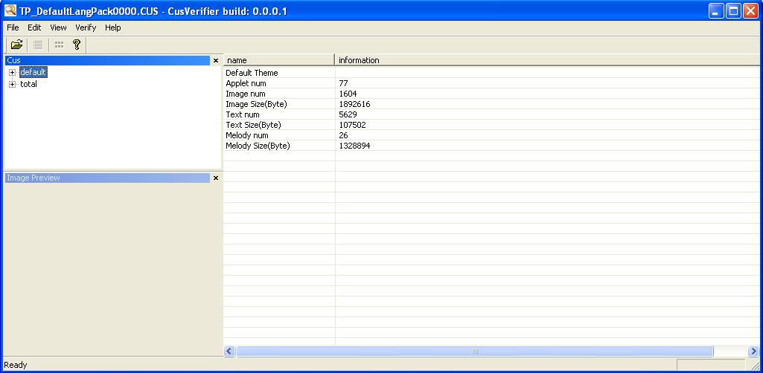
The Result of CUS File 1

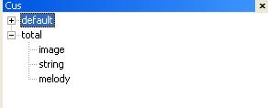
The Result of CUS File 2

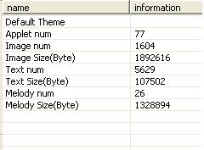
The Total Information of CUS File

According the window of the left right side, users can identify the CUS has one theme named “default” and the “total” option is used to show the total number of Images, String Table, and Melody. Furthermore, when users click the “default” option, the total information is also shown on the right side.

The Information of Image, String Table, and Melody

Image and Melody Result

When users click the image option, the following information is shown on the right side. For the format of the file name of Image and Melody is:

- 1_0x00005006.png
- 1_0x00006001.wav

The first number means that the file is located on which theme, so the id of the 1_0x00005006.png means the image is located in the default theme. For the 0x0000, it means that the Image is located in which AP, thus 0x0000 should be located in the common. The number 5 means the type of the Image. Finally, the number of 006 is the file number.

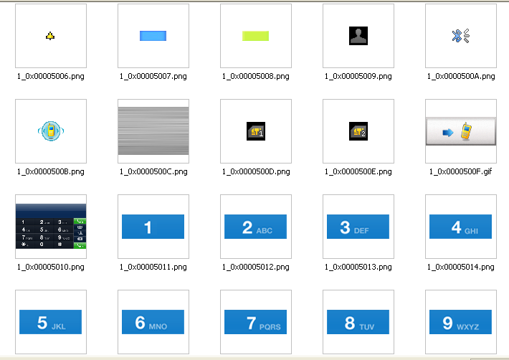
The Image Result

String Table Result

The following diagram is shown the result of the String Table.


The Result of String Table

For the first column, it means the id number of the string and then the language are shown in the second and third column. The id format is the same with Image and Melody. Furthermore, if the result of the string table which only has one string column, it means the “no trans” string in XRG.

Setting View

When users use the CUSVerifier, they may feel that it is not convenient to read the AP0, AP1, AP2, etc. So, users can use the “file” -> “setting” to change the browsing method.

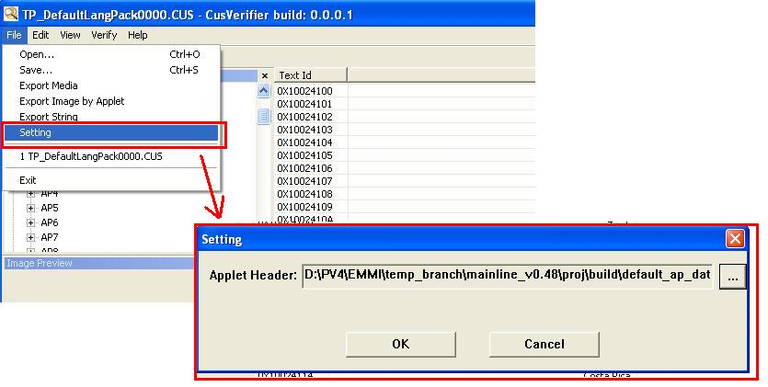
The Setting Function 1

When the setting function is clicked, the application will ask users input the “Applet Header” file. Users should input the file named “default_ap_data.h” and then reopen the application. Users can find the application shows the AP by AP name.

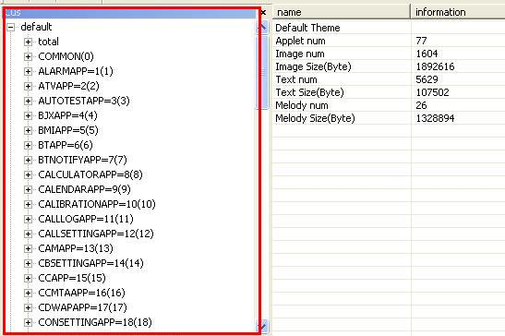
The Setting Function 2

Replace The Image File

The CUSVerifer also provides users to replace the image file with the new one. When users open the Image option and select an image which users want to change to another image and then click the right button, the “replace” function is shown to users.

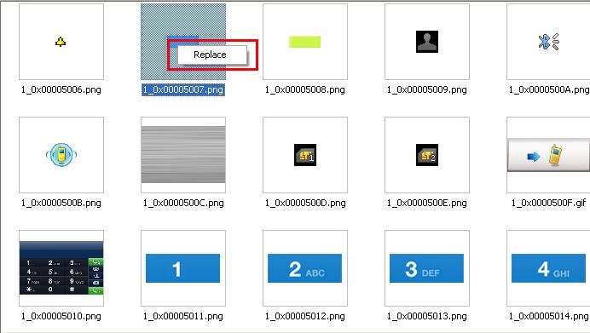
The Image Replace Function

The next step, users should choose an image file to replace the original one. For this step, users have to choose the image file is the same type with the original one and the size of the image file also have to be equal or lesser than the original one. If users choose the different type or too big file, the application will alert users to change it.

Appendix

