

Military Institute Of Science And Technology
Department of Computer Science and Engineering
Course Name: Computer Security
Course Code: CSE-429

Malware Detection and Classification Models: From Signature-Based to Machine Learning Techniques

Md Shahariar Pervez
202014085
CSE-22A

Abstract

Malware remains one of the most persistent and evolving threats to cybersecurity. Over the years, attackers have developed increasingly sophisticated malicious software that can evade traditional detection systems. Early detection strategies, such as signature-based models, laid the foundation of malware defense but soon became inadequate against advanced, polymorphic, and zero-day threats. This paper provides a comprehensive overview of malware detection models, tracing the evolution from traditional signature-based approaches to modern machine learning (ML)-driven techniques. The discussion emphasizes the strengths and weaknesses of each generation, the role of hybrid systems, and the challenges of deploying ML-based solutions at scale. Finally, the paper outlines future directions in malware detection research, focusing on deep learning, behavioral analysis, and explainable artificial intelligence (XAI).

1. Introduction
- The exponential growth of digital technologies has been paralleled by the rise of malicious software (malware), which includes viruses, worms, trojans, spyware, ransomware, and more. Cybercriminals exploit vulnerabilities in computer systems to steal information, disrupt operations, or extort financial gain. Malware detection is, therefore, a cornerstone of cybersecurity.
- Traditionally, malware detection relied on signature-based models, which compared incoming files against a database of known malicious patterns. While efficient in detecting previously known malware, this method struggles with zero-day attacks and polymorphic malware.
- As the threat landscape evolved, researchers explored behavioral analysis, heuristics, and eventually machine learning-based techniques to identify malware more effectively. Today, malware detection models leverage a combination of static features, dynamic behavior, and statistical learning algorithms to classify malicious software with high accuracy.

This paper aims to:
a. Trace the historical evolution of malware detection models.
b. Compare traditional methods with machine learning-based approaches.
c. Highlight challenges and limitations of both categories.
d. Explore future research directions for robust malware detection.

2. Fundamentals of Malware and Its Evolution
2.1 Definition of Malware
Malware is any software intentionally designed to cause damage to a computer, server, client, or computer network. Its objectives may include unauthorized access, disruption of service, data theft, or financial fraud.
2.2 Types of Malware
a. Viruses – malicious code that attaches to files and spreads when executed.
b. Worms – self-replicating software spreading without user interaction.
c. Trojans – disguised as legitimate software but carrying malicious payloads.
d. Spyware/Adware – secretly monitors user activity and collects data.
e. Ransomware – encrypts user files and demands ransom for decryption.
f. Rootkits – hides malicious activity from detection tools.
g. Polymorphic malware – changes its code structure while retaining functionality to evade signature detection.

2.3 Evolution of Malware
- 1980s–1990s: Simple viruses and worms (e.g., Brain, Morris Worm).
- 2000s: Trojans and spyware dominated.
- 2010s: Ransomware and advanced persistent threats (APTs) emerged.
- 2020s onward: AI-powered malware and supply chain attacks increasing.
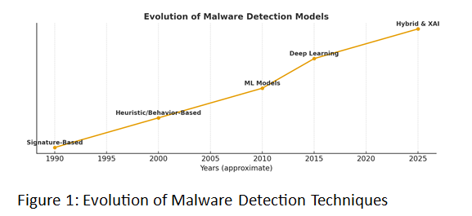

3. Traditional Malware Detection Models
3.1 Signature-Based Detection
- Concept: Uses a unique “fingerprint” (hash or byte pattern) of known malware to detect infections.
- Advantages: Fast, accurate for known malware, low false positives.
- Limitations: Fails against unknown or polymorphic malware.

3.2 Heuristic Analysis
- Concept: Identifies suspicious code structures and behaviors that resemble malware.
- Advantages: Detects new or modified malware.
- Limitations: Higher false positives compared to signature-based detection.

3.3 Behavioral Detection
- Concept: Observes runtime behavior of programs in sandboxes.
- Advantages: Effective against polymorphic and obfuscated malware.
- Limitations: Resource intensive, may be bypassed by anti-sandbox techniques.

4. Transition to Machine Learning in Malware Detection
4.1 Why Machine Learning?
The shortcomings of traditional techniques—especially against zero-day malware—drove researchers to explore machine learning (ML). ML models learn statistical patterns from large datasets of benign and malicious files, enabling generalization beyond known threats.

4.2 Machine Learning Workflow for Malware Detection
a. Data Collection – malware and benign software samples.
b. Feature Extraction – static (opcodes, API calls, byte n-grams) or dynamic (system calls, network activity).
c. Feature Selection – reducing dimensionality for efficiency.
d. Model Training – supervised, semi-supervised, or unsupervised learning.
e. Detection & Classification – applying trained models on new samples.
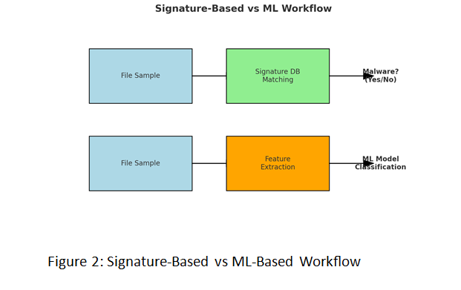
5. Machine Learning Models for Malware Detection
5.1 Supervised Learning Models
- Decision Trees & Random Forests: Classify malware using hierarchical rules.
- Support Vector Machines (SVMs): Effective in high-dimensional malware datasets.
- Naïve Bayes Classifier: Lightweight and probabilistic, used for quick classification.
- Artificial Neural Networks (ANNs): Capture nonlinear relationships in malware features.

5.2 Unsupervised and Semi-Supervised Models
- Clustering: Groups unknown samples into clusters to identify potential new malware families.
- Autoencoders: Detect anomalies by reconstructing normal behavior.
5.3 Deep Learning Approaches
- Convolutional Neural Networks (CNNs): Treat binaries as images for detection.
- Recurrent Neural Networks (RNNs, LSTMs): Capture sequential patterns in code or system calls.
- Graph Neural Networks (GNNs): Model API call graphs and malware relationships.
6. Comparative Analysis: Traditional vs Machine Learning

Criteria | Signature-Based | ML-Based Detection
Accuracy on known malware | Very high | High
Zero-day detection | Very poor | High (generalization ability)
Speed | Very fast | Moderate (depends on features)
Resource usage | Low | Higher (training, computation)
False positives | Low | Moderate to high

7. Challenges in ML-Based Malware Detection
a. Dataset Quality – Availability of large, labeled datasets remains a challenge.
b. Evasion Attacks – Adversarial malware can trick ML models.
c. Explainability – Deep learning models act as black boxes.
d. Resource Constraints – Training requires high computational power.
e. Concept Drift – Malware continuously evolves, requiring frequent retraining.

8. Hybrid Models and Emerging Trends
- Hybrid Systems: Combining signature-based and ML-based models for defense-in-depth.
- Cloud-Assisted Detection: Offloading heavy computation to cloud environments.
- Federated Learning: Collaborative malware detection without data sharing.
- Explainable AI (XAI): Making ML-based malware detection transparent.
- Graph-Based Analysis: Mapping malware behavior through system call graphs.
9. Case Studies
9.1 Microsoft Malware Classification Challenge (BIG 2015)
- Used Kaggle dataset with millions of malware samples.
- Demonstrated efficiency of Random Forest and CNNs.
9.2 Ransomware Detection with ML
- Dynamic features like file system changes used with SVM and LSTM.
- High accuracy in detecting emerging ransomware families.
9.3 Hybrid Antivirus Engines
Vendors like Symantec and Kaspersky integrate ML models with traditional detection.

10. Future Directions
a. Deep Reinforcement Learning for adaptive malware detection.
b. Adversarial Training to make ML models robust against evasion.
c. Explainable ML Models to build trust with cybersecurity professionals.
d. Integration with Threat Intelligence for real-time global defense.
e. Quantum-Resistant Malware Detection as quantum computing advances.

11. Conclusion
The journey from signature-based detection to machine learning-driven approaches reflects the escalating complexity of the malware threat landscape. While traditional techniques still play a role in detecting known threats, ML-based methods provide superior generalization and adaptability to new malware families. However, challenges such as adversarial attacks, explainability, and dataset limitations hinder large-scale deployment.Future research must emphasize hybrid models, deep learning, adversarial robustness, and explainable AI to build resilient malware detection systems capable of addressing rapidly evolving cyber threats.
References
a. M. Ahmadi et al., "Novel feature extraction, selection and fusion for effective malware family classification," CODASPY 2016.
b. Ucci, Daniele, et al. "Survey of machine learning techniques for malware analysis." Computers & Security 81 (2019): 123-147.
c. S. Anderson et al., "DeepDGA: Adversarially-tuned domain generation and detection," ACM CCS 2016.
d. R. Vinayakumar et al., "Deep learning approach for intelligent malware detection system," IEEE Access, 2019.
e. Alazab, Mamoun, et al. "Towards understanding malware behaviour by the extraction of API calls." 2010 Second Cybercrime and Trustworthy Computing Conference.
f. Symantec Internet Security Threat Report, 2024.

