Nuggets Make Franchise History with Strong Start to Season
By: Mar Lonsway, Denver, CO. 12/10/2025
23 games into the season, the Denver Nuggets recently passed the quarter mark of the 2025-2026 season – and it’s their best yet. Having won 17 of the 23 games played so far, the Nuggets have made franchise history.
Their record marks the best performance through their first 23 games since the National Basketball Association (NBA) began publishing data in 1983 (the Nuggets joined the NBA just 6 years prior in 1976).
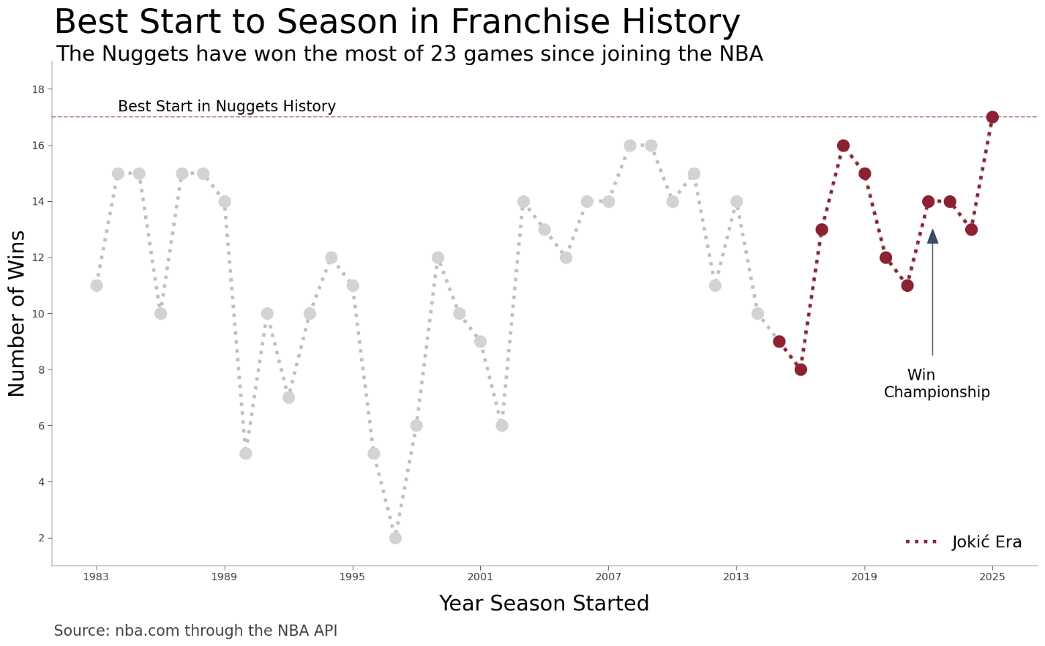

Despite having lost their past four home-court games at Ball Arena, the Nuggets have won 10 straight games on the road. These consecutive wins have helped Denver start off the strongest since their star player, Nikola Jokić, earned his first award for the NBA’s most valuable player (MVP).
Notably, the Nuggets are three games ahead on their early season performance during the year they last won the NBA championship in the 2022-2023 season.
The Nugget’s auspicious beginnings this year are largely supported by bench players performing better in comparison to recent years.
Bench players (i.e., players who are brought into the game to relieve the starters) have a positive point differential for the first time in five years.
The newfound success from the bench is largely driven by the firing of former general manager (GM), Calvin Booth, during the final stretch of the 2024-2025 season.
Having assumed the role of GM since the summer of 2020, Calvin Booth had poorly managed the Denver Nuggets roster beyond the starting lineup, resulting in extreme deficits in points when bench players entered the rotation.
Given the win-now attitude Denver has assumed due their three-time MVP’s age of 30, it had been and still is imperative that the Nuggets add reliable athletes to their roster to ensure games don’t slip away when the stars rest.
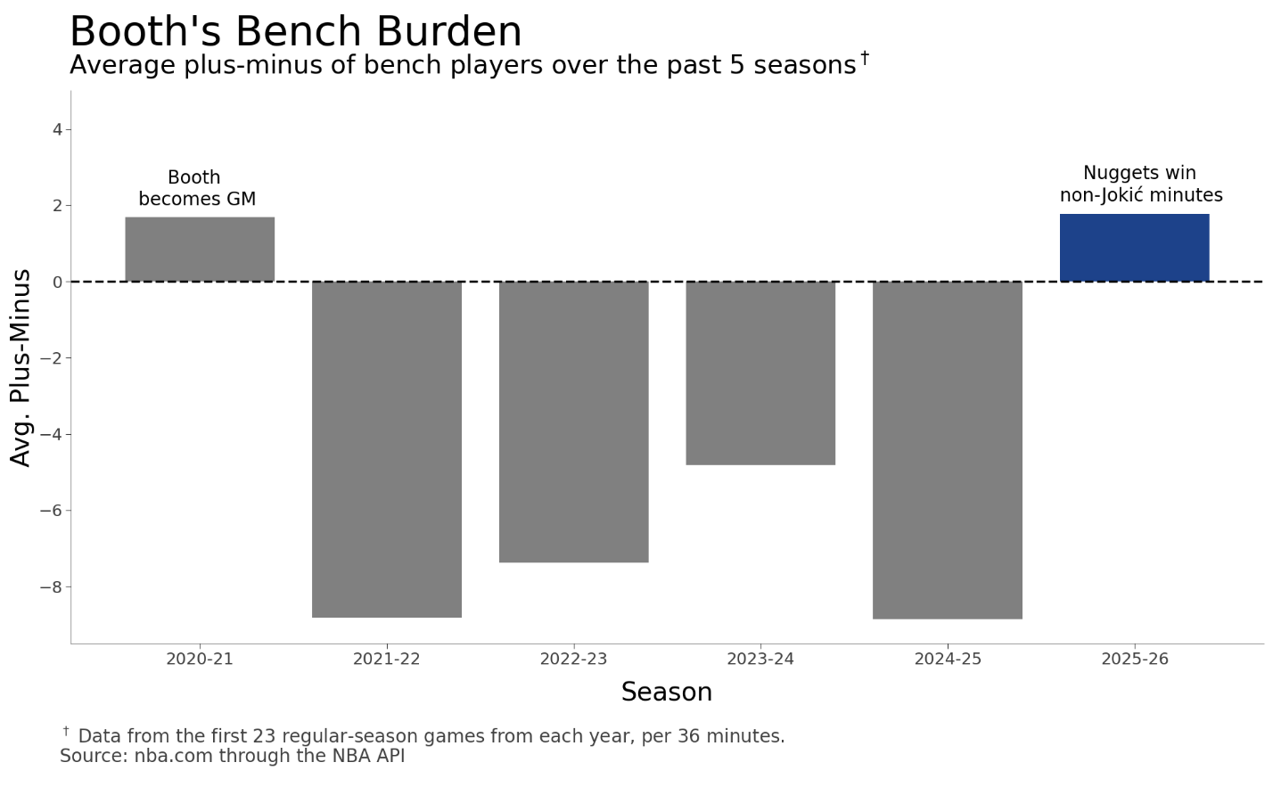
For his part, Calvin Booth was successful at talent acquisition. In 2022, Booth drafted Christian Braun and traded for Peyton Watson – two players that have been starting for the Denver Nuggets this season.
But the real impetus charging the bench player’s performance probably resides in the acquisitions the team made over the summer.
Ben Tenzer and Jon Wallace were made Executive Vice President of Basketball Operations and Executive Vice President of Player Personnel, respectively. The pair worked together as interim-GM in the wake of Booth’s firing.
The pair’s biggest move involved trading Michael Porter Jr (packaged along with a future first-round pick) to the Brooklyn Nets in exchange for Cam Johnson.
While Johnson has fit well into the starting lineup, much of the motivation for the trade involved freeing up salary space for additions to the Nuggets bench.
Notably, Jonas Valančiūnas was acquired in a separate trade not-possible prior to the departure of Porter Jr., given salary limits imposed by the NBA. Valančiūnas, who relieves Jokić at the center position, is a stalwart athlete in the league, having started on another team the season prior.
Furthermore, the Nuggets’ success has heavily been influenced by Jamal Murray, point guard and second option for Denver.
In staggering with the bench players for much of the playtime, Jamal Murray has amassed a career-high points per game (PPG), sitting at just over 25. Given his new offensive ceiling, he has likely helped bolster the bench performance as well by attracting the most talented defenders on the court, freeing up his teammates from the bench to perform better.
