New Players Improve Despite Recent Home Losses for Denver Nuggets
By: Mar Lonsway, Denver, CO. 11:41 AM.
Twenty games into the season The Denver Nuggets are ranked fifth in the Western Conference with a record of 14-6 wins to losses.
However, recent injuries have removed a handful of impactful players from the Denver Nuggets rotation, partially contributing to the mediocre record the team has acquired over the last six games.
Aaron Gordon and Christian Brown, power forward and shooting guard for the starting lineup, have suffered hamstring and ankle injuries that have had them sidelined for weeks. Their injuries will be officially reevaluated towards the end of December.
Meanwhile, Denver Nuggets’ star athletes Nikola Jokić and Jamal Murray have been playing through smaller injuries. Both athletes are listed as “day-to-day” against tonight’s matchup against the Indiana Pacers, as they tend to a sprained wrist and ankle, respectively.
Despite the injuries and the middling record throughout the past six other Denver Nuggets have shown growth.
Notably, Cam Johnson, whom the Denver Nuggets acquired over the summer in a trading Michael Porter Jr, has returned to his offensive levels from the season previous despite a slow start.
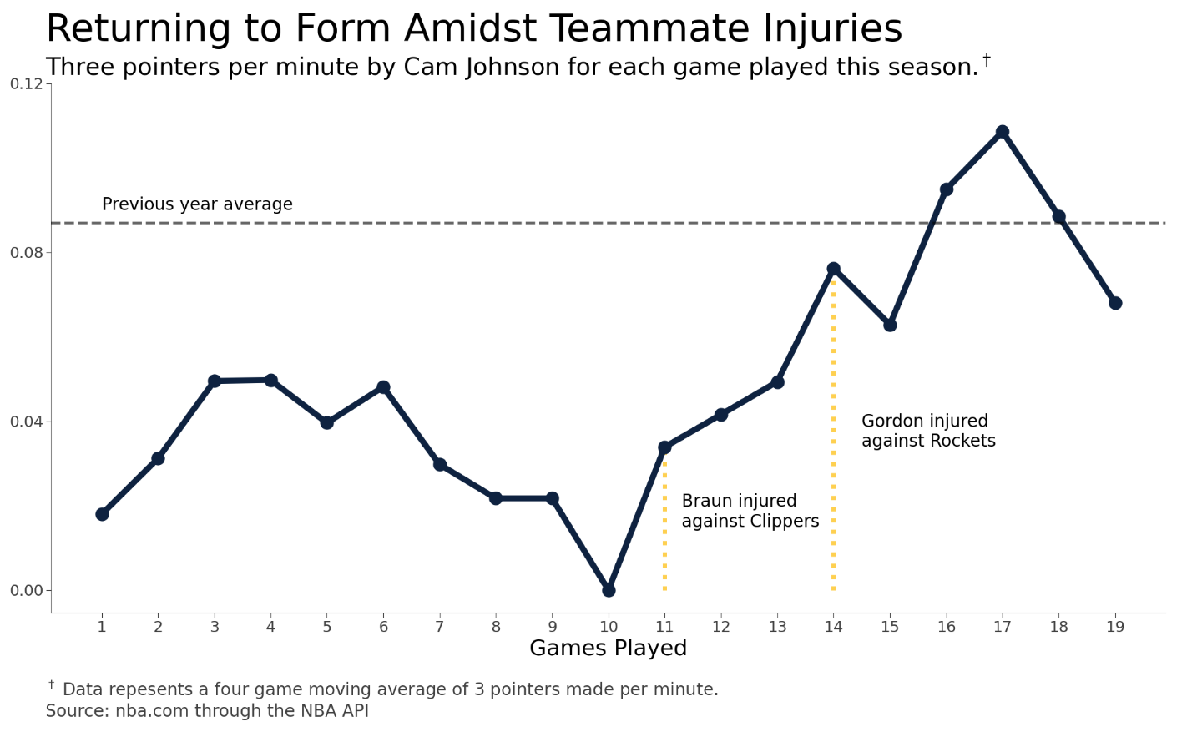
Moreover, Spencer Jones, second-year undrafted small forward scored a career high in points. Jones has only started five games for the Nuggets and has put up impressive numbers in the last three.
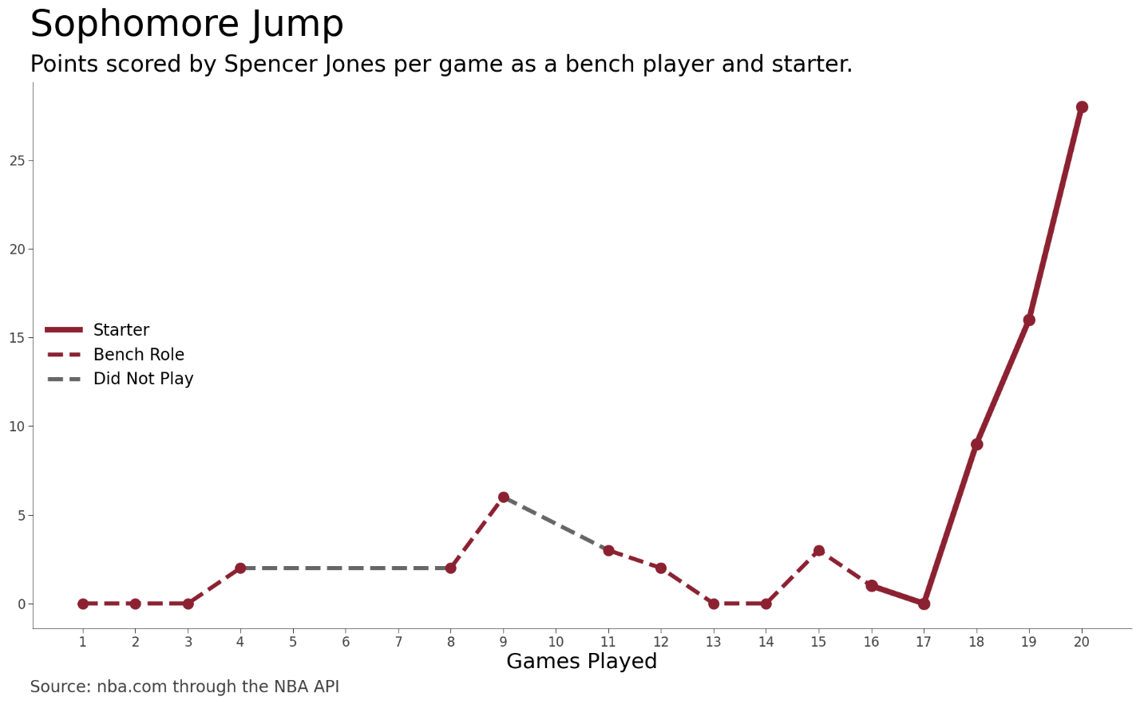
When asked about their recent loss to the Dallas Mavericks, Jones suggested that “we get up so quicky, we feel that the game is easier than it is and it’s going to stay that way,” according to Mile High Sports.
In the 10 point loss to the Mavericks, the Nuggets had lead by 17 points early in the in the first period.
This trend has been a recurring trend: Denver had achieved large leads over their opponents in each of their most recent home losses.
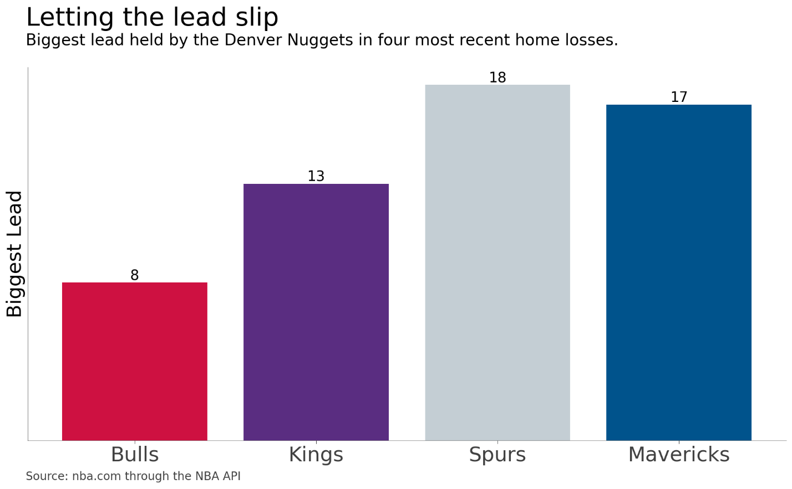
Jones added that, “we take the foot of the gas a little too early.”
That may be true, but the injuries that have removed the starters from the lineup have let others grow.
Perhaps the new responsibilities on Johnson, Jones, and the rest of the supporting cast will help them gain the experience required to keep the foot on the gas throughout the entirety of the game once the full team is healthy.
Tune in tonight at 5:00 p.m. to watch the Indiana Pacers host the Denver Nuggets in their 21st game of this season.

