Louis Wilson, Nick Berk, Matt Berk

CSE 434

Dr. Varsamopoulos

February 22, 2013

Testing Document

Server Testing

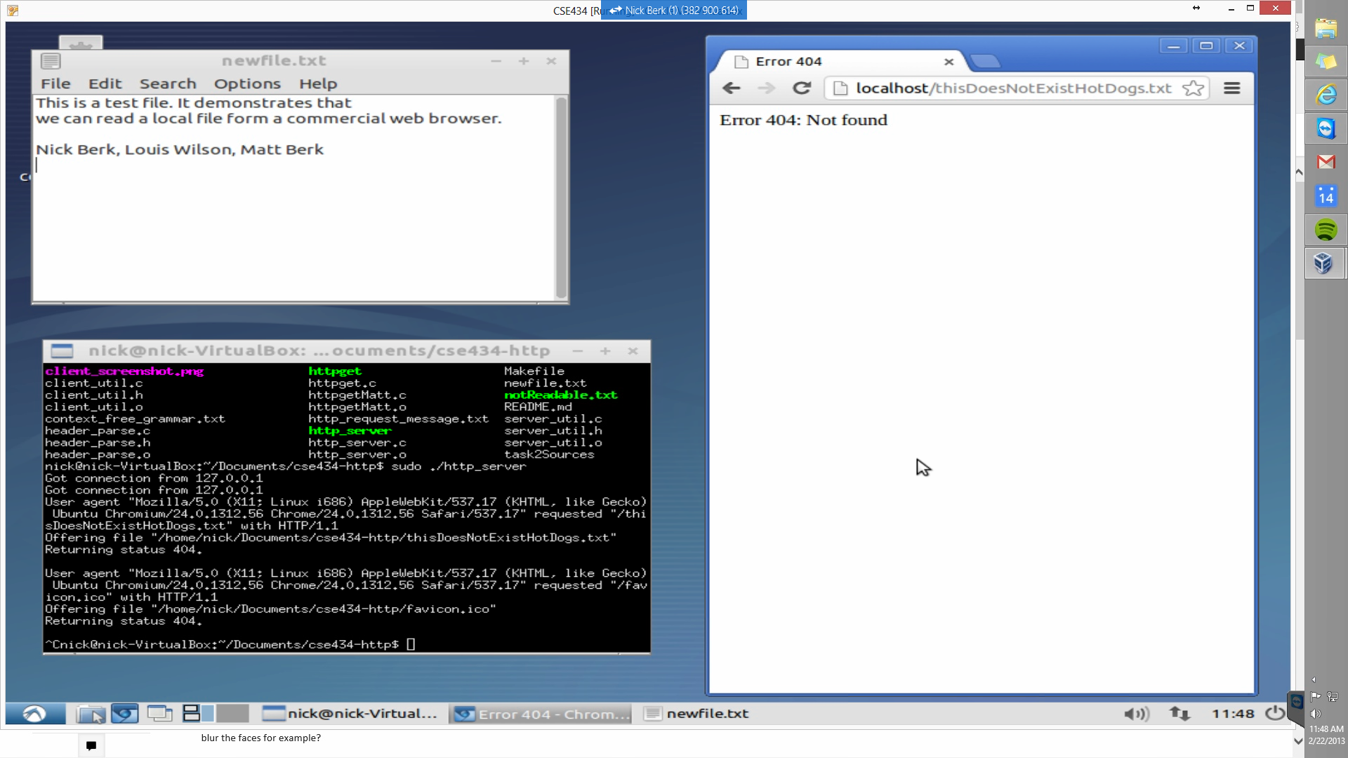**404: Not Found Error:**

Description: The bottom right hand corner shows the file list, which does not include “thisDoesNotExistHotDogs.txt”. The browser on the right shows that when we try to access this document, we get a 404 error.

**403: Forbidden Error**

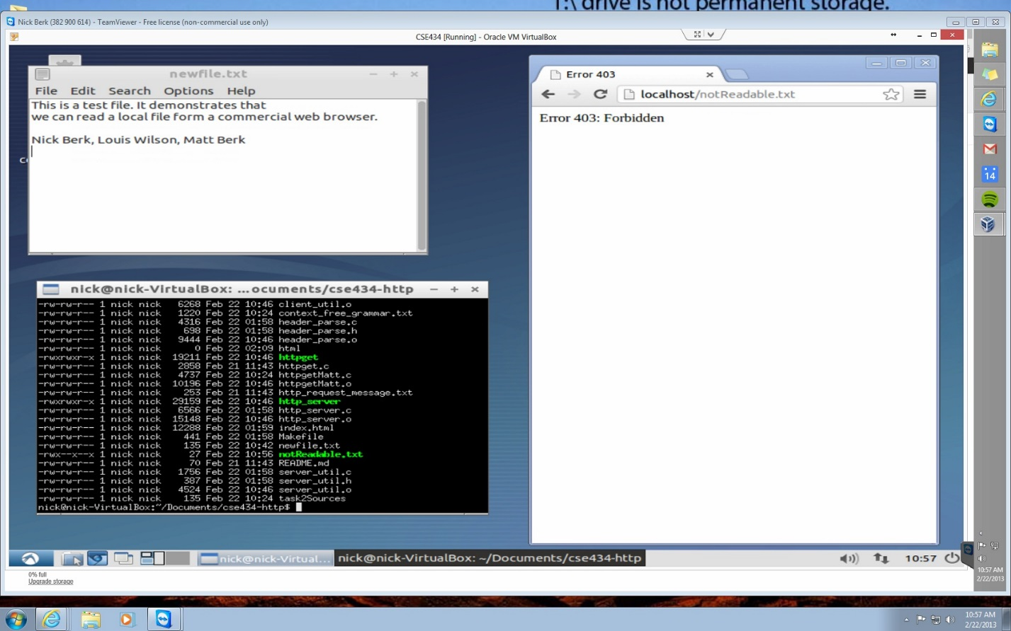

Description: The bottom right corner shows that the “notReadable.txt” file does not have universal read permissions. The browser demonstrates that when a client attempts to access it, it throws a 403, forbidden error.

**200 OK:**

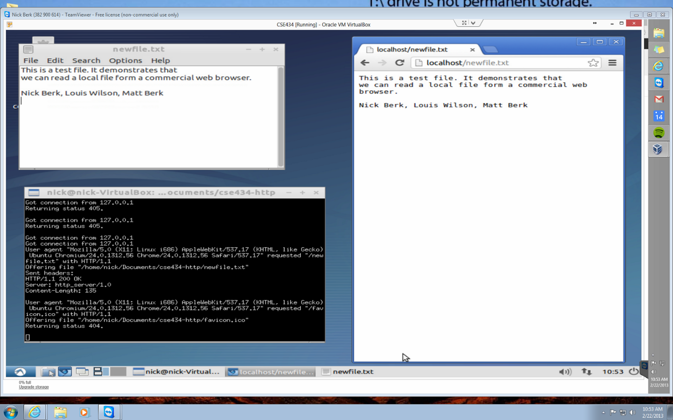

Description: The bottom left shows that the server is running, the top left shows the file “newfile.txt” (which is saved in the same directory as the server), and the right shows the browser which is accessing the file.

**Client Test:**

Successful connection

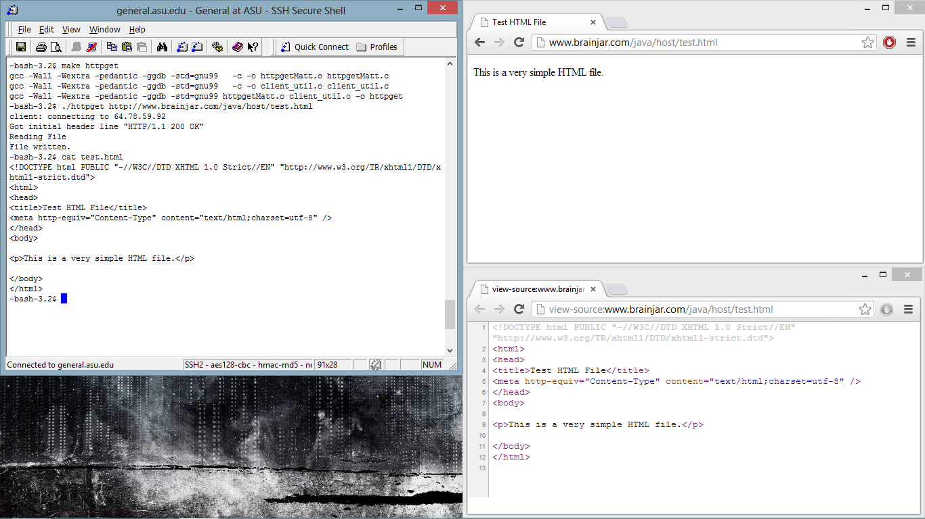Description: The upper left shows that the client is accessing the webpage in the upper left window (the browser). The sources for that window is displayed in the lower right corner. In the command line (in the left), a local copy of the file is printed out, which demonstrates that the client successfully read in the file from the server.