Documentation

The Database tables, stored procedures and Relationships diagram

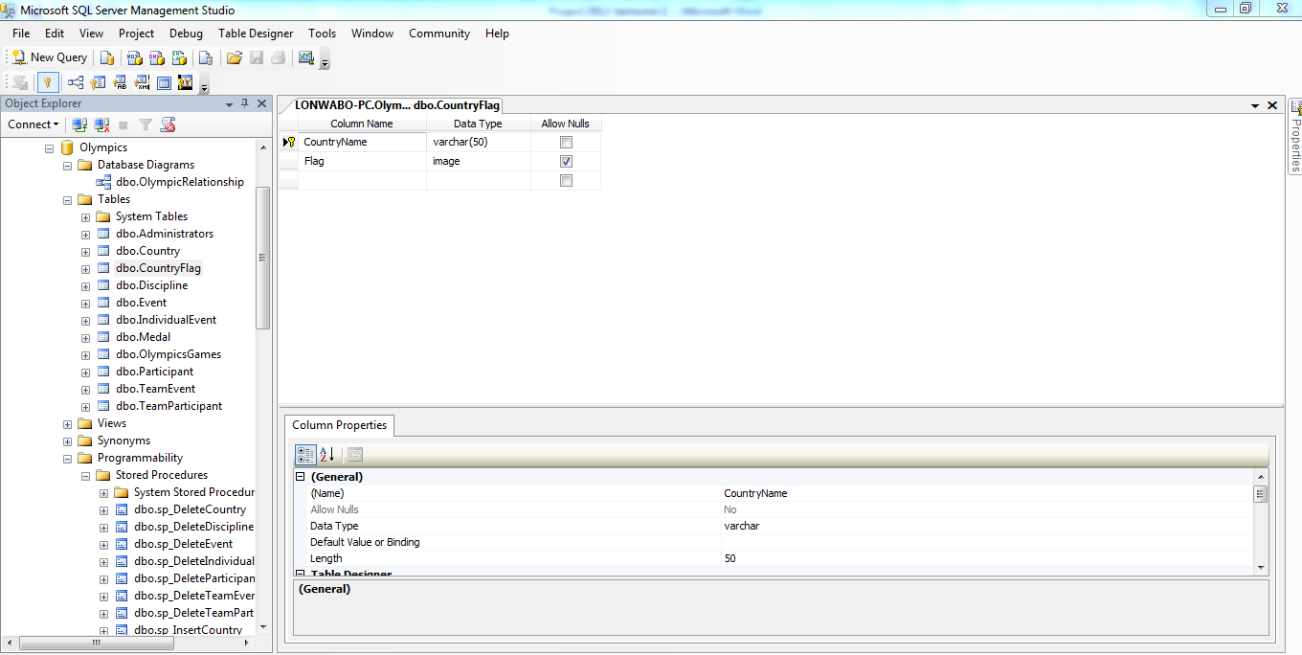

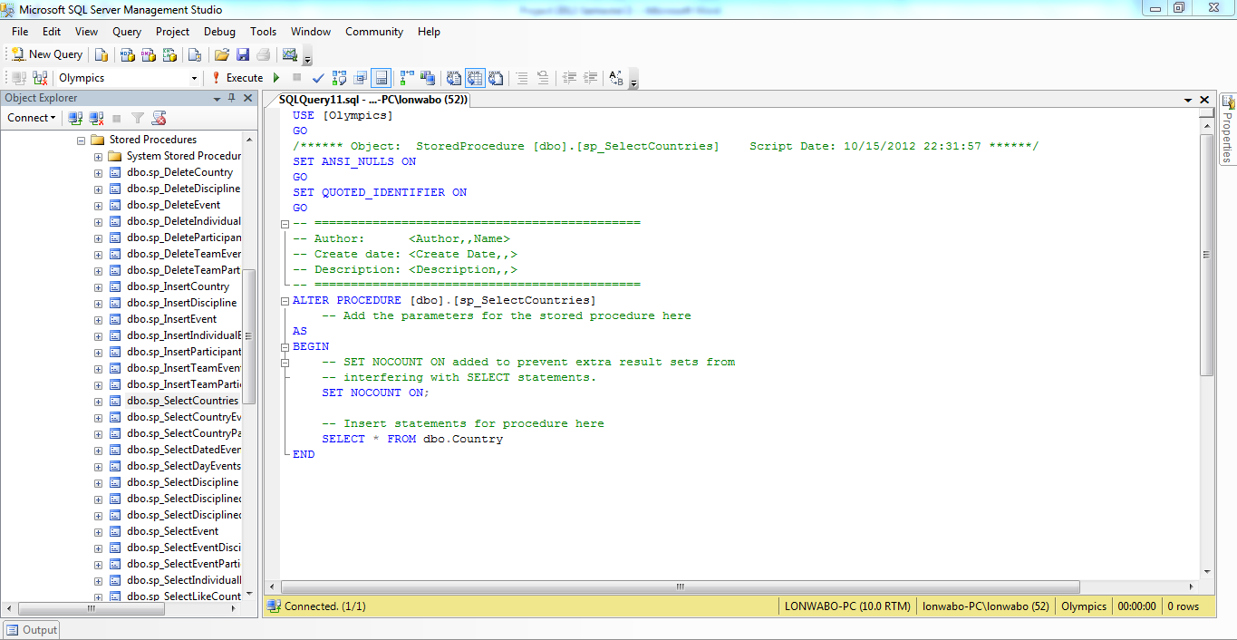

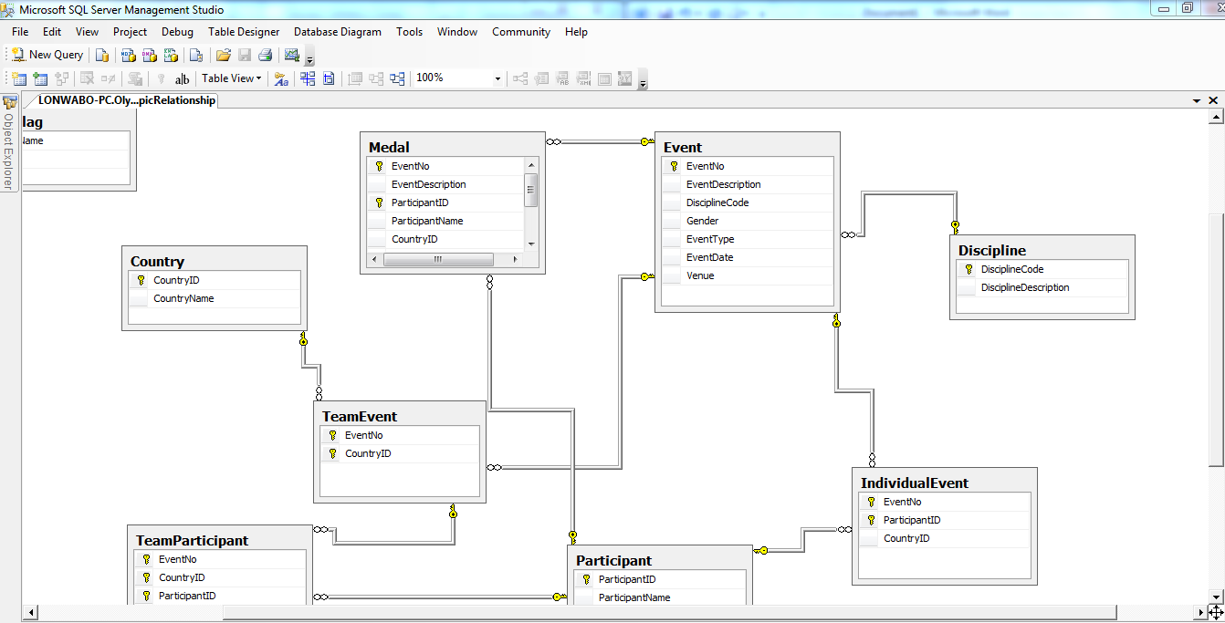

The database uses these to store, control and display data.

Class Diagram

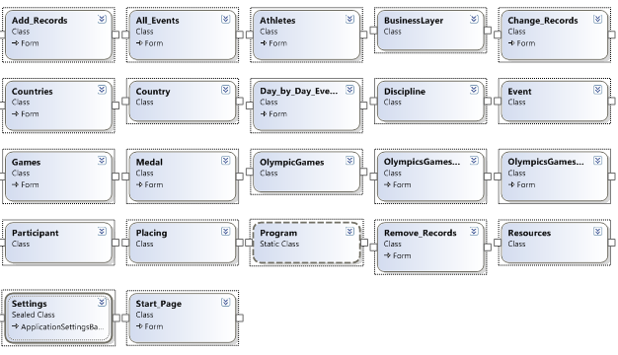

This is the class diagram

Application Class

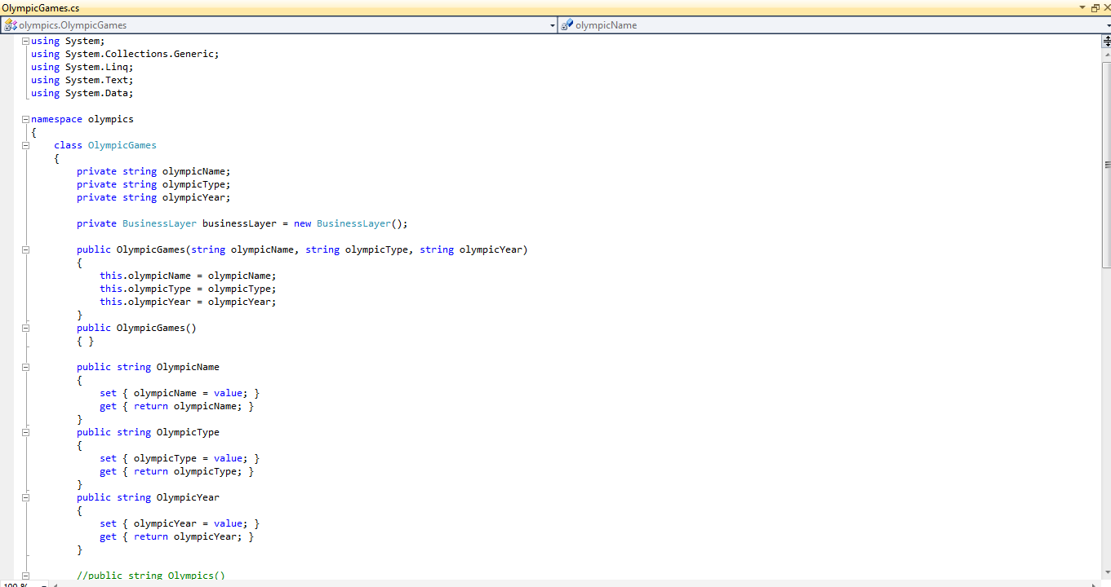

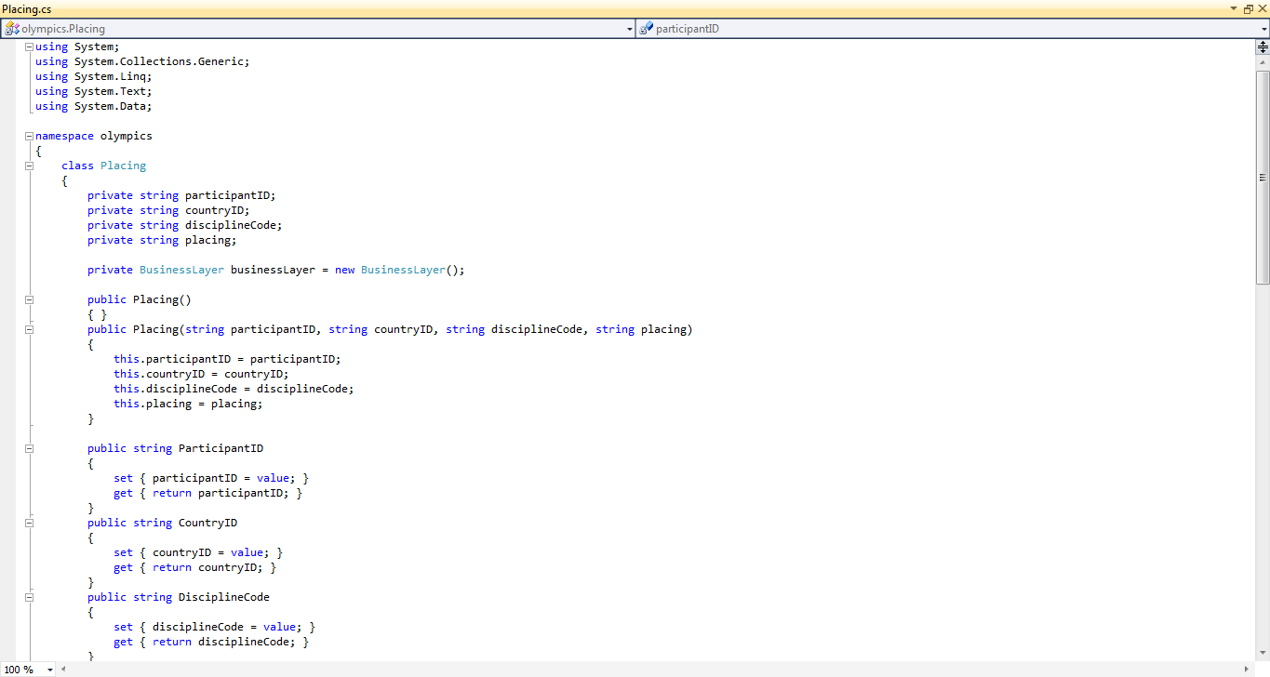

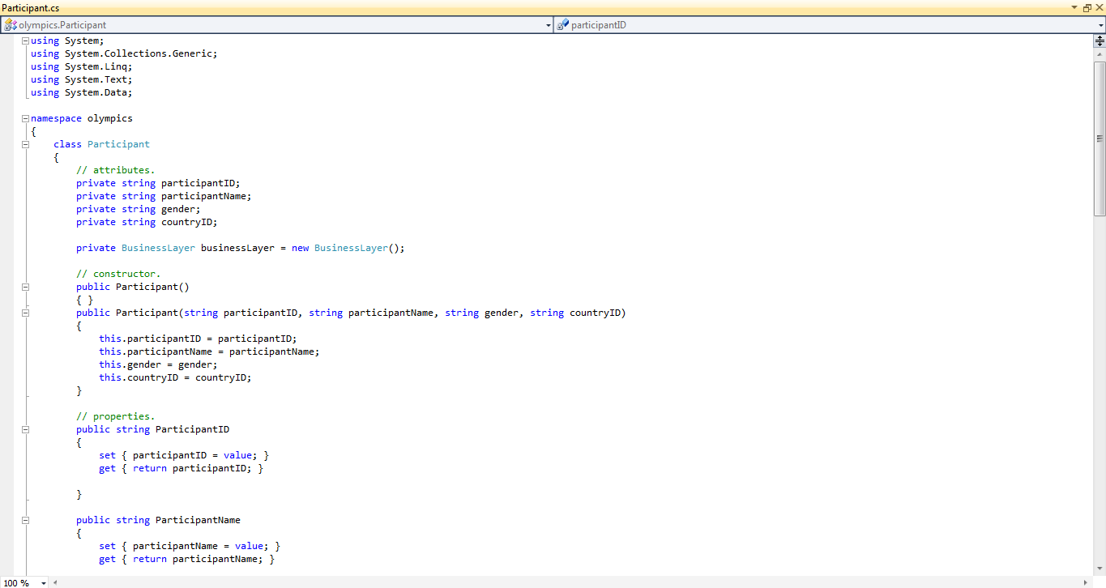

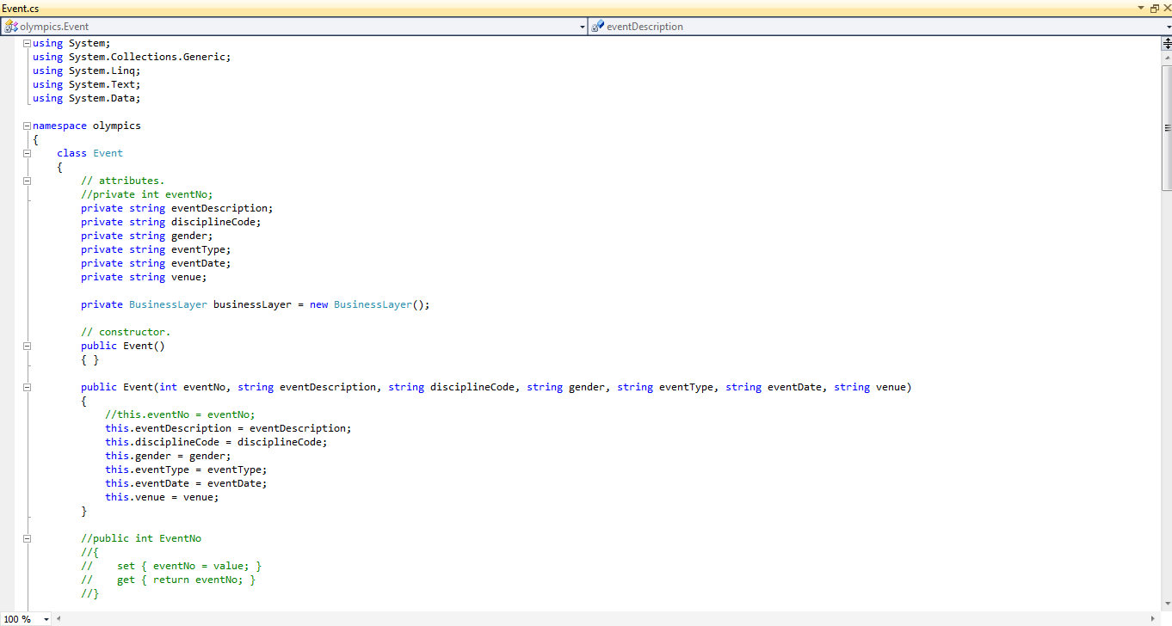

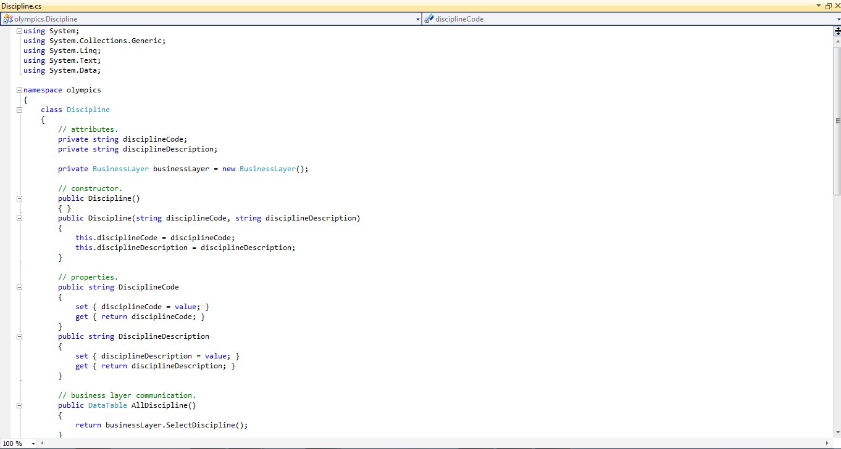

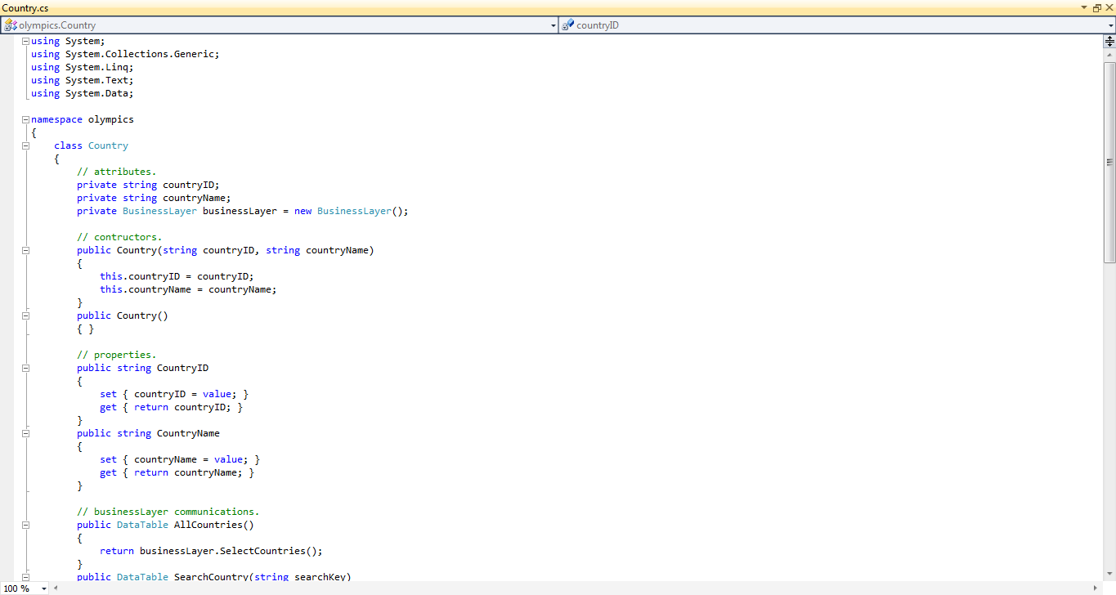

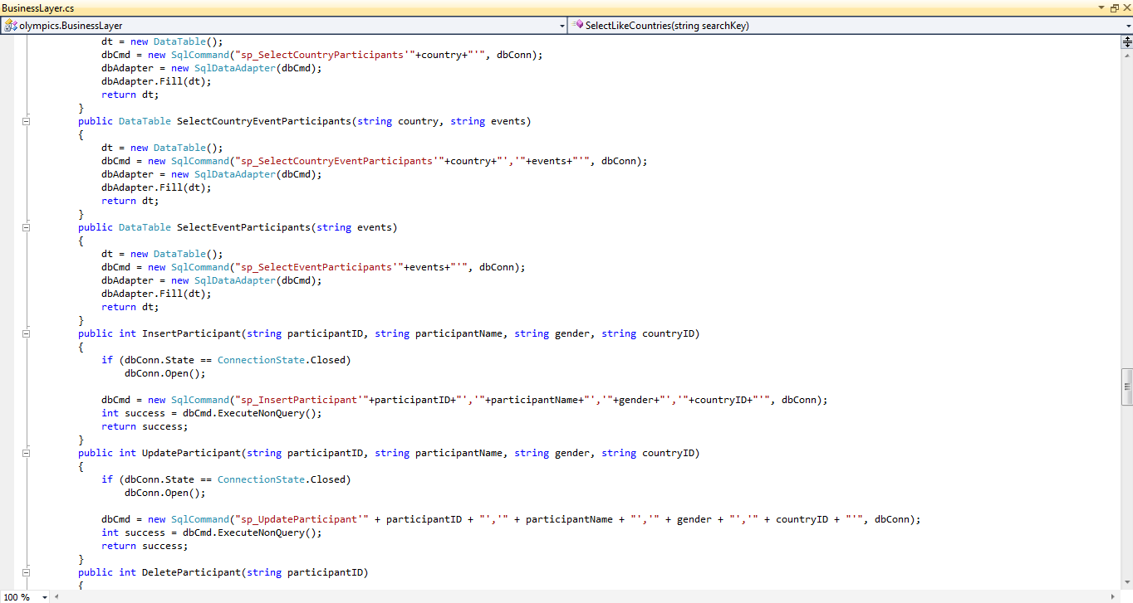

Class used in the application and used to communicate with the business layer and database

Conclusion:

Sometimes your endeavours are fruitless but I must say that this project is definitely not one of those endeavours. I served as a means to revise. This project has taught me a lot from what to expect in the real world, how much help programmer forums are about, how to implement idea and so forth. Through adversity there is always something that you learn and come out of it a better person