Olympics

The purpose of this document is to inform, guide, and help the system administrator and the end user in becoming more proficient

Lonwabo Mnyaiza21164682

Contents

About the Programmer: 2

Acknowledgements: 2

Introduction: 3

About Program Forms: 3

User Navigation: 4

Administrator Navigation: 7

Bibliography & References: 13

Notes: 19

# About the Programmer:

Hi I hope the program is more help than burden to use. Well I will attempt to tell you everything about me that I know (yes there are sides of me that I don’t know yet).   
I am Lonwabo Mnyaiza second year NDip: Software Development student at NMMU.  
I live in Margate (KZN). I like to spend most of my time surrounded my friends if I am not working.

My hobbies are: watching soccer, playing soccer, playing video games or just doing something stimulating.

# Acknowledgements:

The list of the people to thank is quite verbose so to avoid ranting, I will be as concise as possible. Firstly I like to thank Karen Church not for the heavy work load, pressure and stress but for conjuring a project that was both challenging and very much cultivating in terms of learning something new about software development on a daily basis. The project was a much needed twist to the rigorous weekly practical(s), and I think most importantly the project gave me a perception of how software is been developed albeit a simplified environment and in the perspective of an individual programmer (as opposed to team development which I know will be done next year). The project is meant to expand our working knowledge on this module so for that I think my Lecturer deserves reverential appreciation.  
I would also like to thank any of my colleagues who assisted in any way; although the level of comradery is still not that ‘uhm’ good (let me copy once in a while damn).  
To conclude this list I would like send great big thanks to the Google team. Through-out the project Google has been my mentor teaching me things far beyond my knowledge, I’d even go as far as to say Google is responsible for almost 50% of the functionality of my project. Google is the closest thing to omniscience I know.

“Motivation is sometimes the hardest thing to retain but if you are able to vividly visualise your destination, then it becomes water in the sea, abundant” Lonwabo

# Introduction:

If truth be told at the very beginning I was not in any shape or form motivated enough to start the project but I remember reading the requirements and thinking “This is going to be so monotonous” but as soon as I actually started (trying to construct the various tables) I soon realized that this was not only a means to revise what we have been practising but also a way to gain practical understanding on how systems are developed. I read a book once about software development that stated that planning before coding was vital and I can honestly say that I found that to be extremely true, because after starting you have a host of ideas but you soon realize that implementing them might be harder than you initially anticipated.

The program was developed with the following philosophy: creating a robust system without abandoning simplicity (for the users). To further elaborate the applications’ intended use is to cater for the summer Olympics by providing the system administrators with a mechanism of inserting, updating, and deleting data; the end user is then able to view the information of the different facets of the Olympics.

# About Program Forms:

This application has 10 forms in total. This architecture was implemented to bring a sense of progression as one moves from one form to the next. At a glimse one can tell what is the main purpose of the form. Once you have been identified as a user/admin you will not be able to switch between the two at a ad hoc basis (this is a security measure for the system)

# User Navigation:

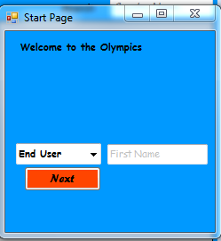

Click next to move on to the next page

Type user name here (optional)

This is the user log in form (users will not be able to add, change or delete data). The user only has permission to view the data in the database. The user can enter his/her first name in the textbox and click on next to proceed to the next form

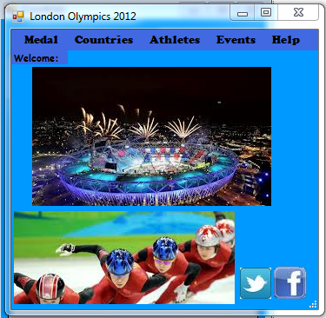

Social media links

User options

This is the main form. The user has a variety of options on what information he/she would like to see. They could either view the medal winners, countries in the Olympic, athletes participating, events, or help options which include: user manual (this document), history of the Olympics, visit the olympic website, Disclaimer, and credits there are also buttons to link to facebook and twitter at the bottom.

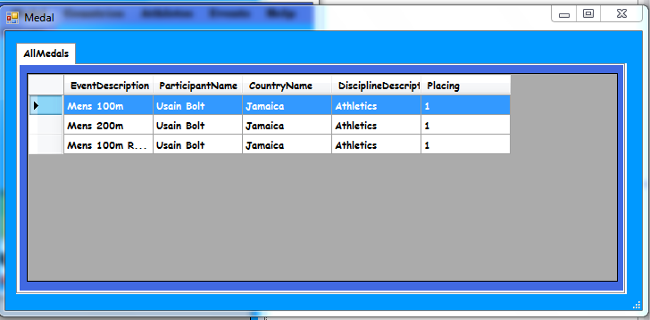

Displays all the medal winners

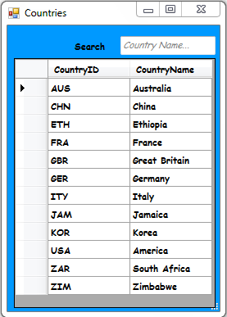

Search for the country

Shows the countries that are participating in the Olympics. Has two fields which are country id and country name and an added search function for filtering through the database.

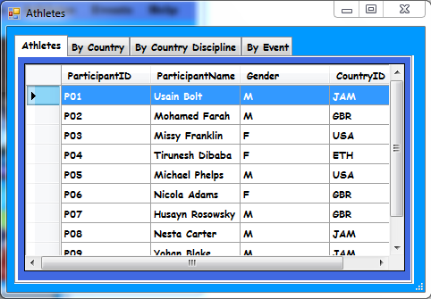

View athletes

The athletes that are involved in the Olympic games. Athletes can be viewed by country, country discipline or by events

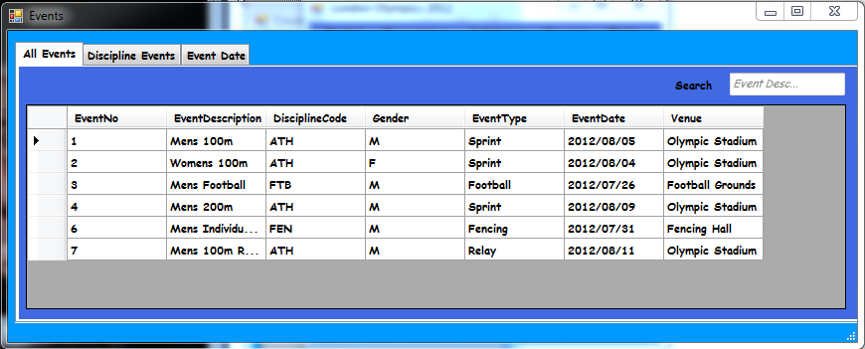

Search box

Shows the events that are been contested. Search function has been included for the user to search through the database

# Administrator Navigation:

## Administration Start Page

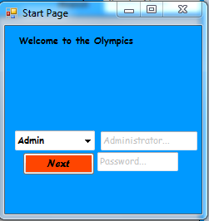

211164682

Lonwabo

This is the administrator log in form. An administrator is responsible for entering, editing and removing data form the database. The administrator must be authenticated by entering his/her credentials in the textbox and clicking on the next button to proceed to the next form.

Currently the only system administrator is Lonwabo 211164682

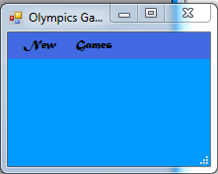

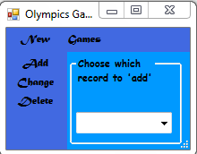

What do you want to add

add

This is the form that the admistrator will spend most of his/her time; this is where they will be adding, changing and deleting data to and from the database. Administrators must remain vigilant whilst carrying out their duty.

## Admin Entering data

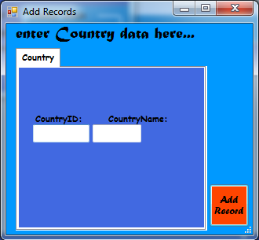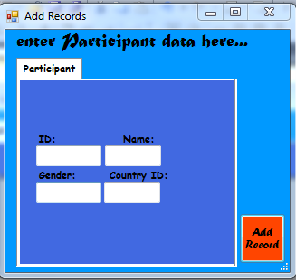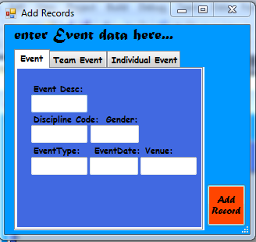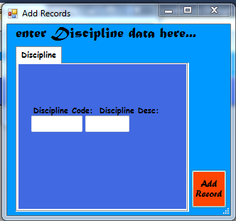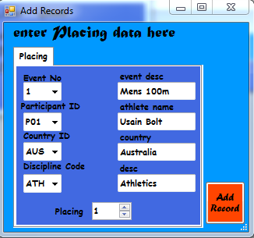

Click add records to enter the data

Add data here…

These are the various ‘add’ forms to facilitate the administrator with inserting data in the database. How this works is, it is basically one form that is dynamically changed to facilitate the data you want to enter. Clicking add will prompt the administrator to make sure all the changes they wish to implement are correct. The data which can be inserted include country, participants, discipline, events and placings

## Editing data

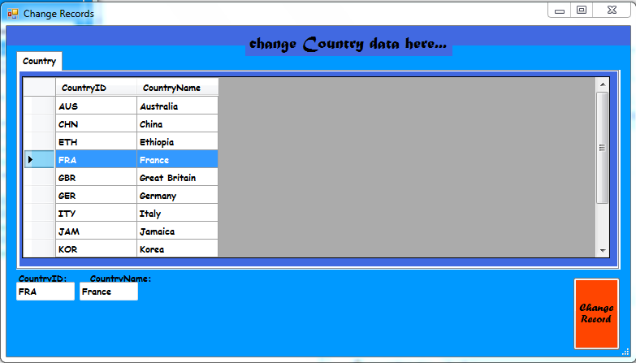

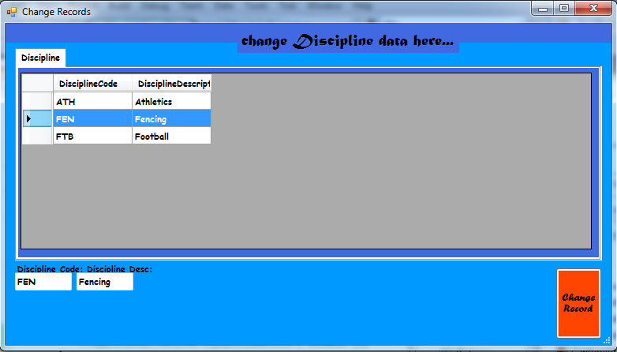

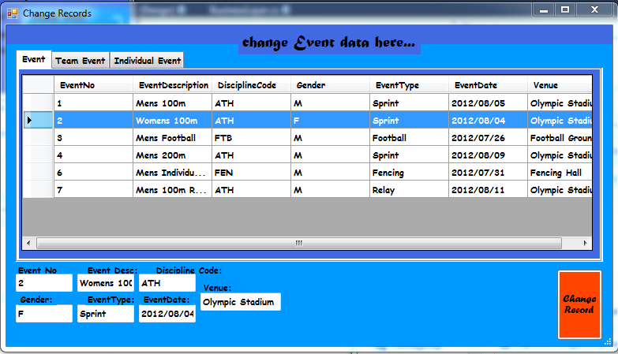

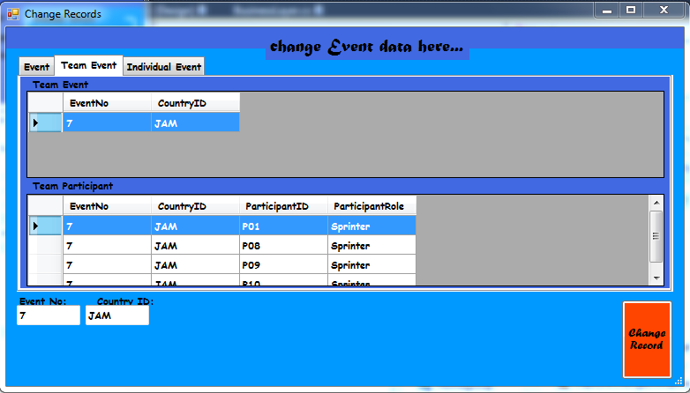

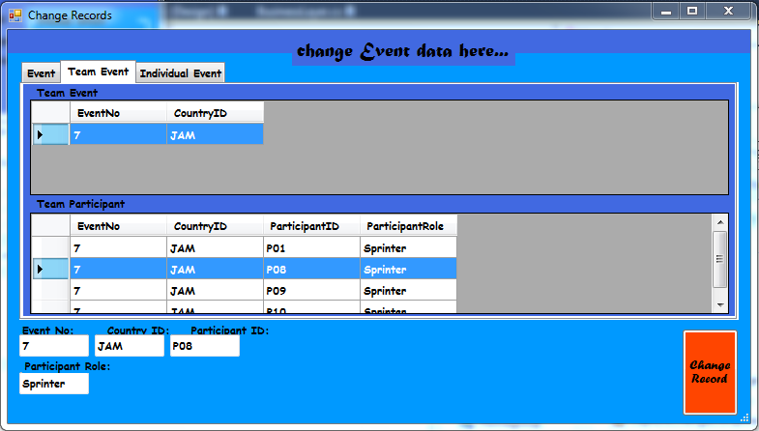

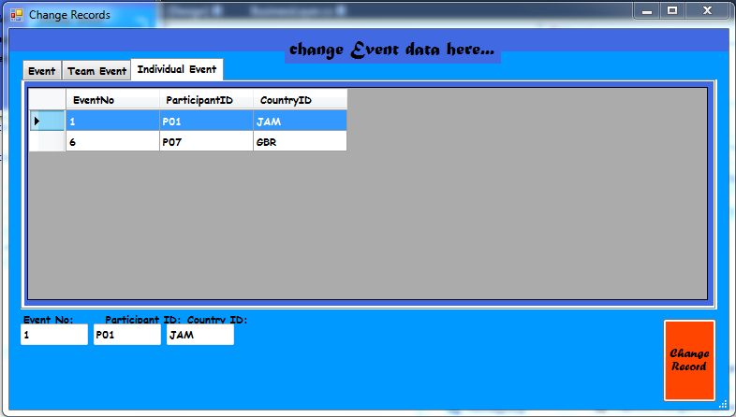

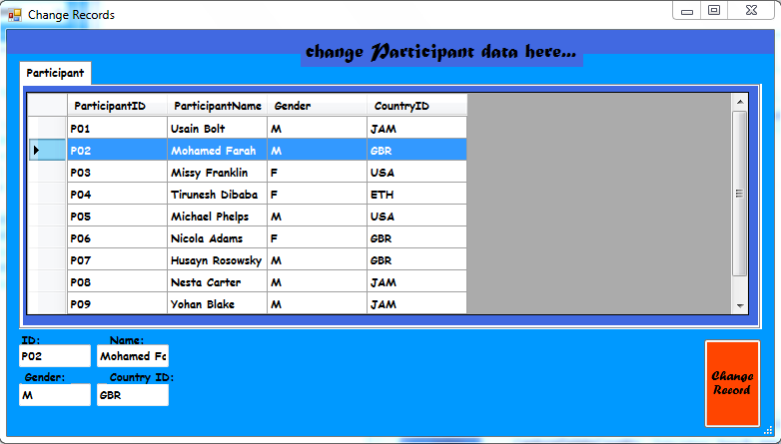

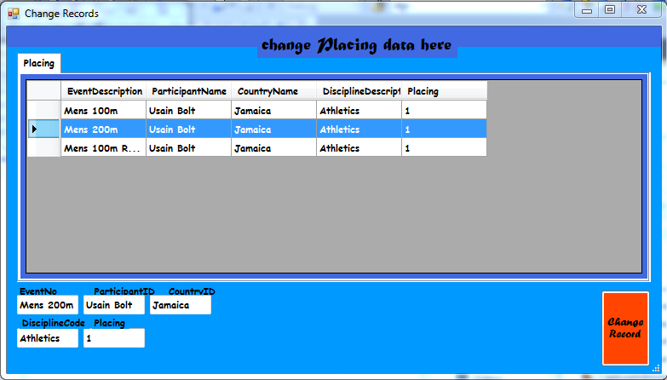

These are the change forms and they facilitate changing of data as the name suggests the Administrator clicks on a cell with the data they wish to change and the data is captured by the text boxes so the administrator can carry out his/her task. How this works is, it is basically one form that is dynamically changed to facilitate the data you want to change. Clicking change will prompt the administrator to make sure all the changes they wish to implement are correct. The data which can be changed include country, participants, discipline, events and placings

Delete data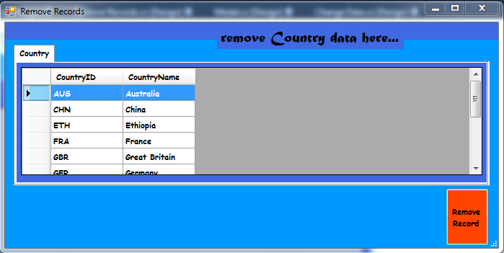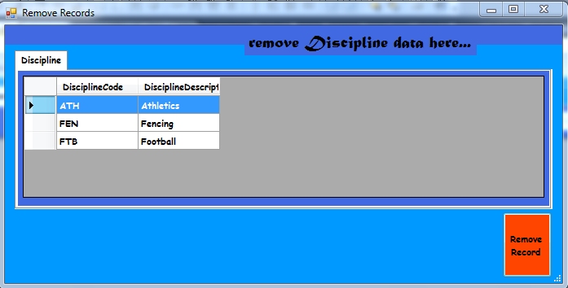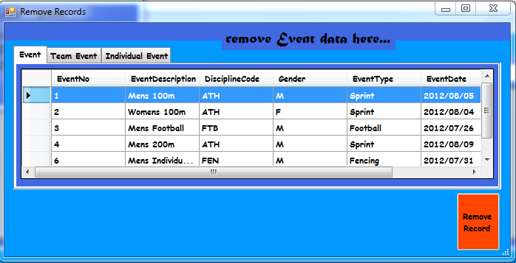

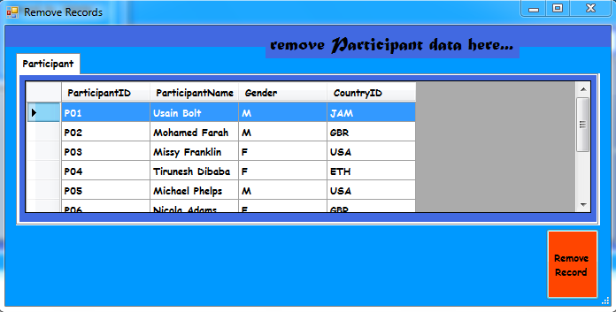

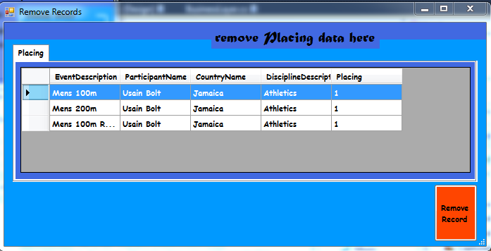

These are the delete forms and they facilitate the removal of data as the name suggests the Administrator clicks on a cell with the data they wish to remove and the data is captured by the text boxes so the administrator can carry out his/her task. How this works is, it is basically one form that is dynamically changed to facilitate the data you want to remove. Clicking remove will prompt the administrator to make sure all the changes they wish to implement are correct. The data which can be deleted include country, participants, discipline, events and placings

# End

# Bibliography & References:

Simple SQL statements

ADO. Databases

SQL 2005

C# and Databases

Database Management

C# 2008 Databases – Agarwale Huddlestone

Database Systems fifth edition - Connolly Begg

ADO.NET 2.0 step-by-step

Pro SQL Server 2000 Database - Design David

Database Systems intnaltial edition – Rob Coronel Crockett

Database Systems design implementation and management – Rob Coronel

ADO.NET, LINQ, & EF with C# 2008

[www.Google.com](http://www.Google.com)

[www.stackoverflow.com/](http://www.stackoverflow.com/)

[www.codeproject.com](http://www.codeproject.com)

[www.london2012.com](http://www.london2012.com)

Google Images

# Notes: