- Gather requirements and initials information

Purpose: To help CS/CIS/BINF students and faculty coordinate study sessions, match with study buddies, and prepare effectively using syllabus-based flashcards.

Users:
- Students / Study Buddies: Create profiles, propose sessions, accept invites, review flashcards.
- Faculty: Organize study teams, share availability, approve groups, host office hours.

Key Features:
- Profile creation and availability upload
- Study buddy matching and session proposal
- Invite acceptance with deadline enforcement
- Faculty-led team organization and event creation
- Flashcard generation from syllabus topics between DATE1 and DATE2
- Automatic cancellation and notifications if invite deadline is missed

- Outline the system
Architecture: Command-line application using Python classes (Profile, StudySession, FlashcardGenerator) with interactive terminal prompts and printed output.
User Interaction: Users interact with the app via terminal input (e.g., typing names, dates, choices). Output is displayed as formatted text (e.g., session status, flashcards, notifications). No graphical interface or web page will be used.

Workflow Summary: Students create profiles and upload availability via terminal prompts. Faculty actions (team organization, event creation) are simulated through backend logic. Study sessions are proposed and accepted/declined via terminal input. Flashcards are generated and printed based on syllabus topics between DATE1 and DATE2. Auto-cancel logic and notifications are displayed as terminal messages
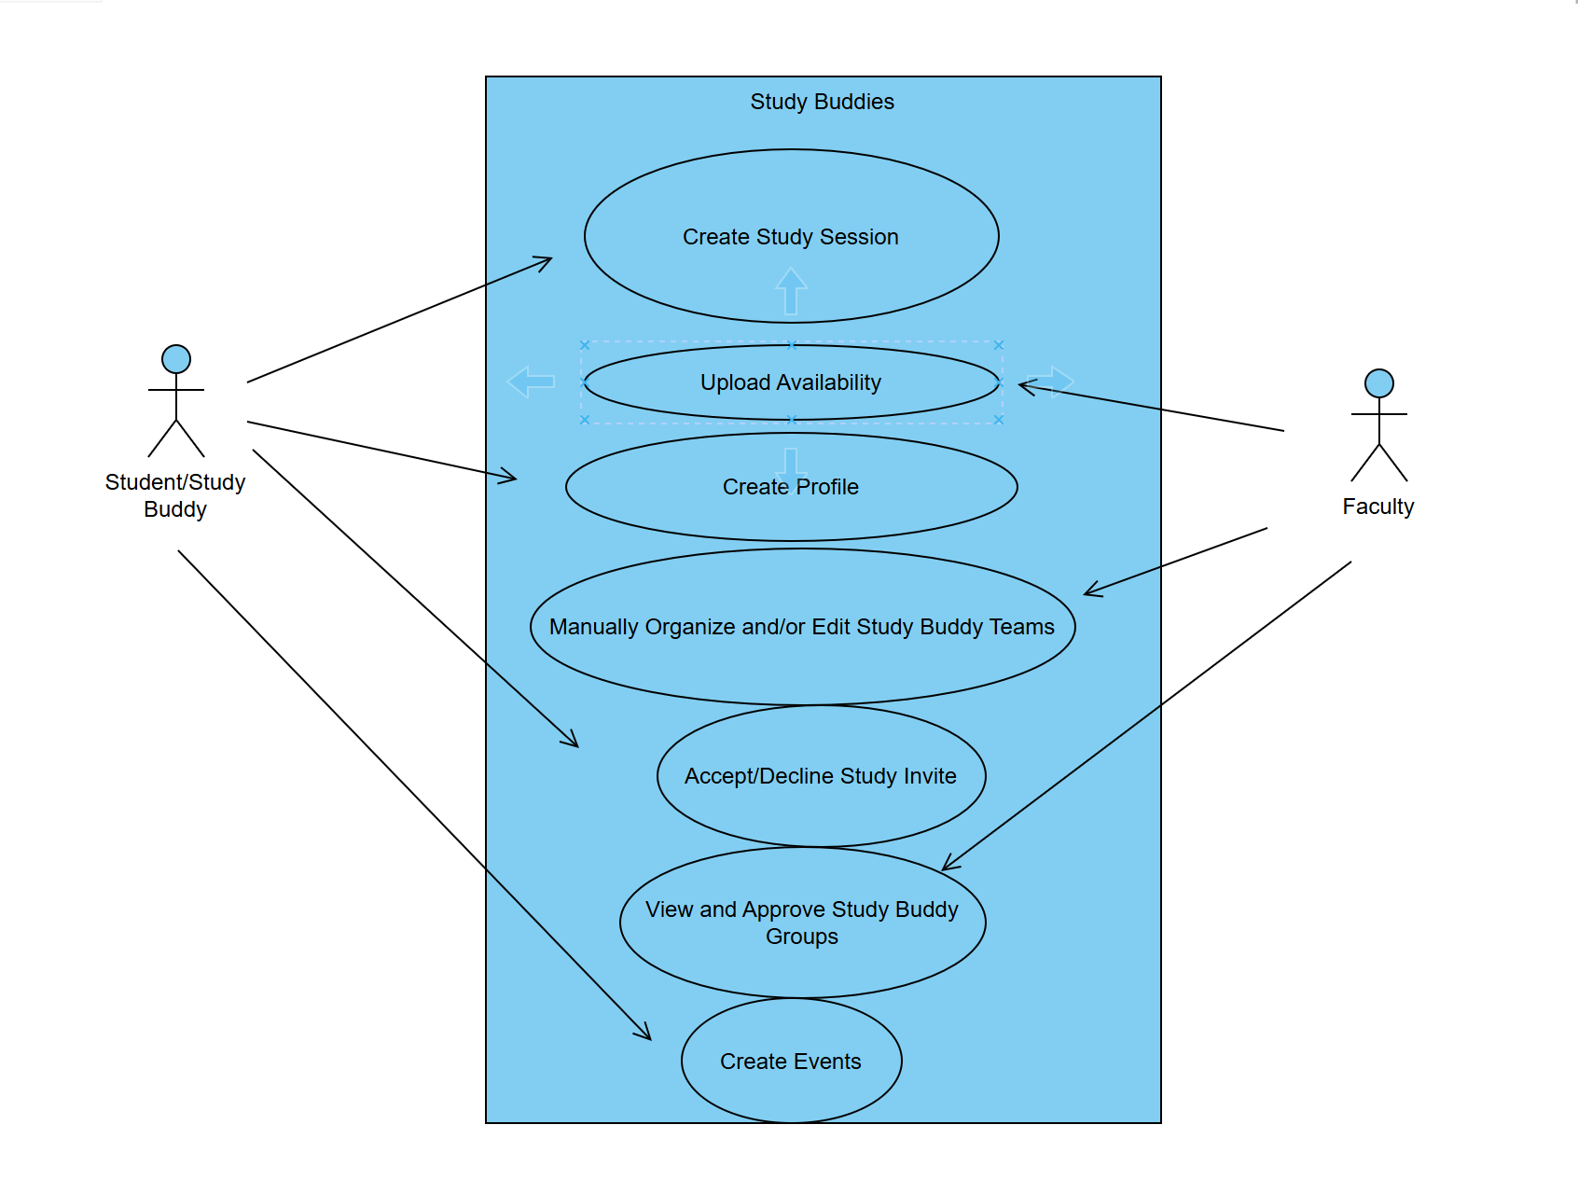

- Detail the data design
Relationships:
- A Profile can propose multiple StudySessions
- A StudySession can invite multiple Profiles
- FlashcardGenerator uses syllabus data to produce flashcards for a session
- Specify the interface and component design
- The application runs entirely in the terminal using text prompts and printed output.
- Users interact by typing responses to prompts (e.g., name, major, session time).
- Output includes confirmation messages, session status updates, and flashcard lists.
- Review and refine the document with stakeholders
Checklist to Review
- All required features are covered
- MVP and MMP scope is defined and testable
- Add unit tests

