**Observations**:

1. Charter schools have higher scores both individual and overall and are among top performing schools while bottom performing schools include the list if district schools. For details, please refer the screenshots from the observations below:

***Top performing schools (five)***

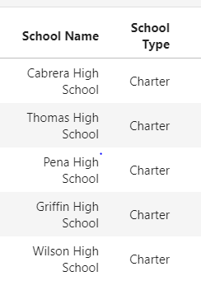

***Bottom performing schools(five)***

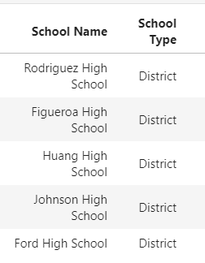

1. Overall reading score is better than math score district wide. Average reading score is above 80% and average math score is below 80% district wide.
2. Charter schools have better math scores than district schools thus concluding that they might have better teachers or students in chartered schools are intelligent than district schools.
3. Schools with medium and small school size perform better than the schools with larger school size.

