Steps to create a local copy of database follow the following steps:

1. Open MySQL
2. Go the scripts folder and execute nutrometer.sql
3. On mysql under the navigator section, select the schema usda. Right click and select Table data import wizard.
4. Select the csv file (file1.csv) using browse button and click next.
5. Change the table name to nutrition in the next step and click Next.
6. Change the data type for NDB_No as INT and complete the next steps.
7. After the successful import message, select the table under navigator section and click on ALTER table, Select NDB_no and set this column as PRIMARY KEY.
8. Verify that all the tables(user_account, meal_record and nutrition are present under the scgema usda.

Please confirm that the table structures are shown below:

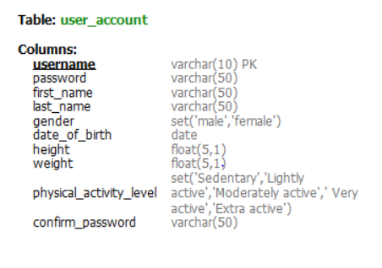

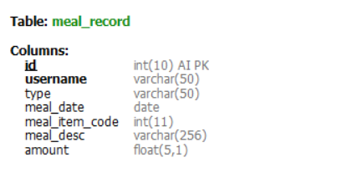

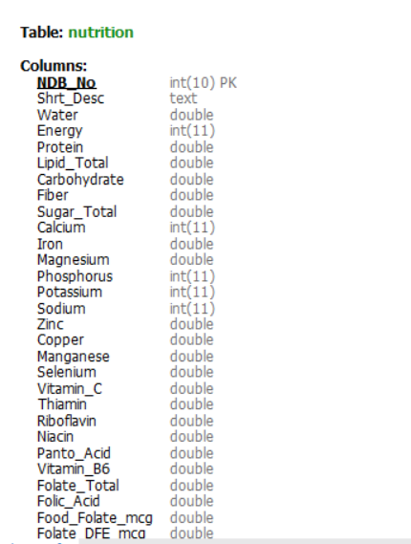

contd..

