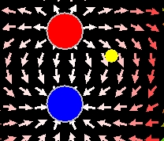
Screen shot of simulation showing the electric field of a dipole and a nearby test charge (yellow).

Lesson Plan: Dipole Trajectory Simulation

Key Topic/Concept: Electric Field and Newton’s 2nd Law

Materials:
- One guide sheet for each student
- Computer with simulation downloaded
- Science Notebook

The EJS Dipole Trajectory simulation can be downloaded from the comPADRE National Digital Library if it not available on the local computer:
< http://www.compadre.org/OSP/items/detail.cfm?ID=9683>

Safety Precautions: No special precautions needed for this lesson.

Written by: Anne J Cox
Edited by: Mario Belloni and Wolfgang Christian

Conditions of Use: This material is freely available for instructional use and may be reproduced and distributed for non-profit, educational purposes.

Physics Classroom Curriculum Alignment:
Static Electricity- Lesson 3: Newton’s Laws and the Electrical Force
Static Electricity- Lesson 4: Action-at-a-Distance
Static Electricity- Lesson 4: Electric Field Intensity

NC Curriculum Alignment (2004):
1.05 Analyze evidence to:
- Explain observations.
- Make inferences and predictions.
- Develop the relationship between evidence and explanation.

1.08 Use oral and written language to:
- Communicate findings.
- Defend conclusions of scientific investigations.

1.09 Use technologies and information systems to:
- Research.
- Visualize data.
4.05 Assess the independence of the vector components of forces.
8.01 Analyze the nature of electrical charges.
- Investigate the electrical charging of objects due to transfer of charge.
- Investigate the conservation of electric charge.
- Analyze the relationship among force, charge and distance summarized in Coulomb's law.

I. ENGAGEMENT

Review: Test Charge and Electric Field. Discuss the gravitational field and motion in such a field.

II. EXPLORATION
Have students work in pairs and open the EJS Electric Field simulation. Allow students about 5 minutes to explore with the simulation.

III. EXPLANATION/CONCEPT INVENTION
Ask students to reset the simulation begin with questions in the guide below. When most students have completed the guide, review the answers with the whole group.

IV. EXPANSION OF THE IDEA
Ask students to write a brief description or make sketches to explain the idea of a field.

V. EVALUATION
Teacher circulates to check that the Introduction and Electric Field Worksheet is completed and stapled into the science notebook.

Introduction: Field Review

Review: What is an Electric Field?
_________________________________________________________
_________________________________________________________

What is a “test charge”?
_________________________________________________________
_________________________________________________________

Other forces that act at a distance can be described by a field. For example, the gravitational field near the earth’s surface could be represented with field vectors as follows:

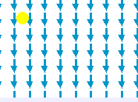
(a) (b)
Sketch the trajectory of a particle a) released from rest in the field above and b) thrown horizontally. Even though the field vectors do not necessarily show the trajectory of the particle, what do they tell you about the trajectory of the particle?
_________________________________________________________
_________________________________________________________

Introduction: Field Review-Answer Key

Review: What is an Electric Field?
_____Answers will vary: the force per unit charge that would act on a positive test charge; a vector that shows the direction and size of the force on a positive charge __________________________________
_________________________________________________________

What is a “test charge”?
____ Answers will vary: particle that is impacted by a field but doesn’t change the field (small charge in comparison to larger charges creating the vector fields observed) _________________________________
_________________________________________________________

Other forces that act at a distance can be described by a field. For example, the gravitational field near the earth’s surface could be represented with field vectors as follows:

(a) (b)
Sketch the trajectory of a particle a) released from rest in the field above and b) thrown horizontally. Even though the field vectors do not necessarily show the trajectory of the particle, what do they tell you about the trajectory of the particle?
____field vectors show the direction and magnitude of the force _______
_________________________________________________________

Activity Guide: EJS Dipole Trajectory Simulation

In this simulation, you can see the electric field around a dipole (red and blue charges). You can use the slider to change the separation between the charges. A test charge, with an adjustable initial position, is released from rest in the electric field when you push play. The arrow is its velocity vector.

- Run the Applet file on-line OR run the simulation by double-clicking on the ejs_electric_sampler.jar and then navigating to the Dipole Trajectory simulation and run the simulation by double-clicking on the green arrow. Push play () to see the test charge move in the field.
- Does the test charge follow the electric field vectors? _________________________________________________________
- Many students find it surprising that the test charge does not follow the field or go in the direction of the arrows so we will explore this. Where can you place the charge initially so that it does follow the field arrows? Explain.
_________________________________________________________
_________________________________________________________
- Reset () the simulation and play it, pausing () the simulation at some point during its path. Sketch the location of the test charge and its velocity:

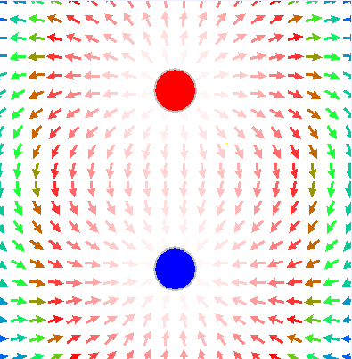
t t+Δt (a few time steps later)

- Step () the simulation through a couple of time steps and sketch the location of the test charge, direction of the field vector and velocity vector at this new location in the diagram above. Describe or sketch the change in the velocity:

- How does the direction of the change in the velocity (remember it is a vector: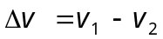) compare with the direction of the electric field vector at that point?
_________________________________________________________
_________________________________________________________

- Using this information, how would you respond to a student who was surprised that the test charge did not necessarily follow the electric field vectors? (What incorrect assumptions might this student be making? What does this student need to know about the electric field?)
_________________________________________________________
_________________________________________________________
_________________________________________________________
_________________________________________________________
_________________________________________________________

Activity Guide: EJS Dipole Trajectory Simulation- Answer Key

In this simulation, you can see the electric field around a dipole (red and blue charges). You can use the slider to change the separation between the charges. A test charge, with an adjustable initial position, is released from rest in the electric field when you push play. The arrow is its velocity vector.
- Run the Applet file on-line OR run the simulation by double-clicking on the ejs_electric_sampler.jar and then navigating to the Dipole Trajectory simulation and run the simulation by double-clicking on the green arrow. Push play () to see the test charge move in the field.
- Does the test charge follow the electric field vectors?
____ no- not necessarily ____________________________________
- Many students find it surprising that the test charge does not follow the field or go in the direction of the arrows so we will explore this. Where can you place the charge initially so that it does follow the field arrows? Explain.
____ between the two charges (because it never experiences a force to the left or right) _____________________________________
- Reset () the simulation and play it, pausing () the simulation at some point during its path. Sketch the location of the test charge Sketch the location of the test charge and its velocity:
Answers will vary:
t t+Δt (a few time steps later)

- Step () the simulation through one or two time steps and sketch the location of the test charge, direction of the field vector and velocity vector at this new location in the diagram above. Describe or sketch the change in the velocity:

Answers will vary:

- How does the direction of the change in the velocity (remember it is a vector:) compare with the direction of the electric field vector at that point?
______in the same direction __________________________________
_________________________________________________________

- Using this information, how would you respond to a student who was surprised that the test charge did not necessarily follow the electric field vectors? (What incorrect assumptions might this student be making? What does this student need to know about the electric field?)
____Answers will vary: The electric field vector shows the direction of the FORCE on the test charge. The force is the direction of the acceleration which is the change in the velocity, not the direction of the velocity (which is along the trajectory) so the vectors only show the path the test charge makes in certain special cases (when the charge is at rest and the field vectors all point in the same direction: like a ball dropped near the earth) __
_________________________________________________________
_________________________________________________________
_________________________________________________________
_________________________________________________________

