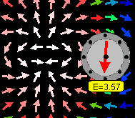
Screen shot of simulation showing a dipole and electric field detector.

Lesson Plan: Electric Multipole Simulation

Key Topic/Concept: Electric Field

Materials:
- One guide sheet for each student
- Computer with simulation downloaded
- Science Notebook

The EJS Electric Multipole simulation can be downloaded from the comPADRE National Digital Library if it not available on the local computer:
< http://www.compadre.org/OSP/items/detail.cfm?ID=9683>

Safety Precautions: No special precautions needed for this lesson.

Written by: Anne J Cox
Edited by: Mario Belloni and Wolfgang Christian

Conditions of Use: This material is freely available for instructional use and may be reproduced and distributed for non-profit, educational purposes.

Physics Classroom Curriculum Alignment:
Static Electricity- Lesson 4: Action-at-a-Distance
Static Electricity- Lesson 4: Electric Field Intensity

NC Curriculum Alignment (2004):
1.05 Analyze evidence to:
- Explain observations.
- Make inferences and predictions.
- Develop the relationship between evidence and explanation.

1.08 Use oral and written language to:
- Communicate findings.
- Defend conclusions of scientific investigations.

1.09 Use technologies and information systems to:
- Research.
- Visualize data.
8.01 Analyze the nature of electrical charges.
- Investigate the electrical charging of objects due to transfer of charge.
- Investigate the conservation of electric charge.
- Analyze the relationship among force, charge and distance summarized in Coulomb's law.

I. ENGAGEMENT/REVIEW
Review the idea of electric fields. Complete as a whole group with a fast pace (about 15 minutes) and with students using their science notebooks.

An electric field is ___________________________________.
Sketch your prediction of the field vectors of a dipole (defined as a positive and a negative charge).

II. EXPLORATION
Have students work in pairs and open the EJS Coulomb Force simulations. Allow students about 5 minutes to explore with the simulation.

III. EXPLANATION/CONCEPT INVENTION
Ask students to reset the simulation begin with questions in the guide below. When most students have completed the guide, review the answers with the whole group.

IV. EXPANSION OF THE IDEA
Ask students to write a brief description or make sketches to explain the motion observed.

V. EVALUATION
Teacher circulates to check that the Introduction and Coulomb Force Worksheet is completed and stapled into the science notebook.

Introduction: Electric Field

An electric field is ________________________________________
______________________________________________________

The configuration below is a dipole: one positive and one negative charge. Sketch what you think the electric field vectors will look like for this dipole:

+
_

Introduction: Electric Field- Answer Key

An electric field is ___Answers will vary: the force per unit charge that would act on a positive test charge; a vector that shows the direction and size of the force on a positive charge_____________________________________

The configuration below is a dipole: one positive and one negative charge. Sketch what you think the electric field vectors will look like for this dipole:

+
_

Activity Guide: EJS Electric Multipole Simulation

In this simulation, you can change the initial configuration (monopole, dipole, quadrupole) and change the amount of charge on the charges.

- Run the Applet file on-line OR run the simulation by double-clicking on the ejs_electric_sampler.jar and then navigating to the Coulomb Pendulum simulation and run the simulation by double-clicking on the green arrow.
- Run the simulation of a monopole (point charge) at the origin. Move the detector around in the electric field and observe the value of the electric field. When the detector is moved twice as far from charge, what happens to the electric field ( if you need to)? Is this consistent with the equation for the electric field of a point charge: E=kq/r²?
_________________________________________________________
_________________________________________________________

- Now, try the dipole simulation. A dipole is constructed of two charges: a positive and negative charge near each other centered at the origin. In what direction is the dipole oriented? Draw a sketch below.

How do you know?
_________________________________________________________

- A quadrupole is constructed from four charges or two dipoles (pointing in opposite directions). Can you tell how the charges are arranged? Draw a sketch or explain.

Optional Quantitative Analysis:
- How does the electric field decrease as you move away from the origin along the x-axis (1/x, 1/x², 1/x³, 1/x⁴)? To find out, move the detector along the positive x-axis (keeping y=0) and record the field values in the Data Table. Then try to find a good fit for the data by clicking on the Wrench () button and using the DataTool. Some notes on working with the DataTool:
  - DataTool automatically draws lines between nearby points and you may find this confusing. Click on the checkbox with a line through it (above the data) to remove the connecting lines.
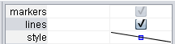
uncheck this
  - If you want DataTool to Fit the data, you first need to pick the data to Fit. DataTool will fit the first two columns of data so to have it fit E as a function of x, you need to move the E column to the vertical axis.
Click and drag this column to the second column
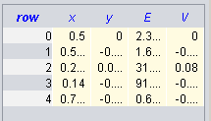
Then, click the Fit checkbox.
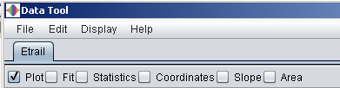
  - Since the electric field decreases as you get further way, you will need to try an equation not in the list by editing the current equation in Fit Builder. For example, if you want to fit the data to a/x³ (and have the program automatically find the value of a), first, double-click on the equation of the line (E=a*x+b)
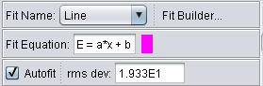
double-click to edit
  - This to automatically opens the Fit Builder. In this case, since you only want to fit one parameter, first delete parameter "b" (from the parameter list)
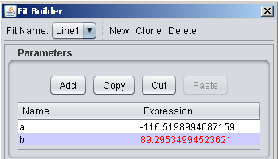
Click to select b and then use “cut” button
(you may need to increase of the size of window if you don’t see both a and b)

and then type your new Line1 = a/x^3 in the equation box.
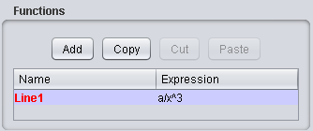
  - Try E = a/x, E=a/x², E=a/x³, E=a/x⁴ …Which is the best fit? Describe your method for determining best equation for each configuration (monopole, dipole and quadrupole):
____________________________________________________________________________________________________________________________________________________________________________________________________________________________________
Configuration | Best Equation  (E=a/x, a/x², a/x³….) | a | rms deviation
Monopole
Dipole
Quadrupole

- Following this trend, then, what dependence would you expect for an octopole (two quadrupoles)?
_________________________________________________________

Activity Guide: EJS Electric Multipole Simulation-Answer Key

In this simulation, you can change the initial configuration (monopole, dipole, quadrupole) and change the amount of charge on the charges.

- Run the Applet file on-line OR run the simulation by double-clicking on the ejs_electric_sampler.jar and then navigating to the Coulomb Pendulum simulation and run the simulation by double-clicking on the green arrow.
- Run the simulation of a monopole (point charge) at the origin. Move the detector around in the electric field and observe the value of the electric field. When the detector is moved twice as far from charge, what happens to the electric field ( if you need to)? Is this consistent with the equation for the electric field of a point charge: E=kq/r²?
______yes________________________________________________
- Now, try the dipole simulation. A dipole is constructed of two charges: a positive and negative charge near each other centered at the origin. In what direction is the dipole oriented? Draw a sketch below.

How do you know?
the field vectors point toward the negative charge and away from the positive charge (and charges are located where E is large) ____
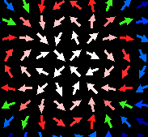
- A quadrupole is constructed from four charges or two dipoles (pointing in opposite directions). Can you tell how the charges are arranged? Draw a sketch or explain.

Optional Quantitative Analysis:
- How does the electric field decrease as you move away from the origin along the x-axis (1/x, 1/x², 1/x³, 1/x⁴)? To find out, move the detector along the positive x-axis (keeping y=0) and record the field values in the Data Table. Then try to find a good fit for the data by clicking on the Wrench () button and using the DataTool. Some notes on working with the DataTool:
  - DataTool automatically draws lines between nearby points and you may find this confusing. Click on the checkbox with a line through it (above the data) to remove the connecting lines.
uncheck this
  - If you want DataTool to Fit the data, you first need to pick the data to Fit. DataTool will fit the first two columns of data so to have it fit E as a function of x, you need to move the E column to the vertical axis.
Click and drag this column to the second column
Then, click the Fit checkbox.
  - Since the electric field decreases as you get further way, you will need to try an equation not in the list by editing the current equation in Fit Builder. For example, if you want to fit the data to a/x³ (and have the program automatically find the value of a), first, double-click on the equation of the line (E=a*x+b)
double-click to edit
  - This to automatically opens the Fit Builder. In this case, since you only want to fit one parameter, first delete parameter "b" (from the parameter list)
Click to select b and then use “cut” button
(you may need to increase of the size of window if you don’t see both a and b)

and then type your new Line1 = a/x^3 in the equation box.
  - Try E = a/x, E=a/x², E=a/x³, E=a/x⁴ …Which is the best fit? Describe your method for determining best equation for each configuration (monopole, dipole and quadrupole):
___lowest rms deviation; looking at the graph and observing which fit goes through the points most closely ____________________________ _________________________________________________________
Configuration | Best Equation  (E=a/x, a/x², a/x³….) | a  (for q=1) | rms deviation
Monopole | a/x² | 3 | less than 1.0
Dipole* | a/x³ | ~.25 (may vary) | less than 1.0
Quadrupole* | a/x⁴ | ~.09 (may vary) | less than 1.0
*the field drops off for dipoles and quadrupoles as 1/x³ and 1/x⁴ ‘far away’ from the charges so the values from the fit may vary depending on the measurements close to the origin
- Following this trend, then, what dependence would you expect for an octopole (two quadrupoles)?
__a/x⁵____________________________________________________

