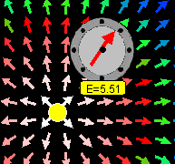
Screen shot of simulation showing the electric field detector near a point charge.

Lesson Plan: Electric Field Simulation

Key Topic/Concept: Electric Field

Materials:
- One guide sheet for each student
- Computer with simulation downloaded
- Science Notebook

The EJS Coulomb Force simulation can be downloaded from the comPADRE National Digital Library if it not available on the local computer:
< http://www.compadre.org/OSP/items/detail.cfm?ID=9683>

Safety Precautions: No special precautions needed for this lesson.

Written by: Anne J Cox
Edited by: Mario Belloni and Wolfgang Christian

Conditions of Use: This material is freely available for instructional use and may be reproduced and distributed for non-profit, educational purposes.

Physics Classroom Curriculum Alignment:
Static Electricity- Lesson 4: Action-at-a-Distance
Static Electricity- Lesson 4: Electric Field Intensity

Introduction: The “Stink” Field
(analogy from Physics Classroom Tutorial, Lesson 4a: Electric Field; Action-at-a-Distance)

Imagine you have just entered a room where there is a baby with a soiled diaper (poopy diaper). How can you tell it is there? What happens if you get closer to it? Describe what you would be able to determine about the poopy diaper just from being in its “stink” field:
_________________________________________________________
_________________________________________________________
_________________________________________________________
_________________________________________________________

Does your detector (nose) change the properties of the source of the “stink” field? Explain.
_________________________________________________________
_________________________________________________________

This is analogous to an Electric Field and your nose in the “stink field” is analogous to an electric field detector (or test charge).

Activity Guide: EJS Electric Field Simulation

In this simulation, there is a point charge at the origin that is the source of the electric field. The colored arrows represent electric field vectors. There is also an electric field detector that you can move around. For further analysis, you can record data on a data table and use a data analysis tool to fit the data to an equation.

- Run the Applet file on-line OR run the simulation by double-clicking on the ejs_electric_sampler.jar and then navigating to the Electric Field: Point Charge simulation and run the simulation by double-clicking on the green arrow.
- Drag the detector around and notice the direction of the electric field as well as the size (magnitude of the field). If the detector is the same distance away from the point charge, is the field the same size? In what direction does the field point? This is the direction that a positive charge would feel a force if it were at that spot.
_________________________________________________________
_________________________________________________________

- The arrows are like a bunch of little electric field detectors and they point in the direction of the electric field. What does the color indicate? Is red a stronger field than blue? Weaker?
_________________________________________________________
_________________________________________________________

- Try changing the slider and see what happens. If you double the charge, does the value at the detector double? At all points? How does the color change?
_________________________________________________________
_________________________________________________________
_________________________________________________________

Quantitative Analysis:
- Keep the value of the point charge fixed. Push the button on the Data Table and notice that it records the position of the Detector and the value of the electric field. Move the detector around and record the value of several points (at least 5) in the table and record them in the table below:
x | y | r | E

- In the table, r is the distance between the Detector and the point charge. Show that 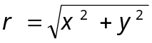 for one of the entries in the table: _________________________________________________________

Explain why is the distance between the point charge (at the origin) and the Detector (make a diagram if necessary):

- Now you are going to use your data to determine the equation for E (electric field) as a function of r. Clicking on the Wrench () button opens up a data analysis tool (DataTool) with your data.
  - DataTool automatically draws lines between nearby points and you may find this confusing. Click on the checkbox with a line through it (above the data) to remove the connecting lines.
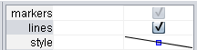
uncheck this
  - If you want DataTool to Fit the data, click the Fit checkbox.
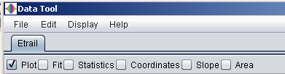
Click on Auto-fit to let the computer complete the best Line fit. Is this a good fit? Explain.
_________________________________________________________
_________________________________________________________
  - Since the electric field decreases as you get further way, you will need to try an equation not in the list by editing the current equation in Fit Builder. For example, if you want to fit the data to a/r³ (and have the program automatically find the value of a), first, double-click on the equation of the line (E=a*r+b)
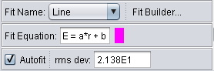
double-click to edit
  - This to automatically opens the Fit Builder. In this case, since you only want to fit one parameter, first delete parameter "b" (from the parameter list)
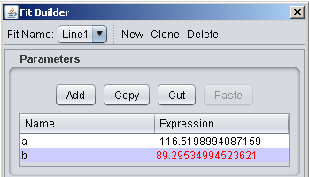
Click to select b and then use “cut” button
(you may need to increase of the size of window if you don’t see both a and b)

and then type your new Line1 = a/r^3 in the equation box.
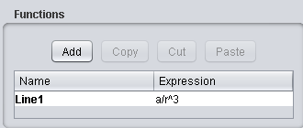
  - Try E = a/r, E=a/r² and E=a/r³. Which is the best fit? How can you tell?
_________________________________________________________
_________________________________________________________
_________________________________________________________
_________________________________________________________
_________________________________________________________
Best equation: ___________________________________________

- If r is very large (the Detector is far away), what should happen to the field (be large or small)? Is this true for your equation?
_________________________________________________________
_________________________________________________________

- If r is measured in meters and E is measured in N/C, what is the charge of the yellow point charge at the origin when the slider for q is set to 1? Show your work:

