SHOPPER PULSE | CUSTOMER ANALYTICS
Customer Shopping Behavior
Performance review, customer diagnostics and growth recommendations
Prepared by: Minh Duc Le
Date: September 23, 2026
Data source: customer_shopping_behavior_cleaned.csv (3,900 customers)
Dashboard: customer_analysis.pbix (Overview, Customers, Behavior & Channels)
Classification: Internal – for management review

Contents

Tip: in Word, right-click the table of contents and choose Update Field if page numbers are missing.

1. Executive summary
This report reviews 3,900 customer transactions captured in the Shopper Pulse dashboard. It assesses how revenue is generated, which customers drive value, and whether the loyalty programs (subscriptions and discounts) are working. The analysis combines the dashboard views with statistical testing to separate real differences from noise.
TOTAL REVENUE  $233,081  Across 50 U.S. states | TRANSACTIONS  3,900  One row per customer | AVG ORDER VALUE  $59.76  Median $60; range $20–$100 | AVG RATING  3.75  17% of ratings below 3.0
SUBSCRIBERS  27.0%  All male; all used discounts | DISCOUNTED ORDERS  43.0%  No lift in order value | LOYAL CUSTOMERS  79.9%  >10 previous purchases | HIGH-FREQUENCY BUYERS  41.7%  ≈83% of est. annual spend

Key conclusions
- Loyalty programs are not creating value and exclude women entirely. All 1,053 subscribers and all 1,677 discounted orders belong to male customers. Discounted orders average $59.28 versus $60.13 without a discount, and the difference is not statistically significant (p = 0.27). The discount appears to give away margin without increasing basket size.
- Purchase frequency, not basket size, drives customer value. Order values are statistically the same across gender, age, category, payment and shipping. However, weekly, bi-weekly and fortnightly buyers (42% of customers) account for an estimated 83% of annual spend.
- Women are under-represented but equally valuable. Female customers are 32% of the base, yet spend the same per order ($60.25 vs $59.54, p = 0.38) and have the same category mix. Growth is a reach problem, not a product problem.
- The portfolio is concentrated but healthy. Clothing and accessories deliver 76% of revenue; the top 10 of 25 products deliver 42%. Fall is the only period with a meaningfully higher order value ($61.56, p = 0.01).
- Acquisition is the weak link. Only 83 customers (2.1%) are first-time buyers, so growth currently depends on a mature, loyal base.

Priority actions
(1) Redesign the discount program around spend thresholds and measure its impact with a control group; (2) open subscriptions and offers to female customers; (3) build a frequency program that moves monthly and quarterly buyers toward fortnightly purchasing; (4) launch a first-purchase acquisition campaign ahead of the Fall peak.

2. Scope, data and methodology

2.1 Objectives
- Describe current revenue performance by product, customer and channel.
- Identify which customer characteristics are associated with higher value.
- Evaluate the effectiveness of the subscription and discount programs.
- Recommend prioritized, measurable actions.

2.2 Data
The cleaned dataset contains 3,900 records and 19 fields: demographics (age, gender, location), purchase details (item, category, amount, size, color, season), behavior (payment method, shipping type, purchase frequency, previous purchases), review rating, and program flags (subscription, discount). Each record represents one customer and their most recent purchase. There are no missing values. One label error ("Midddle-aged") was corrected to "Middle-aged" for reporting.

2.3 Approach
Method | How it was used
Descriptive analysis | Revenue, order counts, averages and shares by every dimension, built as DAX measures in Power BI.
Welch’s t-test | Compared average order value between two groups (e.g., discount vs. no discount). A p-value below 0.05 indicates a real difference.
One-way ANOVA | Tested whether order value or rating differs across groups with 3+ levels (category, season, age group, etc.).
Chi-square test | Tested whether two categorical variables are related (e.g., gender and subscription).
Pearson correlation | Measured linear relationships between numeric fields (age, previous purchases, rating, amount).
Annual spend estimate | Order value × purchases per year implied by the frequency field (weekly = 52, bi-weekly/fortnightly = 26, monthly = 12, quarterly/every 3 months = 4, annually = 1). This is an indicative proxy, not recorded revenue.

2.4 Dashboard used
Report page | Content
Overview | KPI cards, revenue by category, automated key insights, top 10 states, top 10 products
Customers | Revenue by gender, customer segments by purchase history, revenue by age group, orders by size
Behavior & Channels | Revenue by payment method, orders by shipping type, subscription and discount comparison, orders by purchase frequency

All pages share six slicers (gender, age group, category, season, state, subscription) and a filter banner that shows the active selection.

3. Revenue performance

3.1 Category mix
Exhibit 1. Revenue by category
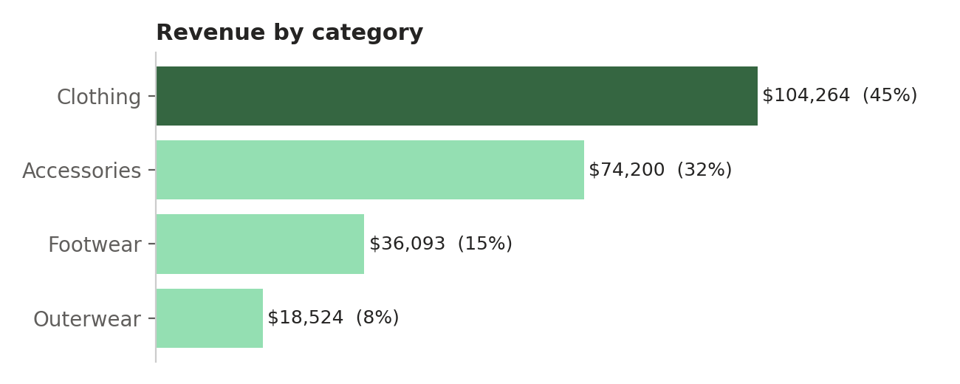
Source: customer_shopping_behavior_cleaned.csv (n = 3,900); Shopper Pulse Power BI model.
Clothing generates $104,264 (44.7%) and accessories $74,200 (31.8%), together three quarters of revenue. Footwear contributes 15.5% and outerwear 7.9%. Average order value ranges only from $57.17 (outerwear) to $60.26 (footwear), and the difference is not significant (ANOVA p = 0.23). Category revenue is therefore driven by the number of orders, not by price.

3.2 Product concentration
Exhibit 2. Revenue by product
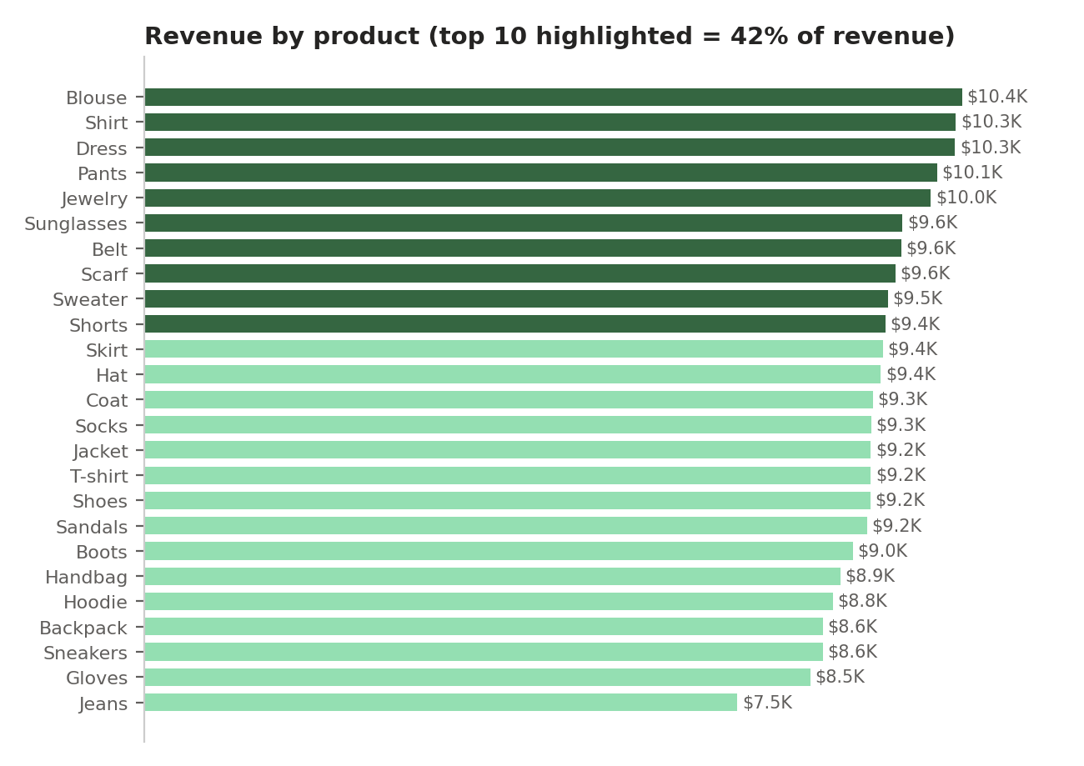
Source: customer_shopping_behavior_cleaned.csv (n = 3,900); Shopper Pulse Power BI model.
The 25 products are closely clustered. The top 10 (led by blouses, shirts, dresses, pants and jewelry, each about $10,000) generate 42.4% of revenue, only slightly above the 40% they would produce if sales were spread evenly. Jeans are the clear laggard at $7,548 and 124 orders, 27% below the leading item. Shirts and jeans also have the lowest average ratings (3.62 and 3.65).
So what: There is no “hero” product to protect, but jeans combine low volume with low satisfaction and should be reviewed for fit, quality or pricing.

3.3 Seasonality and geography
Exhibit 3. Average order value by season  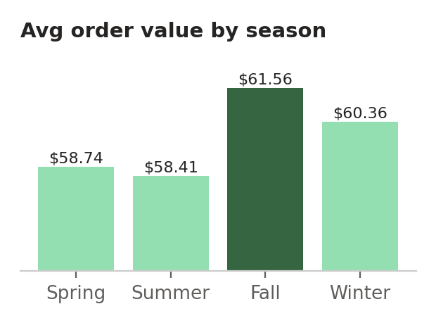 | Revenue by season
  Season | Revenue (share)
  Fall | $60,018 (25.7%)
  Spring | $58,679 (25.2%)
  Winter | $58,607 (25.1%)
  Summer | $55,777 (23.9%)

Season is the only dimension where order value differs significantly (ANOVA p = 0.011): Fall orders average $61.56 compared with $58.41 in Summer, a 5.4% gap. Revenue by state is also evenly spread (coefficient of variation 11%); Montana leads with $5,784 and Kansas trails with $3,437. The top 10 states generate 23% of revenue.
So what: Fall is the best window for premium launches and acquisition campaigns. Geographic targeting is a secondary lever.

4. Customer diagnostics

4.1 Demographics
Exhibit 4. Revenue by gender and age group
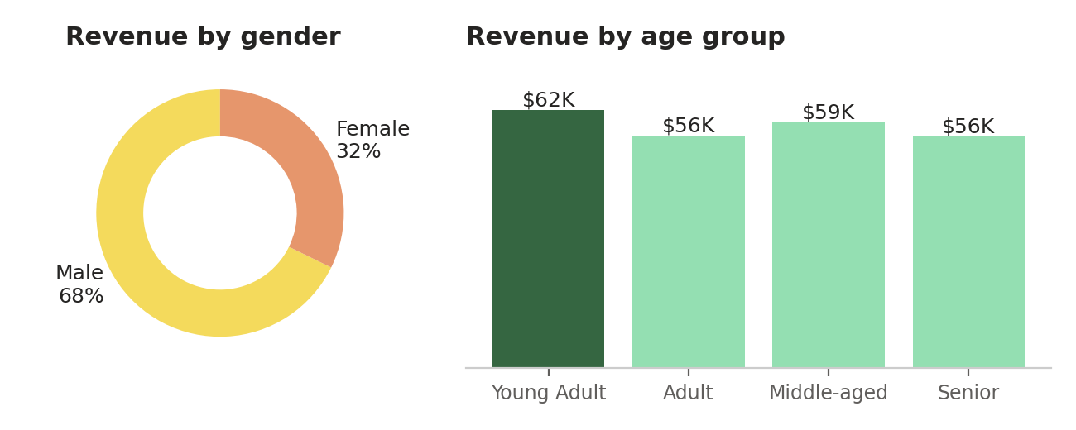
Source: customer_shopping_behavior_cleaned.csv (n = 3,900); Shopper Pulse Power BI model.
Men make up 68% of customers and 67.7% of revenue. Women spend slightly more per order ($60.25 vs $59.54), but the difference is not significant (p = 0.38), and both genders buy the same category mix (chi-square p = 0.90). Age has no relationship with order value (r = −0.01), and revenue is evenly split across the four age groups (24–27% each).

4.2 Loyalty and purchase frequency
Exhibit 5. Customer segments by previous purchases
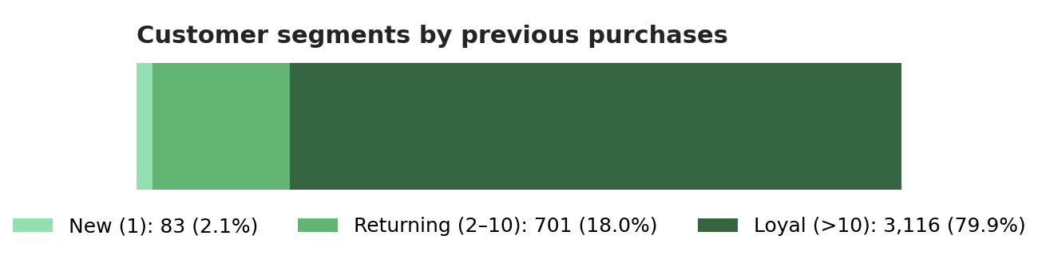
Source: customer_shopping_behavior_cleaned.csv (n = 3,900); Shopper Pulse Power BI model.
79.9% of customers have more than 10 previous purchases, 18.0% have 2–10, and just 2.1% are new. Previous purchases have no correlation with order value (r = 0.01), meaning loyal customers do not spend more per order.
Exhibit 6. Purchase frequency: share of customers vs. estimated annual spend
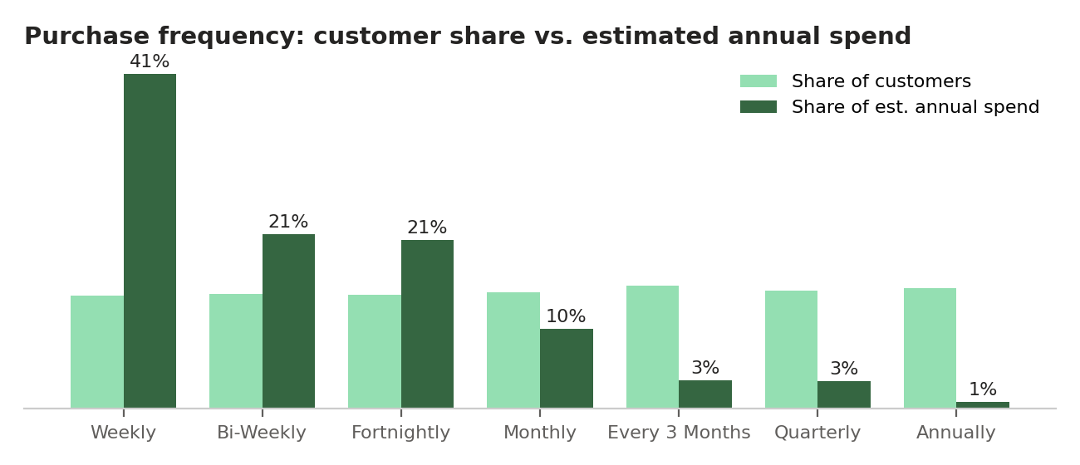
Source: customer_shopping_behavior_cleaned.csv (n = 3,900); Shopper Pulse Power BI model.
The frequency segments are almost equal in size (about 14% each), but their value is not. Using order value multiplied by implied purchases per year, weekly buyers alone represent about 41% of estimated annual spend, and the three highest-frequency groups together about 83%. Annual buyers represent under 1%.
So what: The most important value driver is how often customers buy. Programs should reward frequency (e.g., points per visit, replenishment reminders) rather than one-off discounts.

4.3 Satisfaction
Exhibit 7. Distribution of review ratings  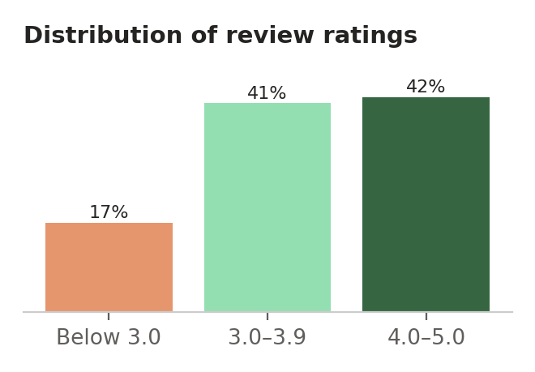 | Average rating by shipping type
  Shipping type | Avg rating
  Standard | 3.82
  Express | 3.77
  2-Day Shipping | 3.77
  Free Shipping | 3.72
  Next Day Air | 3.72
  Store Pickup | 3.71

The average rating is 3.75 out of 5. 42% of ratings are 4.0 or higher, but 17% fall below 3.0, a sizeable dissatisfied group. Differences by shipping type (p = 0.03) and size (p = 0.03) are statistically significant but small: standard shipping and sizes S/XL score highest, store pickup and size M lowest. Ratings are not linked to spending (r = 0.03).
So what: Satisfaction is adequate but not a differentiator. Following up on the 17% of low ratings, especially for shirts, jeans and store pickup, is a low-cost retention win.

5. Program effectiveness: subscriptions and discounts
Exhibit 8. Share of customers enrolled in each program, by gender
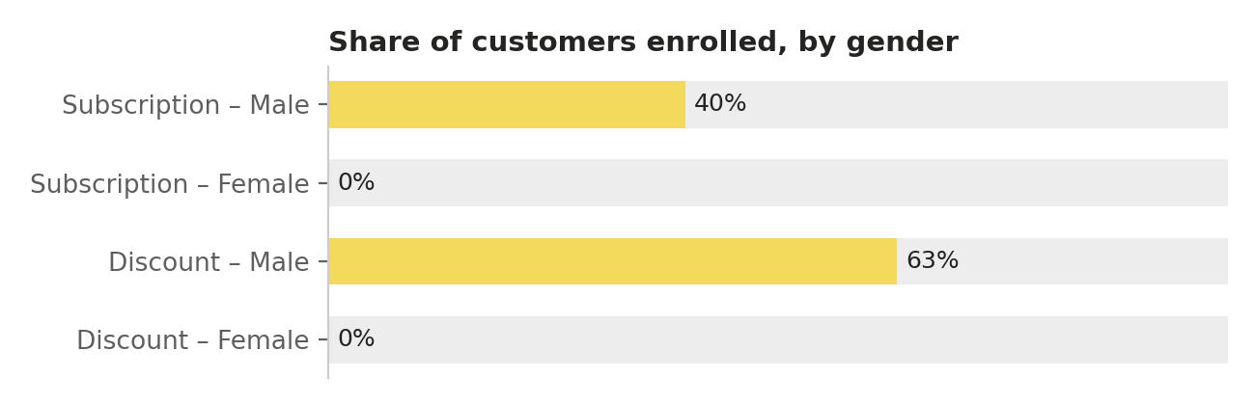
Source: customer_shopping_behavior_cleaned.csv (n = 3,900); Shopper Pulse Power BI model.
This is the most important finding in the dataset. Program participation is entirely determined by gender (chi-square p < 0.001): 39.7% of male customers subscribe and 63.2% received a discount, while no female customer did either. In addition, every subscriber received a discount, so the two programs cannot be evaluated separately.
Exhibit 9. Average order value for program members and non-members
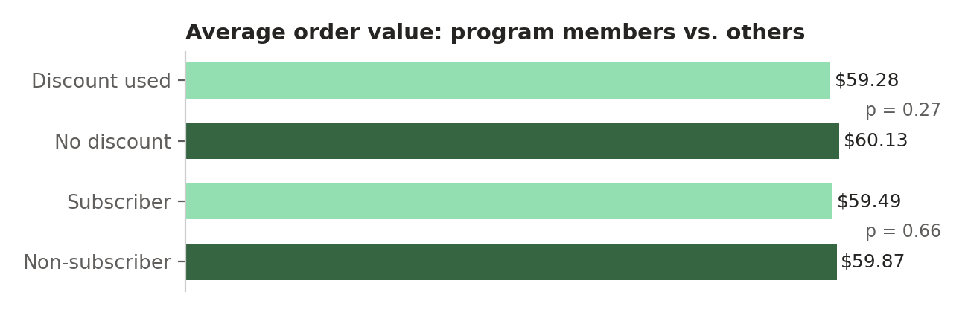
Source: customer_shopping_behavior_cleaned.csv (n = 3,900); Shopper Pulse Power BI model.
Comparison | Members | Non-members | Significant?
Discount vs. no discount (all) | $59.28 | $60.13 | No (p = 0.27)
Subscriber vs. non-subscriber | $59.49 | $59.87 | No (p = 0.66)
Male: discount vs. no discount | $59.28 | $59.98 | No
Previous purchases (subscribers) | 26.1 | 25.1 | Marginal
Est. annual spend (subscribers) | $1,062 | $1,031 | Marginal

Neither program raises order value, and neither is associated with meaningfully higher frequency or loyalty. Discounted orders account for $99,411 of revenue; if the average discount were 10%, the business would have given away roughly $9,900 in margin with no measurable return.
Assessment
In their current form, the subscription and discount programs reduce margin without improving customer value, and they exclude one third of the customer base. They should be redesigned rather than expanded.

6. Channels and payment
Dimension | Highest | Lowest
Payment method | Credit card: $40,310 (17.3%) | Bank transfer: $36,544 (15.7%)
Shipping type | Free shipping: $40,777 (17.5%) | Next Day Air: $37,993 (16.3%)
Purchase frequency (orders) | Every 3 months: 584 | Weekly: 539
Size (orders) | M: 1,755 (45%) | XL: 429 (11%)

Payment and shipping choices are evenly spread, and none is associated with higher order value (ANOVA p = 0.75 and 0.35). Customers are well served by the current mix of options, so there is no case for removing any channel. Size M accounts for 45% of orders, which is relevant for inventory planning.

7. Recommendations
# | Recommendation | Rationale | Impact | Effort | KPI to track
1 | Replace blanket discounts with spend-threshold or bundle offers; test against a control group | Discounts cover 43% of orders with no lift in order value | High | Medium | AOV of discounted orders; discount cost as % of revenue
2 | Open subscriptions and offers to female customers | 0% female participation; women spend the same per order | High | Low | Female share of customers and subscribers
3 | Launch a frequency program (points per visit, replenishment reminders) | High-frequency buyers ≈ 83% of est. annual spend | High | Medium | Share of customers buying fortnightly or more
4 | Run a first-purchase acquisition campaign before the Fall peak | Only 2.1% new customers; Fall has the highest AOV | Medium | Medium | New-customer share; Fall revenue
5 | Review jeans and shirts (fit, quality, price) | Lowest ratings; jeans are the lowest-revenue item | Medium | Low | Item rating; item revenue
6 | Follow up on ratings below 3.0 and improve store pickup | 17% low ratings; store pickup rated lowest | Low | Low | Share of ratings below 3.0

Implementation roadmap
Timeline | Actions
0–30 days | Audit discount rules and costs; confirm why women are excluded from programs; add female-share and frequency KPIs to the dashboard.
30–60 days | Pilot a spend-threshold offer with a control group; open the subscription to all customers; start low-rating follow-up.
60–90 days | Evaluate the pilot (AOV, margin, frequency); launch the frequency program and Fall acquisition campaign; review jeans and shirts.

Expected upside (illustrative)
- Growing the female customer base by 10% (125 customers) at the current order value adds about $7,500 in revenue on this data base, before any repeat purchases.
- Moving 10% of monthly buyers (55 customers) to a fortnightly rhythm would add roughly $46,000 in estimated annual spend.
- Ending untargeted discounts on 1,677 orders protects margin equal to the average discount rate multiplied by $99,411.

8. Limitations and next steps
- No transaction dates: trends over time, true seasonality and customer lifetime cannot be measured directly.
- One purchase per customer: annual spend is estimated from the stated purchase frequency and should be treated as indicative.
- Discount depth is not recorded, so the margin cost of discounts can only be expressed as scenarios.
- Subscription and discount status overlap completely and are limited to male customers, which prevents separate impact estimates.
- Distributions are unusually uniform (e.g., amounts evenly spread from $20 to $100), suggesting a sample or synthetic dataset. Results should be validated with live transaction data.
Recommended next steps: add order dates, discount amounts and customer IDs across multiple orders to the data model, then extend the dashboard with a time-trend page and a program-performance page.

Appendix A. Statistical test results
Test | Method | p-value | Result
Order value: discount vs. none | Welch t-test | 0.266 | Not significant
Order value: subscriber vs. not | Welch t-test | 0.660 | Not significant
Order value: female vs. male | Welch t-test | 0.378 | Not significant
Order value by season | ANOVA | 0.011 | Significant
Order value by category | ANOVA | 0.225 | Not significant
Order value by age group | ANOVA | 0.573 | Not significant
Order value by payment method | ANOVA | 0.746 | Not significant
Order value by shipping type | ANOVA | 0.345 | Not significant
Order value by frequency | ANOVA | 0.875 | Not significant
Rating by shipping type | ANOVA | 0.034 | Significant (small)
Rating by size | ANOVA | 0.027 | Significant (small)
Rating by age group | ANOVA | 0.038 | Significant (small)
Rating by category | ANOVA | 0.108 | Not significant
Gender × subscription | Chi-square | < 0.001 | Strongly related
Gender × discount | Chi-square | < 0.001 | Strongly related
Gender × category | Chi-square | 0.897 | Not related
Subscription × frequency | Chi-square | 0.691 | Not related
Previous purchases vs. amount | Pearson r = 0.008 | 0.615 | No relationship
Age vs. amount | Pearson r = −0.010 | 0.515 | No relationship
Rating vs. amount | Pearson r = 0.030 | 0.064 | No relationship

Appendix B. Dashboard measure definitions
Measure | Definition
Total Revenue | SUM of purchase_amount (USD)
Total Orders | COUNTROWS of the Shopping table (one row per customer)
Avg Order Value | Total Revenue ÷ Total Orders
Avg Rating | AVERAGE of review_rating (1–5)
Subscription Rate | Share of orders where subscription_status = "Yes"
Discount Rate | Share of orders where discount_applied = "Yes"
Loyal Rate | Share of customers with previous_purchases > 10
Customer segments | New = 1 previous purchase; Returning = 2–10; Loyal = more than 10

