Post-earthquake resilience assessment of water distribution network
Zhao Han, Xiaoxia Kou, Benwei Hou*, Shan Wu, Donghui Ma
Beijing University of Technology, Beijing, China
hanzhao@emails.bjut.edu.cn; kxx1001@163.com; *benweihou@163.com

ABSTRACT
Scholars and governments have paid many efforts to assess the post-earthquake resilience of water distribution network (WDN), which is defined as its joint ability to resist the earthquake hazards, absorb the initial damage, and recover to normal operation. According to the its definition, the post-earthquake resilience index (RI) is accumulated of functionality from the occurrence of the earthquake until full recovery (shaded area in Figure 1), and can be calculated by equation 1. The functionality of the WDN is calculated as the percentage of the demand that is supplied by the WDN and the length of pipes in use at each time step after the earthquake.
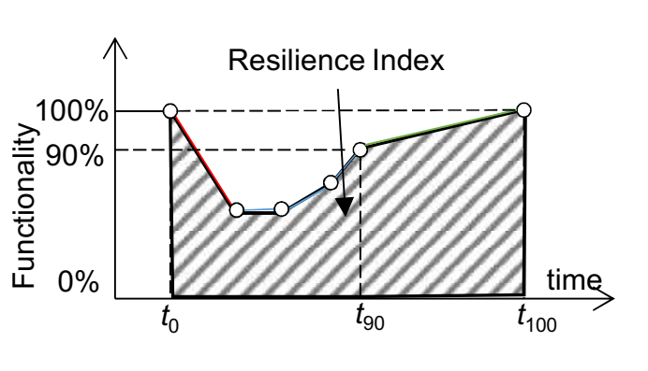
Figure 1 Functionality recovery curve
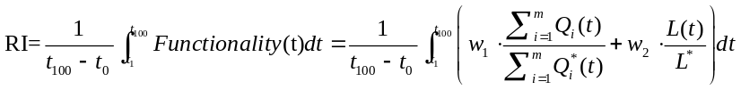 (1)
Where Q_{i}(t) and Q_{i}*(t) is the supplied nodal flow calculated by the WDN hydraulic model using a pressure driven demand (PDD) model of node i at time step t and the desired water demand, respectively. m is the number of nodes, L(t) and L* is the sum length of pipes in use at time step t and the sum length of pipes before the earthquake. w₁ and w₂ are adjustment coefficients.

To assess the post-earthquake resilience of WDN, it is crucial to simulate the post-earthquake recovery process of WDN. this paper develops a post-earthquake recovery model for WDN based on Discrete Event Simulation Model.

In the post-earthquake recovery model, the key elements are entities, variables, and events (Cagnan et al, 2004). In this paper, the pipes and the recovery crews available are modeled as entities, the status of pipes and crews are modeled as variables, the recovery activities (e.g., isolation or reparation) are modeled as events. Table 1 lists the entities, variables and events in the model. Figure 2 shows a simple example of water distribution network and its damage scenarios. In the example scenarios, there are two recovery crews. Table 2 lists the activities and their duration time. As the crew should isolate a pipe before replace it, the activity 1 should be allocated before activity 2.for example, the sequence could be {1,3,4,2}. At the beginning, the crews’ statuses are changed from available to unavailable, when activity 1 and 3 are allocated to crew 01 and 02. When the activity 01 is finished, the status of crew 01 changed from unavailable to available, then the activity 3 is allocated to crew 01. Repeat the above step, until all activities are finished. The result is shown in Table 3.

Table 1 Elements in discrete activitiy model
Elements in DEM | Elements in WDN
Entities | Pipes  Crew
Events | Isolation  Reparation  Replacement
Variables | Status of pipe (opening, closing, leak,break)  Status of crew (available or unavailable)
Table 2 Example of activity in example WDN
Activity ID | Activity | Duration (mins)
1 | Isolate P7 | 30
2 | Replace P7 | 45
3 | Repair P6 | 45
4 | Repair P11 | 30
Table 3 Example of schedule of crews
Crew 01 | Crew 02
Isolate P7 | Repair P6
Repair P11 | Replace P7

When the schedule of crews shown in Table 3 is obtained, a hydraulic simulation is executed considering a pressure driven demand (PDD) model. For each time step, the status of the crews will be checked from the schedule, the status of the pipes will be updated once they are isolated (closing), repaired or replaced (removing the emitter flow), or reopened (opening). Once the hydraulic response of the system is computed, the post-earthquake resilience is assessed using the results.
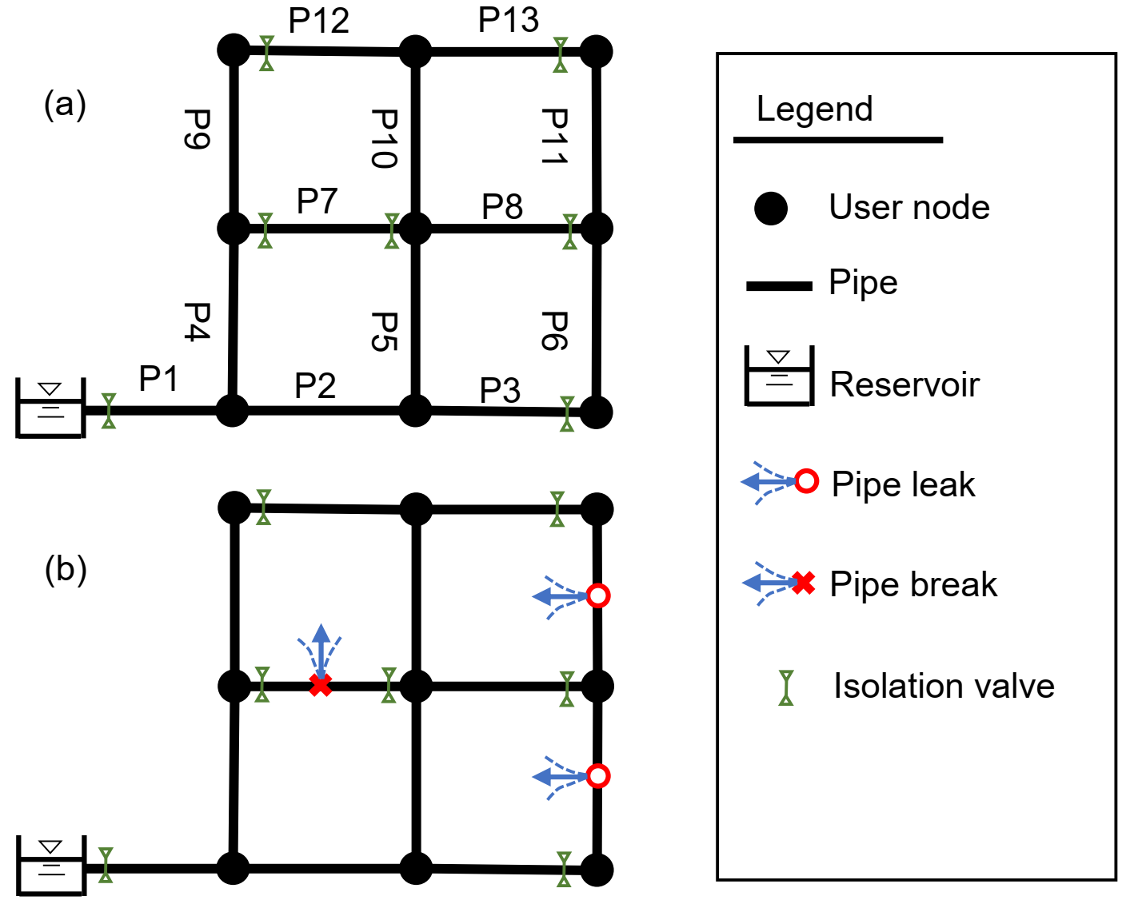
Figure 2 Example of a WDN and damage scenario
Under limited resources, restoration activities sequence plays a crucial role in water distribution network (WDN) recovery process (Ouyang et al, 2012). To help water utility make decisions, two types recovery strategies are proposed. 1) arrange the activity sequence according to the pipe hydraulic importance. 2) build an optimization model, in which the optimization goal is maximum the post-earthquake resilience R, the optimization variable is the activity sequence, and the genetic algorithm is used to solve the optimization model.
Keywords: resilience; water distribution network; discrete event simulation model
Reference

Çagnan Z, Davidson R, Guikema S. (2004)” Post-earthquake restoration modeling of electric power systems.” 13th World Conference on Earthquake Engineering, . August 1-6, Vancouver, British Columbia, Canada
Ouyang M, Dueñas-Osorio L, Min X. (2012) “A three-stage resilience analysis framework for urban infrastructure systems.” Structural Safety, 36(2):23-31.

