

ZKP-RSA-ENGINE

Name: Farhan Hussain
Reg No.: 26BCY10021
Year: 2026-2027

Under the Guidance of: Dr. Gunjan Ansari
Introduction

Modern distributed networks rely on cryptographic primitives to guarantee data confidentiality and verify entity identity without exposing secret parameters over untrusted channels. Traditional authentication systems rely heavily on static password models, where credentials are passed directly across networks or checked against stored database hashes. This model creates major security risks, such as wiretapping and credential leakage during server breaches.
Asymmetric cryptography addresses data confidentiality using mathematically paired public and private keys, while Zero Knowledge Proofs (ZKPs) allow an entity to prove possession of a secret without ever revealing the secret itself.
This project implements a complete terminal-based cryptographic engine written in Python that combines asymmetric RSA encryption with an interactive Zero-Knowledge Proof authentication handshake. Rather than using external security libraries like OpenSSL or PyCryptodome, the system is built entirely from scratch using fundamental mathematical primitives provided by the Python standard library.

Problem Statement

Conventional authentication and messaging implementations in application software frequently suffer from two vulnerabilities: static credential transmission and complete reliance on blackbox third party libraries. Transmitting passwords across network even when encrypted via transport layer protocol exposes systems to session hijacking, credential harvesting, and database compromise. If an attacker gains access to a centralized password store, all accounts using identical or similar credentials are compromised.
At the same time, modern developers frequently import high level cryptographic frameworks without understanding the mathematical operations beneath them. This abstract reliance hides core mechanics like modular arithmetic, trapdoor one way functions, and key generation steps, making it difficult to analyze edge cases or evaluate security guarantees at the hardware or execution level. To address these challenges, this project provides a lightweight, self-contained terminal software system that demonstrates zero-trust authentication alongside asymmetric encryption.
The system eliminates static password transmission entirely by implementing an interactive four phase ZKP commitment challenge response loop. Furthermore, it implements raw RSA key pair construction and character-level modular exponentiation directly in Python code.

Functional Requirements

- Dual Key Pair Generation: The system safely creates independent RSA key pairs for clients and servers by picking random five-digit prime numbers, doing core math calculations, and outputting public and private mathematical keys.
- ZKP Authentication: An interactive four-step protocol allows a client to prove its identity using hidden mathematical secrets and random challenges without ever actually sending a real password across the network.
- Text Transcoding & Encryption: The software easily converts standard raw text messages into integer number arrays, and then securely encrypts each individual number using the recipient's public key and modular math formulas.
- RSA Decryption & Messaging: Encrypted numerical messages are safely retrieved from temporary memory buffers and fully unlocked using the recipient's secret private key, converting the numbers back into easily readable standard text.
- In-Memory Routing: Message queues are safely organized inside a temporary dictionary structure, using strict security flags that completely block all encryption and decryption attempts until the authentication process is successful.

Non-Functional Requirements

- Zero-Knowledge Security: The authentication system mathematically guarantees that hidden secrets and private keys are never transmitted, logged, or exposed, making it completely impossible for hackers to steal the user credentials.
- Performance Efficiency: All complex mathematical calculations execute incredibly fast using optimized built-in tools, guaranteeing that encrypting and decrypting long text messages happens instantly without any annoying lag in the terminal.
- Zero External Dependencies: The entire software relies completely on the standard, built-in tools provided by Python, which ensures the program can run on any computer without downloading extra third-party security libraries.
- Transient Storage: The system stores all active message data completely in temporary computer memory rather than on a hard drive, meaning everything is permanently erased the moment the program closes.

System Architecture

The software uses a four-tier modular architecture that separates mathematical utilities, cryptographic protocols, data management, and user interface execution. The entry point `main.py` handles terminal interactions, maintains execution state (`is_auth`, key variables), and coordinates calls between modules.
The cryptographic operations layer (`crypto_ops`) contains `rsa_gen.py` and `zkp_auth.py`. `rsa_gen.py` manages key generation routines, public key encryption loops, and private key decryption loops. `zkp_auth.py` executes the interactive Zero Knowledge Proof protocol between client and server entities.
The mathematical foundation layer (`math_ops`) supplies core mathematical algorithms. It includes `prime_gen.py`, which generates 5-digit odd numbers.
The utility layer (`utilities`) contains `codec.py` for ASCII string/integer transformations and `memory.py` for transient in-memory data routing.

Design Diagrams

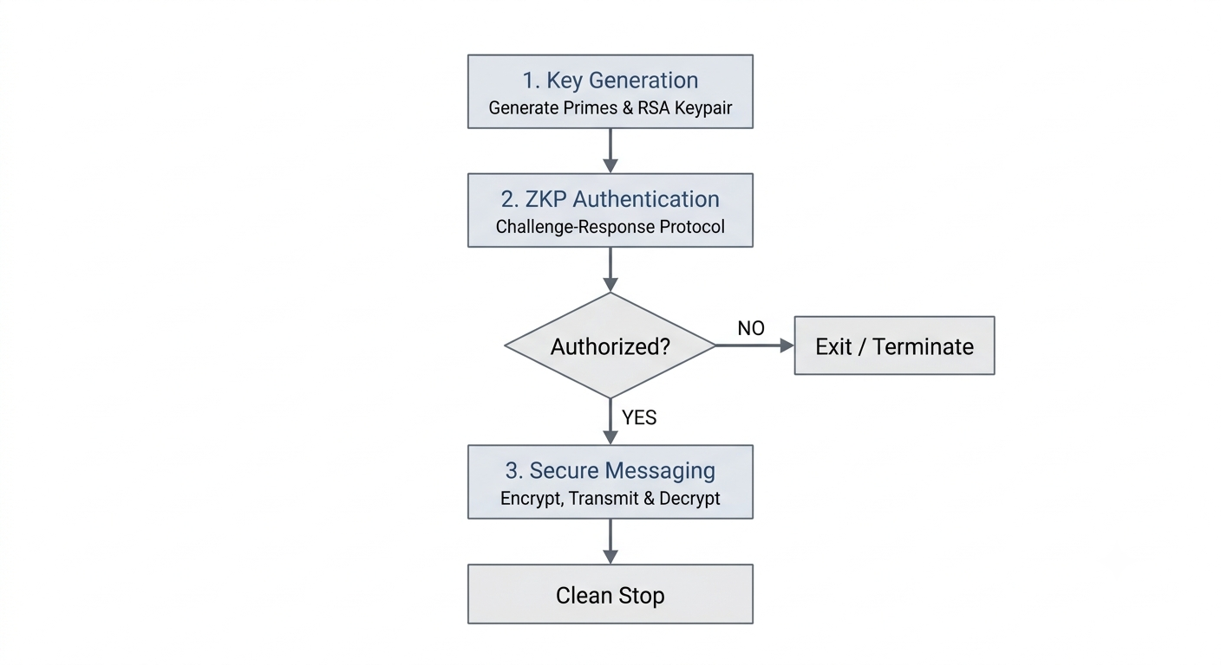
- WORKFLOW DIAGRAM

- FIGURE 1

Design and Rationale

- Standard Library Implementation vs. External Frameworks: The decision to implement core cryptographic math directly using pure Python instead of wrapping high level libraries (e.g., `cryptography` or `pycryptodome`) was deliberate. Native mathematical code ensures total operational visibility over prime generation, GCD searches.

- 5-Digit Prime Selection Range: Random primes are generated within [10001, 99999] using `random.randint()`. Selecting 5-digit primes produces composite moduli n > 10^8. This size provides sufficient value range to prevent modular overflow during per character ASCII conversion, while ensuring that trial division primality tests and modular inverse loops run rapidly without terminal execution lag.

- Per-Character ASCII Transcoding: The system converts input strings into integer arrays using `ord()` before performing modular exponentiation `pow(m, e, n)`. Processing each character individually simplifies tracing during execution, allowing step by step verification of mathematical transformations on individual character codes.

- RAM-Based Transient Data Store: Storing active message queues in a native Python dictionary (`memory.py`) eliminates disk I/O overhead and prevents persistent traces of ciphertext or plaintext from remaining on local storage media when the process exits.

Implementation Details

- Prime Generation Module: The prime number file automatically tests and verifies random five-digit odd numbers using division loops to ensure high-quality prime numbers are correctly picked for the core security equations.
- GCD and Exponent Module: This math file specifically uses standard algorithms to calculate the greatest common divisor, ensuring the public and private security keys are properly linked together for accurate message encryption.
- RSA Generation Module: The core security file coordinates finding distinct prime numbers, calculates the necessary math values, and handles the actual mathematical formulas required to encrypt and decrypt individual text characters.
- ZKP Authentication Module: This verification file controls the interactive back and forth communication between the client and server, calculating the random math challenges and verifying the final equations to grant secure system access.
- Codec and Memory Utilities: The utility files manage translating standard text words into numerical arrays, turning decrypted numbers back into readable text, and holding all the active message data safely in memory.

Results
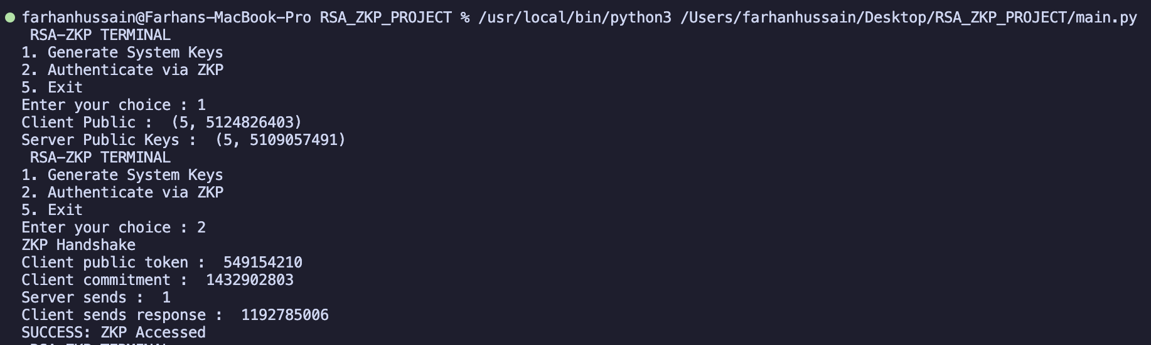

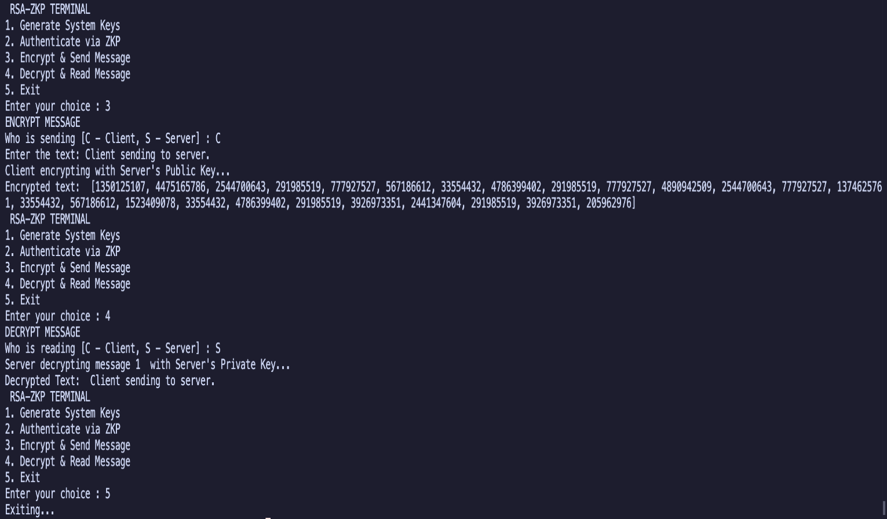

- FIGURE 2

Testing Approach

- Unit Testing: Mathematical functions like prime generation and modular inverses were heavily tested against known values to guarantee zero false positives and ensure the core cryptographic math worked flawlessly before being integrated into the main system.

- ZKP Boundary Testing: Both successful logins and intentionally forced failures were tested multiple times. Modifying the response values resulted in an immediate denial, proving the system successfully blocks unauthorized tokens and protects the authentication gateway.

- End-to-End Validation: Complex text strings containing uppercase letters, lowercase letters, numbers, spaces, and punctuation were completely processed through the encryption and decryption steps, mathematically proving a one hundred percent loss-free reconstruction of all characters.

- State Guard Testing: Terminal menu options for sending and reading messages were intentionally clicked out of order to ensure the system strictly blocked access and displayed warnings until the mandatory key setup and ZKP authentication were completed.

Challenges Faced

- Prime Selection Constraints: The random number generator occasionally picked the exact same prime number twice, which completely broke the cryptographic math equations. A conditional loop was added to the code to guarantee the system only selects two distinct primes.

- Character Integer Bounds: Standard ASCII text numbers were too small for the mathematical formulas, leading to errors. This limitation was bypassed by specifically generating larger 5-digit prime numbers to ensure the final calculated value exceeded the maximum text bounds.

- Terminal Control Flow: Allowing users to choose the messaging options before generating their security keys caused the terminal program to crash. This was fixed by setting starting variables to zero and adding strict security guards to the menu system.

Learnings and Key Takeaways

- Zero-Knowledge Dynamics: Building the interactive challenge-response system clearly demonstrated how zero-trust security architecture works in practice, successfully proving a user's identity without ever transmitting or exposing real credentials across the terminal network.
- Modular Code Design: Separating the software into completely distinct files for raw math operations, security protocols, memory storage, and user menus made the entire project significantly easier to build, isolate for unit testing, and debug when errors occurred.
- Algorithmic Efficiency: Utilizing Python's highly optimized built-in math functions highlighted how incredibly important fast logarithmic exponentiation is when processing and transforming long streams of text characters without causing any noticeable delay in the terminal window.

Future Enhancements

- Large Prime Generation: The system can be upgraded to generate massive 2048-bit prime numbers using the advanced Miller Rabin primality test, elevating the current basic security levels to match modern commercial and enterprise grade encryption standards.
- Block-Based Padding: The text processing module can be improved with block-based encryption padding, which prevents deterministic patterns by ensuring that identical input words do not produce the exact same encrypted number sequences every single time.
- Network Socket Integration: The single screen terminal execution can be replaced with a distributed TCP/IP socket network, allowing true multi node communication where different computers can send encrypted messages to each other over a local area network.
- Persistent Storage: The system's temporary memory buffers can be upgraded by integrating a secure SQLite database or encrypted files, allowing users to permanently and safely save their encrypted message histories even after the main application is closed.
- Digital Signatures: The cryptographic engine can be expanded to fully support message signing with private keys and hash verification with public keys, providing absolute proof of who sent the message and guaranteeing the data was not altered.

References

- Rivest, Shamir, & Adleman (1978): This foundational academic paper introduced the original RSA cryptographic algorithm, detailing the essential core mathematical principles and formulas behind asymmetric key generation, public key encryption, and secret key decryption methods.

- Fiat & Shamir (1986): This landmark research paper established practical solutions for identification and authentication, introducing the fundamental concepts behind interactive Zero Knowledge Proof protocols that verify identity without revealing secrets.

- Python Software Foundation (2024): The official standard library documentation provides technical guidance on native Python functions like pow(), math, and random, enabling dependency free development of custom modular arithmetic and exponentiation algorithms.

- Introduction to Python Programming 3E : Reema Thareja

