## **Raining Teachers**

**Game Summary:**  
Dodge all the teacher’s meteors and avoid to get killed by them  
  
**Core Mechanics**

* Move left and right to dodge meteors
* Dash to get a sprint and dodge faster for a few second

**Gameplay:**   
Your planet made by fire and desert is attacked by Ice meteors sent by MCAST lecturers, save yourself by dodging all the meteors, and avoid to get frozen.  
  
**Music:**   
The same soundtrack will be played in loop from the main menu to the main game scene.

Sfx will be played when meteors crashes on the ground and on the player.

Each time the player gets hurt, he will emit a sound of pain.

**Art Style:**

The art style will be inspired by games like: The binding of Isaac and Spelunky.

The sprites will be animated directly in unity (they will not be animated as a sequence of sprites)

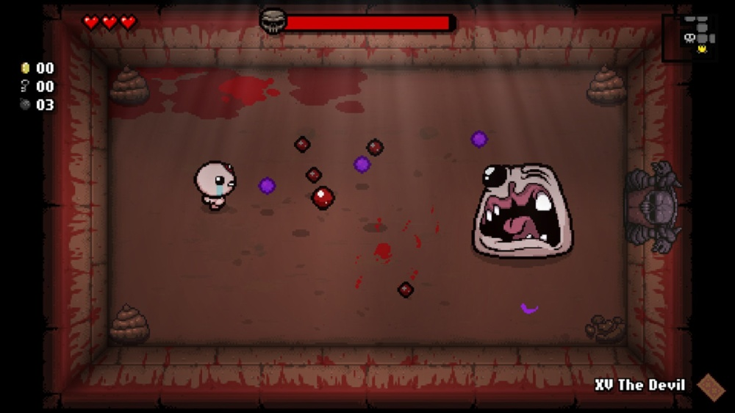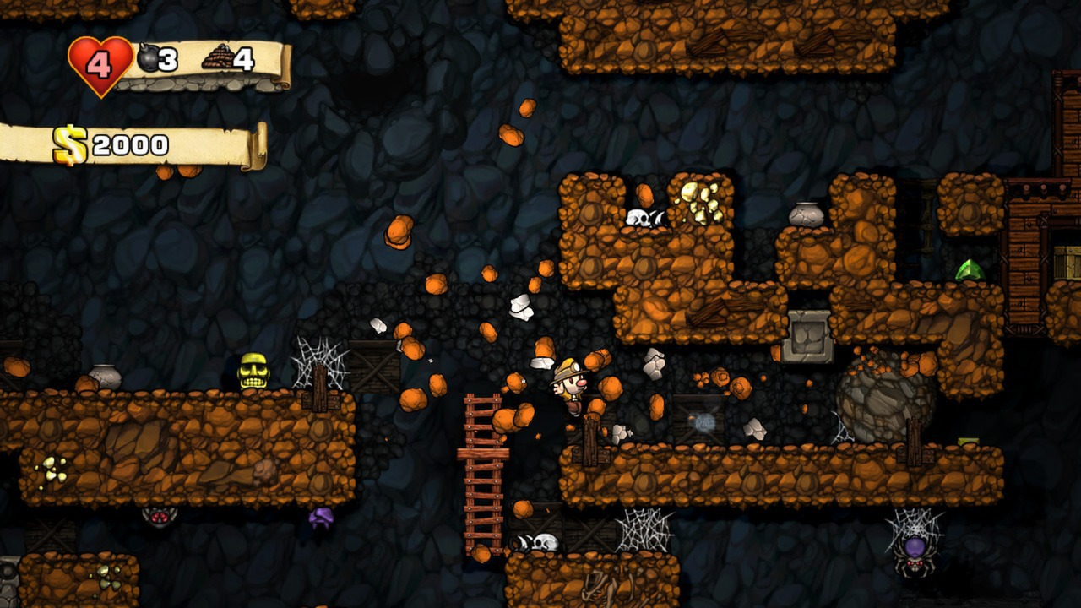

**Target Device:** Pc (1440x900)

**Control Methods:** Right/Left Arrow, Space Bar, Left Mouse Click

## Part 1: Visualization and Implementation

**Visualization**

Start by imagining that you are playing the game. Imagine choosing a specific goal, for example:

* You are an habitant of a planet made by fire and desert
* Icy MCAST teachers decided that your world is not worth living, so they decided to bombard your planet with meteors.
* The only thing that the player can do is dodge them and hope to survive

Answer these questions **based on the moment you have sketched** (not the whole game).

1. Sketch:

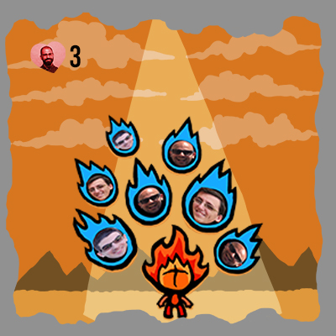

1. Ground, mountains, sky, clouds, light, player, meteors, heart and number.
2. Player: moves left and right, when he get hit he lose one or more lives and he produces a sound.

Meteors: moves down, when they hit the player or the ground they produce particles and sounds.

1. The player press left and right key to move and space bar to dash

When gets a hit by a meteor he lose a heart

**Implementation**

1. Imagine how you would write the code for each thing in your last two lists (things that move and player interactions/feedback).
   1. Have you done anything like it before? Is there code from previous projects that you could copy and adapt, rather than starting from scratch?

I have done and Arkanoid like game before and I can use exactly the same type of scripts.

**CRC Cards**

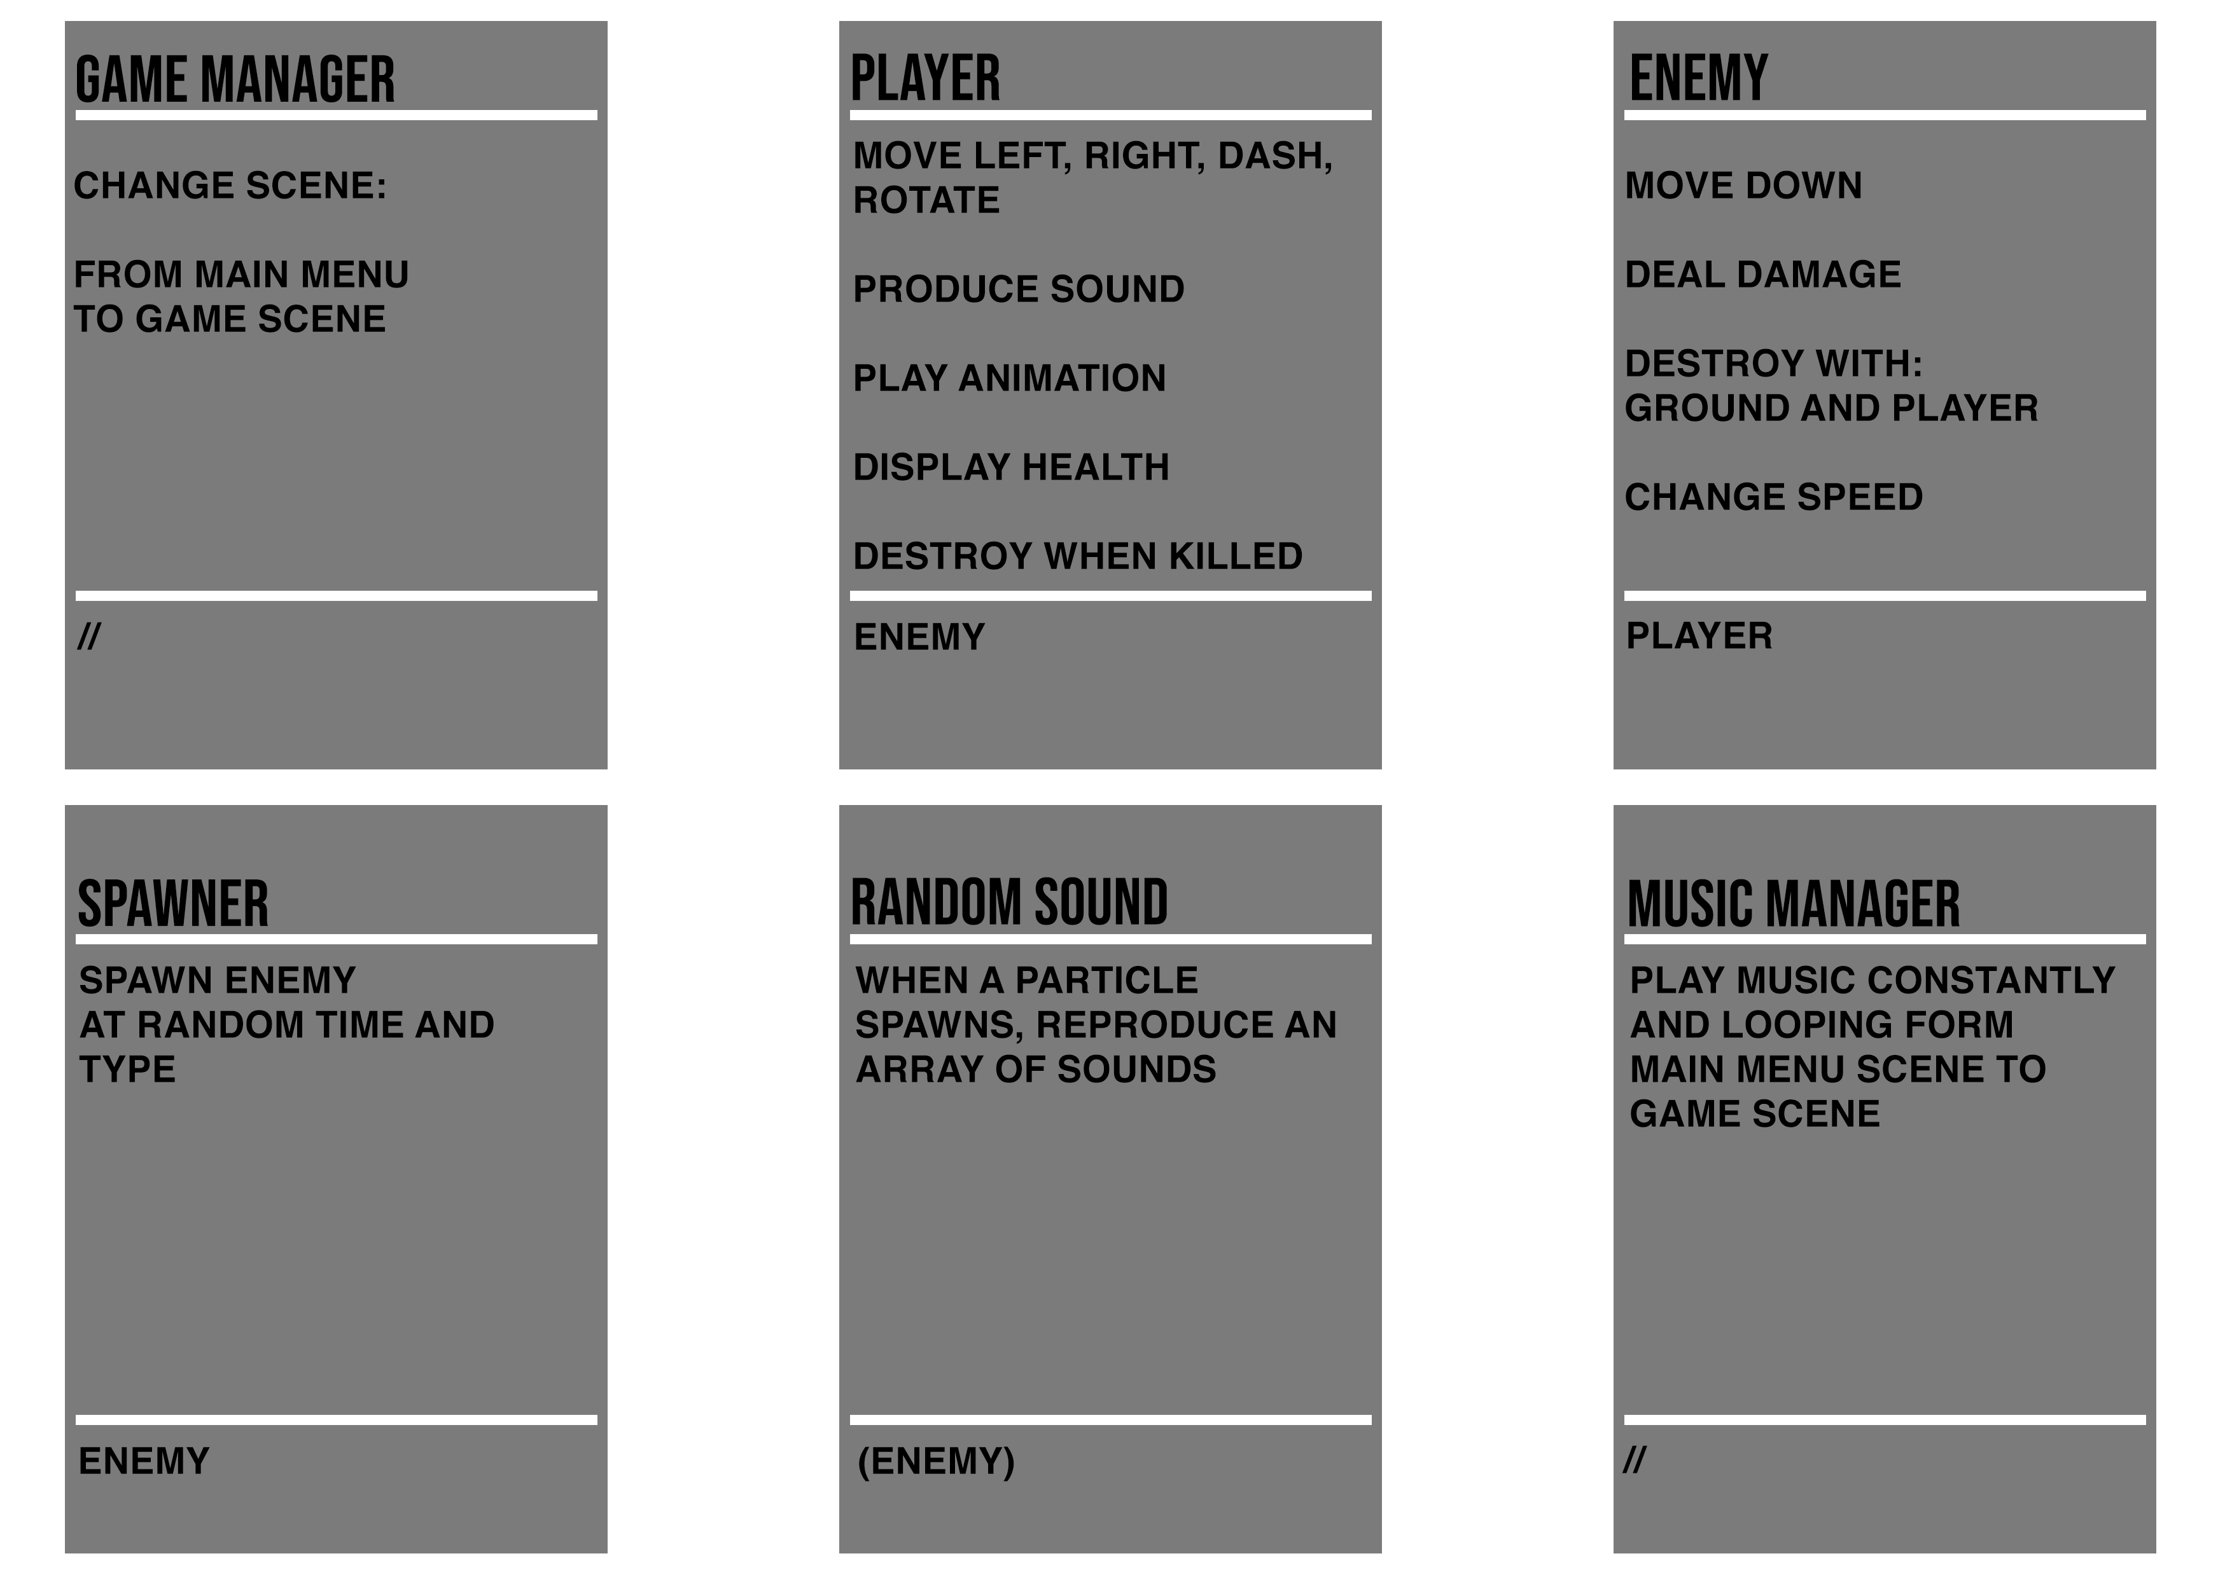

1. Write down your three biggest coding questions, e.g. “how to make one-way platforms” or “how to make the tower icon move with the mouse”.

How to make the music start from the START scene and continue to the MAIN GAME scene?

1. Make a list of every visual and audio asset in the sequence (i.e. you don’t need to think about the whole game). Be thorough – don’t forget things like animations and particles, or UI elements like score.
   1. Player sprite, Ground sprite, Mountain sprite, Cloud Sprite, Explosion sound (1,2,3,4), Hurt sound, Main theme music, Particles.
   2. Visual Assets:

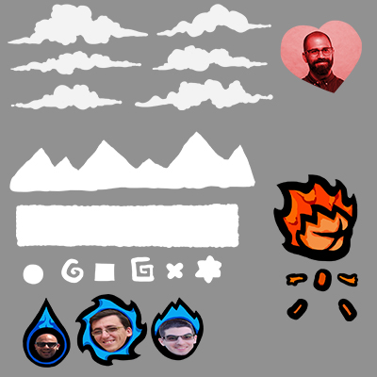

**Flow Chart**

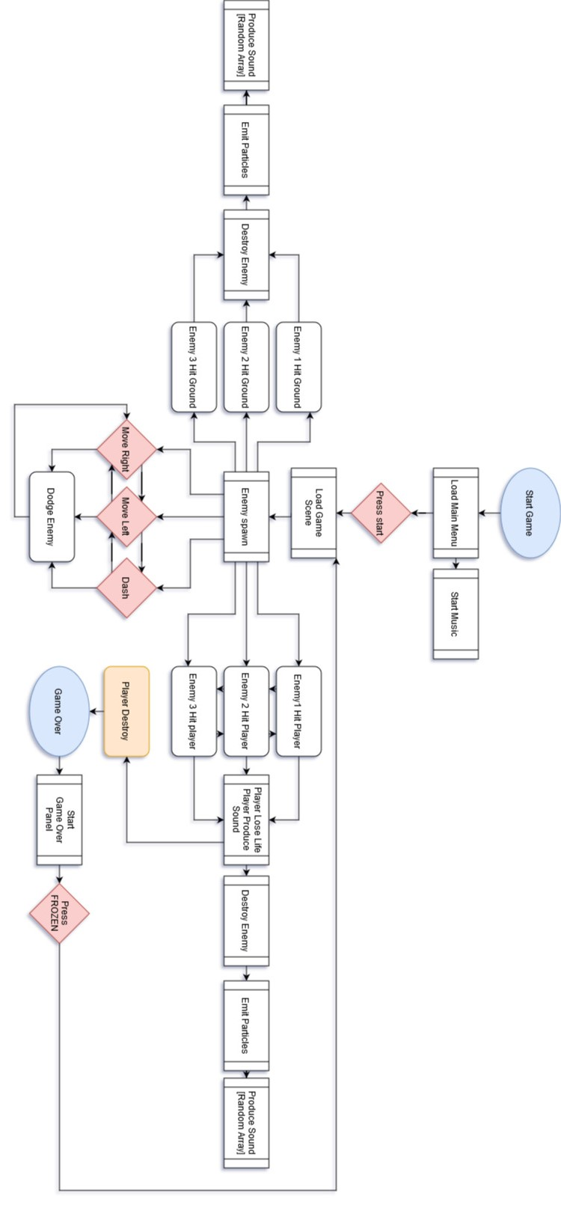

## Part 2: Scale, Challenges and Resources

**Scale**

Now step back from that sequence mentally and think about the whole game. Think about all the parts of the game that can be numbered and grouped:

|  |  |
| --- | --- |
| * 2 Scenes (Start, Game) * 3 enemy types * 4 Enviroment Sprites * 6 Scripts * 2 Buttons * 4 Explosion Sounds | * 1 Charachter * 1 Hearth * 2 Character animations (Idle, Run) * 1 Text * 1 Particle Emitter * 1 Hurt sound * 1 Background Music |

1. Mentally cut each number in half. Is the game still playable? Does it still create your core experience? Now try reducing each number to one, and ask yourself the same questions.

Write down your final list, with numbers, here.

Yes, it is still playable

**Challenges**

Based on all of the above, write down the top three challenges you foresee in the process of making your game over the next few weeks. Be specific, and phrase them as questions.

* “I do not have much time, Smart code or Straightforward code?”
* “Do I will lose other 20 marks on this damn game design document?”
* “Can I reach an A?”
* “Can I do everything in one day?”

**Game Screens**:

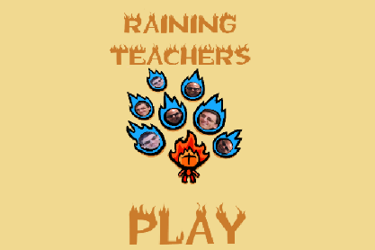 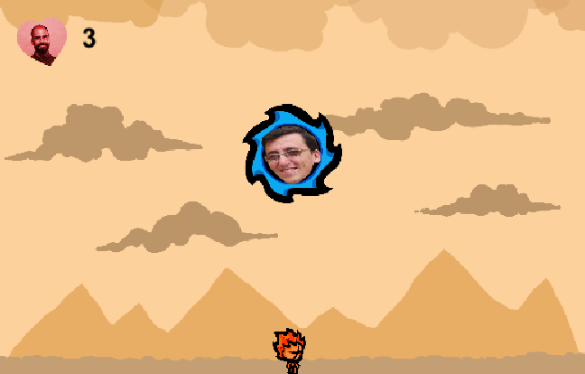

**Resources**

1. The most important resource is your own time.

**Gantt Chart**

|  |  |  |  |  |
| --- | --- | --- | --- | --- |
| **Tasks** | **22 DIC** | **23DIC** | **11 GEN** | **12 GEN** |
| **Research** | 2h |  |  |  |
| **Planning** |  | 3h |  |  |
| **Implementation** |  | 3h | 5h |  |
| **Testing** |  |  | 1h |  |
| **Documentation** | 2h |  |  | 3h |

## Steps (23 Dic - 11 Gen):

|  |
| --- |
| 23 DicGame Art |
| Rigging Player |
| Animating Player |
| Player Script controller |
| Enemy Script and physics |
| Enemy Damage |
| Make Enemy Prefabs |
| Enemy Spawner Script |
| 11 GenAdd Enviroment Art |
| Add particles |
| Add Ui for health |
| Add Dash Move |
| Add Music and Sfx |
| Create Main Menu |
| Create Game Over Panel |
| Make Build |

1. Next, paste in links to three or more specific tutorials that will help you make your game.

<https://www.youtube.com/watch?v=_RIsfVOqTaE>

<https://www.youtube.com/watch?v=a1RFxtuTVsk>

<https://www.youtube.com/watch?v=nMquxE6ywpg>

<https://www.youtube.com/watch?v=tLyj02T51Oc>

<https://www.udemy.com/course/unitycourse/>

<https://blackthornprod-games.itch.io/raining-apocalypse>

## Part 3: Reality Check

**Assessment**

I am able to do a fun game because I have the time, the idea, the resource and enough skill to do that. Probably it will not be polished enough, but I can meet all the course requirements.

This time I will focus more on the Game Design document.