**China Exchange ABS ETL**

**Description：**  
The tool would monitor msg sent from SAIL and transform msg attachment to repo-readable format.

**ISSUES：**

Dependencies on third party - SAIL:

* Exchange deals are private deals and public source has a month delay of information disclosure.

Manual Data Entry:

* Require self-judgement to translate entity& deal name to English and create record on ISPX
* Data points updated manually in excel template and REPO

Cross system communication:

* Mortgage deal is maintained on both Bloomberg terminal and backend REPO system.

**Legacy workflow:**   
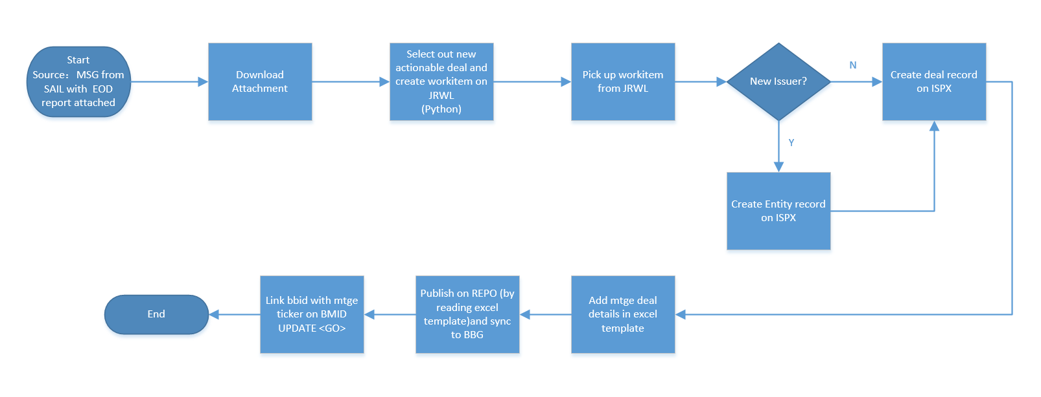

**New workflow: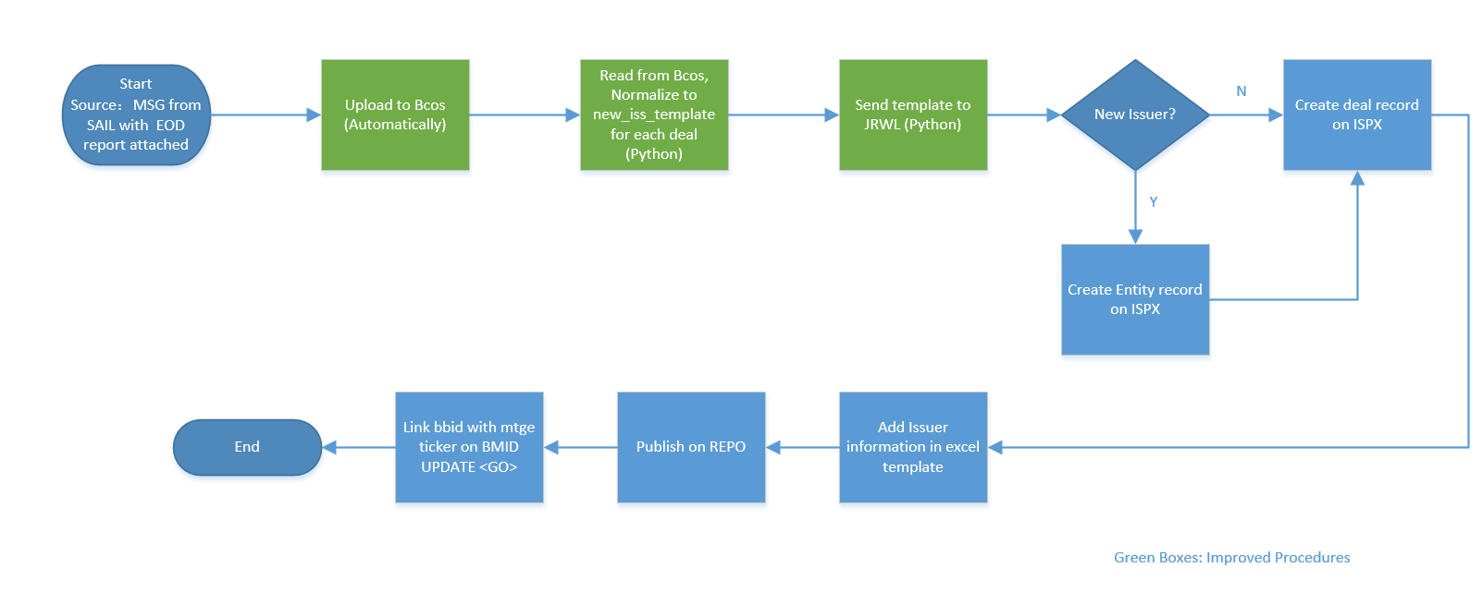 ROI calculations:**

|  |  |
| --- | --- |
| Base on 2018 data, | |
| Total no. of exchange deals | 676 |
| Time spent before to complete each deal | 30 mins |
| Time spent in total | 30 mins * 676 = 338 hrs |
| Time saved per deal | 15 mins |
| Time saved in total | 15 mins *676 = 169 hours |