# Windows termnal:
usbipd list
wsl --list --all --verbose
usbipd wsl attach -d Ubuntu -b 2-1
usbipd wsl detach -b 2-1

# WSL2 Ubuntu:
lsusb
cat /proc/net/fib_trie

##################################
# config 1: WSL Ubuntu
##################################
vEthernet (WSL) fixed ip 172.22.144.1 / 255.255.240.0
WSL Ubuntu$ cat /proc/net/fib_trie:
+-- 172.22.144.0/20 2 0 1
|-- 172.22.144.0
/20 link UNICAST

CIDR range chack (https://tehnoblog.org/ip-tools/ip-address-in-cidr-range/): IP Address 172.22.144.1 is in CIDR range 172.22.144.0/20

##################################
# config 2: docker container ubuntu
##################################
docker run -it --rm --privileged -e DISPLAY=host.docker.internal:0.0 -v "E:\dev\instrumentation\hardware\6DOF":/6dof:rw ubuntu bash

apt update
apt upgrade
apt install --fix-missing linux-tools-virtual hwdata
update-alternatives --install /usr/local/bin/usbip usbip `ls /usr/lib/linux-tools/*/usbip | tail -n1` 20

cat /proc/net/fib_trie:
+-- 172.17.0.0/16 2 0 2
+-- 172.17.0.0/30 2 0 2
|-- 172.17.0.0
/16 link UNICAST

docker inspect -f '{{range .NetworkSettings.Networks}}{{.IPAddress}}{{end}}' a2e3c3f470e2
https://tehnoblog.org/ip-tools/ip-address-in-cidr-range/
Avant usbipd attach
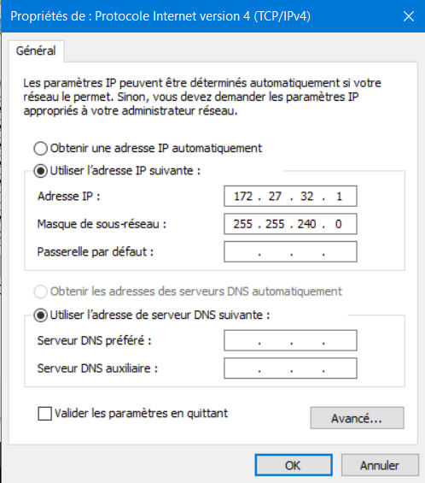
E:\dev\instrumentation\hardware\6DOF>docker run -it --rm --privileged -e LOCAL_USER_ID=”%USERNAME%” -e DISPLAY=host.docker.internal:0.0 -v "%cd%":/src:rw ubuntu bash

distro wsl2 Ubuntu:
Windows ipconfig:
Carte Ethernet vEthernet (WSL) :

Suffixe DNS propre à la connexion. . . :
Adresse IPv6 de liaison locale. . . . .: fe80::65b9:b88f:45ca:a75f%44
Adresse IPv4. . . . . . . . . . . . . .: 172.27.32.1
Masque de sous-réseau. . . . . . . . . : 255.255.240.0
Passerelle par défaut. . . . . . . . . :

wsl cat /proc/net/fib_trie
Main:
+-- 0.0.0.0/0 3 0 5
|-- 0.0.0.0
/0 universe UNICAST
+-- 127.0.0.0/8 2 0 2
+-- 127.0.0.0/31 1 0 0
|-- 127.0.0.0
/8 host LOCAL
|-- 127.0.0.1
/32 host LOCAL
|-- 127.255.255.255
/32 link BROADCAST
+-- 172.27.32.0/20 2 0 1
|-- 172.27.32.0
/20 link UNICAST
|-- 172.27.38.181
/32 host LOCAL
|-- 172.27.47.255
/32 link BROADCAST
Local:
+-- 0.0.0.0/0 3 0 5
|-- 0.0.0.0
/0 universe UNICAST
+-- 127.0.0.0/8 2 0 2
+-- 127.0.0.0/31 1 0 0
|-- 127.0.0.0
/8 host LOCAL
|-- 127.0.0.1
/32 host LOCAL
|-- 127.255.255.255
/32 link BROADCAST
+-- 172.27.32.0/20 2 0 1
|-- 172.27.32.0
/20 link UNICAST
|-- 172.27.38.181
/32 host LOCAL
|-- 172.27.47.255
/32 link BROADCAST

