Cheng, K., Tian, J. F., Kohno, T., & Roesner, F. (2023). Exploring user reactions and mental models towards perceptual manipulation attacks in mixed reality. In 32nd USENIX Security Symposium (USENIX Security 23) (pp. 911-928).

Task: click on a green box; Similar to detection of a green bounding box..

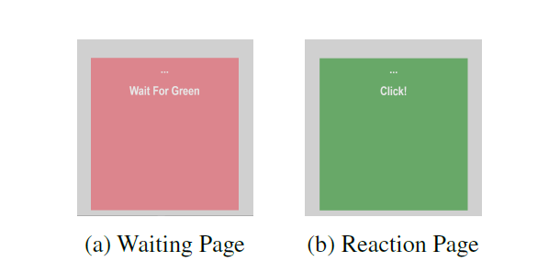
Attacks: 4 different kinds of transparent colored overlays

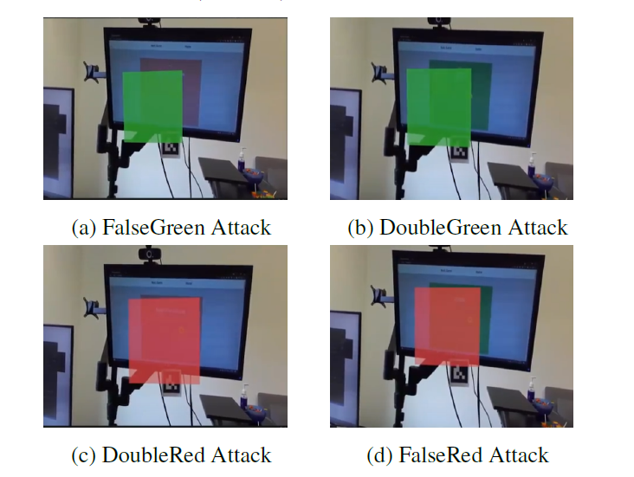
Attacker most likely will require access to the device..

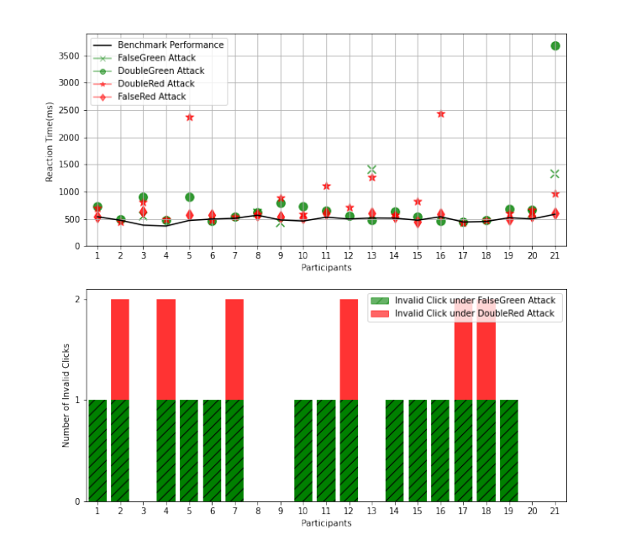
Model: delayed reaction times (for all 4) and false positives (falsegreen and doublered)

AGREE: models delayed reaction times for falsered and doublegreen attacks..

Our scenario: checkpoint operator with HMD that displays green bounding box around objects of interest..

https://github.com/loonwerks/MATRICS/tree/main/Models/Perception/contract_based/Overlays

