BancNet was the first and is now the largest electronic banking consortium in the Philippines. In line with their mission, it is the leading electronic network for the excellent and secure delivery of financial and related services for member institutions, affiliates and customers locally and globally.

BancNet currently has over 108 Members and Affiliates. They have about 10,060 ATM machines established all over the Philippines. Their largest base of active cardholders was over 26.8 million. The largest asset size of BancNet that has been recorded is over 700 Million pesos, as of January 2013.

They have a special acronym for their core values which is the “ExCI^2Te”

Ex – for Excellence

C – for Concern of the Individual

I – for Integrity

I – for Innovation

Te – for Teamwork

In BancNet, they have four channels that highlight their products and services:

1. Automated Teller Machines

* Cash Withdrawal
* Cash Advance
* Intrabank fund transfer
* Interbank fund transfer
* Checkbook recorder
* Statement Request
* G-Cash Reload

1. Internet

* Intrabank fund transfer
* Interbank fund transfer
* Checkbook recorder
* E-Shopping
* Tax Payment
* SSS-EDI Corporate
* G-Cash Reload

1. Mobile

* Intrabank fund transfer
* Interbank fund transfer
* Checkbook recorder
* e-Load
* G-Cash Reload

1. Point-of-sale (POS)

* Debit Card Purchase/Sale
* Cash Back

Here is 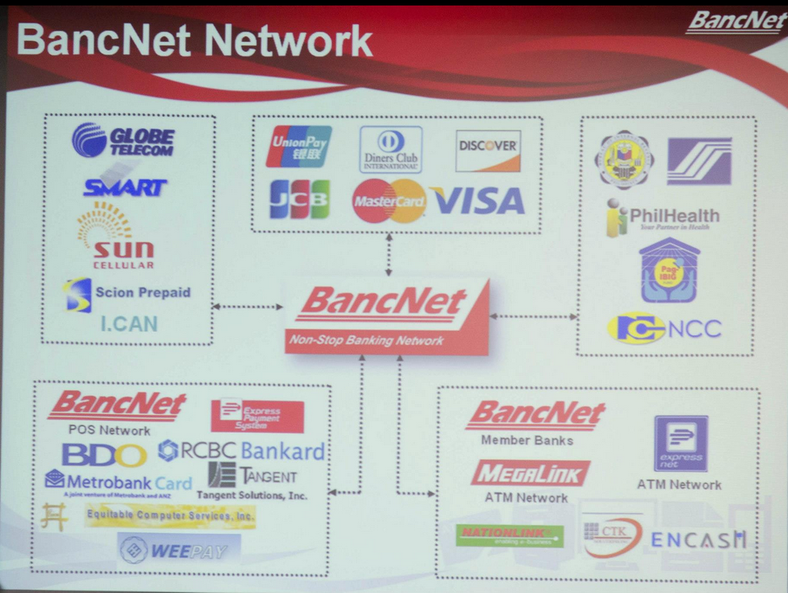a sample framework of BancNet’s Network (FLASH THIS IMAGE ON SCREEN)

There are 3 types of membership/affiliation in Bancnet:

Direct Members or the banking institutions

* Equity/ Co-Equal
* Associate
* Alliance

Members thru an Affiliate Switch Network

* Subscribers (possibly banks or cooperatives)

Affiliates

* Affiliate Switch Network or ASN
* Independent ATM Deployer or IAD
* EMI Affiliates

Being a member entails benefits such as inter-connection with local and international networks, products and services availability, direct/indirect participation in formulating policies and running the consortium as well as marketing campaigns, training programs and corporate events among others.

Now, we go over the operational strengths of BancNet which have benefits for each.

1. Backup and Disaster Recovery

Benefit: Member banks are assured of uninterrupted connection / operation

* Redundant Data Center
* Redundant Frame Delay
* Automatic Switch-over to the 2nd site in case the primary site is down
* Regular Daily Routing Exercises
* BSP-compliant

1. Systematic Risk Management

Benefit: Leverage on the sound settlement Risk Policy of BancNet, thus eliminating settlement risk for member institutions.

* They establish their own net settlement limit for each member.
* In case of default by any member, BancNet assures settlement will go full cycle by leveraging on the sound Settlement Risk Policy of the company.
* System can put a limit on overdraft for each member as well.

1. Back Office Support

Benefit: Ease of reconciliation, reporting and settlement, and improved customer service

* Automatic Reconciliation of Issuer and Acquirer Transactions Across BancNet Channels
* Helpdesk Support
* Tracking of Claims and resolution of customer complaints
* Daily Settlement

1. Training and Marketing Support

Benefit: Continued education of the members and income opportunities on usage of BancNet products

* Members’ participation in BancNet sponsored seminars on ATM Operations, security, audit, sales and marketing.
* Benefits from marketing activities to promote usage of BancNet products
* No cost to the members

1. Assigned Account Manager per Bank

Benefit: Income opportunities for the banks

* Planning collaboration with the bank
* Monitors Bank Progress
* Handles feedback Mechanism
* Conducts in-bank training

Here are the ongoing projects of Bancnet:

1. Business Support System
   1. Reconciliation
   2. Billing and Settlement
   3. Partner Management
2. Payment Card Industry Data Security Standard or PCI-DSS Certification
3. Intranet, e-Learning and Document Management System
4. Information Technology Infrastructure Library or ITIL – Based Service Desk