Transfer of business cards:
The key idea is to design an app which lets you share your business card either locally with a known person by sharing your user Id, respectively your QR code (which can be automatically generated by some API) or to share/fetch business cards from people surrounding you in some distance. To fullfill this task, this document tries to structure the workload that has to be done in an understandable way.
Work distribution:
-Planing, ranking and general functionalities: Irfan
-Back-End, Testing, Google Map API: Luyi, Zhaoqi, Zhang
-UI-implementation, Video: David
General things:
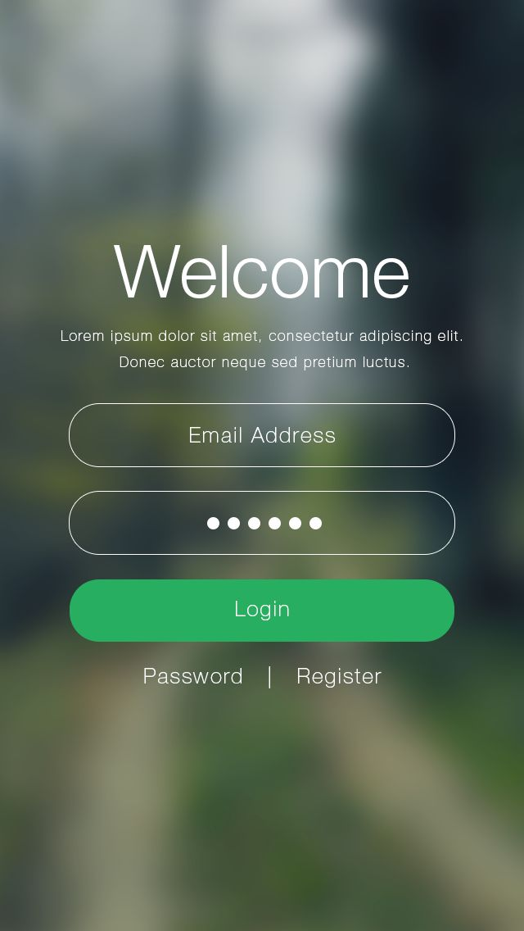
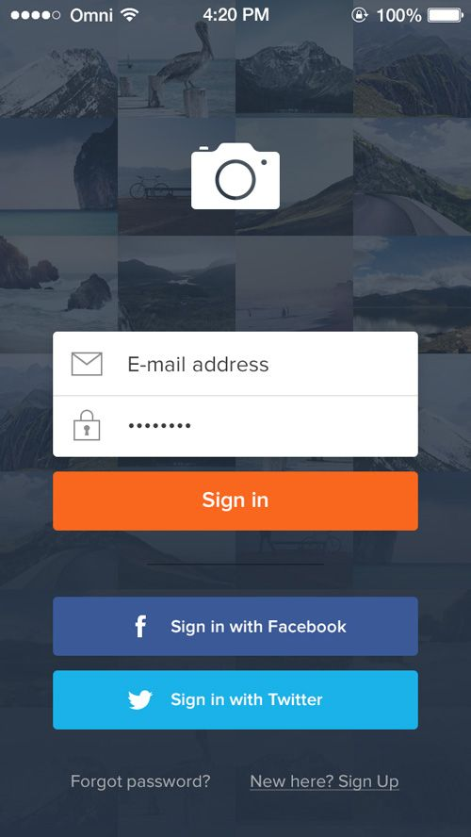
The App should have a tree-like hierarchy, where the root is the start screen, and with every click/choice one goes down to a children node, while clicking the return button brings us back to the parent node of the current node. The structure of this file will be the following. A chapter with a number for example x.y is the parrent node of any chapter x.y.z, and so on. For example the chapter 1.3 is the parent node of 1.3.x for any x. I will try to introduce a reasonable hierarchy, while the design is still open and can be discussed. The main navigation inside our app will be forward and backward navigation along the hierarchy tree, with only little lateral movement (maybe no lat. Movement at all) on the same hierarchy level. The lateral movement is limited to accessing the different key functionalities of the app (and to nodes sharring a common parrent?).
Each account consists of a private and a public business card, where the public card is visible by anyone, and the private consists of information that you only want to share with people that you grant access to.
1 Front Page/ Login screen
The first page should consist of the login screen, as known by many apps it should consist of a field for the login and the password. The password must not be visible (e.g by replacing letters with dots). If no account exists, one should be able to create a new one. In a first step I propose that we only make it possible to sign in with an account they have to create to keep it simple. In a later step and if we have time, we can extend it to sign up with their social media accounts (see the example images). This functionality should already exist in the firebase API.

1.1 Register screen
Here we have to make a design decision about how much the persons have to reveal about their personality. Either they have to sign in only with minimal information and can add the rest in a later step in the settings, or they have to add all their information from the beginning. I would propose that we make the register screen rather detailed, with most fields being optional and only the necessary information must be inserted and can be marked by a * or similar. I would go with a similar layout as the following and the mandatory fields marked :
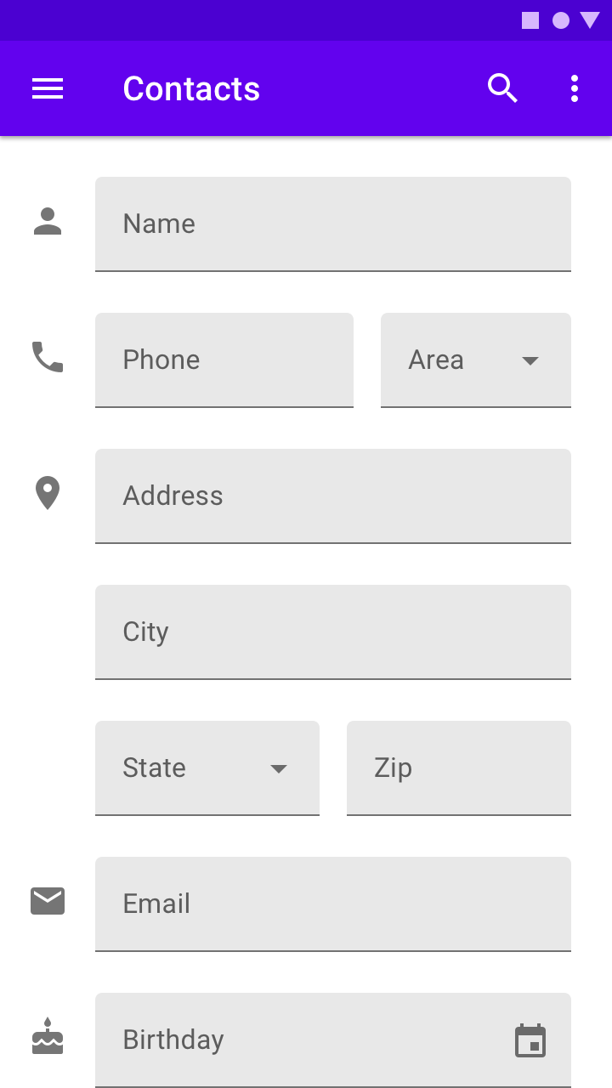
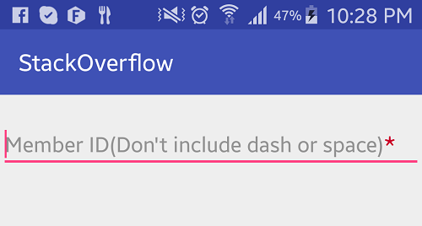

The informations included in the register side (* mandatory, TF: Type-in field, DL: drop down list):
Last Name*: TF
First Name*: TF
Middle Name: TF
Phone*: DL for the area code, another TF for the phone number
Address, I.e Street: TF
Street Nr.
City: TF
Country: DL(?)
Zip:
(If there is an API for that, we could make the input of the address neater by suggesting area codes etc.)
e-mail*: TF
Birthday*: TF or select in calendar (if feasible).
Occupation: (For filtering it might make sense to have a limited choice, so not a TF but rather select from different categories)
Profile Picture:

Further this should have an “add account” function, which gives a DL where the user can select a social media platform which we support, then they should be able to add their social media account. Depending on the account it is either a username, a link or some userID. The “add account” button should be pressable multiple times, I.e if you press it, it should be replaced by an DL and a new “add account” button.:
“add account”
------> press button
DL
“add account”
------> press button
DL
DL
“add account”
etc.
Suggested platforms:
Facebook
Twitter
LinkedIn
Wechat (since the tutor is chinese)
Extensions if time left:
Whatsapp
Instagram
Telegram
own websites
Each field chosen while signing up should have a checkmark or similar where one can choose if it is on the public business card or on the private one. Some fields should be public by default, e.g last name and userID.

Implementation of the business card in the backend: This is to decide for the back-end guys if it makes more sense to have to separate business cards stored in the backend, or if the information is all saved in the same entry and the information given out is filtered during the query request of the business card (I.e which information is shown). Further an Entry should have a location tag, which when updated should expire after a certain time and it should not be visible to any user.

1.2 First page
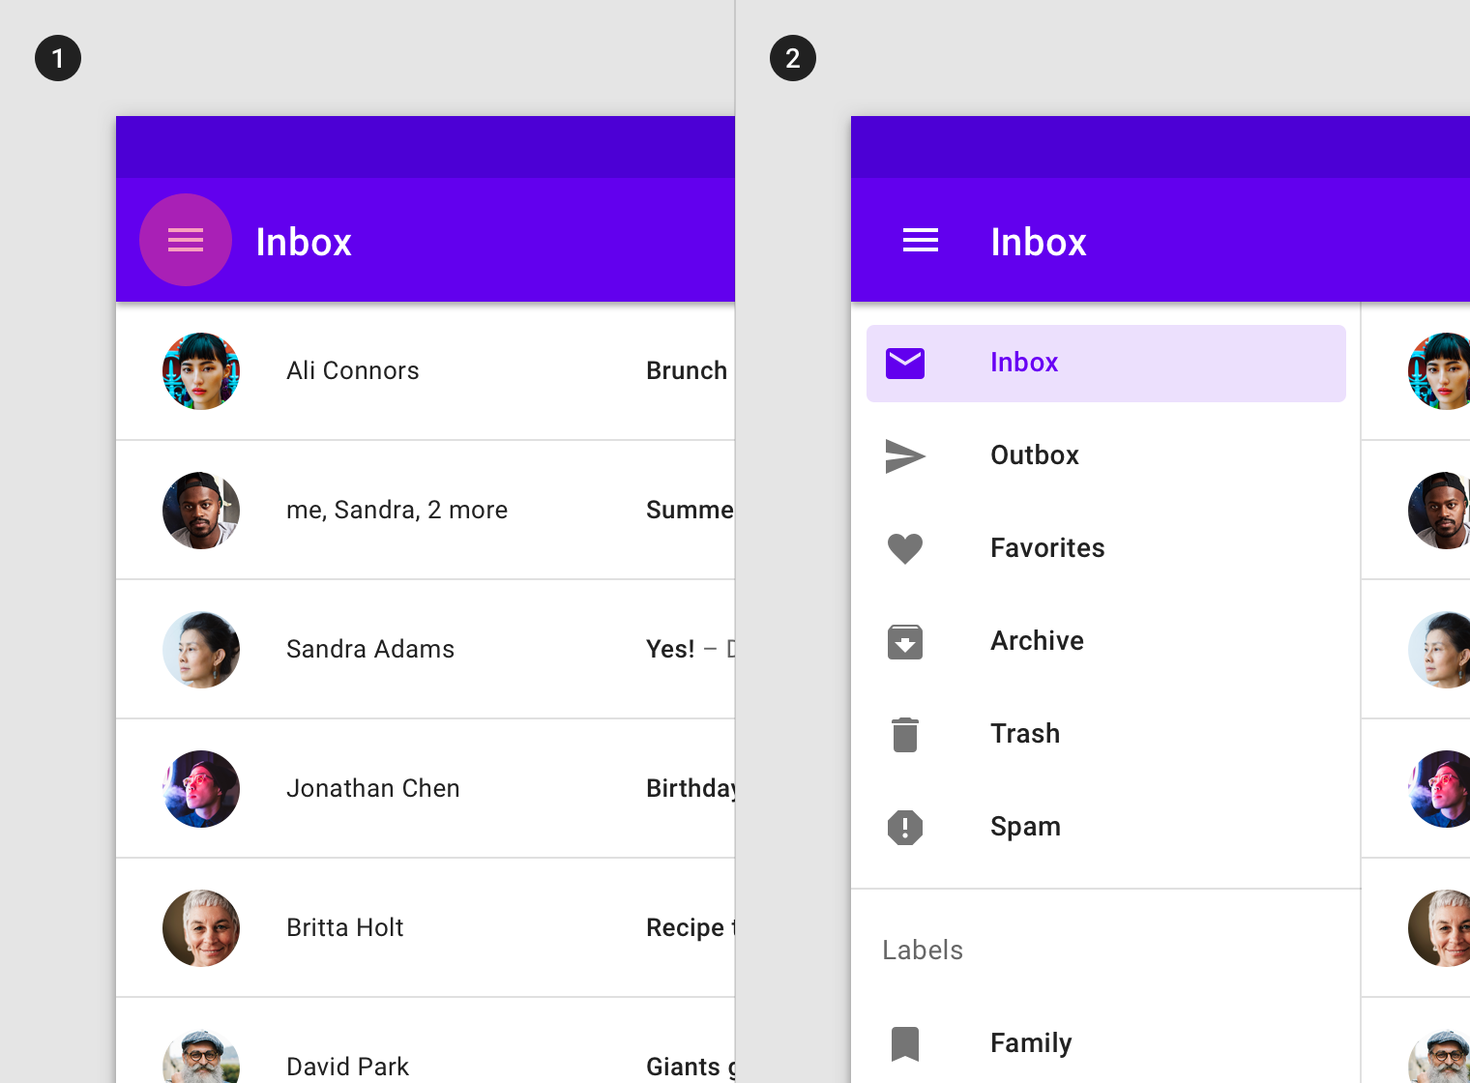
This is the root of our app where the main part of the navigation begins. I would keep this simple with only the minimum of options as grids with the following subcategories (we might need better naming though, since the names I chose are not that good):

-Local
-Map
-Profile
-Contacts
-Settings

After this page, there should be a navigation bar, from which one can choose each of this options from any point in the app like above:

1.2.1 Local
This part is quite simple, here one should be able share the business card and add new ones by scanning a QR code. When you share a QR code, you should be able to choose if the QR code gives access to your private or your public business card. We could also make it possible to add people through their userID, but then we need to solve how the user can decide if it is the private or the public business card which is shared. We could also use the public card by default and make kind of request the other user if he is willing to share the private card as well.
The design of this part is quite open

1.2.2 Map
This part gives us the possibility to fetch/share business cards with people close to us, which might make sense at specific places like unis/meetings etc. Here one should have the choice between fetching and sending the own business card to people close by. The calculation of the distance to select people close-by should be done in the backend, such that the exact location of a user is not shared to other users to ensure some level of privacy. The general idea of the sharing and the fetching of business cards is closely related so I’ll explain the functionality here: The user wants to filter his/her query such that it reaches only people of interest. Filter categories should be distance, while with the distance category we do not provide a fine-grained selection but a rather coarse grained one, to make it harder to trace other users to not misuse the app. For example steps like 500m, 1km, 3km, 5km. 10Km etc. (visualized as a slide bar). The distance should be calculated by a simple euclidean distance (not by finding a route), to keep it simple Then the query should be filterable by the information provided from the people. I would propose that we only filter by the information given by the public business card to ensure privacy. I.e if a user A starts a query which includes a filter for the age (e.g age in [20,30]), then people that share their age and are between 20 and 30 should be included and all that are not in that age group and share it should be excluded. (An extension could be that people that do not share their age should be included as well. This approach then ensures that we have enough people returned by a search query and we can then during the ranking step ensure that people who share the information and are inside of the query are favored. I think this approach would make sense even in an initial phase.) The ranking should be based on the search query and on the availability of contact possibilities, since a user is more valuable if he/she is contactable through a platform that we share. The ranking algorithm should be computable fast and localy after fetching a certain number of people. From the people matching the search query, a number (maybe 10 or 20) should be selected randomly and returned to the query holder, these fetched cards will den be ranked by 1. If their public information matches the query (e.g in the previous example if the age is shared and matches, it is ranked higher. If it is not shared and that’s why it is matched, it’s ranked lower). 2. on the platforms provided. The platform ranking works as follows: When adding a contact platform to your profile, you can add a weight to it which determines how important that value is to you. For example if we have the platforms [Facebook, Twitter, WeChat, Email, Phone], and the inquerier has them weighted as [3 , 0 , 5 , 1.5, 2], the fetched card has a similarity value of the weight of a platform, multiplied by the indicator variable determining if that contact platform is provided. E.g if a fetched card B provides Facebook and WeChat, it would have a similarity of 3x1 + 5x1 = 8.

1.2.2.1 share business card
Here a user can start a query to share their own business card with people which fullfill the query criteria as described above. Here also only a random number of people should receive the card to avoid spamming. The user can decide if he wants to share his public or private business card and the people receiving it should receive a push notification.

1.2.2.2 fetch business cards
Here business cards are fetched and a user can after the ranking decide which cards he wants to add to add to his contacts.

1.2.3 Profile
Overview of the users Information and their visibility (public/private). Add possibility to change information and to add new information, such as new platforms.

1.2.4 Contacts
This should contain a list of all saved/added contact cards and another one of all the people which have the users card in their contact list, this could be sortable by different criteria such as name, userID or last-modified. By clicking on an entry, the card should be expanded with all the information available and the information should be stored if the other person has access to the users private or public business card. This should include an option to remove the access to the private business card. If it is possible: open an application automatically after clicking the corresponding contact platform (e.g open facebook after clicking on FB contact on the business card), otherwise add the functionality to just copy it to the clipboard.

1.2.5 general settings
General app settings. Not exactly sure what should be here. Could probably be combined with the Profile menu

Updates
-No distinction between private/public business card, due to simplicity.
-Ranking algorithm kept simple

