

Functional Safety Concept Lane Assistance

**Document Version: 1.0**



# Document history

|  |  |  |  |
| --- | --- | --- | --- |
| Date | Version | Editor | Description |
| 06/04/2019 | 1.0 | Jian Li | Initial version |
|  |  |  |  |
|  |  |  |  |
|  |  |  |  |
|  |  |  |  |

# Table of Contents

Document history

Table of Contents

Purpose of the Functional Safety Concept

Inputs to the Functional Safety Concept

Safety goals from the Hazard Analysis and Risk Assessment

Preliminary Architecture

Description of architecture elements

Functional Safety Concept

Functional Safety Analysis

Functional Safety Requirements

Refinement of the System Architecture

Allocation of Functional Safety Requirements to Architecture Elements

Warning and Degradation Concept

# Purpose of the Functional Safety Concept

# Inputs to the Functional Safety Concept

## Safety goals from the Hazard Analysis and Risk Assessment

|  |  |
| --- | --- |
| **ID** | **Safety Goal** |
| Safety_Goal_01 | The oscillating steering torque from lane departure warning function shall be limited. |
| Safety_Goal_02 | The lane keeping assistance function shall be time limited, and the additional steering torque shall end after a given time interval so that the driver cannot misuse the system for autonomous driving. |

## Preliminary Architecture

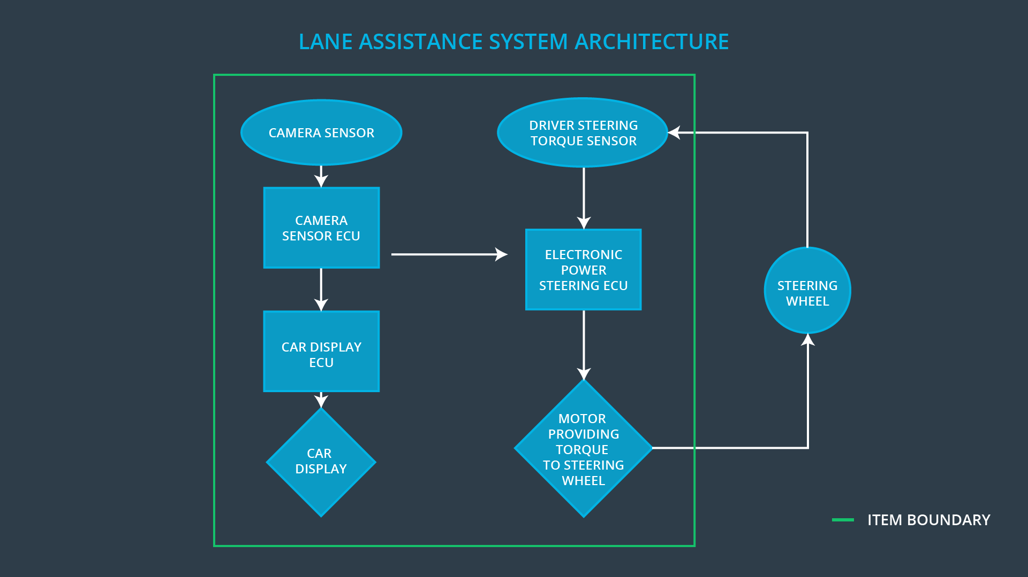

### Description of architecture elements

|  |  |
| --- | --- |
| **Element** | **Description** |
| Camera Sensor | The Camera Sensor reads the images from the road. |
| Camera Sensor ECU | The Camera Sensor ECU identifies when the vehicle has accidentally departed its lane, and sends the appropriate messages to the car display ECU and electronic power steering ECU. |
| Car Display | The Car Display shows the status of the function to the driver. |
| Car Display ECU | The Car Display ECU controls the Car Display based on the request to show warning on/off. |
| Driver Steering Torque Sensor | The Driver Steering Torque Sensor measures the torque provided the driver. |
| Electronic Power Steering ECU | The Electronic Power Steering ECU reads the measured torque from the sensor and controls the Motor to add an appropriate amount of torque based on a torque request. |
| Motor | The Motor executes the request from Electronic Power Steering ECU and add an appropriate amount of torque to the steering wheel. |

# Functional Safety Concept

The functional safety concept consists of:

* Functional safety analysis
* Functional safety requirements
* Functional safety architecture
* Warning and degradation concept

## Functional Safety Analysis

|  |  |  |  |
| --- | --- | --- | --- |
| **Malfunction ID** | **Main Function of the Item Related to Safety Goal Violations** | **Guidewords (NO, WRONG, EARLY, LATE, MORE, LESS)** | **Resulting Malfunction** |
| Malfunction_01 | Lane Departure Warning (LDW) function shall apply an oscillating steering torque to provide the driver a haptic feedback | MORE | The lane departure warning function applies an oscillating torque with very high torque amplitude (above limit). |
| Malfunction_02 | Lane Departure Warning (LDW) function shall apply an oscillating steering torque to provide the driver a haptic feedback | MORE | The lane departure warning function applies an oscillating torque with very high torque frequency (above limit). |
| Malfunction_03 | Lane Keeping Assistance (LKA) function shall apply the steering torque when active in order to stay in ego lane | NO | The lane departure warning function applies an oscillating torque with very high torque frequency (above limit). |

## Functional Safety Requirements

Lane Departure Warning (LDW) Requirements:

|  |  |  |  |  |
| --- | --- | --- | --- | --- |
| **ID** | **Functional Safety Requirement** | **ASIL** | **Fault Tolerant Time Interval** | **Safe State** |
| Functional  Safety  Requirement  01-01 | The lane keeping item shall ensure that the lane departure oscillating torque amplitude is below Max_Torque_Amplitude. | C | 50ms | Turn off LDW |
| Functional  Safety  Requirement  01-02 | The lane keeping item shall ensure that the lane departure oscillating torque frequency is below Max_Torque_Frequency. | C | 50ms | Turn off LDW |

Lane Departure Warning (LDW) Verification and Validation Acceptance Criteria:

|  |  |  |
| --- | --- | --- |
| **ID** | **Validation Acceptance**  **Criteria and Method** | **Verification Acceptance**  **Criteria and Method** |
| Functional  Safety  Requirement  01-01 | Set the oscillating torque amplitude to Max_Torque_Amplitude, and the warning light is ON. | When the torque amplitude crosses the limit, the lane assistance output is set to zero within the 50 ms fault tolerant time interval. |
| Functional  Safety  Requirement  01-02 | Set the oscillating torque amplitude to Max_Torque_Frequency, and the warning light is ON. | When the torque frequency crosses the limit, the lane assistance output is set to zero within the 50 ms fault tolerant time interval. |

Lane Keeping Assistance (LKA) Requirements:

|  |  |  |  |  |
| --- | --- | --- | --- | --- |
| **ID** | **Functional Safety Requirement** | **ASIL** | **Fault Tolerant Time Interval** | **Safe State** |
| Functional  Safety  Requirement  02-01 | The electronic power steering ECU shall ensure that the lane keeping assistance torque is applied for only Max_Duration. | B | 500ms | Turn off LKA |

Lane Keeping Assistance (LKA) Verification and Validation Acceptance Criteria:

|  |  |  |
| --- | --- | --- |
| **ID** | **Validation Acceptance**  **Criteria and Method** | **Verification Acceptance**  **Criteria and Method** |
| Functional  Safety  Requirement  02-01 | The max_duration chosen really did dissuade drivers from taking their hands off the wheel. | The system turns off when the lane keeping assistance every exceeded max_duration |

## Refinement of the System Architecture

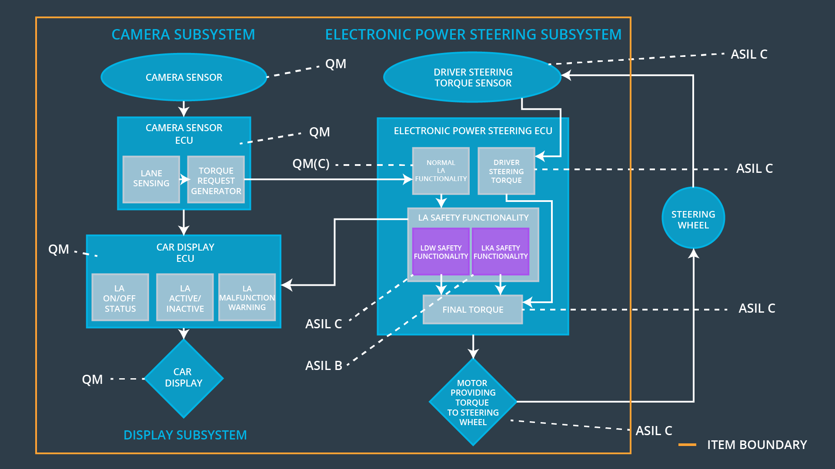

## Allocation of Functional Safety Requirements to Architecture Elements

|  |  |  |  |  |
| --- | --- | --- | --- | --- |
| **ID** | **Functional Safety Requirement** | **Electronic Power Steering ECU** | **Camera ECU** | **Car Display ECU** |
| Functional  Safety  Requirement  01-01 | The lane keeping item shall ensure that the lane departure oscillating torque amplitude is below Max_Torque_Amplitude. | **x** |  |  |
| Functional  Safety  Requirement  01-02 | The lane keeping item shall ensure that the lane departure oscillating torque frequency is below Max_Torque_Frequency. | **x** |  |  |
| Functional  Safety  Requirement  02-01 | The electronic power steering ECU shall ensure that the lane keeping assistance torque is applied for only Max_Duration. | **x** |  |  |

## Warning and Degradation Concept

|  |  |  |  |  |
| --- | --- | --- | --- | --- |
| **ID** | **Degradation Mode** | **Trigger for Degradation Mode** | **Safe State invoked?** | **Driver Warning** |
| WDC-01 | Turn off the function | Torque crosses the Max_Torque | Yes | The warning light is on. |
| WDC-02 | Turn off the function | Activated time elapsed over Max_Duration | Yes | The warning light is on. |