[首页](http://www.codeweblog.com/) > [Python](http://www.codeweblog.com/category/python/) > [python的USB通信](http://www.codeweblog.com/python%e7%9a%84usb%e9%80%9a%e4%bf%a1/)

python的USB通信

手头有个用libusb-win32驱动的USB设备，idVendor= 0x5345, idProduct= 0x1234，就来测试下[pyusb](https://pypi.python.org/pypi/pyusb/1.0.0a3)模块的应用，pyusb让usb编程变得简单和方便，支持 libusb 0.1.x（libusb-win32采用此库）, libusb 1.x, and OpenUSB，主要测试发送和接收数据，usb设备信息如下：

[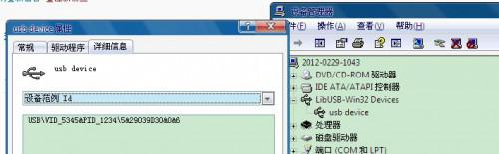](http://image.codeweblog.com/upload/9/03/903369f21e614e25.jpg)

代码如下：

import usb.core

import usb.util

import sys

dev = usb.core.find(idVendor= 0x5345, idProduct= 0x1234)

cfg = dev.get_active_configuration()

intf = cfg[(0,0)]

ep = usb.util.find_descriptor(

intf,

# match the first OUT endpoint

custom_match = \

lambda e: \

usb.util.endpoint_direction(e.bEndpointAddress) == \

usb.util.ENDPOINT_OUT

)

print 'The length of data(write USB) is:', ep.write('WANTFORGETTXT')

ep_read = usb.util.find_descriptor(

intf,

# match the first IN endpoint

custom_match = \

lambda e: \

usb.util.endpoint_direction(e.bEndpointAddress) == \

usb.util.ENDPOINT_IN

)

data_len = ep_read.read(4)

print 'Get USB data:',data_len

len = (data_len[3] << 24) + (data_len[2] << 16) + (data_len[1] << 8) + data_len[0]

print 'data len is:',len

dev.reset()

结果如下：  
  
[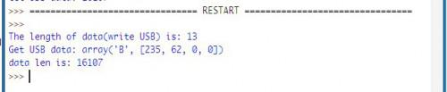](http://image.codeweblog.com/upload/d/7a/d7a1ca9bf91fef34.jpg)