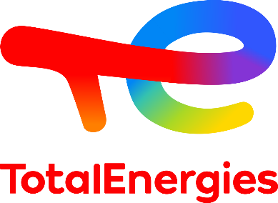Loris Vial

Route de Rossillon, 20

1226 Thônex

+33 6 29 47 07 13

[loris.vial@ehl.ch](mailto:loris.vial@ehl.ch)

In Geneva, on 11 April 2022

**Subject: Spontaneous application for September 2022.**

To whom it may concern,

My name is Loris Vial, and I have dual French and Swiss nationality. I am currently in my 3rd and final year at the EHL Hospitality Business School and will graduate with a Bachelor of Science HES-SO in June 2022. To improve my knowledge and skills, I am currently looking for an internship or an entry position in a field of activity that I am passionate about, hence my spontaneous application.

I have always been passionate about the hospitality and the finance industry. During my studies, I had the opportunity to do internships in these two fields and while working at Quaero Capital, I developed a very deep and strong passion for the finance markets and more especially for the commodity market. Therefore, I would like to focus and direct my future experiences in the support areas (back/middle office and operations) and commodity trading with the aim to start a career in this industry. Moreover, I am especially interested in the new energies and issues related to the ecological transition that you can address with the TotalEnergies Gas & Power entity. Nevertheless, the energetic transition is just one out of many challenges that the commodity industry is and will face; this moving and thrilling environment is part of the reasons that raised my interest and why I do believe I would greatly perform in this industry.

I am, by nature, a motivated person and open to new learning and culture. I have had the opportunity to work in a team on many projects, but I am also very comfortable working individually due to my great organization. I am also interested in new technologies and innovations whose approaches and methods can be applied in many fields. Therefore, I can meet your expectations because I have the motivation and the necessary skills to work in your company. Additionally, moved by a strong passion I will always go the extra step, eager to bring my very best to the company.

TotalEnergies' commitment to the environment and the development and fulfillment of its employees are values that I share, and that motivate my application. It has always been essential for me to work for a committed and responsible company. What I like about your company is the importance you give to the transition to more sustainable energy (electricity and natural gas). However, you do not forget the foundations on which TotalEnergies was built while still trying to improve these practices (biofuels and CO2 capture and storage). Finally, I share and support the values that you put forward, such as respect for others, the strength of solidarity, and a taste for performance.

In the hope of a positive response from you, I remain at your disposal for any further information you may require. Please accept my most sincere greetings.

Loris Vial