LWScratch
by loosewheel

Version 0.1.0

This mod provides scratch programmable robots.

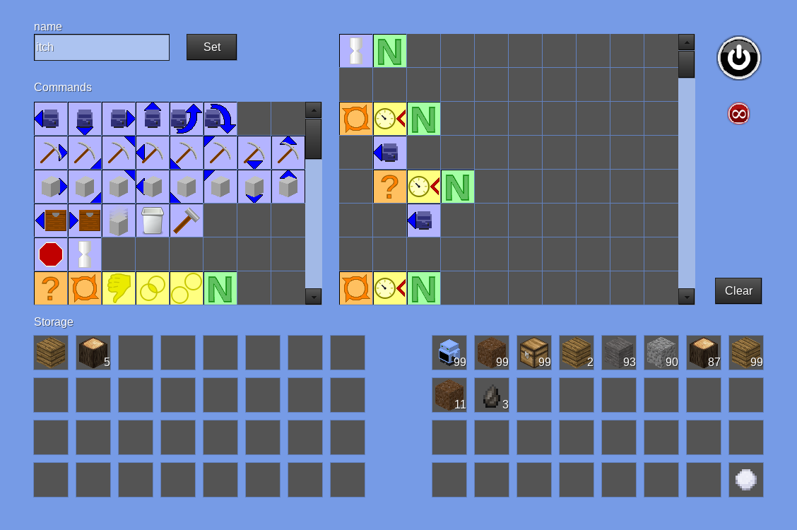
The first time a robot is placed in the world a form opens asking the player that placed it, if the machine is public or private. If private is selected, the player becomes the owner and other players (except those with protection_bypass privilege) cannot access it.

The persistence button  toggles on and off. If persistence is on, the block the robot is in remains loaded when out of range. This persistence is retained across world startups. Robots retain their persistence state when moved. The maximum force loaded blocks is limited to the max_forceloaded_blocks setting (default is 16).

Each robot can be given a name, by entering the name in the name field and clicking the Set button. The name will display when the robot is pointed at or as the tool tip if it is in an inventory.

Each robot has a storage area (bottom left).

While a robot is running sneak + punch will open a form to stop it.

Robots are programmed graphically, by dragging a command from a pallet (top left) to the program sheet (top right). Items can be dragged from the inventories. These are only markers, the item is not used. To remove an item from the program sheet, drag it to an empty space in the command pallet. To clear the whole program click the clear button. Commands are run in order, left to right per line, then down the lines.

Block delimiting (for loop and if) is by indenting. When a following line is indented to the same level or less, this marks the end of the block.

To run the program click the power  button . If the program has an error a red message below the program sheet details the error.

Command items are color coded by type:
Orange | Statement, controls program flow.
Green | Value, represents a given value.
Yellow | Condition, results as true or false.
Blue | Action, performs an action of some kind.
White | Sheet action, used to edit the program sheet.

Statements
  Loop | Followed by a condition which evaluates to true or false. The following lines of commands indented greater than the loop statement will run repeatedly until the condition is false.  Each loop has an internal counter, which starts at zero and increments by one every iteration.
  If | Followed by a condition which evaluates to true or false. The following lines of commands indented greater than the if statement will run once if the condition is true.

Values
  Number | Can be set with an number value when placed (or moved) in the program sheet. An input field and button labelled Number appear. Set the value and click the button to set the value. Hovering over the number item the tool tip displays its current value.

Conditions
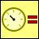  Counter is equal to | Followed by a number item, and results in true if the loop's counter is equal to the number.  Outside of a loop the counter is always zero.
  Counter is less than | Followed by a number item, and results in true if the loop's counter is less than the number.  Outside of a loop the counter is always zero.
  Counter is greater than | Followed by a number item, and results in true if the loop's counter is greater than the number.  Outside of a loop the counter is always zero.
  Detect up | If followed by an inventory item, true if the node in the up direction matches the inventory item.  If followed by a blank space, true if there is any node in the up direction.
  Detect down | If followed by an inventory item, true if the node in the down direction matches the inventory item.  If followed by a blank space, true if there is any node in the down direction.
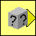  Detect forward | If followed by an inventory item, true if the node in the forward direction matches the inventory item.  If followed by a blank space, true if there is any node in the forward direction.
  Detect forward up | If followed by an inventory item, true if the node in the forward, up direction matches the inventory item.  If followed by a blank space, true if there is any node in the forward, up direction.
  Detect forward down | If followed by an inventory item, true if the node in the forward, down direction matches the inventory item.  If followed by a blank space, true if there is any node in the forward, down direction.
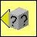  Detect back | If followed by an inventory item, true if the node in the back direction matches the inventory item.  If followed by a blank space, true if there is any node in the back direction.
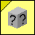  Detect back up | If followed by an inventory item, true if the node in the back, up direction matches the inventory item.  If followed by a blank space, true if there is any node in the back, up direction.
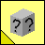  Detect back down | If followed by an inventory item, true if the node in the back, down direction matches the inventory item.  If followed by a blank space, true if there is any node in the back, down direction.
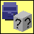  Contains item | If followed by an inventory item, true if the robot's storage contains at least one of the inventory item.  If followed by a blank space, true if the robot's storage contains anything at all.
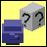  Item fits | If followed by an inventory item, true if one of the inventory item can fit in the robot's storage.  If followed by a blank space, true if the robot's storage has at least one empty slot (can fit anything).
  Not | Inverts the next condition result (true to false, or false to true).
  And | Placed between two conditions and is true only if both the left and right conditions are true.
  Or | Placed between two conditions and is true if either the left or right (or both) condition is true.

Actions
  Move forward | Moves one node in the forward direction, if nothing is there.
  Move backward | Moves one node in the backward direction, if nothing is there.
  Move up | Moves one node in the up direction, if nothing is there.
  Move down | Moves one node in the down direction, if nothing is there.
  Turn left | Turns 90 degrees in the left direction.
  Turn right | Turns 90 degrees in the right direction.
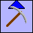  Dig up | Digs the node in the up direction, if there is anything there. If dug, node is placed in the robot's storage if there is room, otherwise it is dropped.
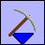  Dig down | Digs the node in the down direction, if there is anything there. If dug, node is placed in the robot's storage if there is room, otherwise it is dropped.
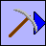  Dig forward | Digs the node in the forward direction, if there is anything there. If dug, node is placed in the robot's storage if there is room, otherwise it is dropped.
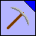  Dig forward up | Digs the node in the forward up direction, if there is anything there. If dug, node is placed in the robot's storage if there is room, otherwise it is dropped.
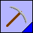  Dig forward down | Digs the node in the forward down direction, if there is anything there. If dug, node is placed in the robot's storage if there is room, otherwise it is dropped.
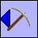  Dig back | Digs the node in the back direction, if there is anything there. If dug, node is placed in the robot's storage if there is room, otherwise it is dropped.
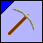  Dig back up | Digs the node in the back up direction, if there is anything there. If dug, node is placed in the robot's storage if there is room, otherwise it is dropped.
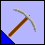  Dig back down | Digs the node in the back down direction, if there is anything there. If dug, node is placed in the robot's storage if there is room, otherwise it is dropped.
  Place up | Followed by an inventory item. Places the given inventory item in the up direction if there is nothing at that position. The item must be in the robot's storage.
  Place down | Followed by an inventory item. Places the given inventory item in the down direction if there is nothing at that position. The item must be in the robot's storage.
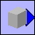  Place forward | Followed by an inventory item. Places the given inventory item in the forward direction if there is nothing at that position. The item must be in the robot's storage.
  Place forward up | Followed by an inventory item. Places the given inventory item in the forward, up direction if there is nothing at that position. The item must be in the robot's storage.
  Place forward down | Followed by an inventory item. Places the given inventory item in the forward, down direction if there is nothing at that position. The item must be in the robot's storage.
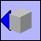  Place back | Followed by an inventory item. Places the given inventory item in the back direction if there is nothing at that position. The item must be in the robot's storage.
  Place back up | Followed by an inventory item. Places the given inventory item in the back, up direction if there is nothing at that position. The item must be in the robot's storage.
  Place back down | Followed by an inventory item. Places the given inventory item in the back, down direction if there is nothing at that position. The item must be in the robot's storage.
  Pull | If followed by an inventory item, moves one of the given inventory items from an inventory (chest) immediately in front of the robot, into the robot's storage if it can fit.  If followed by a blank space, moves everything from an inventory (chest) immediately in front of the robot, into the robot's storage or as much as can fit.
  Put | If followed by an inventory item, moves one of the given inventory items from the robot's storage into an inventory (chest) immediately in front of the robot, if it can fit.  If followed by a blank space, moves everything from the robot's storage into an inventory (chest) immediately in front of the robot, or as much as can fit.
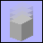  Drop | If followed by an inventory item, drops one of the given inventory items from the robot's storage into the world, if it contains one.  If followed by a blank space, drops everything from the robot's storage into the world.
  Trash | If followed by an inventory item, destroys (gone forever) one of the given inventory items in the robot's storage, if it contains one.  If followed by a blank space, destroys (gone forever) everything in the robot's storage.
  Craft | Followed by an inventory item. Crafts the given inventory item. The materials for the craft must be in the robot's storage.
  Wait | Followed by a number item. Pauses the robot's program by the number value in tenths of a second (10 = 1 second pause).
  Stop | Stops the robot's program.

Sheet actions
  Insert line | Inserts a line in the program sheet where it is dropped. The last line of the sheet is lost.
  Remove line | Removes a line in the program sheet where it is dropped. The removed line of the sheet is lost.

