PRACTICAL 1:-----Blinking of LED using Arduino

**Arduino Code:**

void setup()

{ // put your setup code here, to run once:

pinMode(13,OUTPUT);

}

void loop()

{ // put your main code here, to run repeatedly:

digitalWrite(13,LOW);

delay(1000);

digitalWrite(13,HIGH);

delay(1000);

}

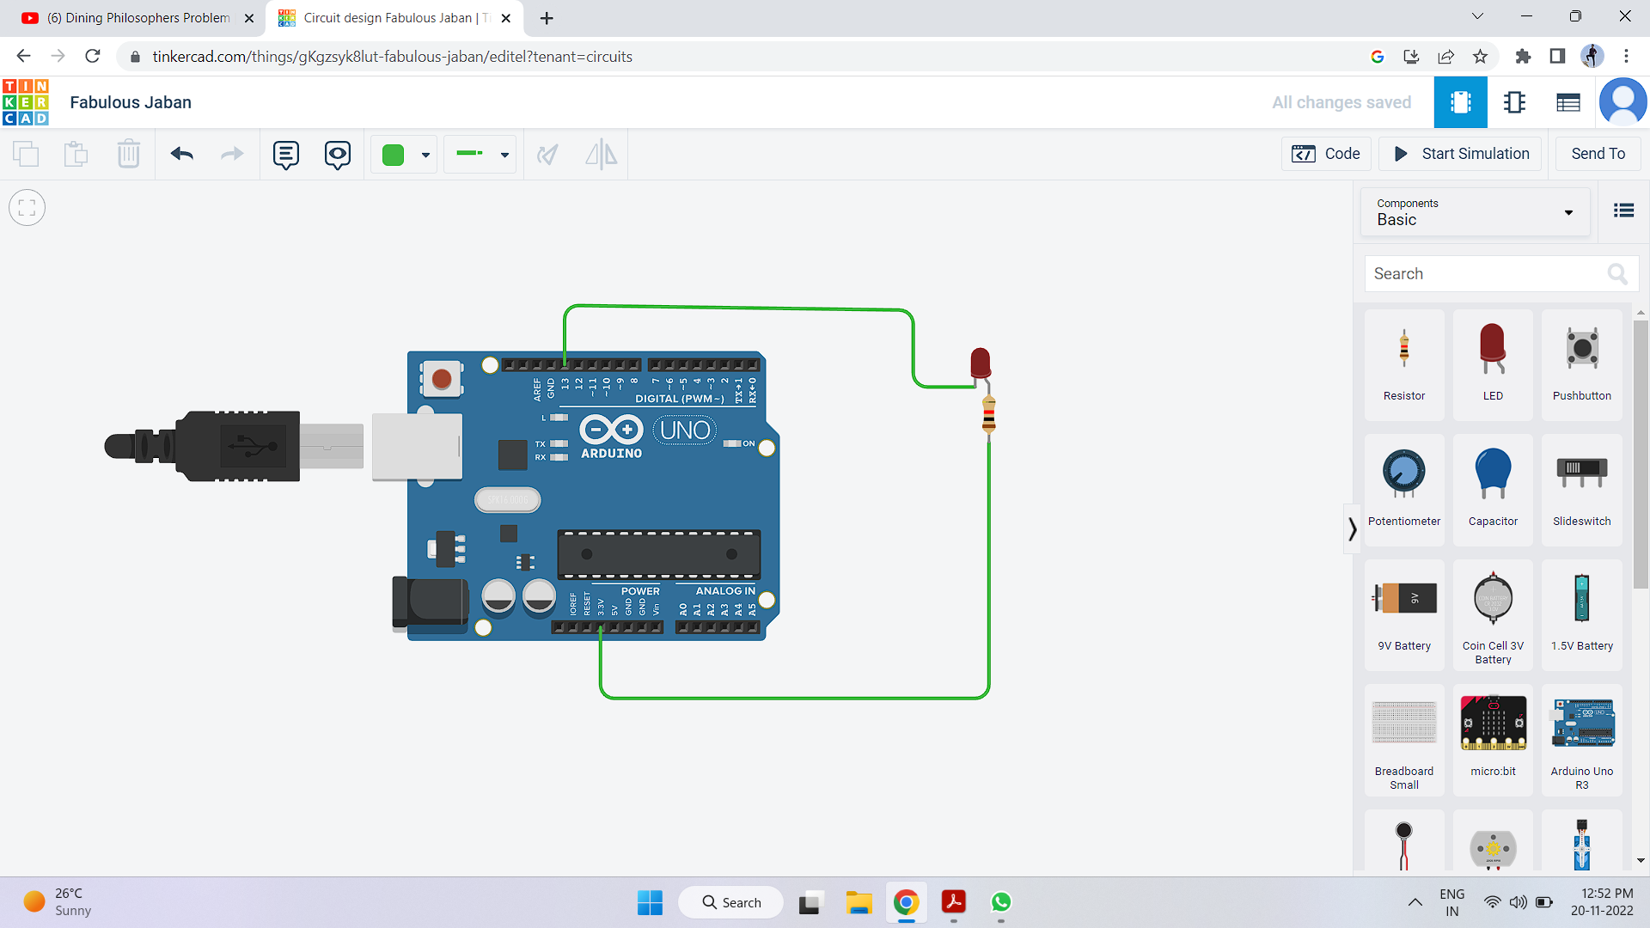

PRACTICAL 2:---Blinking of LED Using Raspberry pi

**Raspberry Pi Code:**

import RPi.GPIO as GPIO

import time

GPIO.setmode(GPIO.BCM)

GPIO.setwarnings(False)

GPIO.setup(21,GPIO.OUT)

While True:

GPIO.output(21,GPIO.HIGH)

time.sleep(1)

GPIO.output(21,GPIO.LOW)

time.sleep(1)

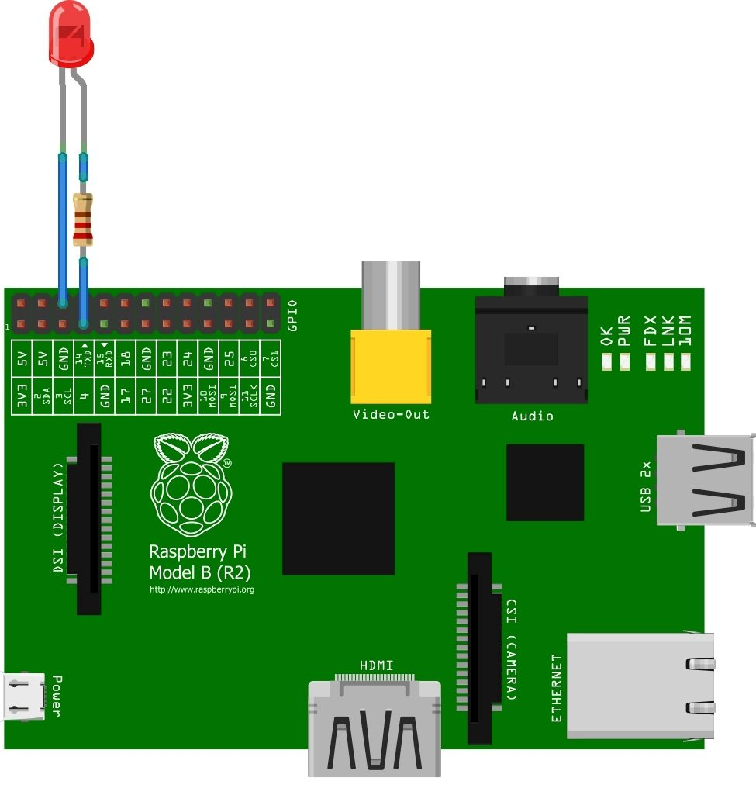

**PRACTICAL 3**:---Object detection using IR Sensor and Arduino

**Arduino Code:**

Arduino Code for Obstacle detection using IR Sensor

int IRSensor = 2; // connect ir sensor to arduino pin 2

int LED = 13; // conect Led to arduino pin 13

void setup()

{

pinMode (IRSensor, INPUT); // sensor pin INPUT

pinMode (LED, OUTPUT); // Led pin OUTPUT

}

void loop()

{

int statusSensor = digitalRead (IRSensor);

if (statusSensor == 1)

digitalWrite(LED, LOW); // LED LOW

}

else

{

digitalWrite(LED, HIGH); // LED High

}

}

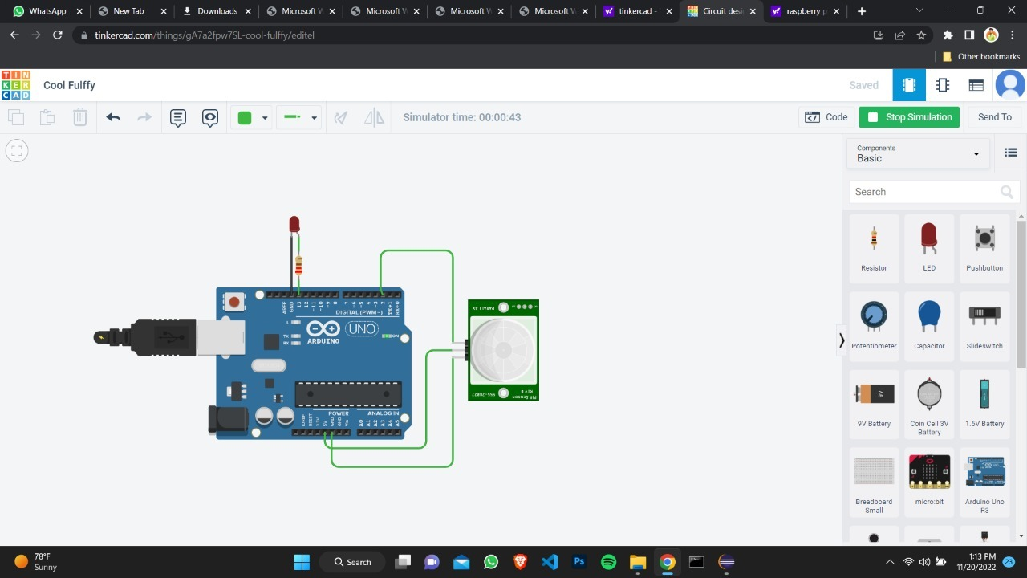**PRACTICAL 4**:-Object detection using IR sensor and Raspberry pi

import RPi.GPIO as GPIO

import time

GPIO.setmode(GPIO.BOARD)

GPIO.setwarnings(False)

GPIO.setup(3,GPIO.IN)

GPIO.setup(5,GPIO.OUT)

while True:

val=GPIO.input(3)

print(val)

if val = = 0:

print("Object Detected")

GPIO.output(5,GPIO.HIGH)

time.sleep(1)

else:

print("Object Not Detected")

GPIO.output(5,GPIO.LOW)

time.sleep(1)

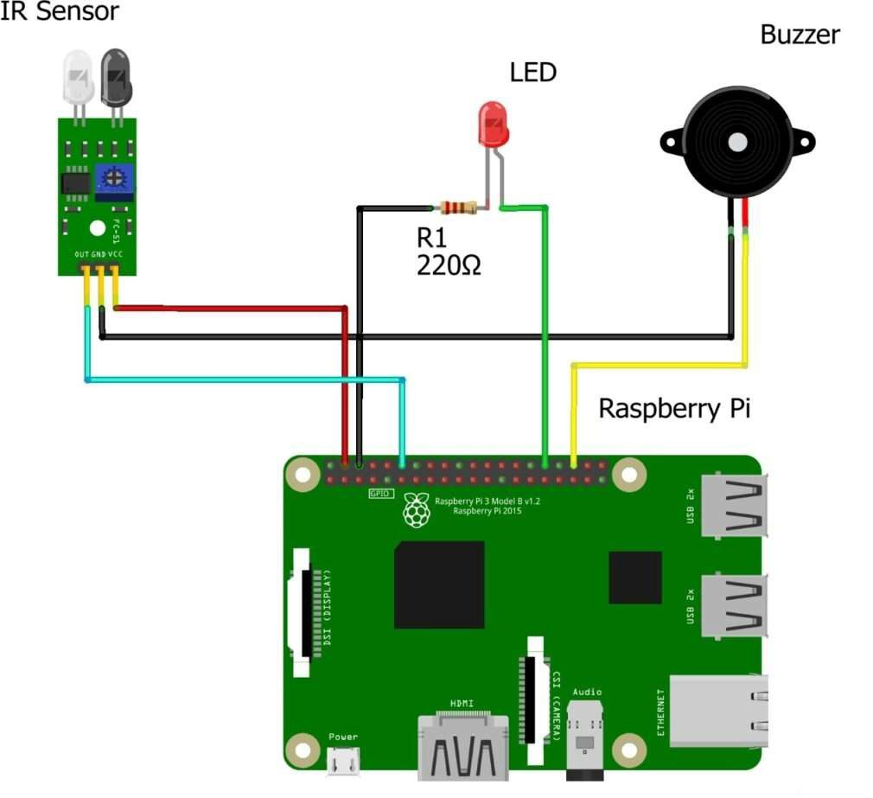

**PRACTICAL 5**:----Temperature and Humidity Monitoring using DHT 11 and Raspberry pi

import adafruit_DHT

from time import sleep

sensor = Adafruit_DHT.DHT11

humidity, temperature = AdaFruit_DHT.read-retry(sensor, 4)

import Rpi.GPIO as g

g.setmode(g. BCM)

g.setup(5,g.OUT)

if humidity is not None and temperature is not None:

while true:

print(‘Temp ={0:0.1f}*c Humidity={1:O.1f}%’.format (temperature, humidity))

Sleep(1)

if (temperature > 25):

g.output(5,g.HIGH)

sleep(1)

else:

g.output(5,g.LOW)

sleep(1)

else:

print(‘failed to get reading. try again’)

