In this video, Shreyas briefly revisited the topics that were covered in this session, which can be summarised as follows:

Best practices: Some of the best practices that you should remember while writing an SQL query are as follows:
- Comment your code using a hyphen '-' for a single line and '/* ... */' for multiple lines of code.
- Always use table aliases when your query involves more than one source table.
- Assign simple and descriptive names to columns and tables.
- Write SQL keywords in upper case and the names of columns, tables and variables in lower case.
- Always use column names in the 'order by' clause instead of numbers.
- Maintain the right indentation for different sections of a query.
- Use new lines for different sections of a query.
- Use a new line for each column name.
- Use the SQL Formatter or the MySQL Workbench Beautification tool (Ctrl+B) to clean your code.
Indexing: Indexing is an effective way to optimise query execution, as it selects the required data values instead of processing the entire table. The syntaxes for creating, adding and dropping an index are as follows:

CREATE INDEX index_name
ON table_name (column_1, column_2, ...);

ALTER TABLE table_name
ADD INDEX index_name(column_1, column_2, ...);

ALTER TABLE table_name
DROP INDEX index_name;

Clustered vs non-clustered indexing: The major differences between clustered and non-clustered indexing are summarised in the table given below.

Clustered Index | Non-Clustered Index
1. This is mostly the primary key of the table. | 1. It is a combination of one or more columns of the table.
2. It is present within the table. | 2. The unique list of keys is present outside the table.
3. It does not require a separate mapping. | 3. The external table points to different sections of the main table.
4. It is relatively faster. | 4. It is relatively slower.

Order of query execution: The order in which the different SQL statements are executed in a query is depicted in the diagram given below.
You observed that the average profit per order for furniture products is low (₹75.23) compared with that of the other product categories.

In the next video, let's compute the fourth and last metric: average profit percentage per order. While coding along with Shreyas, you must have observed that he examined each table to check whether there are any other metrics that could be useful for the analysis.
You calculated the average profit per order for each product category. Why do you think this is a useful metric? Write your answer in the space provided below.?
Calculating the average profit per order for each product category is a useful metric because it provides insight into the financial performance of different categories. This metric allows a business to identify which categories are more profitable and which may need attention. By analyzing average profit per order, businesses can make more informed decisions about pricing strategies, inventory management, marketing efforts, and product development. It also helps in evaluating the efficiency of each category in generating profit, leading to better resource allocation and more targeted actions to increase profitability across categories.
In this video, you were introduced to the problem statement, the required metrics and required tables, which can be summarised as follows:

Problem statement: Identify the sustainable (profitable) product categories so that the growth team can capitalise on them to increase sales.

Metrics: Some of the metrics that can be used for performing the profitability analysis are as follows:
- Profits per product category
- Profits per product subcategory
- Average profit per order
- Average profit percentage per order

Tables: The tables that are required for solving this problem are as follows:
- 'market_fact_full'
- 'prod_dimen'
- 'orders_dimen'

The ERD for the 'market star' schema is given below for your reference.

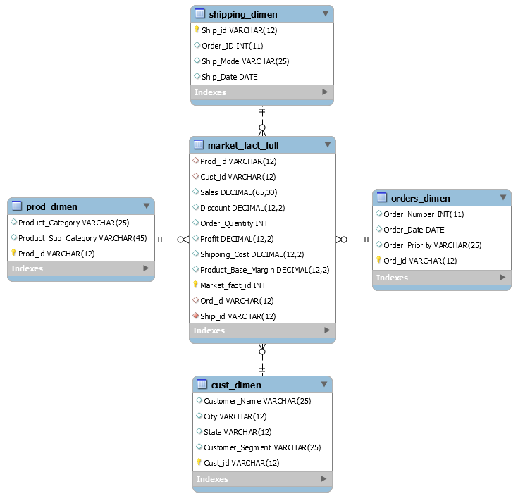

Although you have used the schema throughout this module, make sure you are familiar with its tables, columns and the relationships between its tables. In the next segment, you will start solving the problem statement along with Shreyas.
In this session, you solved various business problems using SQL. You might encounter similar problems in your daily job role.

Profitability analysis: You performed a profitability analysis on the 'market star' schema by identifying sustainable/profitable product categories so that the growth team can capitalise on them and increase sales. You calculated the following metrics:
- Profits per product category
- Profits per product subcategory
- Average profit per order
- Average profit percentage per order

Profitable customers: You also identified the ten most profitable customers and extracted their details in the format given below.

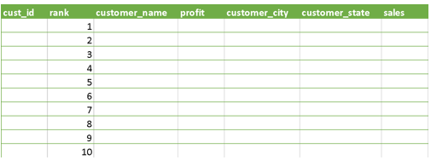

Fraud detection: Finally, you found out the details of fraud customers after retrieving their data in the following columns:
- 'cust_id'
- 'cust_name'
- 'city'
- 'state'
- 'customer_segment'
- A flag to indicate that there is another customer with the exact same name and city but a different customer ID.

You must have realised that there are various applications of SQL in the data analytics domain. Hence, it is important for you to have a strong understanding of both basic and advanced SQL concepts to derive useful insights.

You can find the script file used in the demonstrations throughout this session in the link provided below.

Advanced SQL Script File

Finally, you can download the PPT used throughout this module from the link provided below.

Advanced SQL PPT

