Olympic Games Performance Prediction System

Project Id: AIML-26

Name : AVIKA ABHIMANYUE KUSH
Class Roll Number:41
University Roll Number : 2028680
Section and Group: K,G2

Name : LOPAMUDRA BATABYAL
Class Roll Number:51
University Roll Number : 2028757
Section and Group: K,G2

TABLE OF CONTENTS
- Problem Description 3
- Flow diagram 4
- Models used 7
- Evaluation metrics used 8
- Results and Visualizations 9
- References 12

- Problem Description
The objective of this project is to design and develop an end-to-end machine learning system to predict Olympic Games performance using numerical sports data. The project involves selecting a suitable Olympic dataset containing features such as athlete participation counts, medal totals, event statistics, and country-wise performance across multiple years. Data preprocessing techniques including data cleaning, normalization, and transformation are applied to ensure consistency and reliability of the data. Exploratory Data Analysis is performed to analyze medal distributions, participation trends, and performance variations across countries and time periods using statistical summaries and trend analysis. Visualization techniques such as bar charts, line plots, and heatmaps are used to understand long-term performance patterns and relationships between variables. Correlation analysis is conducted to identify key factors influencing medal outcomes. Based on insights obtained from EDA, relevant features are selected to improve model performance(PCA,Forward Selection,Backward Selection). Machine learning models are then developed to predict medal counts using regression techniques or to classify countries into performance categories such as high, medium, or low performance. The trained models are evaluated using appropriate performance metrics(F1 score) to assess their predictive effectiveness, demonstrating a complete machine learning pipeline from raw sports data to evaluated predictive models.

2 Flow Diagram
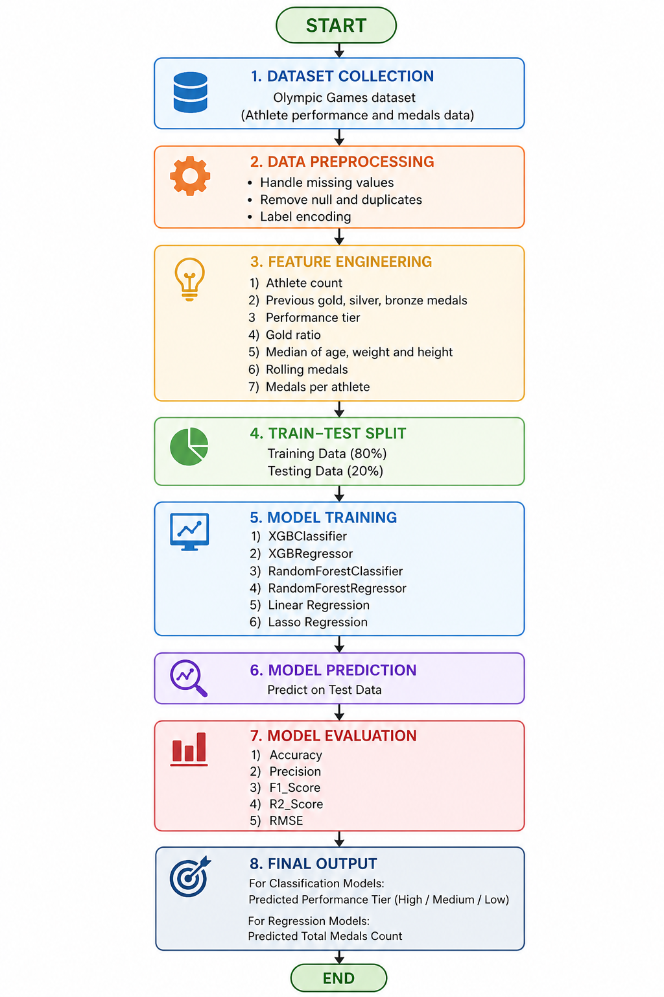

3. Models used(applied/planned) Give a brief introduction of the models used

1. Random Forest Classifier
Random Forest is an ensemble learning algorithm that builds multiple decision trees and combines their outputs using majority voting for classification. It reduces overfitting and improves accuracy by introducing randomness in feature selection and data sampling.
- Searching Technique Used:
GridSearchCV was applied to tune hyperparameters such as number of trees (n_estimators), maximum depth (max_depth), and minimum samples split. This helps in finding the optimal combination of parameters for better model performance.

2. XGBoost Classifier
XGBoost (Extreme Gradient Boosting) is an advanced ensemble technique based on boosting, where models are built sequentially to correct the errors of previous models. It is highly efficient and performs well on structured datasets.
- Searching Technique Used:
GridSearchCV was used to optimize parameters like n_estimators, max_depth, and learning_rate. This improves prediction accuracy and prevents overfitting.

3. Linear Regression
Linear Regression is a basic supervised learning algorithm used for predicting continuous values. It assumes a linear relationship between input features and the target variable.
- Searching Technique Used:
Sequential Feature Selector (SFS) was used to select the most relevant features. This reduces dimensionality and improves model efficiency.

4. Lasso Regression
Lasso Regression is a regularized version of Linear Regression that uses L1 regularization. It not only improves prediction accuracy but also performs feature selection by shrinking some coefficients to zero.
- Searching Technique Used:
Sequential Feature Selector (SFS) was used along with Lasso to further refine feature selection and improve model performance.

5. XGBoost Regressor
XGBoost Regressor is a powerful boosting algorithm used for regression tasks. It builds models sequentially and minimizes prediction errors using gradient descent techniques.
- Searching Technique Used:
Sequential Feature Selector (SFS) was applied to select the most important features contributing to prediction accuracy.

6. Random Forest Regressor
Random Forest Regressor is an ensemble model that constructs multiple decision trees and averages their outputs to improve prediction accuracy and reduce variance.
- Searching Technique Used:
Sequential Feature Selector (SFS) was used to identify and retain the most significant features, enhancing model performance and reducing complexity.

Additional Techniques Used Across Models
- SMOTE (Synthetic Minority Oversampling Technique):
Applied in classification models to handle class imbalance by generating synthetic samples for minority classes.
- Train-Test Split:
Used to divide the dataset into training and testing sets (80-20 and 60-40) for proper model evaluation.

4. Evaluation metrics used

1. Accuracy
Accuracy measures the proportion of correctly predicted instances out of the total instances.
Formula:
Accuracy=TP+TNTP+TN+FP+FNAccuracy = \frac{TP + TN}{TP + TN + FP + FN}Accuracy=TP+TN+FP+FNTP+TN​
Where:
- TP = True Positives
- TN = True Negatives
- FP = False Positives
- FN = False Negatives

2. Precision
Precision measures how many of the predicted positive instances are actually positive.
Formula:
Precision=TPTP+FPPrecision = \frac{TP}{TP + FP}Precision=TP+FPTP​

3. Recall
Recall (Sensitivity) measures how many actual positive instances are correctly identified.
Formula:
Recall=TPTP+FNRecall = \frac{TP}{TP + FN}Recall=TP+FNTP​

4. F1 Score
F1 Score is the harmonic mean of Precision and Recall. It balances both metrics, especially useful for imbalanced datasets.
Formula:
F1=2×Precision×RecallPrecision+RecallF1 = 2 \times \frac{Precision \times Recall}{Precision + Recall}F1=2×Precision+RecallPrecision×Recall​

5. Confusion Matrix
A confusion matrix is a table used to evaluate classification performance by comparing actual and predicted values.
 | Predicted Positive | Predicted Negative
Actual Positive | TP | FN
Actual Negative | FP | TN

6. Mean Squared Error (MSE)
MSE measures the average of squared differences between actual and predicted values.
Formula:
MSE=1n∑i=1n(yi−y^i)2MSE = \frac{1}{n} \sum_{i=1}^{n}(y_i - \hat{y}_i)^2MSE=n1​i=1∑n​(yi​−y^​i​)2

7. Mean Absolute Error (MAE)
MAE measures the average absolute difference between actual and predicted values.
Formula:
MAE=1n∑i=1n∣yi−y^i∣MAE = \frac{1}{n} \sum_{i=1}^{n}|y_i - \hat{y}_i|MAE=n1​i=1∑n​∣yi​−y^​i​∣

8. Root Mean Squared Error (RMSE)
RMSE is the square root of MSE and provides error in the same unit as the target variable.
Formula:
RMSE=1n∑i=1n(yi−y^i)2RMSE = \sqrt{\frac{1}{n} \sum_{i=1}^{n}(y_i - \hat{y}_i)^2}RMSE=n1​i=1∑n​(yi​−y^​i​)2​

9. R² Score (Coefficient of Determination)
R² measures how well the model explains the variance in the target variable.
Formula:
R2=1−∑(yi−y^i)2∑(yi−yˉ)2R^2 = 1 - \frac{\sum (y_i - \hat{y}_i)^2}{\sum (y_i - \bar{y})^2}R2=1−∑(yi​−yˉ​)2∑(yi​−y^​i​)2​
Where:
- yiy_iyi​ = actual value
- y^i\hat{y}_iy^​i​ = predicted value
- yˉ\bar{y}yˉ​ = mean of actual values

5. Results and Visualizations
- Before hyperparameter tuning
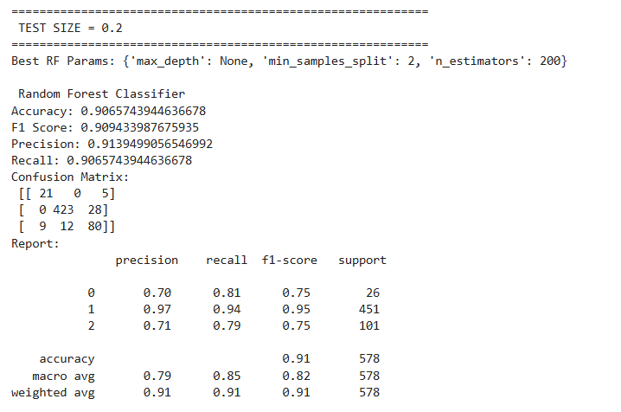
- After hyperparameter tuning
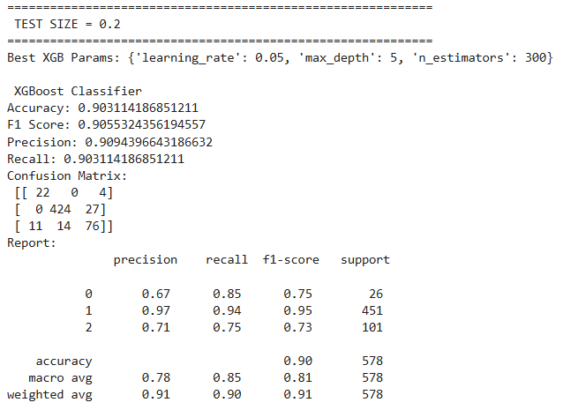
7. References:
Books:
- Let Us Python – Yashavant Kanetkar

Online Resources:
  - GeeksforGeeks – https://www.geeksforgeeks.org/
  - TutorialsPoint – https://www.tutorialspoint.com/cprogramming/index.htm

