Olympic Games Performance Prediction System

Project Id: AIML-26

Name : AVIKA ABHIMANYUE KUSH
Class Roll Number:41
University Roll Number : 2028680
Section and Group: K,G2

Name : LOPAMUDRA BATABYAL
Class Roll Number:51
University Roll Number : 2028757
Section and Group: K,G2

TABLE OF CONTENTS
- Problem Description 3
  - Dataset Description 3
  - Flow diagram 4
- Modules for Project Implementation…………………..…………………………5
  - Modules Used 10
  - Platform Used 1
- Machine Learning model/ Searching Technique used 7
- Evaluation metrics used 8
- Results and Visualizations 9
- Conclusion and Future Scope 11
- References 12

- Problem Description
The objective of this project is to design and develop an end-to-end machine learning system to predict Olympic Games performance using numerical sports data. The project involves selecting a suitable Olympic dataset containing features such as athlete participation counts, medal totals, event statistics, and country-wise performance across multiple years. Data preprocessing techniques including data cleaning, normalization, and transformation are applied to ensure consistency and reliability of the data. Exploratory Data Analysis is performed to analyze medal distributions, participation trends, and performance variations across countries and time periods using statistical summaries and trend analysis. Visualization techniques such as bar charts, line plots, and heatmaps are used to understand long-term performance patterns and relationships between variables. Correlation analysis is conducted to identify key factors influencing medal outcomes. Based on insights obtained from EDA, relevant features are selected to improve model performance(PCA,Forward Selection,Backward Selection). Machine learning models are then developed to predict medal counts using regression techniques or to classify countries into performance categories such as high, medium, or low performance. The trained models are evaluated using appropriate performance metrics(F1 score) to assess their predictive effectiveness, demonstrating a complete machine learning pipeline from raw sports data to evaluated predictive models.
1.1 Dataset Description

The dataset used in this project contains historical records of athletes who participated in the Olympic Games across multiple years. Each row in the dataset represents an individual athlete’s participation in a specific event, along with relevant demographic, performance, and event-related details.
The dataset includes the following key attributes:
- ID: Unique identifier for each athlete entry
- Name: Name of the athlete
- Sex: Gender of the athlete (M/F)
- Age: Age of the athlete at the time of participation
- Height: Height of the athlete (in cm)
- Weight: Weight of the athlete (in kg)
- Team: Country or team the athlete represents
- NOC: National Olympic Committee code (country abbreviation)
- Games: Edition of the Olympic Games (e.g., 1992 Summer)
- Year: Year of the Olympic Games
- Season: Type of Olympics (Summer/Winter)
- City: Host city of the Olympic Games
- Sport: Sport category (e.g., Basketball, Judo)
- Event: Specific event within the sport
- Medal: Medal won by the athlete (Gold, Silver, Bronze, or NA if no medal)
The dataset spans multiple Olympic years and includes athletes from various countries, enabling analysis of long-term performance trends. Since the data is recorded at the athlete-event level, it can be aggregated to obtain country-level statistics such as total medals, athlete participation counts, and performance metrics over time.
This dataset provides a rich foundation for performing exploratory data analysis, identifying trends in Olympic participation and performance, and building machine learning models to predict medal outcomes or classify country performance levels.

1.2 Flow Diagram
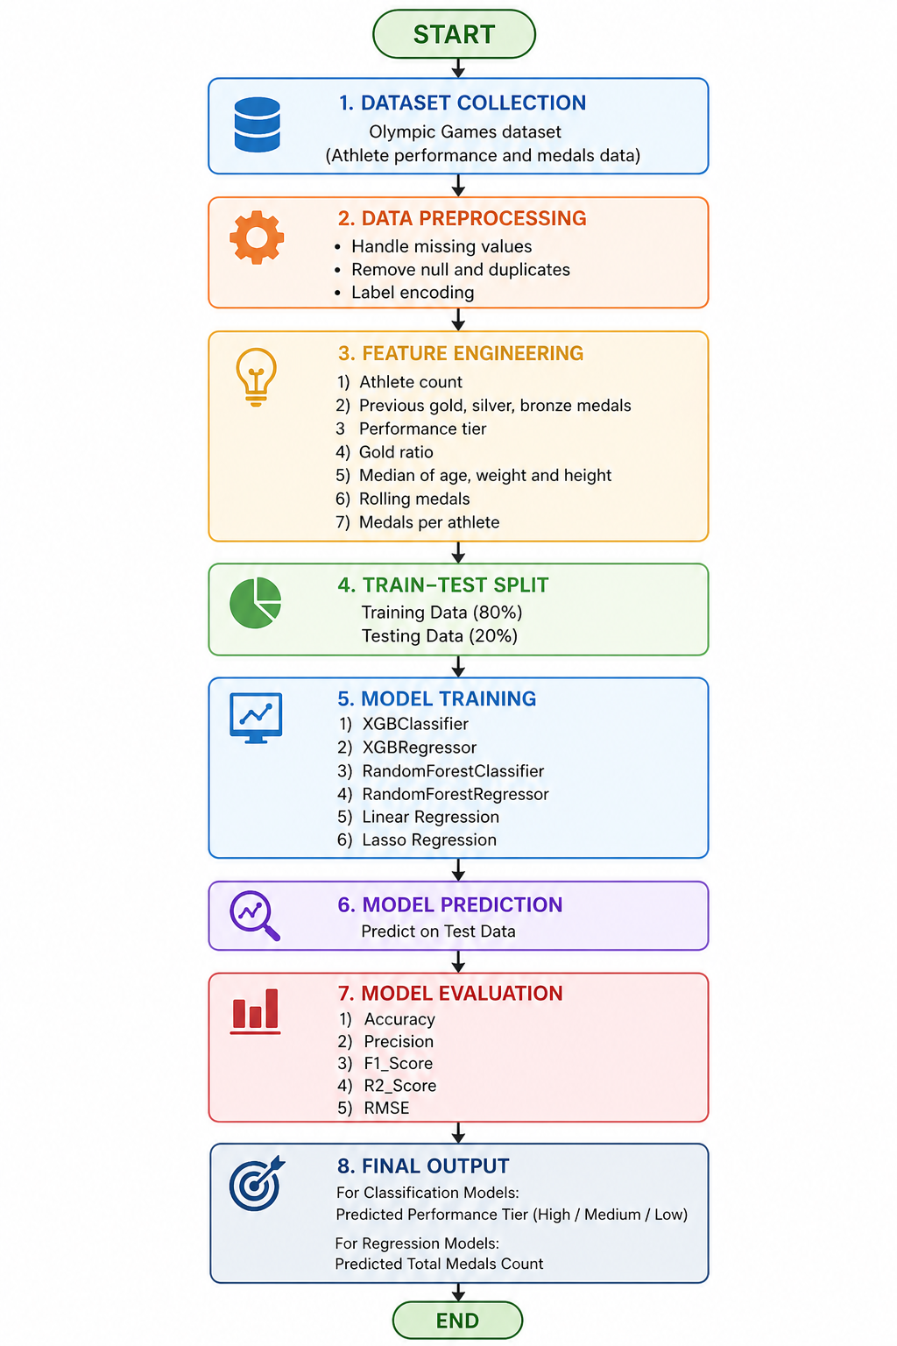

Modules for Project Implementation

- Pandas – Used for data manipulation and analysis.
Functions: pd.read_csv() – to load dataset into DataFrame.
- NumPy – Used for numerical operations and array handling.
Functions: np.array() – to create numerical arrays.
- Matplotlib – Used for data visualization.
Functions: plt.plot() – to create plots and graphs.
- Seaborn – Used for advanced statistical visualizations.
Functions: sns.heatmap() – to visualize correlations.
- Scikit-learn (Preprocessing) – Used for data scaling and encoding.
Functions: StandardScaler() – to normalize features.
- Scikit-learn (Model Selection) – Used for splitting and tuning data.
Functions: train_test_split() – to split dataset into train and test sets.
- Scikit-learn (Linear Models) – Used for regression models.
Functions: LinearRegression(), Lasso() – for prediction and regularization.
- Scikit-learn (Feature Selection) – Used for selecting important features.
Functions: SequentialFeatureSelector() – to select best feature subset.
- Scikit-learn (Ensemble) – Used for ensemble models.
Functions: RandomForestClassifier(), RandomForestRegressor() – for classification and regression.
- XGBoost – Used for advanced boosting models.
Functions: XGBClassifier(), XGBRegressor() – for high-performance prediction.
- Scikit-learn (Metrics) – Used for model evaluation.
Functions: accuracy_score(), precision_score(), f1_score(), r2_score(), mean_squared_error() – to evaluate performance.
- LabelEncoder – Used for encoding categorical variables.
Functions: fit_transform() – to convert labels into numeric form.
- GridSearchCV – Used for hyperparameter tuning.
Functions: GridSearchCV() – to find best model parameters.
- SMOTE (imblearn) – Used for handling class imbalance.
Functions: SMOTE() – to generate synthetic samples.
- Warnings – Used to suppress unnecessary warnings.
Functions: warnings.filterwarnings() – to ignore warnings.

Platform Used: (mention all the platforms with the reason of using it)

Jupyter Notebook was used as the primary development environment for implementing the machine learning model.

Reasons for using Jupyter Notebook:
- Interactive_Execution:
It allows code to be run step-by-step, which is helpful for testing data preprocessing, feature engineering, and model building in stages.
- Easy_Data_Visualization:
Graphs and plots (like matplotlib, seaborn) can be displayed instantly, making it easier to understand trends in Olympic data.
- Better_Debugging:
Errors can be identified and fixed quickly by running individual cells instead of the whole program.
- Documentation_Support:
It supports Markdown, so explanations, observations, and results can be written alongside the code, improving clarity of the project.
- Integration_with_ML_Libraries:
Easily works with libraries like pandas, NumPy, scikit-learn, and XGBoost used in the project.
- Reproducibility:
The entire workflow (data loading → preprocessing → model → evaluation) can be saved and reused.

3. Machine Learning Model/ Searching Technique Used(Describe each ML model/ searching technique used)

1. Random Forest Classifier
Random Forest is an ensemble learning algorithm that builds multiple decision trees and combines their outputs using majority voting for classification. It reduces overfitting and improves accuracy by introducing randomness in feature selection and data sampling.
- Searching Technique Used:
GridSearchCV was applied to tune hyperparameters such as number of trees (n_estimators), maximum depth (max_depth), and minimum samples split. This helps in finding the optimal combination of parameters for better model performance.

2. XGBoost Classifier
XGBoost (Extreme Gradient Boosting) is an advanced ensemble technique based on boosting, where models are built sequentially to correct the errors of previous models. It is highly efficient and performs well on structured datasets.
- Searching Technique Used:
GridSearchCV was used to optimize parameters like n_estimators, max_depth, and learning_rate. This improves prediction accuracy and prevents overfitting.

3. Linear Regression
Linear Regression is a basic supervised learning algorithm used for predicting continuous values. It assumes a linear relationship between input features and the target variable.
- Searching Technique Used:
Sequential Feature Selector (SFS) was used to select the most relevant features. This reduces dimensionality and improves model efficiency.

4. Lasso Regression
Lasso Regression is a regularized version of Linear Regression that uses L1 regularization. It not only improves prediction accuracy but also performs feature selection by shrinking some coefficients to zero.
- Searching Technique Used:
Sequential Feature Selector (SFS) was used along with Lasso to further refine feature selection and improve model performance.

5. XGBoost Regressor
XGBoost Regressor is a powerful boosting algorithm used for regression tasks. It builds models sequentially and minimizes prediction errors using gradient descent techniques.
- Searching Technique Used:
Sequential Feature Selector (SFS) was applied to select the most important features contributing to prediction accuracy.

6. Random Forest Regressor
Random Forest Regressor is an ensemble model that constructs multiple decision trees and averages their outputs to improve prediction accuracy and reduce variance.
- Searching Technique Used:
Sequential Feature Selector (SFS) was used to identify and retain the most significant features, enhancing model performance and reducing complexity.

Additional Techniques Used Across Models
- SMOTE (Synthetic Minority Oversampling Technique):
Applied in classification models to handle class imbalance by generating synthetic samples for minority classes.
- Train-Test Split:
Used to divide the dataset into training and testing sets (80-20 and 60-40) for proper model evaluation.

4. Evaluation metrics used (Describe each evaluation metric used along with formulae)

1. Accuracy
Accuracy measures the proportion of correctly predicted instances out of the total instances.
Formula:
Accuracy=TP+TNTP+TN+FP+FNAccuracy = \frac{TP + TN}{TP + TN + FP + FN}Accuracy=TP+TN+FP+FNTP+TN​
Where:
- TP = True Positives
- TN = True Negatives
- FP = False Positives
- FN = False Negatives

2. Precision
Precision measures how many of the predicted positive instances are actually positive.
Formula:
Precision=TPTP+FPPrecision = \frac{TP}{TP + FP}Precision=TP+FPTP​

3. Recall
Recall (Sensitivity) measures how many actual positive instances are correctly identified.
Formula:
Recall=TPTP+FNRecall = \frac{TP}{TP + FN}Recall=TP+FNTP​

4. F1 Score
F1 Score is the harmonic mean of Precision and Recall. It balances both metrics, especially useful for imbalanced datasets.
Formula:
F1=2×Precision×RecallPrecision+RecallF1 = 2 \times \frac{Precision \times Recall}{Precision + Recall}F1=2×Precision+RecallPrecision×Recall​

5. Confusion Matrix
A confusion matrix is a table used to evaluate classification performance by comparing actual and predicted values.
 | Predicted Positive | Predicted Negative
Actual Positive | TP | FN
Actual Negative | FP | TN

6. Mean Squared Error (MSE)
MSE measures the average of squared differences between actual and predicted values.
Formula:
MSE=1n∑i=1n(yi−y^i)2MSE = \frac{1}{n} \sum_{i=1}^{n}(y_i - \hat{y}_i)^2MSE=n1​i=1∑n​(yi​−y^​i​)2

7. Mean Absolute Error (MAE)
MAE measures the average absolute difference between actual and predicted values.
Formula:
MAE=1n∑i=1n∣yi−y^i∣MAE = \frac{1}{n} \sum_{i=1}^{n}|y_i - \hat{y}_i|MAE=n1​i=1∑n​∣yi​−y^​i​∣

8. Root Mean Squared Error (RMSE)
RMSE is the square root of MSE and provides error in the same unit as the target variable.
Formula:
RMSE=1n∑i=1n(yi−y^i)2RMSE = \sqrt{\frac{1}{n} \sum_{i=1}^{n}(y_i - \hat{y}_i)^2}RMSE=n1​i=1∑n​(yi​−y^​i​)2​

9. R² Score (Coefficient of Determination)
R² measures how well the model explains the variance in the target variable.
Formula:
R2=1−∑(yi−y^i)2∑(yi−yˉ)2R^2 = 1 - \frac{\sum (y_i - \hat{y}_i)^2}{\sum (y_i - \bar{y})^2}R2=1−∑(yi​−yˉ​)2∑(yi​−y^​i​)2​
Where:
- yiy_iyi​ = actual value
- y^i\hat{y}_iy^​i​ = predicted value
- yˉ\bar{y}yˉ​ = mean of actual values

5. Results and Visualizations
1)CLASSIFICATION

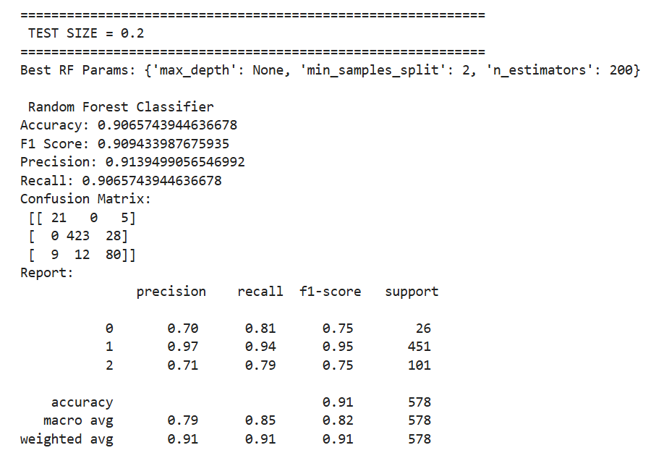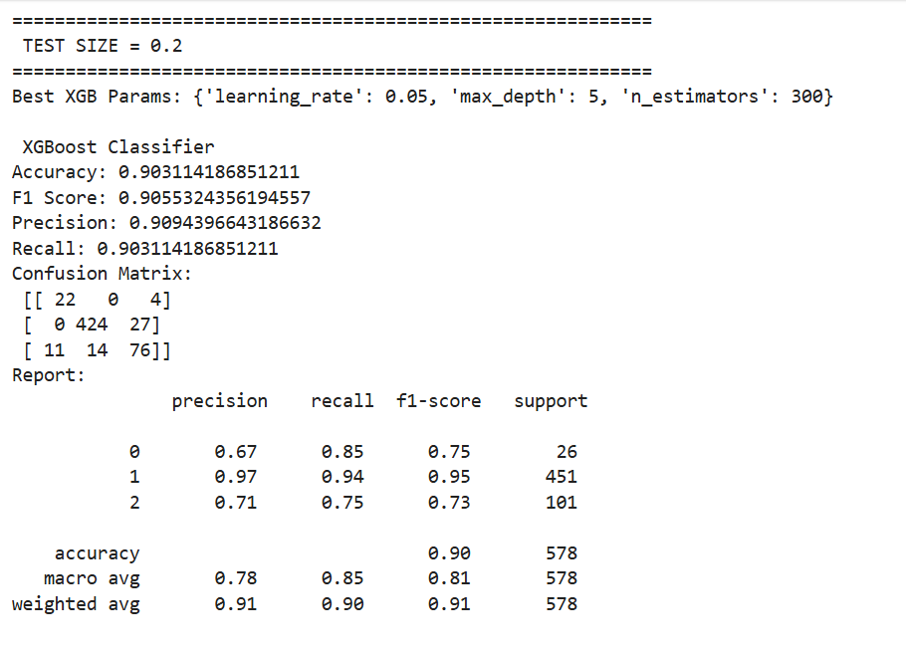

2)REGRESSION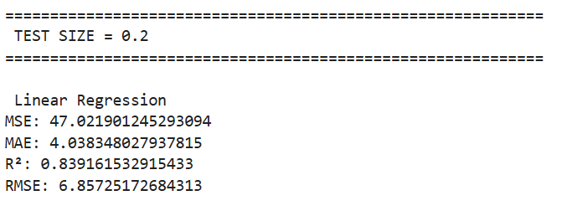 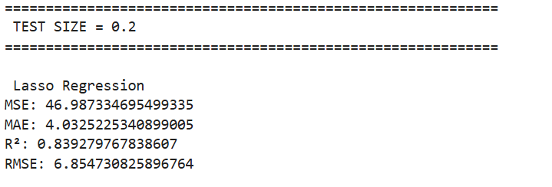 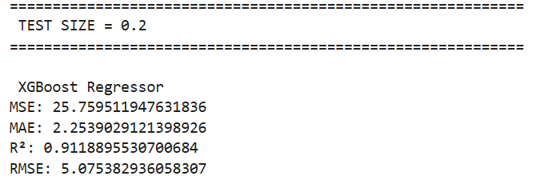 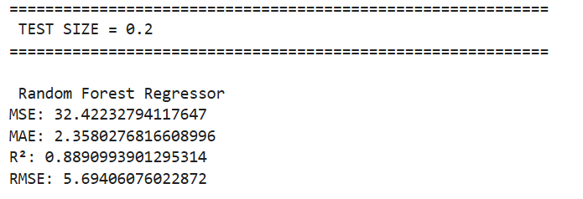

6. Conclusion and Future Scope:

Conclusion
In this project, an end-to-end machine learning system was developed to analyze and predict Olympic performance using historical sports data. Various preprocessing techniques such as data cleaning, normalization, feature selection, and handling class imbalance using SMOTE were applied to improve data quality and model performance.
A total of six machine learning models were implemented, including Random Forest and XGBoost for classification, and Linear Regression, Lasso Regression, Random Forest Regressor, and XGBoost Regressor for regression tasks. Hyperparameter tuning using GridSearchCV and feature selection using Sequential Feature Selector (SFS) were employed to optimize model performance.
The experimental results showed that ensemble models like Random Forest and XGBoost performed better compared to linear models, as they effectively captured complex patterns and relationships in the data. Evaluation metrics such as Accuracy, Precision, Recall, F1-score, MSE, MAE, RMSE, and R² score were used to assess the performance of the models.
Overall, the project demonstrates that machine learning techniques can be effectively used to analyze historical Olympic data and provide meaningful insights and predictions regarding country-wise performance.

Future Scope
The project can be further enhanced in several ways:
- Incorporation of More Features:
Additional factors such as economic indicators, training facilities, population, and host country advantage can be included to improve prediction accuracy.
- Advanced Models:
More advanced techniques such as Deep Learning models (ANN, LSTM) can be explored for better performance.
- Time-Series Analysis:
Since Olympic data is year-based, time-series models can be applied to capture trends and temporal patterns.
- Real-Time Data Integration:
Integrating real-time or recent data can make predictions more dynamic and useful for upcoming Olympic events.
- Model Optimization:
Further tuning of hyperparameters and use of advanced optimization techniques like Random Search or Bayesian Optimization can improve results.
- Deployment:
The model can be deployed as a web application or dashboard to make it accessible for users, analysts, or sports organizations.

7. References:
Books:
- Let Us Python – Yashavant Kanetkar

Online Resources:
  - GeeksforGeeks – https://www.geeksforgeeks.org/
  - TutorialsPoint – https://www.tutorialspoint.com/cprogramming/index.htm

