synopsis

**ON**

**E-Commerce Website Using MERN Stack**



**United school of business management**

**37/A,Chandaka Industrial Estate, Near Infocity ,Patia Bhubaneswar-751024**

**Submitted By Guided By**

**Project Title:E-Commerce Website Using MERN Stack**

**1. Introduction**

In today’s digital world, online shopping is an essential part of life. This project aims to develop a user-friendly e-commerce platform using the MERN stack. The website will allow users to browse products, add them to the cart, and complete purchases using secure payment methods.

**2. Objectives**

1. To develop a secure and interactive shopping website.
2. To allow users to browse, search, and filter products.
3. To provide secure authentication and user management.
4. To implement an admin panel for product and order management.

**3. Scope**

1. The website will include user authentication, product management, and a shopping cart.
2. Users will be able to view product details and place orders.
3. Payment gateways will be integrated for online transactions.
4. The system will be scalable for future enhancements.

**4. Methodology & System Design**

1. The project will follow the Agile model for development.
2. The system will use the MERN stack (MongoDB, Express.js, React.js, Node.js).
3. The database schema will include Users, Products, Orders, and Payments tables.

**5. Technologies Used**

1. Frontend: React.js, Bootstrap, Redux
2. Backend: Node.js, Express.js
3. Database: MongoDB
4. Authentication: JWT (JSON Web Token)

**6. Hardware & Software Requirements**

Hardware: Minimum 4GB RAM, i5 Processor

Software: Windows/Linux, VS Code, Node.js, MongoDB

**7. ER Diagram**



**8. DFD (Data Flow Diagram)**

(A Level-0 DFD showing how users interact with the system.)

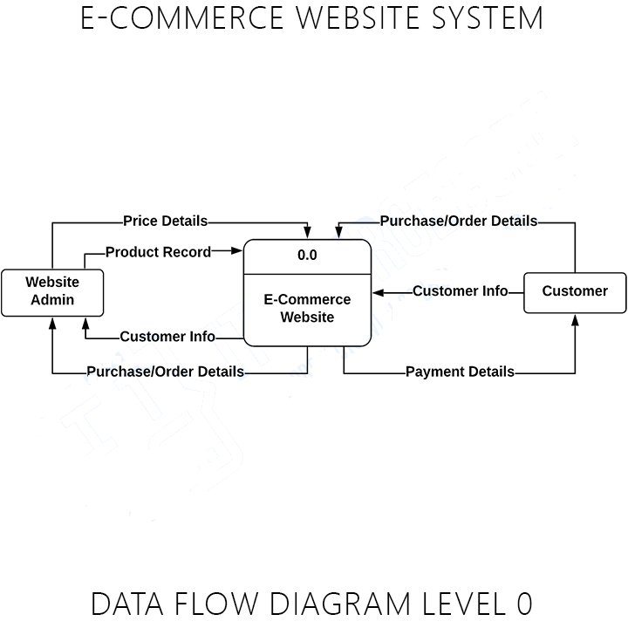

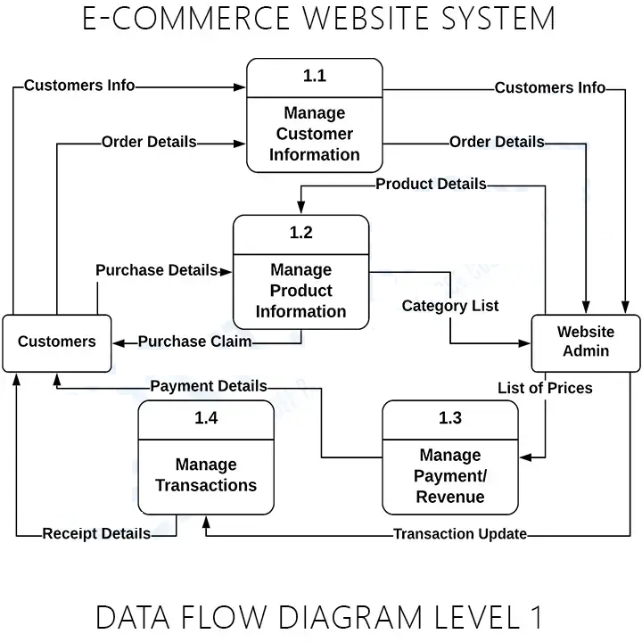

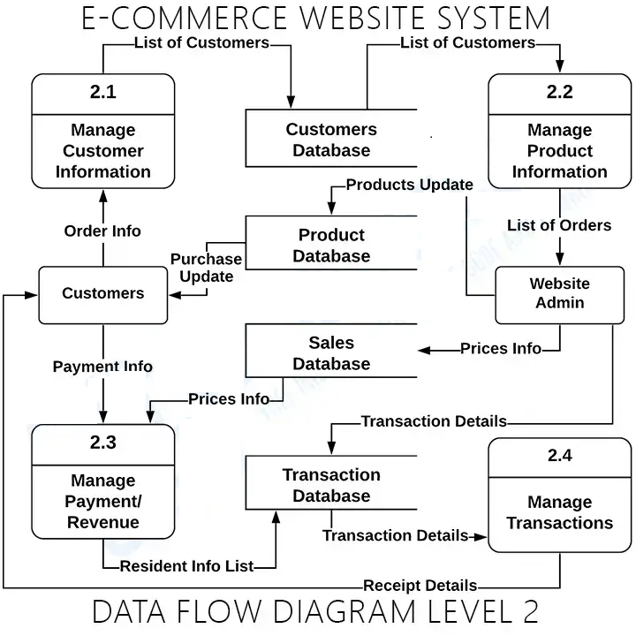

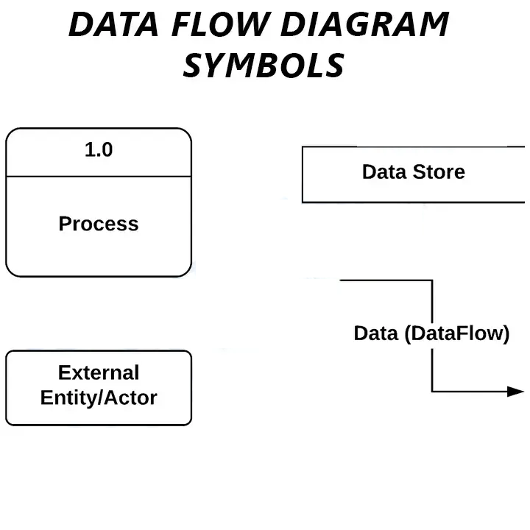

**9. Expected Outcomes**

A fully functional e-commerce website where users can buy products.

1. A secure authentication system for users and admins.
2. An admin dashboard for product and order management.

**10. Conclusion**

This project will provide an efficient and user-friendly e-commerce platform. In the future, features like AI-powered recommendations and mobile app support can be added.