More seeds yield more shoots, but not higher per-seed establishment in a clam-mediated seagrass restoration experiment
Cori Lopazanski¹
Christina Cutshaw¹
Mason Ibrahim¹
Joseph P. Morton¹
Brian Silliman¹
¹Nicholas School of the Environment, Duke University, Durham, NC 28516

Abstract
Seagrass restoration increasingly relies on seed-based approaches, yet optimal seeding densities and deployment methods remain poorly resolved. We evaluated the relative effects of seed density and clam-mediated seed placement on eelgrass (Zostera marina) establishment in a field restoration experiment in Back Sound, North Carolina. Eelgrass seeds were attached to juvenile live clams at densities ranging from 10 to 100 seeds per clam, and deployed in a fully factorial design crossing seed density with two clam placement treatments - manually buried or placed on the sediment surface. Plots were monitored biweekly for shoot establishment and growth over six months. Shoot density increased through time and was higher in plots receiving greater numbers of seeds. However, the proportion of seeds that produced shoots did not vary with seed density, indicating that higher seeding rates yielded more shoots but did not increase per-seed establishment success. We found no evidence that initial clam placement (i.e., on the surface or in the sediment) influenced seedling establishment. Similarly, shoot growth trajectories were broadly comparable between clam placement treatments, though higher seed densities yielded taller shoots. Although manually buried clams were more frequently detected during early monitoring and shell fragments were more common in surface treatments, these differences did not influence restoration outcomes, suggesting that successful seed deployment occurred despite substantial early clam loss – potentially because seedsd drop off of clams they are glued to in 24-48 hours. Our results suggest that increasing seed inputs can increase restoration outcomes by producing more established shoots, but does not improve the probability that individual seeds establish. These findings indicate that seed density per deployment unit can be selected based on desired restoration configuration and design. Furthermore, manually burying clams provided little measurable benefit over surface placement, suggesting that less labor-intensive surface deployment of clams with seeds glued to them may be sufficient for large-scale restoration efforts.

Introduction
Seagrass meadows provide important ecosystem services, including habitat for marine organisms, shoreline stabilization, and carbon storage (Barbier et al. 2011; Fourqurean et al. 2012), but they continue to decline in many regions worldwide (Waycott et al. 2009; Dunic et al. 2021; Peng et al. 2026). As a result, restoration has become an increasingly important tool for recovering lost seagrass habitat (Marieke M. van Katwijk et al. 2016). Seed-based seagrass restoration is especially attractive because it can be scaled to larger areas than traditional transplant-based approaches with less damage do donor meadows (Reynolds et al. 2012; Robert J. Orth et al. 2000), but establishment rates are often low and highly variable (Bayraktarov et al. 2016; Robert J. Orth et al. 2020).
One of the challenges in seed-based restoration is determining how many seeds should be deployed Gräfnings et al. (2023). Increasing seed density may increase the total number of seedlings that establish simply because more seeds are available. However, establishment may not increase proportionally if seeds or seedlings begin competing with one another or if other factors limit success (Gräfnings et al. 2023). From a restoration perspective, it is important to know whether adding more seeds increases the number of established shoots, improves the probability that individual seeds establish, or both. It is also unclear whether increasing seed density results in proportional increases in shoot establishment or whether density-dependence processes alter establishment success.
Recent restoration studies have increasingly suggested incorporating positive species interactions to enhance success (Valdez et al. 2020). In seagrass, experimental studies have shown that bivalve addition can enhance several measures of performance, including patch expansion, increased shoot density and biomass, and greater resilience to disturbance (Zhang et al. 2021; Donaher et al. 2021). Proposed mechanisms include nutrient inputs through excretion, sediment bioturbation, suspension feeding that improves water clarity, and modification of sediment biogeochemistry (B. Peterson and Heck 2001; Wall, Peterson, and Gobler 2008).
Building on these positive interactions, attaching seagrass seeds to live clams may provide a novel means of harnessing their natural burrowing behavior for seed delivery. As clams burrow, they may carry attached seeds below the sediment surface where conditions are favorable for germination. However, it remains unclear whether clams burrow rapidly enough after deployment to protect both themselves and attached seeds from predation or physical disturbance. Manually burying seeded clams may reduce this initial vulnerability but also increases deployment effort and may limit scalability. Whether natural clam burrowing is sufficient for seed deployment will affect the scalability of clam-mediated seagrass restoration.
In this study, we tested how seed density and clam placement influence eelgrass (Zostera marina) establishment in a field restoration experiment in North Carolina. Specifically, we asked whether increasing seed density increases establishment, whether manually burying clams improves establishment relative to placing them on the sediment surface, and whether these effects interact. We quantified both total shoot establishment and per-seed establishment to evaluate how restoration efficiency changes across a range of seeding densities.

Methods

Seed retrieval and storage
Reproductive Zostera marina shoots were collected from seagrass beds in Back Sound, NC in May 2025. Shoots were held in flow-through seawater tanks indoors until mature seeds were naturally released. Released seeds were collected from the bottom of the tank and stored in mesh bags in a flow-through tank. While this storage tank was exposed to general ambient light conditions, the mesh bags reduced overall light exposure. Before deployment, 100 seeds were randomly selected to test for viability using tetrazolium staining (Jarvis, Moore, and Judson Kenworthy 2014), with 89% of seeds classified as viable. CITE CHRISTY AND MASONS MS, we should submiot these all to the same issue and have themcite each other.!

Planting experiment
To test how seed planting density and clam placement influences seagrass establishment and growth, we conducted a field experiment near Harker’s Island, North Carolina. Juvenile live clams (Mercenaria mercenaria; ~2 cm shell length) were sourced from aquaculture facilities at Carteret Community College and stored in flow-through seawater tanks prior to deployment. Seagrass seeds were attached to live clams using a gelatin-based bioglue at one of ten density levels, spanning 10-100 seeds per clam in increments of 10 seeds. Seed planting density was crossed with two clam placement treatments (manually buried or placed on sediment surface) in a fully factorial design with four replicates per treatment combination (80 plots total).
The bioglue was prepared by dissolving dry gelatin powder in saltwater (35 ppt) to a final concentration of 9% (w/v). The solution was heated to 35°C until fully dissolved and then cooled to 28°C before application. A thin layer of bioglue was pipetted onto one shell from each clam and allowed to partially set before seeds were arranged in a single layer and covered with a second thin coat of glue. Clams with seeds were refrigerated at 9°C for 30 minutes to allow the glue to solidify, then transported to the field in coolers and deployed the same day. The total time from initial glue preparation through field deployment was less than four hours. Say something her that in lab trials the glued kept the seeds on the clam for this range of time.
Clams were either manually buried to a depth of 2 cm or placed on the sediment surface [add why] to allow natural self-burial. Each clam was positioned at the center of a 0.25 m x 0.25 m plot, with the corner of each plot marked with a lawn staple to facilitate resampling. Plots were arranged in a grid with 0.5 m spacing in a sandy area located at least 10 m away from adjacent salt marsh, oyster reef, and seagrass habitat.
Plots were monitored approximately every two weeks from November 2025 through April 2026. During each survey, we recorded the number of live shoots and measured the height of up to five randomly selected shoots to the nearest millimeter. During the first four sampling dates, we assessed clam presence by searching for siphon holes and gently probing the sediment surface to detect the edge of the clam shell. We avoided excavating clams to limit seedling disturbance. For each plot, we recorded whether a live clam was confirmed, whether shell fragments or empty shells were present (as evidence of potential clam predation/mortality), or whether no clam evidence was detected.

Data analyses
To evaluate how seed planting density and clam placement influenced restoration outcomes, we quantified three complementary response variables: shoot density, per-seed establishment, and shoot growth. Shoot density was quantified as the number of shoots per plot (0.0625 m²). Per-seed establishment was quantified as the number of observed live shoots relative to the number of seeds initially planted in each plot. Both shoot density and per-seed establishment were analyzed for the final sampling date: April 17, 2026. Shoot growth was quantified as mean shoot height through time.
Final shoot density was analyzed using a generalized linear model with a negative binomial distribution and log link. Per-seed establishment was analyzed using a beta-binomial distribution with a logit link. Both models included seed planting density (continuous), clam placement (factor; buried or surface), and their interaction as fixed effects. Mean shoot height was analyzed using a linear mixed-effects model with plot included as a random intercept to account for repeated measurements through time. Fixed effects for included seed planting density, clam placement treatment, sampling date, and the interaction between seed planting density and sampling date.
To evaluate whether clam placement treatment influenced early detection of deployed clams, we fit a binomial generalized linear model with clam placement treatment as the predictor and the presence or absence of a live clam during the first two post-deployment surveys as the response variable. A clam was classified as present if it was observed during either survey. [Wordy, fix this]: Although occurrence of shells or shell fragments on the sediment surface were also recorded, these observations were not used as the primary response because shell observations were occasionally followed by subsequent live clam observations within the same plot, making shell evidence an ambiguous indicator of deployed clam fate. Only the first two surveys were included because they occurred before the first seedlings were observed. We then fit exploratory models for final shoot density, per-seed establishment, and final shoot height that included seed planting density, clam placement treatment, their interaction, and the binary clam indicator as an additional fixed effect to evaluate whether early clam presence explained variation in restoration outcomes after accounting for the experimental treatments.
Significance of fixed effects was evaluated using Type II ANOVA ($χ^{2}$ tests), and model assumptions were assessed using simulated residual diagnostics (DHARMa; REF) to evaluate dispersion and zero inflation. Model predictions and estimated marginal means (emmeans; REF) were used to visualize treatment effects and quantify effect sizes. All analyses were conducted in R version 4.5.3 (REF) & RStudio (version 2025.09.2+418; REF).

Results
Shoot establishment increased significantly with seed planting density ($χ^{2}$ = 7.34, p = 0.007), whereas both clam placement ($χ^{2}$ = 0.65, p = 0.421) and the interaction between seed planting density and clam placement ($χ^{2}$ = 1.05, p = 0.307) were not significant (Figure 1). Each additional 10 seeds planted increased the expected number of established shoots by 24.2% (95% CI: 6.6-44.6%). Model predictions indicated that increasing planting density from 10 to 100 seeds increased the expected number of established shoots from 1.4 (95% CI: 0.6-3.1) to 9.8 (95% CI: 4.5-21.2).
Shoot establishment increased throughout the experiment across all treatments (Figure 2). Following the onset of shoot establishment in December, higher planting densities accumulated shoots more rapidly than lower planting densities, resulting in progressively greater differences in shoot establishment through time.
This increase reflected greater shoot establishment rather than higher per-seed establishment: while shoot density increased with seed density, the proportion of seeds that produced shoots did not. Per-seed establishment was not significantly affected by seed density ($χ^{2}$ = 2.71, p = 0.1), clam placmeent ($χ^{2}$= 0.16, p = 0.69), or their interaction ($χ^{2}$ = 0.79 , p = 0.373) (Figure 1). Model-predicted per-seed establishment ranged from approximately 5% to 12% across planting densities, although these differences were not statistically significant.
Mean shoot height increased throughout the experiment ($χ^{2}$ = 684.02 , p < 0.001), and the relationship between seed planting density and shoot height varied across sampling dates (seed density x sampling date: $χ^{2}$ = 11.85 , p = 0.037). Clam placement did not affect shoot height ($χ^{2}$ = 1.24 , p = 0.266). Model predictions indicated that shoot height was similar among planting densities during the first three months, whereas shoots in higher-density treatments were consistently taller during the latter half of the experiment (Figure 3).
Clam placement influenced the short-term fate of deployed clams (Figure 4). Manually buried clams were more likely to be found during the first two post-deployment surveys than surface-deployed clams ($χ^{2}$ = 8.44, p = 0.004). Shell fragments were also observed more frequently in surface treatments (n = 25, 62.5%) compared to manually buried treatments (n = 16, 40%). However, confirmed clam presence was not associated with either final shoot establishment ($χ^{2}$ = 0.5, p = 0.479), per-seed establishment ($χ^{2}$ = 0.43, p = 0.513), or final shoot height ($χ^{2}$ = 0.1, p = 0.749) after accounting for seed planting density and clam placement. Seed planting density remained the only significant predictor in the model of final shoot establishment, and was marginally significant for both per-seed establishment and final shoot height (SI: Table 1).

Discussion
Our study suggests that attaching eelgrass seeds to live clams offers a viable seed deployment strategy for restoration. Increasing seed planting density produced proportionally more established shoots while maintaining similar per-seed establishment. Likewise, manually burying clams increased short-term clam retention but did not improve shoot establishment or growth compared to surface deployment. These findings indicate that clam-mediated seed deployment can provide predictable restoration outcomes across a wide range of planting densities, offering practitioners flexibility in how limited seed resources are allocated during restoration efforts.
The positive relationship between planting density and shoot establishment is consistent with previous seed-based eelgrass restoration studies, where planting more seeds generally results in more established seedlings or shoots (Robert J. Orth et al. 2003; Marion and Orth 2010; R. J. Orth et al. 2012). However, relatively few studies have examined establishment efficiency on a per-seed basis. Although Gräfnings et al. (2023) reported lower per-seed recruitment at a higher seed density using seed injection in the Dutch Wadden Sea (2 vs. 20 seeds per injection), per-seed establishment remained constant across the 10-100 seeds per clam evaluated here. This lack of density dependence suggests that neither competition nor facilitation strongly influenced seedling establishment during the first growing season. Instead, establishment appears to have been governed by seed viability and local environmental conditions rather than interactions among neighboring seedlings. Whether positive or negative density dependence emerges at substantially lower or higher planting densities, or later during seagrass meadow development, remains an important question for future work. Well done. Maybe say this could happen at even higher densiites???
One of the primary uncertainties surrounding clam-mediated seed deployment was whether natural burrowing would rapidly incorporate attach seeds into the sediment. Although manually burying clams increased the probability of relocating live clams during the first two post-deployment surveys, this difference did not translate into greater shoot establishment, per-seed establishment, or shoot growth. Likewise, overall clam persistence was low in both treatments, and surface-deployed plots contained more shell fragments and empty shells, suggesting greater predation or mortality following deployment. Juvenile clams are susceptible to predation by blue crabs, mud grabs, gastropods, and cownose rays, making predation a plausible explanation for the observed losses (Micheli 1997; C. H. Peterson 1982). Collectively, this suggests that seed incorporation occurred rapidly regardless of clam fate. A likely explanation is that seeds detached from clams soon after deployment. Preliminary laboratory trials indicated that the gelatin adhesive retained attached seeds for approixmately 8-10 hours, GREAT@ potentially allowing sufficient time for natural burrowing before seed release. The duration of seed attachment is therefore likely to be an important consideration in the design of this restoration approach, with the objective of timing seed release with initial sediment incorporation rather than maintaining long-term attachment.
The limited relationship between clam persistence and restoration outcomes should not be interpreted as evidence that bivalves do not facilitate seagrass restoration. Previous studies have shown that persistent bivalve populations can enhance seagrass performance (B. Peterson and Heck 2001; Zhang et al. 2021; Donaher et al. 2021). In contrast, our experiment evaluated only the first six months post-deployment and included a single juvenile clam per plot. This density and timescale was likely insufficient to generate the ecosystem engineering effects typically associated with mature bivalve populations. Instead, our results highlight that successful seed deployment did not depend on prolonged clam persistence during the initial establishment phase. Also facilitaton could be context deependnt depdning on for instance amount of nturietns in sediment, at high nutrietns, seeds likely don’t need clams.
Although planting density did not influence establishment efficiency, shoots in higher-density treatments became taller later in the experiment. Increased shoot height at higher planting densities may represent the early development of positive interactions among neighboring shoots or competion for light?. As patches expand, greater local shoot density could reduce hydrodynamic stress or enhance sediment stabilization, processes known to reinforce seagrass persistence (Fonseca and Fisher 1986; M. M. van Katwijk et al. 2009). Since these responses emerged only after shoot establishment, they likely reflect post-establishment interactions rather than mechanisms affecting initial seed establishment.
From a restoration perspective, these findings shift the practical question from how many seeds should be planted to how limited seed resources should be allocated. Seed availability frequently constrains the scale of seagrass restoration (Robert J. Orth et al. 2003; Marieke M. van Katwijk et al. 2016), making efficient allocation a central management challenge. Because per-seed establishment remained similar across planting densities, practitioners can select seed density per clam based on desired restoration outcomes without sacrificing per-seed performance. For example, concentrating many seeds on fewer clams is expected to produce dense patches, whereas distributing the same number of seeds among more clams would produce a similar number of established shoots distributed across a larger area. Determining the design that best promotes long-term seagrass expansion will depend on site conditions and restoration goals. The big question is do density effects emerge later on over years so that higher densites have higher srivival, so suggest long term studies are needed to determine density dependence in seed density.
Overall, our results demonstrate that live hard clams can function as effective seed deployment agents despite limited long-term persistence. Early restoration success was determined primarily by seed supply rather than clam placement or persistence, and establishment efficiency remained consistent across a broad range of planting densities. These findings support clam-mediated seed deployment as a practical addition to the growing suite of seed-based restoration approaches and provide a framework for optimizing seed allocation at larger spatial scales.

Figures
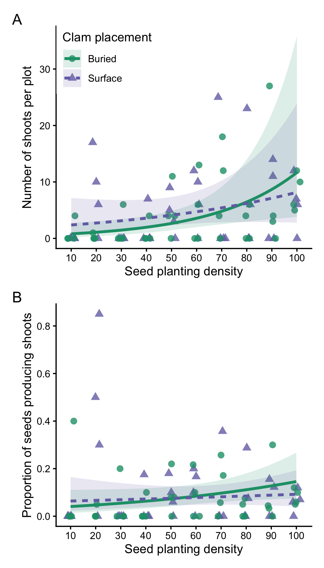
Figure 1: Effects of seed planting density on (A) final shoot count and (B) establishment probability at the final sampling point. Establishment probability was calculated as the proportion of planted seeds that produced observable shoots, integrating seed retention, germination, and early seedling survival. Points represent individual plots. Lines show model predictions (±95% CI) by clam placement treatment: on the sediment surface (purple triangles, dashed line) or manually buried (green circles, solid line).

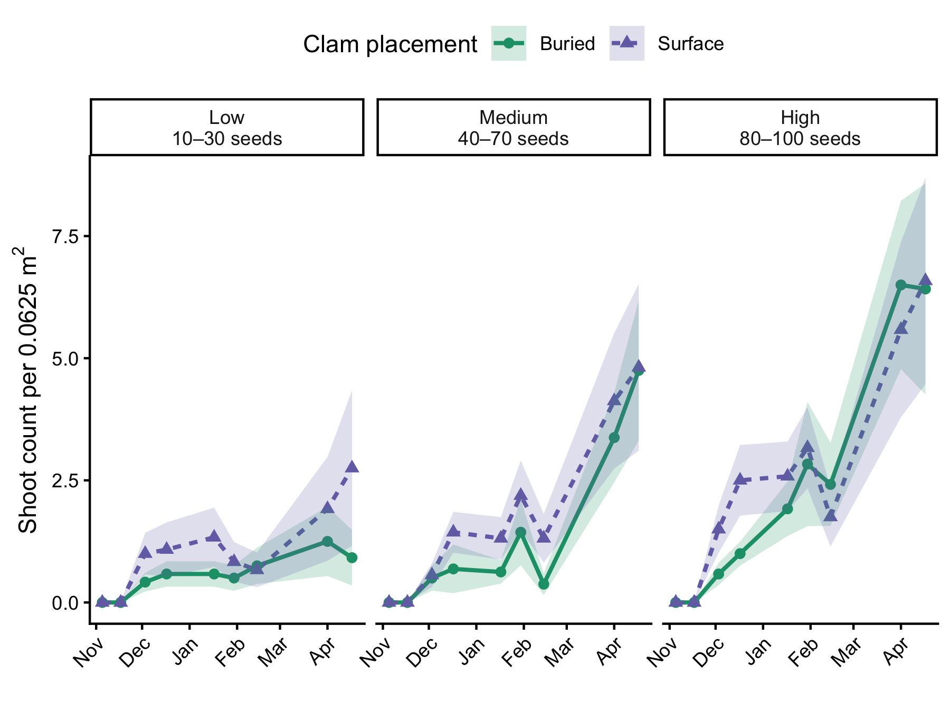
Figure 2: Temporal patterns in shoot establishment across seed planting density groups and clam placement treatments. For visualization, seed planting densities were grouped into low (10-30 seeds), medium (40-70 seeds), and high (80-100 seeds) categories. Points represent the average shoot count per plot (±SE) at each sampling date, averaged across all plots within each seed density group and clam placement treatment. Green circles and solid lines indicate manually buried clams; purple triangles and dashed lines indicate clams placed on the sediment surface.

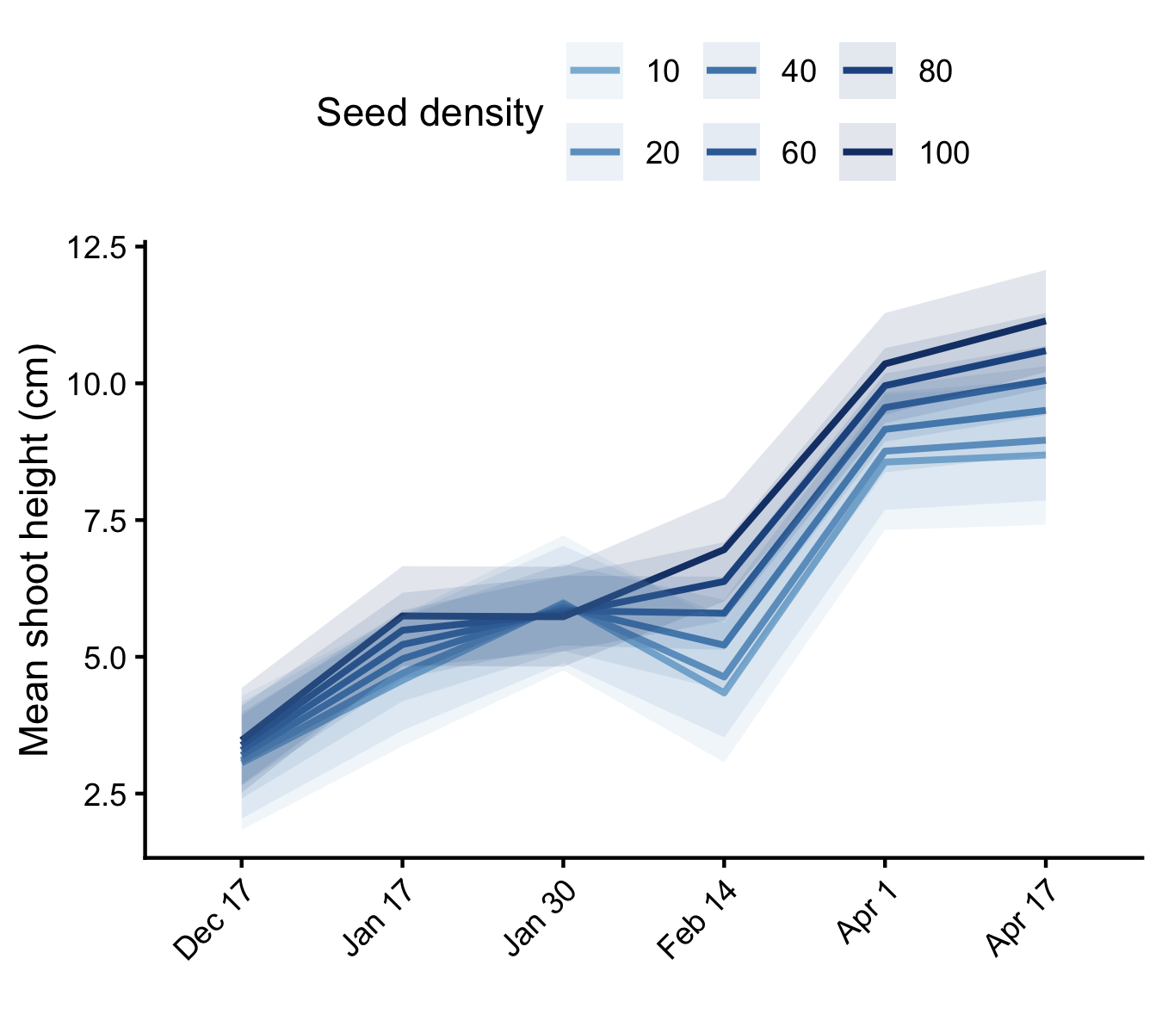
Figure 3: Effects of seed planting density on mean shoot height (cm) over the course of the experiment. Lines show model-predicted mean shoot height (±95% CI) from a linear mixed effects model, averaged across clam placement treatments. Darker blue lines indicated higher seed densities. [Refine wording:] Only six densities are shown to facilitate visualization, other density treatments follow the same trend.

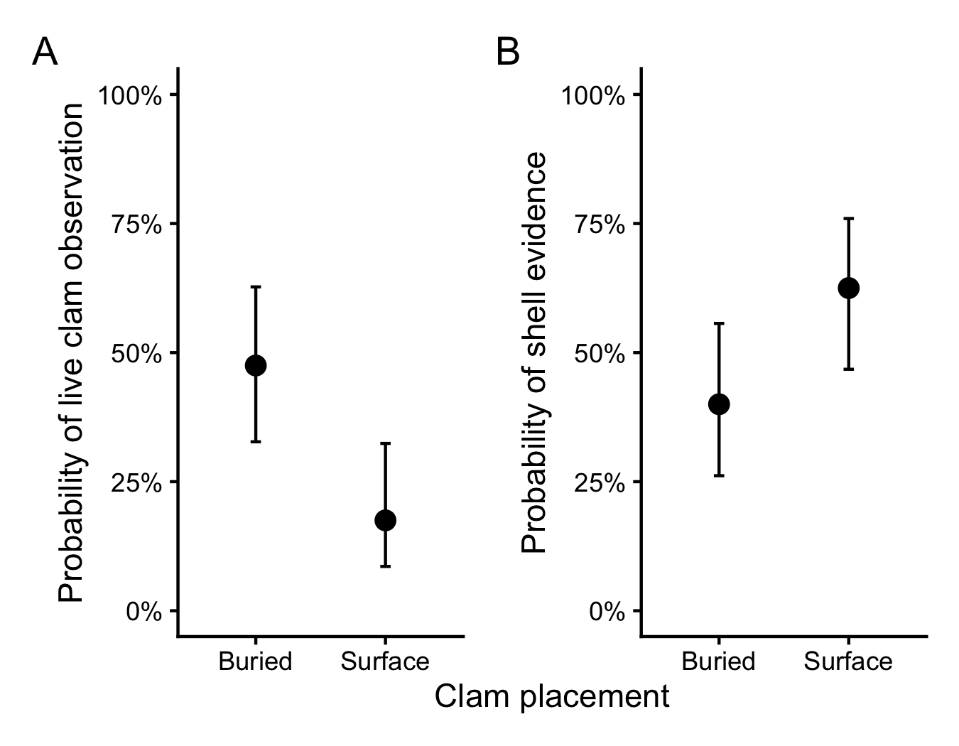
Figure 4: Effects of clam placement treatment on short-term clam fate. Model-predicted probabilities (±95% CI) of observing (A) a live clam and (B) shell evidence (shell fragments or empty shells) during the first two post-deployment surveys from binomial generalized linear models.

References
Barbier, Edward B., Sally D. Hacker, Chris Kennedy, Evamaria W. Koch, Adrian C. Stier, and Brian R. Silliman. 2011. “The Value of Estuarine and Coastal Ecosystem Services.” Ecological Monographs 81 (2): 169–93. https://doi.org/10.1890/10-1510.1.
Bayraktarov, Elisa, Megan I. Saunders, Sabah Abdullah, Morena Mills, Jutta Beher, Hugh P. Possingham, Peter J. Mumby, and Catherine E. Lovelock. 2016. “The Cost and Feasibility of Marine Coastal Restoration.” Ecological Applications 26 (4): 1055–74. https://doi.org/10.1890/15-1077.
Donaher, Sarah E., Christopher J. Baillie, Carter S. Smith, Y. Stacy Zhang, Anna Albright, Stacy N. Trackenberg, Emory H. Wellman, Nina Woodard, and Rachel K. Gittman. 2021. “Bivalve Facilitation Mediates Seagrass Recovery from Physical Disturbance in a Temperate Estuary.” Ecosphere 12 (11): e03804. https://doi.org/10.1002/ecs2.3804.
Dunic, Jillian C., Christopher J. Brown, Rod M. Connolly, Mischa P. Turschwell, and Isabelle M. Côté. 2021. “Long-term declines and recovery of meadow area across the world’s seagrass bioregions.” Global Change Biology 27 (17): 4096–4109. https://doi.org/10.1111/gcb.15684.
Fonseca, M. S., and J. S. Fisher. 1986. “A Comparison of Canopy Friction and Sediment Movement Between Four Species of Seagrass with Reference to Their Ecology and Restoration.” Marine Ecology Progress Series 29 (January): 15–22. https://doi.org/10.3354/meps029015.
Fourqurean, James W., Carlos M. Duarte, Hilary Kennedy, Núria Marbà, Marianne Holmer, Miguel Angel Mateo, Eugenia T. Apostolaki, et al. 2012. “Seagrass Ecosystems as a Globally Significant Carbon Stock.” Nature Geoscience 5 (7): 505–9. https://doi.org/10.1038/ngeo1477.
Gräfnings, Max L. E., Jannes H. T. Heusinkveld, Dieuwke J. J. Hoeijmakers, Quirin Smeele, Henk Wiersema, Maarten Zwarts, Tjisse van der Heide, and Laura L. Govers. 2023. “Optimizing Seed Injection as a Seagrass Restoration Method.” Restoration Ecology 31 (3): e13851. https://doi.org/10.1111/rec.13851.
Jarvis, Jessie C., Kenneth A. Moore, and W. Judson Kenworthy. 2014. “Persistence of Zostera Marina l. (Eelgrass) Seeds in the Sediment Seed Bank.” Journal of Experimental Marine Biology and Ecology 459 (October): 126–36. https://doi.org/10.1016/j.jembe.2014.05.024.
Katwijk, M. M. van, A. R. Bos, V. N. de Jonge, L. S. a. M. Hanssen, D. C. R. Hermus, and D. J. de Jong. 2009. “Guidelines for seagrass restoration: importance of habitat selection and donor population, spreading of risks, and ecosystem engineering effects.” Marine Pollution Bulletin 58 (2): 179–88. https://doi.org/10.1016/j.marpolbul.2008.09.028.
Katwijk, Marieke M. van, Anitra Thorhaug, Núria Marbà, Robert J. Orth, Carlos M. Duarte, Gary A. Kendrick, Inge H. J. Althuizen, et al. 2016. “Global Analysis of Seagrass Restoration: The Importance of Large-Scale Planting.” Journal of Applied Ecology 53 (2): 567–78. https://doi.org/10.1111/1365-2664.12562.
Marion, Scott R., and Robert J. Orth. 2010. “Innovative Techniques for Large-Scale Seagrass Restoration Using Zostera Marina (Eelgrass) Seeds.” Restoration Ecology 18 (4): 514–26. https://doi.org/10.1111/j.1526-100X.2010.00692.x.
Micheli, Fiorenza. 1997. “Effects of Predator Foraging Behavior on Patterns of Prey Mortality in Marine Soft Bottoms.” Ecological Monographs 67 (2): 203–24. https://doi.org/10.1890/0012-9615(1997)067[0203:EOPFBO]2.0.CO;2.
Orth, R. J., Kenneth A. Moore, Scott R. Marion, David J. Wilcox, and David B. Parrish. 2012. “Seed Addition Facilitates Eelgrass Recovery in a Coastal Bay System.” Marine Ecology Progress Series 448 (February): 177–95. https://doi.org/10.3354/meps09522.
Orth, Robert J., James R. Fishman, Matthew C. Harwell, and Scott R. Marion. 2003. “Seed-Density Effects on Germination and Initial Seedling Establishment in Eelgrass Zostera Marina in the Chesapeake Bay Region.” Marine Ecology Progress Series 250 (March): 71–79. https://doi.org/10.3354/meps250071.
Orth, Robert J., Matthew C. Harwell, Eva M. Bailey, Aaron Bartholomew, Jennifer T. Jawad, Alfonso V. Lombana, Kenneth A. Moore, Jennifer M. Rhode, and Helen E. Woods. 2000. “A Review of Issues in Seagrass Seed Dormancy and Germination: Implications for Conservation and Restoration.” Marine Ecology Progress Series 200 (July): 277–88. https://doi.org/10.3354/meps200277.
Orth, Robert J., Jonathan S. Lefcheck, Karen S. McGlathery, Lillian Aoki, Mark W. Luckenbach, Kenneth A. Moore, Matthew P. J. Oreska, Richard Snyder, David J. Wilcox, and Bo Lusk. 2020. “Restoration of Seagrass Habitat Leads to Rapid Recovery of Coastal Ecosystem Services.” Science Advances 6 (41): eabc6434. https://doi.org/10.1126/sciadv.abc6434.
Peng, Jianghai, Jiwei Li, Johannes R. Krause, Mitchell B. Lyons, Nicholas J. Murray, Steven R. Schill, Chris M. Roelfsema, and Gregory P. Asner. 2026. “Global High-Resolution Mapping of Seagrass to Support Conservation.” Nature 655 (8123): 663–69. https://doi.org/10.1038/s41586-026-10704-3.
Peterson, Bj, and Kl Heck. 2001. “Positive Interactions Between Suspension-Feeding Bivalves and Seagrass-a Facultative Mutualism.” Marine Ecology Progress Series 213: 143–55. https://doi.org/10.3354/meps213143.
Peterson, C. H. 1982. “Clam Predation by Whelks (Busycon Spp.): Experimental Tests of the Importance of Prey Size, Prey Density, and Seagrass Cover.” Marine Biology 66 (2): 159–70. https://doi.org/10.1007/BF00397189.
Reynolds, Laura K., M. Waycott, Karen J. McGlathery, R. J. Orth, and J. C. Zieman. 2012. “Eelgrass Restoration by Seed Maintains Genetic Diversity: Case Study from a Coastal Bay System.” Marine Ecology Progress Series 448 (February): 223–33. https://doi.org/10.3354/meps09386.
Valdez, S. R., S. Zhang, T. Heide, M. Vanderklift, and B. R.Silliman Fl. Tarquinio. 2020. “Positive Ecological Interactions and the Success of Seagrass Restorations.” Frontiers in Marine Science 7: 91. https://doi.org/10.3389/fmars.2020.00091.
Wall, Charles C., Bradley J. Peterson, and Christopher J. Gobler. 2008. “Facilitation of Seagrass Zostera Marina Productivity by Suspension-Feeding Bivalves.” Marine Ecology Progress Series 357 (April): 165–74. https://doi.org/10.3354/meps07289.
Waycott, M., C. M. Duarte, T. J. B. Carruthers, R. J. Orth, W. C. Dennison, S. Olyarnik, A. Calladine, et al. 2009. “Accelerating Loss of Seagrasses Across the Globe Threatens Coastal Ecosystems.” Proceedings of the National Academy of Sciences 106 (30): 12377–81. https://doi.org/10.1073/pnas.0905620106.
Zhang, Y. Stacy, Rachel K. Gittman, Sarah E. Donaher, Stacy N. Trackenberg, T. van der Heide, and Brian R. Silliman. 2021. “Inclusion of Intra- and Interspecific Facilitation Expands the Theoretical Framework for Seagrass Restoration.” Frontiers in Marine Science 8 (April). https://doi.org/10.3389/fmars.2021.645673.

Supplementary Information
Table 1: Results of exploratory models evaluating whether early live clam observations explained variation in restoration outcomes after accounting for seed planting density and clam placement treatment. Models included the binary live-clam indicator, seed planting density, clam placement treatment, and their interaction. Significant effects (p < 0.05) are shown in bold.
 | Term | χ² | df | p
Model 1. Effects on shoot establishment | Seed density | 7.83 | 1 | 0.005 | **
 | Clam placement | 0.27 | 1 | 0.602
 | Live clam observed | 0.50 | 1 | 0.479
 | Seed density × Clam placement | 0.84 | 1 | 0.360
Model 2. Effects on per-seed establishment probability | Seed density | 2.97 | 1 | 0.085
 | Clam placement | 0.34 | 1 | 0.559
 | Live clam observed | 0.43 | 1 | 0.513
 | Seed density × Clam placement | 0.83 | 1 | 0.361
Model 3. Effects on final shoot height (cm) | Seed density | 3.78 | 1 | 0.052
 | Clam placement | 0.45 | 1 | 0.500
 | Live clam observed | 0.10 | 1 | 0.749
 | Seed density × Clam placement | 0.26 | 1 | 0.607

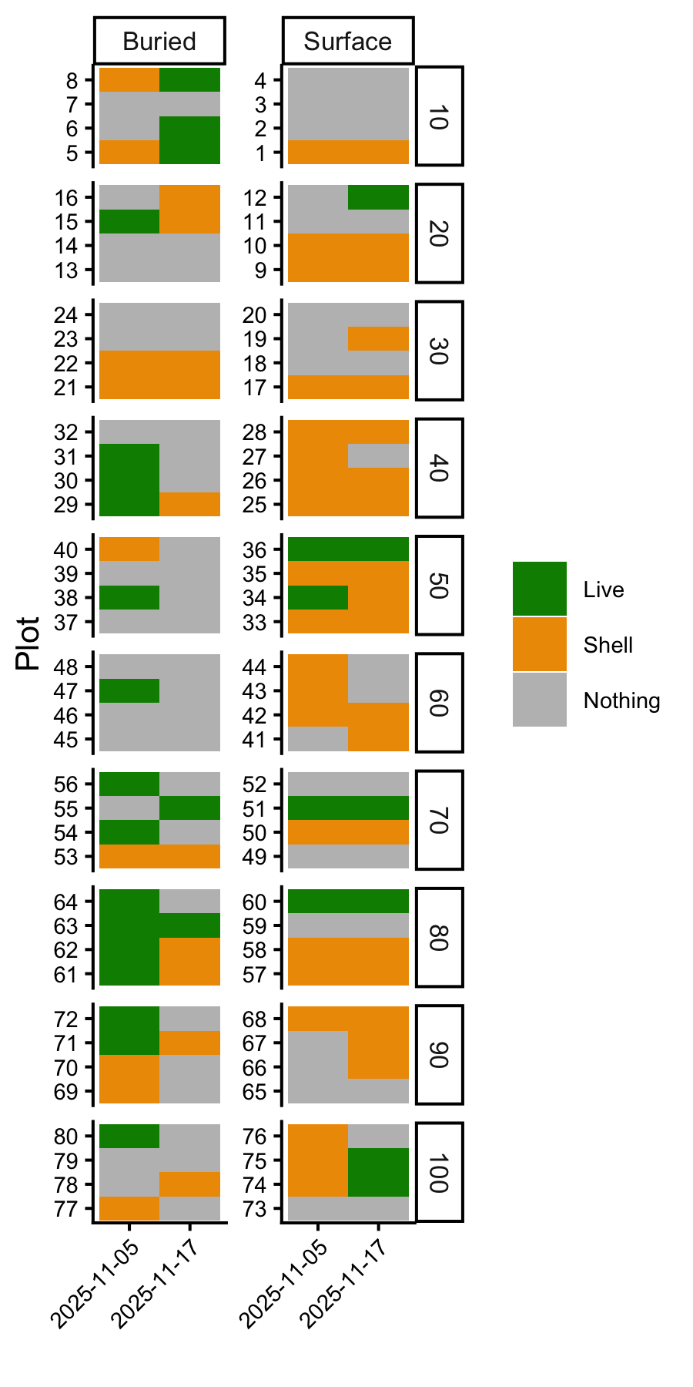
Figure 5: Clam observations are shown for each plot – the left column is clams that were manually buried and the right column is clams that were placed on the sediment surface. Rows are grouped by seed density levels (10-100 seeds per plot). Colors indicate whether the clam was confirmed live (green), shell fragments or empty shells were observed (yellow), or nothing was observed (grey).

