More seeds yield more shoots, but not higher per-seed establishment in a clam-mediated seagrass restoration experiment
Cori Lopazanski¹
Christina Cutshaw¹
Mason Ibrahim¹
Joseph P. Morton¹
Brian Silliman¹
¹Nicholas School of the Environment, Duke University, Durham, NC 28516

Abstract
Seagrass restoration increasingly relies on seed-based approaches, yet optimal seeding densities and deployment methods remain poorly resolved. We evaluated how seed density and clam-mediated seed placement influence eelgrass (Zostera marina) establishment in a field restoration experiment in Back Sound, North Carolina. Eelgrass seeds were attached to juvenile live clams at densities ranging from 10 to 100 seeds per clam, and deployed in a fully factorial design crossing seed density with two clam placement treatments - manually buried or placed on the sediment surface. Plots were monitored biweekly for shoot establishment and growth over six months. Shoot density increased through time and was generally higher in plots receiving greater numbers of seeds. However, the proportion of seeds that produced shoots did not vary with seed density, indicating that higher seeding rates yielded more shoots but did not increase per-seed establishment success. We found no evidence that clam placement influenced seedling establishment. Similarly, shoot growth trajectories were broadly comparable between clam placement treatments, though higher seed densities generally yielded taller shoots. Extensive clam predation and disturbance occurred shortly after deployment, potentially contributing to unexplained variation among plots and influencing treatment effects. Our results suggest that increasing seed inputs can increase restoration outcomes by producing more established shoots, but does not improve the probability that individual seeds establish. These findings suggest that seed density per deployment unit can be selected based on desired restoration configuration and design. Furthermore, manually burying clams provided little measurable benefit over surface placement, suggesting that clams likely sufficiently bury seeds through natural behavior and therefore this less labor-intensive deployment method may be sufficient for large-scale restoration efforts.

Introduction
Seagrass meadows provide important ecosystem services, including habitat for marine organisms, shoreline stabilization, and carbon storage, but they continue to decline in many regions worldwide. As a result, restoration has become an increasingly important tool for recovering lost seagrass habitat. Seed-based restoration is especially attractive because it can be scaled to larger areas than traditional transplant-based approaches, but establishment rates are often low and highly variable.
One of the major challenges in seed-based restoration is determining how many seeds should be deployed. Increasing seed density may increase the total number of seedlings that establish simply because more seeds are available. However, establishment may not increase proportionally if seeds or seedlings begin competing with one another or if other factors limit success. From a restoration perspective, it is important to know whether adding more seeds increases the number of established shoots, improves the probability that individual seeds establish, or both. It is also unclear whether increasing seed density results in proportional increases in shoot establishment or whether density-dependence processes alter establishment success.
Recent restoration efforts have also explored using clams as a seed delivery mechanism. As clams move and bury themselves in the sediment, they may help place seeds in conditions that promote germination and reduce seed loss. There are also positive interactions between clams and seagrass that can improve establishment success, potentially through nutrient enhancement (Zhang). However, manually burying clams requires additional effort and may not be practical at large scales, though clams on the surface remain vulnerable to predation. Whether manual burial is necessary to achieve restoration outcomes remains unclear.
In this study, we tested how seed density and clam placement influence eelgrass (Zostera marina) establishment in a field restoration experiment in North Carolina. Specifically, we asked whether increasing seed density increases establishment, whether manually burying clams improves establishment relative to placing them on the sediment surface, and whether these effects interact. We quantified both total shoot establishment and per-seed establishment to evaluate how restoration efficiency changes across a range of seeding densities.

Methods

Seed retrieval and storage
Reproductive Zostera marina shoots were collected from seagrass beds in Back Sound, NC in May 2025. Shoots were held in flow-through seawater tanks indoors until mature seeds were naturally released. Released seeds were collected from the bottom of the tank and stored in mesh bags in a flow-through tank. While this storage tank was exposed to general ambient light conditions, the mesh bags reduced overall light exposure. Before deployment, 100 seeds were randomly selected to test for viability using tetrazolium staining (REF), with 89% of seeds classified as viable.

Planting experiment
To test how seed planting density and clam placement influences seagrass establishment and growth, we conducted a field experiment near Harker’s Island, North Carolina. Seagrass seeds were attached to live clams (Mercenaria mercenaria; ~2 cm shell length) using a gelatin-based bioglue at one of ten density levels, spanning 10-100 seeds per clam in increments of 10 seeds. Seed planting density was crossed with two clam placement treatments (manually buried or placed on sediment surface) in a fully factorial design with four replicates per treatment combination (80 plots total).
The bioglue was prepared by dissolving dry gelatin powder in saltwater (35 ppt) to a final concentration of 9% (w/v). The solution was heated to 35°C until fully dissolved and then cooled to 28°C before application. A thin layer of bioglue was pipetted onto one shell from each clam and allowed to partially set before seeds were arranged in a single layer and covered with a second thin coat of glue. Clams were refrigerated at 9°C for 30 minutes to allow the glue to solidify, then transported to the field in coolers and deployed the same day. The total time from initial glue preparation through field deployment was less than four hours.
Clams were either manually buried to a depth of 2 cm or placed on the sediment surface to allow natural self-burial. Each clam was positioned at the center of a 0.25 m² plot, with the corner of each plot marked with a lawn staple to facilitate resampling. Plots were arranged in a grid with 0.5 m spacing in a sandy area located at least 10 m away from adjacent salt marsh, oyster reef, and seagrass habitat.
Plots were monitored approximately every two weeks from November 2025 through April 2026. During each survey, we recorded the number of live shoots and measured the height of up to five randomly selected shoots to the nearest millimeter. During the first four sampling dates, we assessed clam presence using brief visual and tactile confirmation. We avoided excavating clams to limit seedling disturbance. We recorded evidence of clam predation (e.g., shell fragments, empty shells), and whether the clam was live, dead, or not located.

Data analyses
To evaluate how seed planting density and clam placement influenced restoration outcomes, we quantified three complementary response variables: shoot density, per-seed establishment, and shoot growth. Shoot density was quantified as the number of shoots per plot (0.0625 m²). Per-seed establishment was quantified as the number of observed live shoots relative to the number of seeds initially planted in each plot. Both shoot density and per-seed establishment were analyzed for the final sampling date: April 17, 2026. Shoot growth was quantified as mean shoot height through time.
Final shoot density was analyzed using a generalized linear model with a negative binomial distribution and log link. Per-seed establishment was analyzed using a beta-binomial distribution with a logit link. Both models included seed planting density (continuous), clam placement (factor; buried or surface), and their interaction as fixed effects. Mean shoot height was analyzed using a linear mixed-effects model with plot included as a random intercept to account for repeated measurements through time. Fixed effects for included seed planting density, clam placement treatment, sampling date, and the interaction between seed planting density and sampling date.
Significance of fixed effects was evaluated using Type II ANOVA ($χ^{2}$ tests), and model assumptions were assessed using simulated residual diagnostics (DHARMa; REF) to evaluate dispersion and zero inflation. Model predictions and estimated marginal means (emmeans; REF) were used to visualize treatment effects and quantify effect sizes. All analyses were conducted in R (version X; REF) & RStudio (version X; REF).

Results
Shoot establishment increased significantly with seed planting density ($χ^{2}$ = 7.34, p = 0.007), whereas both clam placement ($χ^{2}$ = 0.65, p = 0.421) and the interaction between seed planting density and clam placement ($χ^{2}$ = 1.05, p = 0.307) were not significant (Figure 1). Each additional 10 seeds planted increased the expected number of established shoots by 24.2% (95% CI: 6.6-44.6%). Model predictions indicated that increasing planting density from 10 to 100 seeds increased the expected number of established shoots from 1.4 (95% CI: 0.6-3.1) to 9.8 (95% CI: 4.5-21.2).
Shoot establishment increased throughout the experiment across all treatments (Figure 2). Following the onset of shoot establishment in December, higher planting densities accumulated shoots more rapidly than lower planting densities, resulting in progressively greater differences in shoot establishment through time.
This increase reflected greater shoot establishment rather than higher per-seed establishment: while shoot density increased with seed density, the proportion of seeds that produced shoots did not. Per-seed establishment was not significantly affected by seed density ($χ^{2}$ = 2.71, p = 0.1), clam placmeent ($χ^{2}$= 0.16, p = 0.69), or their interaction ($χ^{2}$ = 0.79 , p = 0.373) (Figure 1).
Mean shoot height increased throughout the experiment ($χ^{2}$ = 684.02 , p = 0), and the relationship between seed planting density and shoot height varied across sampling dates (seed density x sampling date: $χ^{2}$ = 11.85 , p = 0.037). Clam placement did not affect shoot height ($χ^{2}$ = 1.24 , p = 0.266). Model predictions indicated that shoot height was similar among planting densities during the first three months, whereas shoots in higher-density treatments were consistently taller during the latter half of the experiment (Figure 3).

Discussion
[Start of very rough draft, edits + major changes welcome]: Increasing seed planting density produced proportionally more established shoots without altering per-seed establishment. This indicates that, over the range of planting densities tested, early restoration outcomes were determined primarily by the number of seeds planted rather than changes in establishment efficiency. This distinction is important because it separates the effects of propagule supply from the processes governing per-seed establishment.
The absence of a planting density effect on per-seed establishment suggests little evidence for either facilitation or competition during early establishment. Increasing local seed density neither enhanced nor reduced establishment success, indicating that other processes, such as [add some], likely played a greater role in determining which seeds ultimately established. Whether density-dependent effects emerge at higher planting densities or later stages remains an important question for future work.
These findings shift the practical question for seed-based restoration from how many seeds should be planted to how those seeds should be allocated. Because per-seed establishment remained similar across planting densities, restoration practitioners can select seed density per deployment unit based on desired restoration outcomes rather than concerns about establishment efficiency. For example, concentrating many seeds on a single clam is expected to produce dense founder patches, whereas distributing the same number of seeds among multiple clams would produce a similar number of established shoots distributed across a larger area.
[Rest of discussion TBD, suggestions welcome].

Figures
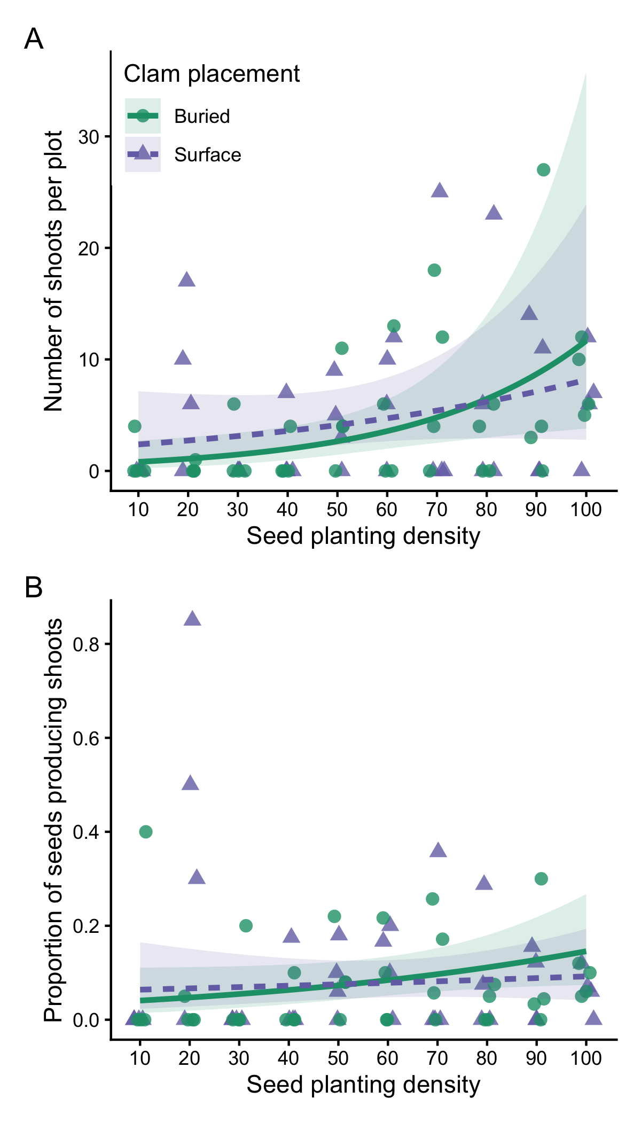
Figure 1: Effects of seed planting density on (A) final shoot count and (B) establishment probability at the final sampling point. Establishment probability was calculated as the proportion of planted seeds that produced observable shoots, integrating seed retention, germination, and early seedling survival. Points represent individual plots. Lines show model predictions (±95% CI) by clam placement treatment: on the sediment surface (purple triangles, dashed line) or manually buried (green circles, solid line).
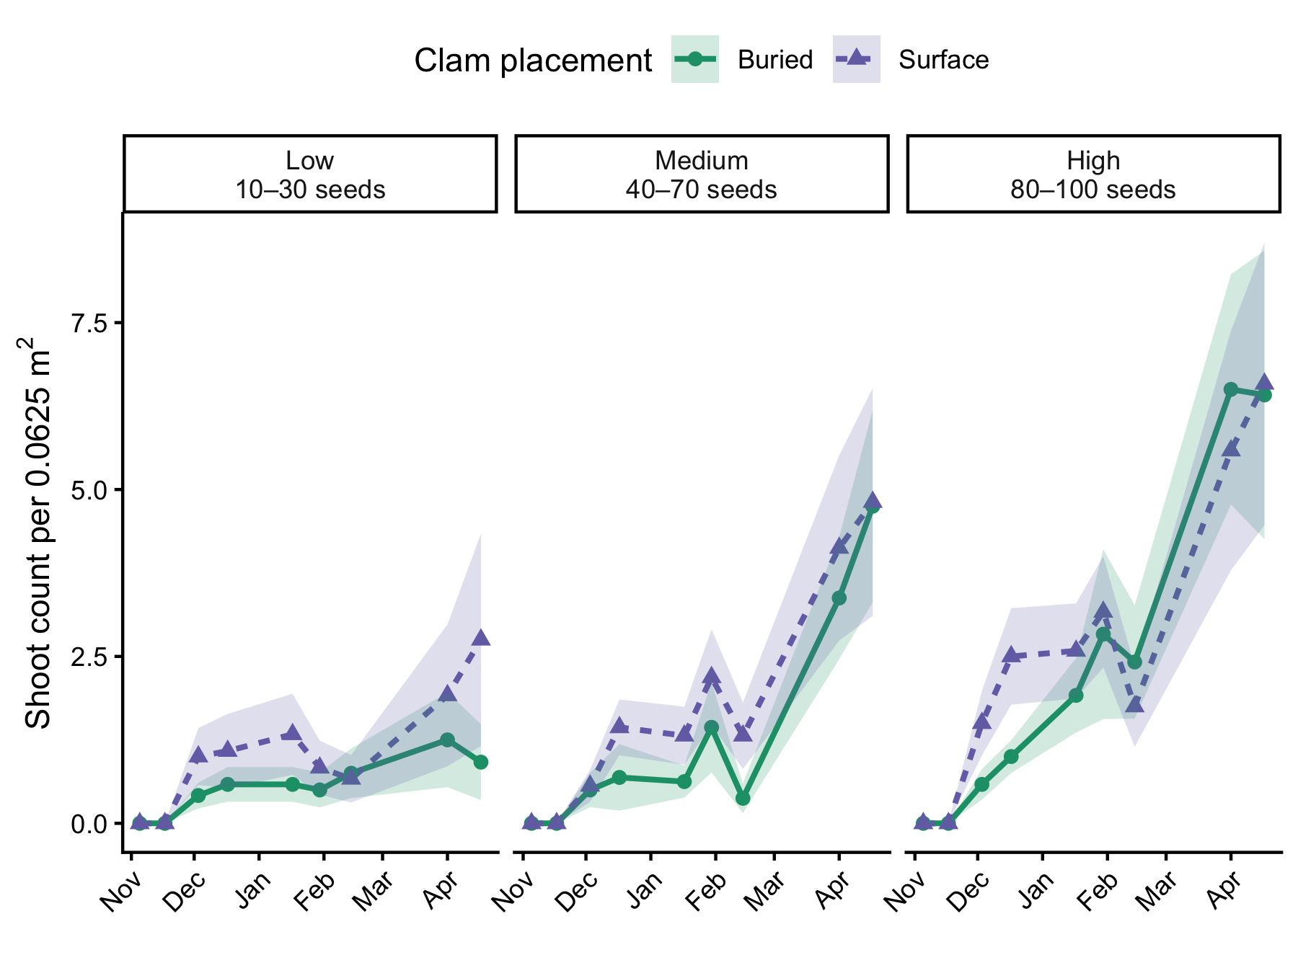
Figure 2: Temporal patterns in shoot establishment across seed planting density groups and clam placement treatments. For visualization, seed planting densities were grouped into low (10-30 seeds), medium (40-70 seeds), and high (80-100 seeds) categories. Points represent the average shoot count per plot (±SE) at each sampling date, averaged across all plots within each seed density group and clam placement treatment. Green circles and solid lines indicate manually buried clams; purple triangles and dashed lines indicate clams placed on the sediment surface.
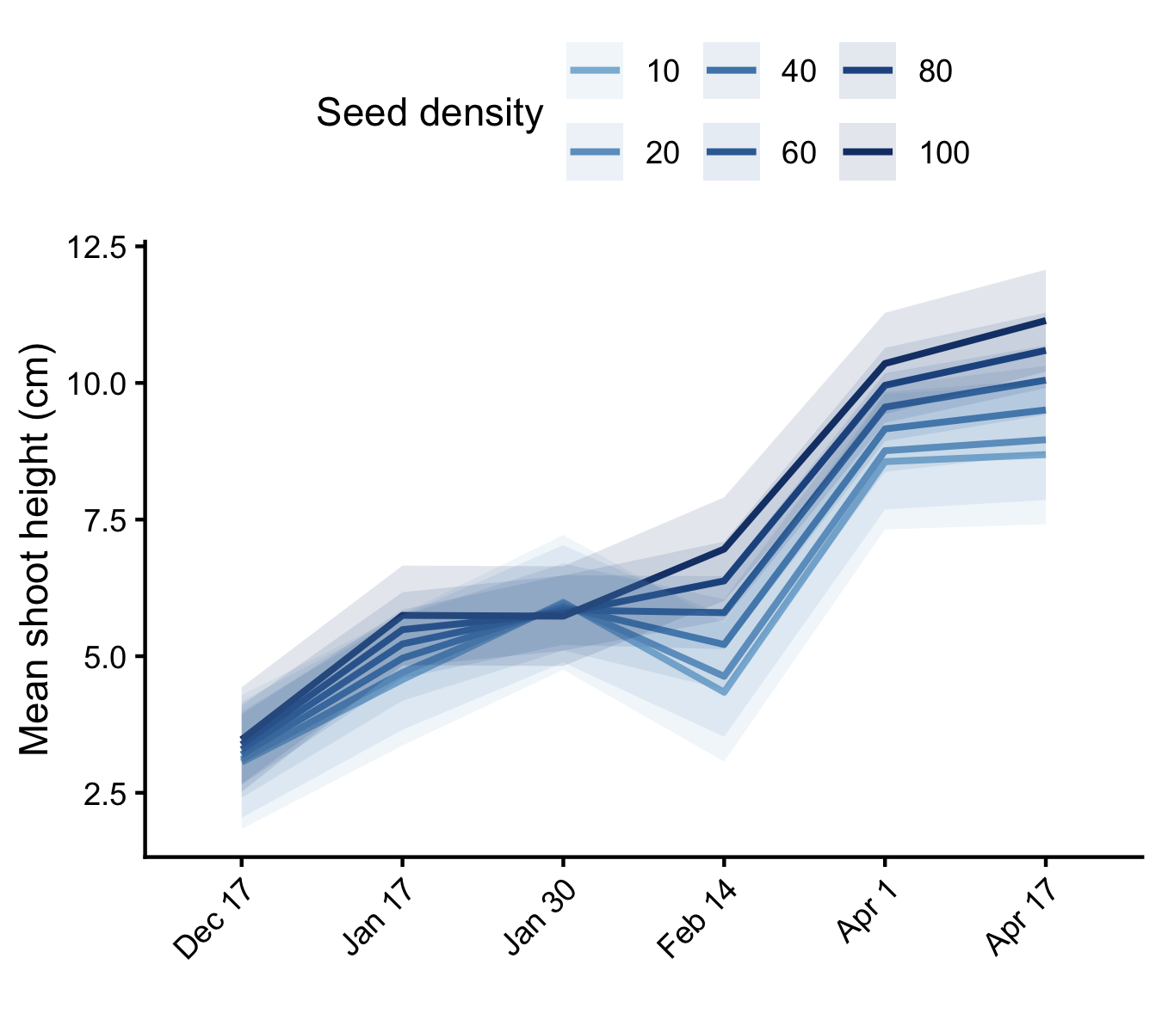
Figure 3: Effects of seed planting density on mean shoot height (cm) over the course of the experiment. Lines show model-predicted mean shoot height (±95% CI) from a linear mixed effects model, averaged across clam placement treatments. Darker blue lines indicated higher seed densities.

Extra Figures
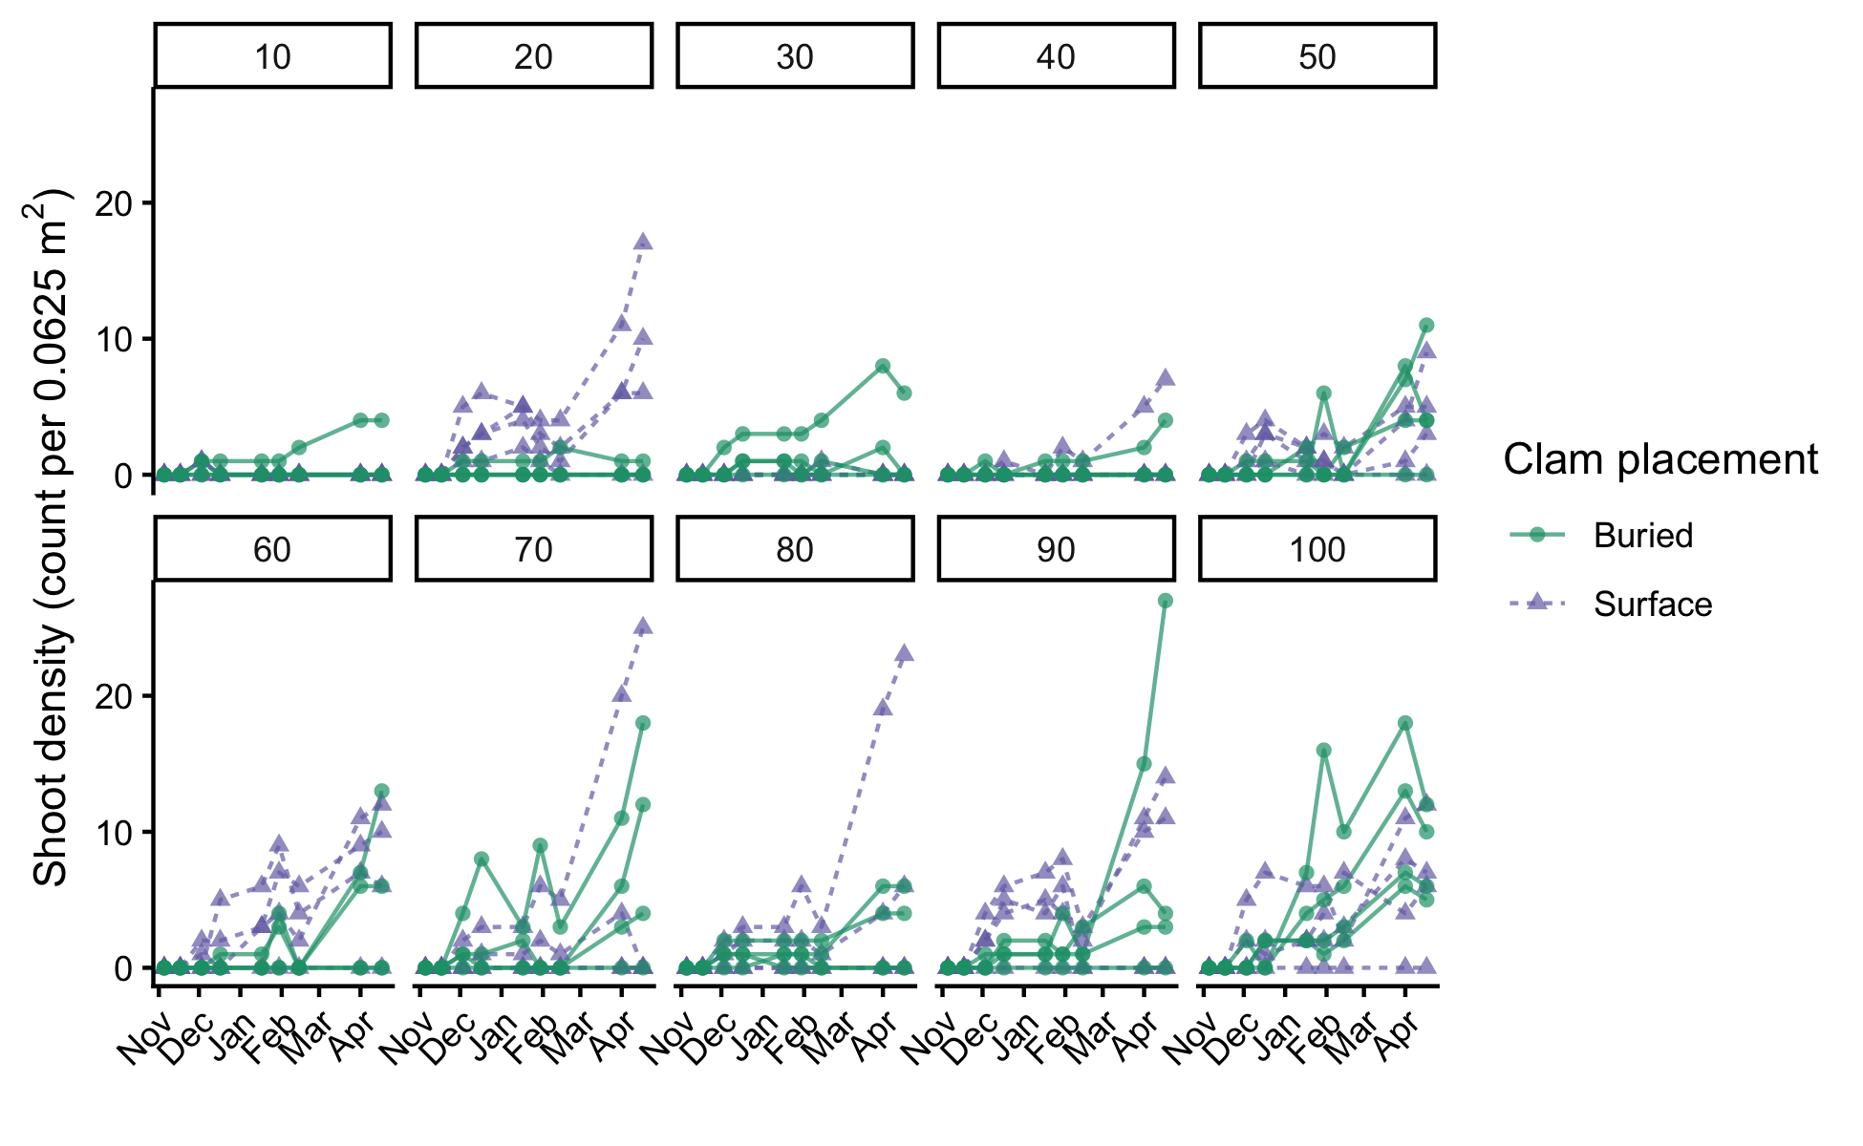
Temporal trajectories of shoot density (count per 0.0625 m²) from November 2025 through April 2026 across experimental plots, shown separately for initial seed densities from 10 to 100 seeds (facets). Each line represents a single plot. Clam placement treatments are indicated by symbol and line type: clams placed on the sediment surface are shown as green circles with solid lines, and manually buried clams as purple triangles with dashed lines.
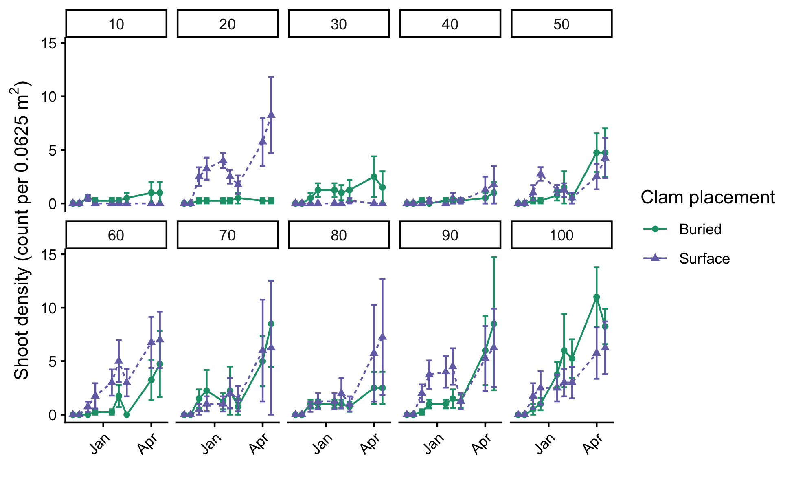
Temporal trajectories of mean shoot density (count per 0.0625 m²) from November 2025 through April 2026, shown separately for initial seeding densities from 10 to 100 seeds (facets). Values represent treatment-level means (n = 4 plots per density × clam placement combination) and error bars show +/- 1 standard error. Clam placement treatments are indicated by symbol and line type: clams placed on the sediment surface are shown as green circles with solid lines, and manually buried clams as purple triangles with dashed lines.
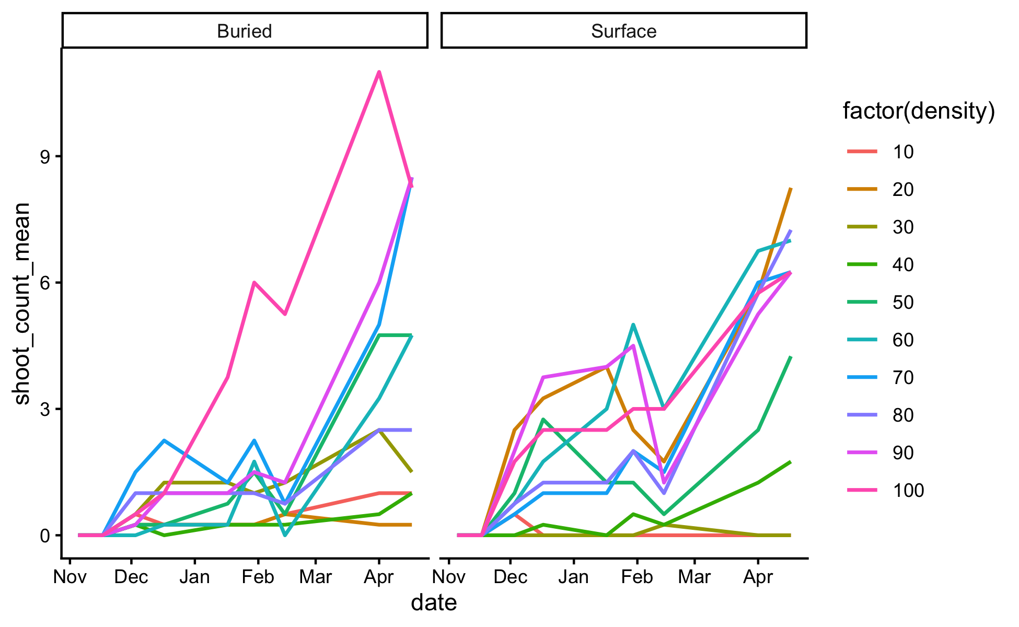
Temporal trajectories of mean shoot density (count per 0.0625 m²) from November 2025 through April 2026, shown separately for initial seeding densities from 10 to 100 seeds (facets). Values represent treatment-level means (n = 4 plots per density × clam placement combination) and error bars show +/- 1 standard error. Clam placement treatments are indicated by symbol and line type: clams placed on the sediment surface are shown as green circles with solid lines, and manually buried clams as purple triangles with dashed lines.
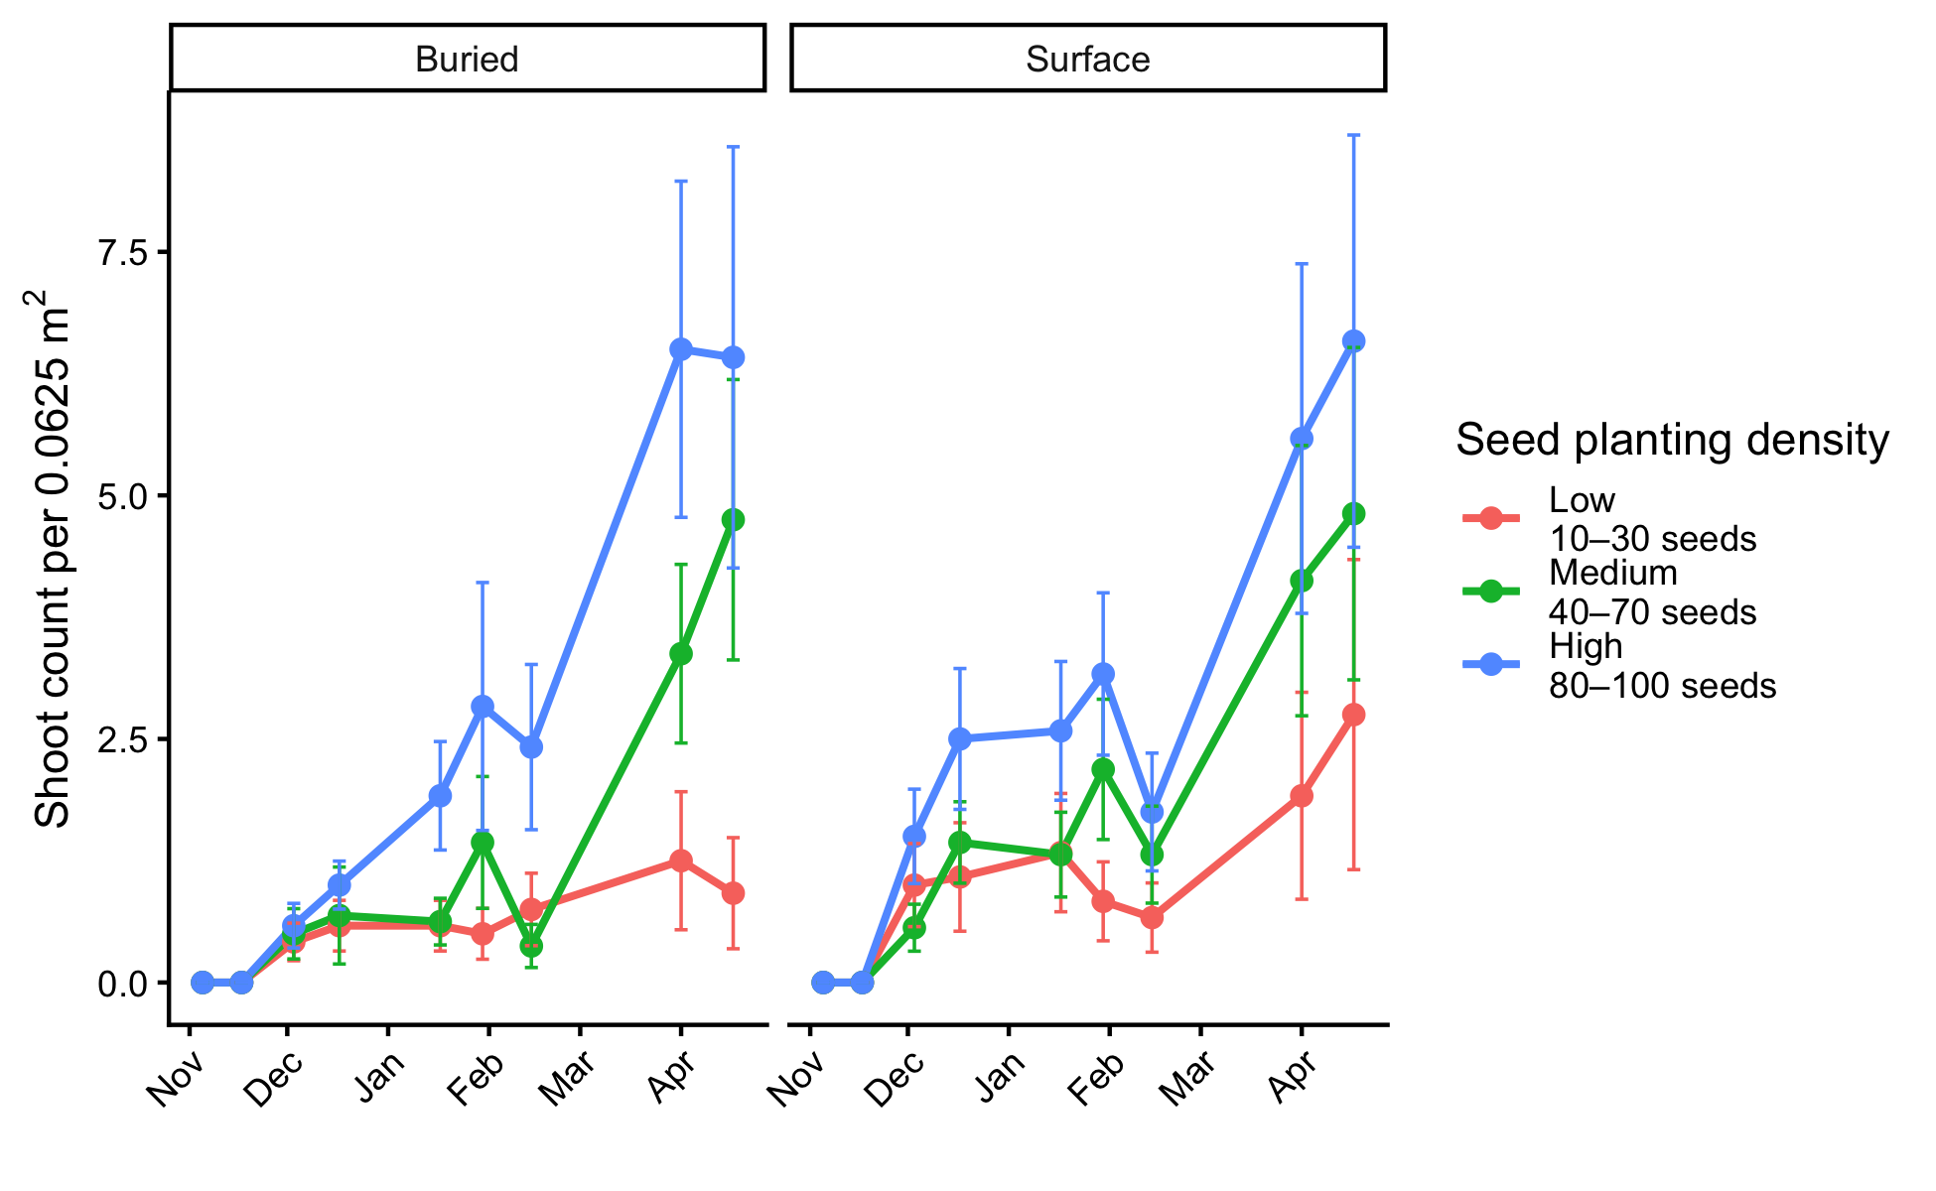

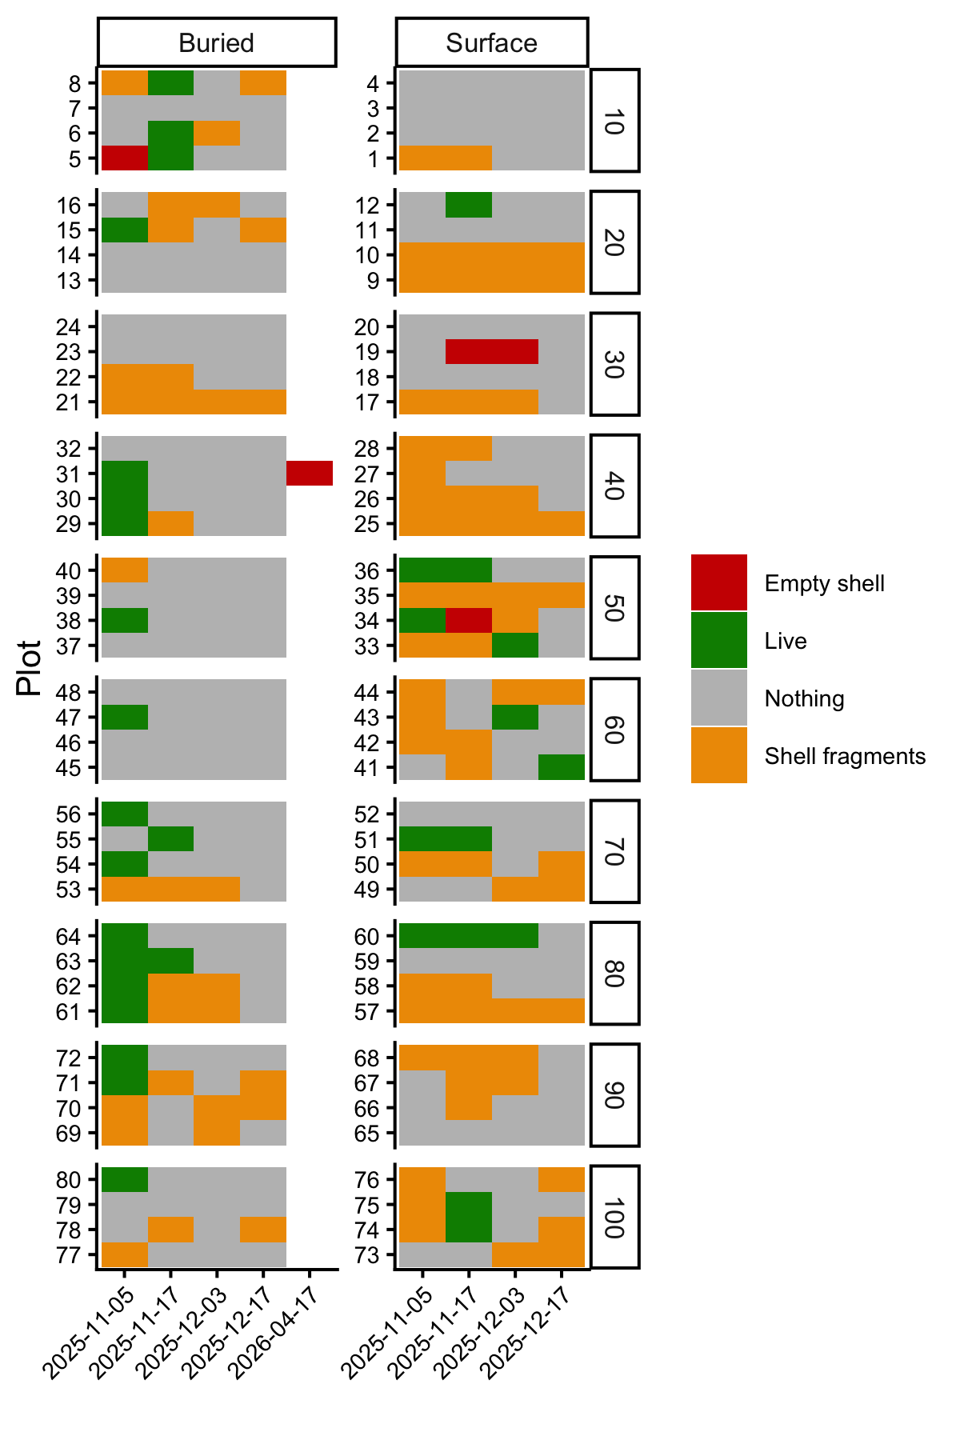
Recorded observations for clam presence and evidence of predation. Observations are shown for each plot – the left column is clams that were manually buried and the right column is clams that were placed on the sediment surface. Rows are grouped by seed density levels (10-100 seeds per plot). Colors indicate whether the clam was confirmed live (green), shell fragments were observed (yellow), an empty shell was found (red), or nothing was observed (grey).

