More seeds yield more shoots, but not higher per-seed establishment in a clam-mediated seagrass restoration experiment
Cori Lopazanski¹
Christina Cutshaw¹
Mason Ibrahim¹
Joseph P. Morton¹
Brian Silliman¹
¹Nicholas School of the Environment, Duke University, Durham, NC 28516

Abstract
Seagrass restoration increasingly relies on seed-based approaches, yet optimal seeding densities and deployment methods remain poorly resolved. We evaluated how seed density and clam-mediated seed placement influence eelgrass (Zostera marina) establishment in a field restoration experiment in Back Sound, North Carolina. Eelgrass seeds were attached to juvenile live clams at densities ranging from 10 to 100 seeds per clam, and deployed in a fully factorial design crossing seed density with two clam placement treatments - manually buried or placed on the sediment surface. Plots were monitored biweekly for shoot establishment and growth over six months. Shoot density increased through time and was generally higher in plots receiving greater numbers of seeds. However, the proportion of seeds that produced shoots did not vary with seed density, indicating that higher seeding rates yielded more shoots but did not increase per-seed establishment success. We found no evidence that clam placement influenced seedling establishment. Similarly, shoot growth trajectories were broadly comparable between clam placement treatments, though higher seed densities generally yielded taller shoots. Although manually buried clams were more frequently relocated during early monitoring and shell fragments were more common in surface treatments, these differences did not influence restoration outcomes, suggesting that successful seed deployment occurred despite substantial early clam loss. Our results suggest that increasing seed inputs can increase restoration outcomes by producing more established shoots, but does not improve the probability that individual seeds establish. These findings indicate that seed density per deployment unit can be selected based on desired restoration configuration and design. Furthermore, manually burying clams provided little measurable benefit over surface placement, suggesting that less labor-intensive surface deployment may be sufficient for large-scale restoration efforts.

Introduction
Seagrass meadows provide several important ecosystem services, including habitat for marine organisms, shoreline stabilization, and carbon storage, but they continue to decline in many regions worldwide. As a result, restoration has become an increasingly important tool for recovering lost seagrass habitat. Seed-based seagrass restoration is especially attractive because it can be scaled to larger areas than traditional transplant-based approaches, but establishment rates are often low and highly variable.
One of the major challenges in seed-based restoration is determining how many seeds should be deployed. Increasing seed density may increase the total number of seedlings that establish simply because more seeds are available. However, establishment may not increase proportionally if seeds or seedlings begin competing with one another or if other factors limit success. From a restoration perspective, it is important to know whether adding more seeds increases the number of established shoots, improves the probability that individual seeds establish, or both. It is also unclear whether increasing seed density results in proportional increases in shoot establishment or whether density-dependence processes alter establishment success.
Recent restoration efforts have also explored using clams as a seed delivery mechanism. As clams move and bury themselves in the sediment, they may help place seeds in conditions that promote germination and reduce seed loss. There are also positive interactions between clams and seagrass that can improve establishment success, potentially through nutrient enhancement and other mechanisms. However, manually burying clams requires additional effort and may not be practical at large scales, though clams on the surface remain vulnerable to predation. Whether manual burial is necessary to achieve restoration outcomes remains unclear.
In this study, we tested how seed density and clam placement influence eelgrass (Zostera marina) establishment in a field restoration experiment in North Carolina. Specifically, we asked whether increasing seed density increases establishment, whether manually burying clams improves establishment relative to placing them on the sediment surface, and whether these effects interact. We quantified both total shoot establishment and per-seed establishment to evaluate how restoration efficiency changes across a range of seeding densities.

Methods

Seed retrieval and storage
Reproductive Zostera marina shoots were collected from seagrass beds in Back Sound, NC in May 2025. Shoots were held in flow-through seawater tanks indoors until mature seeds were naturally realeased. Released seeds were collected from the bottom of the tank and stored in mesh bags in a flow-through tank. While this storage tank was exposed to general ambient light conditions, the mesh bags reduced overall light exposure. Before deployment, 100 seeds were randomly selected to test for viability using tetrazolium staining (REF), with 89% of seeds classified as viable.

Planting experiment
To test how seed planting density and clam placement influences seagrass establishment and growth, we conducted a field experiment near Harker’s Island, North Carolina. Seagrass seeds were attached to live clams (Mercenaria mercenaria; ~2 cm shell length) using a gelatin-based bioglue at one of ten density levels, spanning 10-100 seeds per clam in increments of 10 seeds. Seed planting density was crossed with two clam placement treatments (manually buried or placed on sediment surface) in a fully factorial design with four replicates per treatment combination (80 plots total).
The bioglue was prepared by dissolving dry gelatin powder in saltwater (35 ppt) to a final concentration of 9% (w/v). The solution was heated to 35°C until fully dissolved and then cooled to 28°C before application. A thin layer of bioglue was pipetted onto one shell from each clam and allowed to partially set before seeds were arranged in a single layer and covered with a second thin coat of glue. Clams were refrigerated at 9°C for 30 minutes to allow the glue to solidify, then transported to the field in coolers and deployed the same day. The total time from initial glue preparation through field deployment was less than four hours.
Clams were either manually buried to a depth of 2 cm or placed on the sediment surface to allow natural self-burial. Each clam was positioned at the center of a 0.25 m x 0.25 m plot, with the corner of each plot marked with a lawn staple to facilitate resampling. Plots were arranged in a grid with 0.5 m spacing in a sandy area located at least 10 m away from adjacent salt marsh, oyster reef, and seagrass habitat.
Plots were monitored approximately every two weeks from November 2025 through April 2026. During each survey, we recorded the number of live shoots and measured the height of up to five randomly selected shoots to the nearest millimeter. During the first four sampling dates, we assessed clam presence by searching for siphon holes and gently probing the sediment surface to detect the edge of the clam shell. We avoided excavating clams to limit seedling disturbance. For each plot, we recorded whether a live clam was confirmed, whether shell fragments or empty shells were present (as evidence of potential clam predation/mortality), or whether no clam evidence was detected.

Data analyses
To evaluate how seed planting density and clam placement influenced restoration outcomes, we quantified three complementary response variables: shoot density, per-seed establishment, and shoot growth. Shoot density was quantified as the number of shoots per plot (0.0625 m²). Per-seed establishment was quantified as the number of observed live shoots relative to the number of seeds initially planted in each plot. Both shoot density and per-seed establishment were analyzed for the final sampling date: April 17, 2026. Shoot growth was quantified as mean shoot height through time.
Final shoot density was analyzed using a generalized linear model with a negative binomial distribution and log link. Per-seed establishment was analyzed using a beta-binomial distribution with a logit link. Both models included seed planting density (continuous), clam placement (factor; buried or surface), and their interaction as fixed effects. Mean shoot height was analyzed using a linear mixed-effects model with plot included as a random intercept to account for repeated measurements through time. Fixed effects for included seed planting density, clam placement treatment, sampling date, and the interaction between seed planting density and sampling date.
To evaluate whether clam placement treatment influenced early detection of deployed clams, we fit a binomial generalized linear model with clam placement treatment as the predictor and the presence or absence of a live clam during the first two post-deployment surveys as the response variable. A clam was classified as present if it was observed during either survey. [Wordy, fix this]: Although occurrence of shells or shell fragments on the sediment surface were also recorded, these observations were not used as the primary response because shell observations were occasionally followed by subsequent live clam observations within the same plot, making shell evidence an ambiguous indicator of deployed clam fate. Only the first two surveys were included because they occurred before the first seedlings were observed. We then fit exploratory models for final shoot density, per-seed establishment, and final shoot height that included seed planting density, clam placement treatment, their interaction, and the binary clam indicator as an additional fixed effect to evaluate whether early clam presence explained variation in restoration outcomes after accounting for the experimental treatments.
Significance of fixed effects was evaluated using Type II ANOVA ($χ^{2}$ tests), and model assumptions were assessed using simulated residual diagnostics (DHARMa; REF) to evaluate dispersion and zero inflation. Model predictions and estimated marginal means (emmeans; REF) were used to visualize treatment effects and quantify effect sizes. All analyses were conducted in R version 4.5.3 (REF) & RStudio (version 2025.09.2+418; REF).

Results
Shoot establishment increased significantly with seed planting density ($χ^{2}$ = 7.34, p = 0.007), whereas both clam placement ($χ^{2}$ = 0.65, p = 0.421) and the interaction between seed planting density and clam placement ($χ^{2}$ = 1.05, p = 0.307) were not significant (Figure 1). Each additional 10 seeds planted increased the expected number of established shoots by 24.2% (95% CI: 6.6-44.6%). Model predictions indicated that increasing planting density from 10 to 100 seeds increased the expected number of established shoots from 1.4 (95% CI: 0.6-3.1) to 9.8 (95% CI: 4.5-21.2).
Shoot establishment increased throughout the experiment across all treatments (Figure 2). Following the onset of shoot establishment in December, higher planting densities accumulated shoots more rapidly than lower planting densities, resulting in progressively greater differences in shoot establishment through time.
This increase reflected greater shoot establishment rather than higher per-seed establishment: while shoot density increased with seed density, the proportion of seeds that produced shoots did not. Per-seed establishment was not significantly affected by seed density ($χ^{2}$ = 2.71, p = 0.1), clam placmeent ($χ^{2}$= 0.16, p = 0.69), or their interaction ($χ^{2}$ = 0.79 , p = 0.373) (Figure 1). Model-predicted per-seed establishment ranged from approximately 5% to 12% across planting densities, although these differences were not statistically significant.
Mean shoot height increased throughout the experiment ($χ^{2}$ = 684.02 , p < 0.001), and the relationship between seed planting density and shoot height varied across sampling dates (seed density x sampling date: $χ^{2}$ = 11.85 , p = 0.037). Clam placement did not affect shoot height ($χ^{2}$ = 1.24 , p = 0.266). Model predictions indicated that shoot height was similar among planting densities during the first three months, whereas shoots in higher-density treatments were consistently taller during the latter half of the experiment (Figure 3).
Clam placement influenced the short-term fate of deployed clams (Figure 4). Manually buried clams were more likely to be relocated during the first two post-deployment surveys than surface-deployed clams ($χ^{2}$ = 8.44, p = 0.004). Shell fragments were also observed more frequently in surface treatments (n = 25, 62.5%) compared to manually buried treatments (n = 16, 40%). However, confirmed clam presence was not associated with either final shoot establishment ($χ^{2}$ = 0.5, p = 0.479), per-seed establishment ($χ^{2}$ = 0.43, p = 0.513), or final shoot height ($χ^{2}$ = 0.1, p = 0.749) after accounting for seed planting density and clam placement. Seed planting density remained the only significant predictor in the model of final shoot establishment, and was marginally significant for both per-seed establishment and final shoot height (SI: Table 1).

Discussion
Increasing seed planting density produced proportionally more established shoots without altering per-seed establishment. This indicates that, over the range of planting densities tested, early restoration outcomes were determined primarily by the number of seeds planted rather than changes in establishment efficiency. This distinction is important because it separates the effects of propagule supply from the processes governing per-seed establishment.
The absence of a planting density effect on per-seed establishment suggests little evidence for either facilitation or competition during early establishment. Increasing local seed density neither enhanced nor reduced establishment success, indicating that microsite conditions or other local environmental factors likely played a greater role in determining which seeds ultimately established. Whether density-dependent effects emerge at higher planting densities or later stages remains an important question for future work.
Although manually burying clams increased the probability of relocating live clams during the first two post-deployment surveys, this difference did not translate into greater shoot establishment, per-seed establishment, or shoot growth. Shell fragments and empty shells were observed more frequently in surface treatments, suggesting that surface-deployed clams experienced greater loss, likely through predation or exposure. Despite this apparent clam loss, restoration outcomes were unaffected, indicating that seed deployment was largely successful regardless of subsequent clam fate. One plausible explanation is that seeds detached from clams and became incorporated into the sediment before many clams were lost, allowing seed establishment to proceed even when the deployment vector was no longer present. This suggests that clam-mediated deployment may be relatively robust to post-deployment clam loss, provided seed release occurs shortly after deployment.
The absence of a clam effect on eelgrass establishment should not be interpreted as evidence that clams are unimportant to seagrass ecosystems more broadly. Numerous studies have demonstrated that bivalves can facilitate seagrass growth through mechanisms such as nutrient enrichment, sediment modification, and bioturbation. However, these facilitative effects typically develop over longer timescales and involve persistent bivalve populations interacting with established plants. In contrast, our experiment evaluated whether short-term persistence of deployed clams influenced the earliest stages of seed establishment. Under these conditions, clams appear to function primarily as temporary seed deployment vectors rather than long-term ecosystem engineers
These findings shift the practical question for seed-based restoration from how many seeds should be planted to how those seeds should be allocated. Because per-seed establishment remained similar across planting densities, restoration practitioners can select seed density per deployment unit based on desired restoration outcomes rather than concerns about establishment efficiency. For example, concentrating many seeds on a single clam is expected to produce dense founder patches, whereas distributing the same number of seeds among multiple clams would produce a similar number of established shoots distributed across a larger area.

Figures
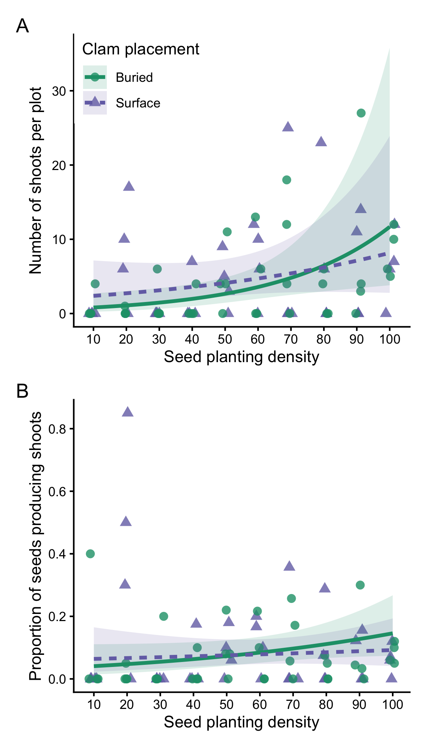
Figure 1: Effects of seed planting density on (A) final shoot count and (B) establishment probability at the final sampling point. Establishment probability was calculated as the proportion of planted seeds that produced observable shoots, integrating seed retention, germination, and early seedling survival. Points represent individual plots. Lines show model predictions (±95% CI) by clam placement treatment: on the sediment surface (purple triangles, dashed line) or manually buried (green circles, solid line).

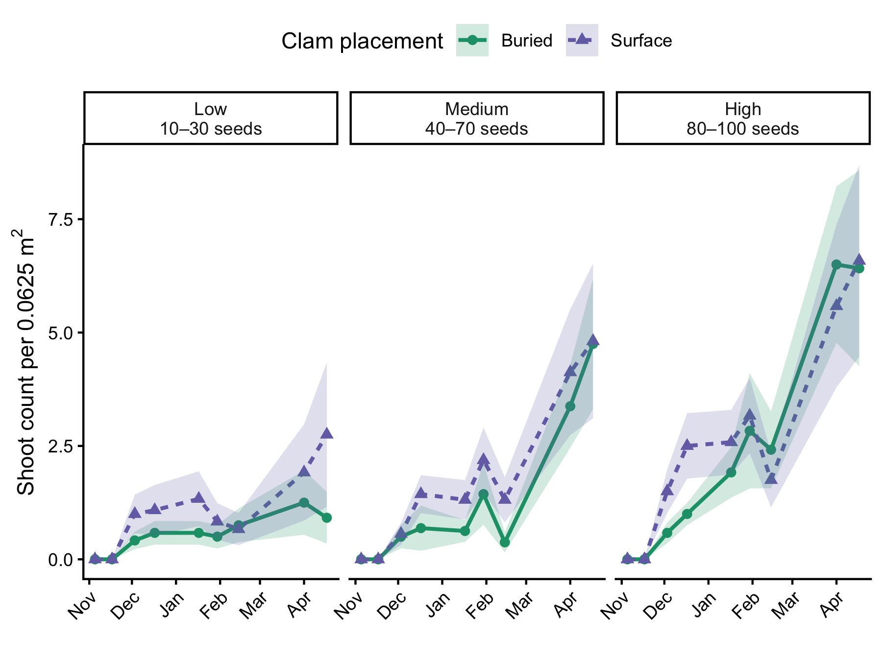
Figure 2: Temporal patterns in shoot establishment across seed planting density groups and clam placement treatments. For visualization, seed planting densities were grouped into low (10-30 seeds), medium (40-70 seeds), and high (80-100 seeds) categories. Points represent the average shoot count per plot (±SE) at each sampling date, averaged across all plots within each seed density group and clam placement treatment. Green circles and solid lines indicate manually buried clams; purple triangles and dashed lines indicate clams placed on the sediment surface.

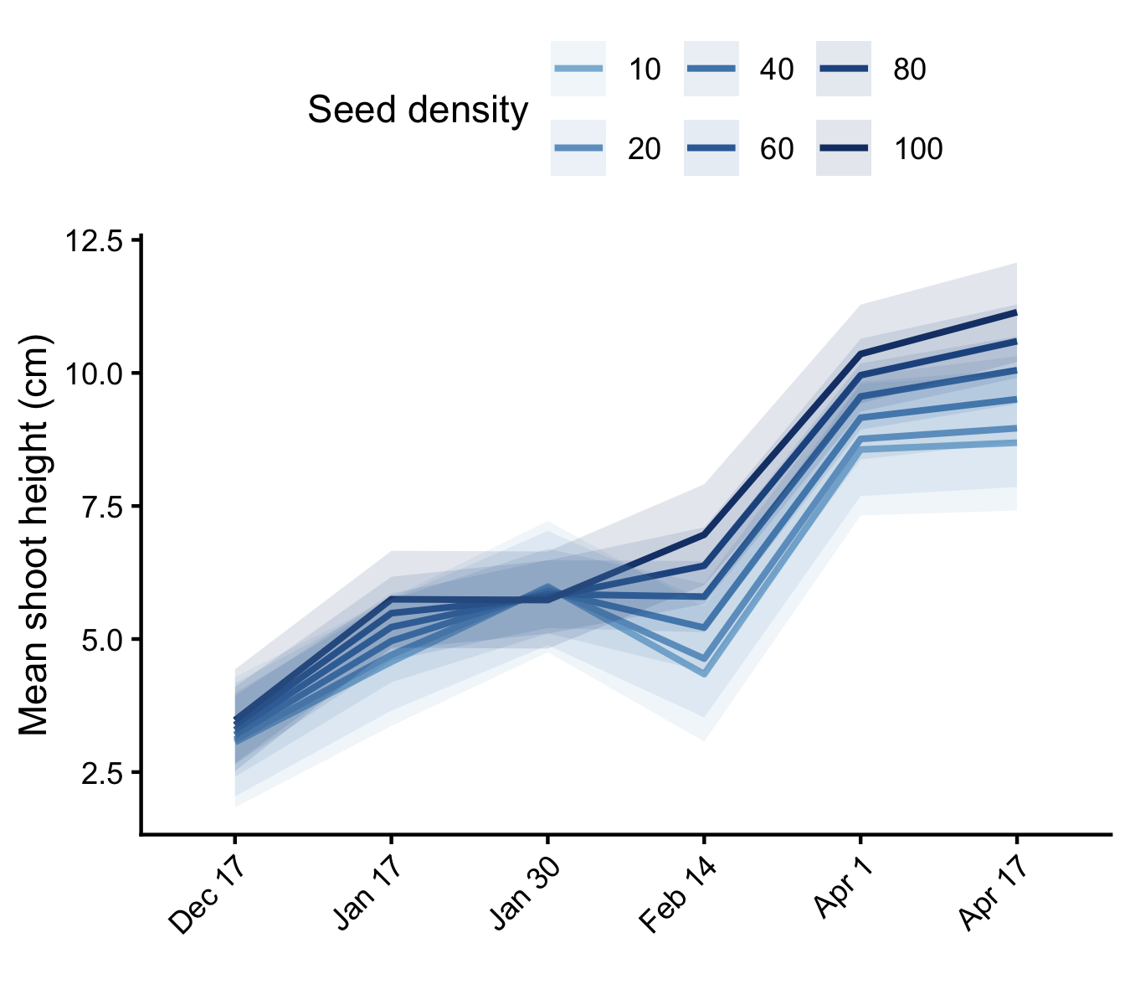
Figure 3: Effects of seed planting density on mean shoot height (cm) over the course of the experiment. Lines show model-predicted mean shoot height (±95% CI) from a linear mixed effects model, averaged across clam placement treatments. Darker blue lines indicated higher seed densities.

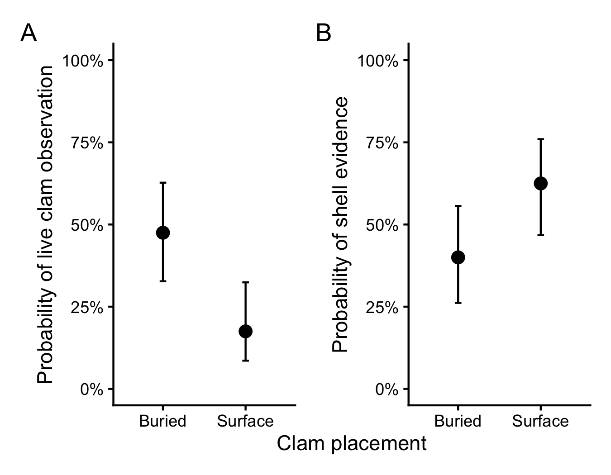
Figure 4: Effects of clam placement treatment on short-term clam fate. Model-predicted probabilities (±95% CI) of observing (A) a live clam and (B) shell evidence (shell fragments or empty shells) during the first two post-deployment surveys from binomial generalized linear models.

References
TBD

Supplementary Information
Table 1: Results of exploratory models evaluating whether early live clam observations explained variation in restoration outcomes after accounting for seed planting density and clam placement treatment. Models included the binary live-clam indicator, seed planting density, clam placement treatment, and their interaction. Significant effects (p < 0.05) are shown in bold.
 | Term | χ² | df | p
Model 1. Effects on shoot establishment | Seed density | 7.83 | 1 | 0.005 | **
 | Clam placement | 0.27 | 1 | 0.602
 | Live clam observed | 0.50 | 1 | 0.479
 | Seed density × Clam placement | 0.84 | 1 | 0.360
Model 2. Effects on per-seed establishment probability | Seed density | 2.97 | 1 | 0.085
 | Clam placement | 0.34 | 1 | 0.559
 | Live clam observed | 0.43 | 1 | 0.513
 | Seed density × Clam placement | 0.83 | 1 | 0.361
Model 3. Effects on final shoot height (cm) | Seed density | 3.78 | 1 | 0.052
 | Clam placement | 0.45 | 1 | 0.500
 | Live clam observed | 0.10 | 1 | 0.749
 | Seed density × Clam placement | 0.26 | 1 | 0.607

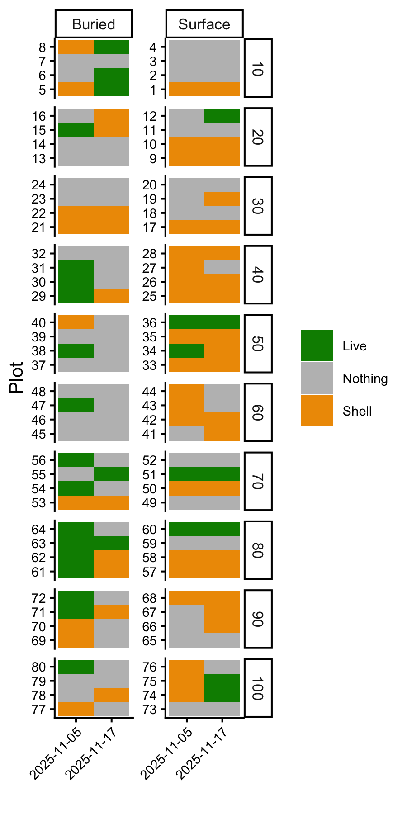
Figure 5: Clam observations are shown for each plot – the left column is clams that were manually buried and the right column is clams that were placed on the sediment surface. Rows are grouped by seed density levels (10-100 seeds per plot). Colors indicate whether the clam was confirmed live (green), shell fragments or empty shells were observed (yellow), or nothing was observed (grey).

