**ME 169: Week 8 Update**

*Tyler Nguyen and Lorenzo Shaikewitz*

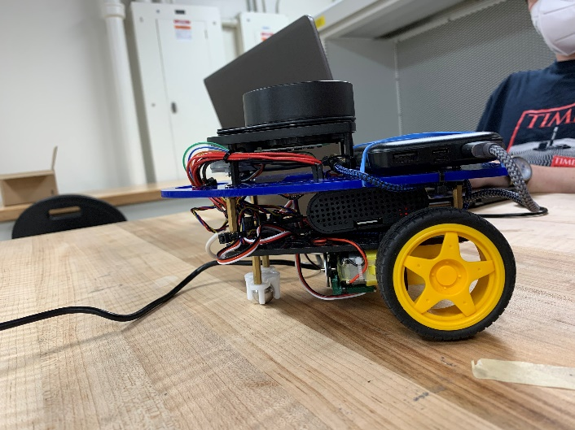This week we focused on the transition to LiDAR and planning out our final project. The first task was to redesign the robot’s top plate to accommodate the new LiDAR module:

After redesigning the chassis, we installed the RPLiDAR ROS package. This took a little longer than it should have, but we eventually got it working by placing the packing in the “robotws” workspace instead of installws. Here’s a screenshot of our robot localizing with the LiDAR:

Note that there was a box in the corner of the square. Once we powered up the motors, the robot was quite confused. We were unable to (easily) get it to move around with the existing framework so we set about writing a new one.

We are now basically implementing SLAM using this point cloud. We’re trying to make it robust to robot motion, moving obstacles, and sensor uncertainties.

**Week 9 Goals: basic SLAM**

* Convert LiDAR points to line obstacles while stationary
* Update line obstacle estimates with new points
* Incorporate odometry uncertainty and add object recognition with movement

**Week 10 Goals: planning with SLAM**

* Implement planning algorithm to achieve maximum coverage.