„Solomon Marcus” Linguistics Olympiad
2024–2025 editions — 10-problem compilation
Exercise A (grades 5–6) · Performance Section (grades 9–12)
County round — 24 February 2024 • National round — 5–7 April 2024
This compilation gathers all ten problems: the four 2024 Exercise A problems (Problems 1–4, grades 5–6) and the six 2025 Performance problems (Problems 5–10, grades 9–12), grouped by round below.
General rules
- Listen carefully to the invigilators and follow their instructions.
- The effective working time was three hours for each 2024 Exercise A round and four hours for each 2025 Performance round. You may solve the problems in any order.
- During the competition it is forbidden to use any written or printed materials, as well as any outside help.
- If you have questions about any of the problems, raise your hand and ask one of the invigilators. The invigilator will call a member of the Central Committee to answer you.
- The maximum score for each problem is 100 points. The final result is the arithmetic mean of the scores.
Rules for formulating the solution of the problems
- Do not copy out the problems.
- Solve each problem on a separate sheet (or sheets).
- Write the answers to the problem's tasks, together with the rules you have identified. The reasoning you followed need not be described.

PART I · 2024 Exercise A (grades 5–6)
County round (24 Feb 2024) & National round (5–7 Apr 2024) · Problems 1–4
PROBLEM NO. 1 (100 points)
The following verb forms in Aroma are given, together with their translations into English:
1. avamake | I have just made (him/her) spin.
2. aripa | I have just known.
3. enevariparia | He is about to teach them.
4. evaripaku | He has just taught me.
5. govaripatha | You (pl.) have just taught him.
6. igavaveripa | We are about to teach ourselves.
7. maigomakewaiku | You (pl.) are about to keep making me spin.
8. maigavaripawaimu | We are about to keep teaching you (sg.).
9. mapigeripawai | They will keep knowing.
10. maporipawaia | You (sg.) have kept knowing him.
11. onomakea | You (sg.) are about to make him spin.
12. pavemake | I spun (myself).
13. pegeveripa | They knew (themselves).
14. pigavaripatha | We will teach him.
15. pigovamakeria | You (pl.) will make them spin.
16. ponoveripa | You (sg.) will know (yourself).
The following verbs are also known:
‘pala’ — to dance, ‘thapana’ — to hunt, ‘riku’ — to swim, ‘vagi’ — to kill
(a) Translate into English:
17. panamakea | 20. evavagimu
18. peripaku | 21. igothapanatha
19. maonopalawai | 22. pegevethapana
(b) Translate into Aroma:
23. you (pl.) hunted | 27. we have just killed him
24. they have just made him dance | 28. they are about to swim
25. he will make me swim | 29. I am about to keep hunting them
26. you (sg.) have just spun (yourself) | 30. we have kept making ourselves spin
⚠ Aroma is an Austronesian language spoken by about 4,000 people in 11 villages on the east coast of the Central Province of Papua New Guinea.
— Paul Helmer

PROBLEM NO. 2 (100 points)
The following sentences in Yawalapiti are given, together with their translations into English:
1. piputi piɾ̥ula nu | You give me your turtle.
2. nunupi iru isetela nukuɲala | I see her CD in my forest.
3. niɾ̥ula unupi pa | My turtle sees the house.
4. uwa iputi sete iru iju paɲa | The uncle gives her the CD in the house.
5. pamikula unupi iru initala | Your friend sees her bow.
6. niputi puluɲila hiu ukuɲa | I give you your porridge in the forest.
7. iru inunupi nukawarula | She sees my horse.
8. kawaru unupi nukula | The horse sees my forest.
9. iru iniputi moto nu | She gives me the motorcycle.
10. piputi iru imatʃila iru iju | You give her her corn.
(a) Translate into English:
11. amiku unupi iru imotola
12. iru inamikula unupi moto
(b) Translate into Yawalapiti:
13. You see your forest.
14. She gives her my corn.
(c) Translate into Yawalapiti by writing the letter corresponding to the correct answer:
15. I give you the bow.  a) apiputi pitala hiu  b) niputi itala nu  c) piputi nita nu  d) niputi ita hiu  e) niputi itala hiu | 16. Her turtle sees the friend in the forest.  a) iru iniɾ̥ula unupi amiku ukuɲa  b) iru iɾ̥ula inupi amiku ukuɲa  c) iniɾ̥ula unupi amiku ukuɲa  d) iru iɾ̥u inupi amiku ukuɲa  e) iru iniɾ̥u unupi amiku ukuɲa
17. Her friend gives me my horse in the house.  a) iru inamikula iputi nukawarula nu paɲa  b) iru inamikula iputi kawarula nu paɲa  c) amiku iputi nukawaru paɲa  d) iru amikula iputi kawaru nu paɲa  e) amikula iputi nkawarula paɲa | 18. She sees my porridge in the house.  a) iru inunupi uluɲila paɲa  b) iru inupi uluɲi paɲa  c) iru inupi nuluɲila pa  d) iru inunupi nuluɲi pa  e) iru inunupi nuluɲila paɲa
⚠ Yawalapiti belongs to the Arawak family and is spoken by about 150 people in the Xingu Indigenous Park in Brazil.
tʃ = ch in church; ɲ = ni in onion; ɾ̥ is a consonant produced by a very brief tap of the tongue against the dental alveoli (like r in Spanish pero) and without vibration of the vocal cords.
— Fernando César G. Filho

PROBLEM NO. 3 (100 points)
The following expressions in baybayin sign language are given:
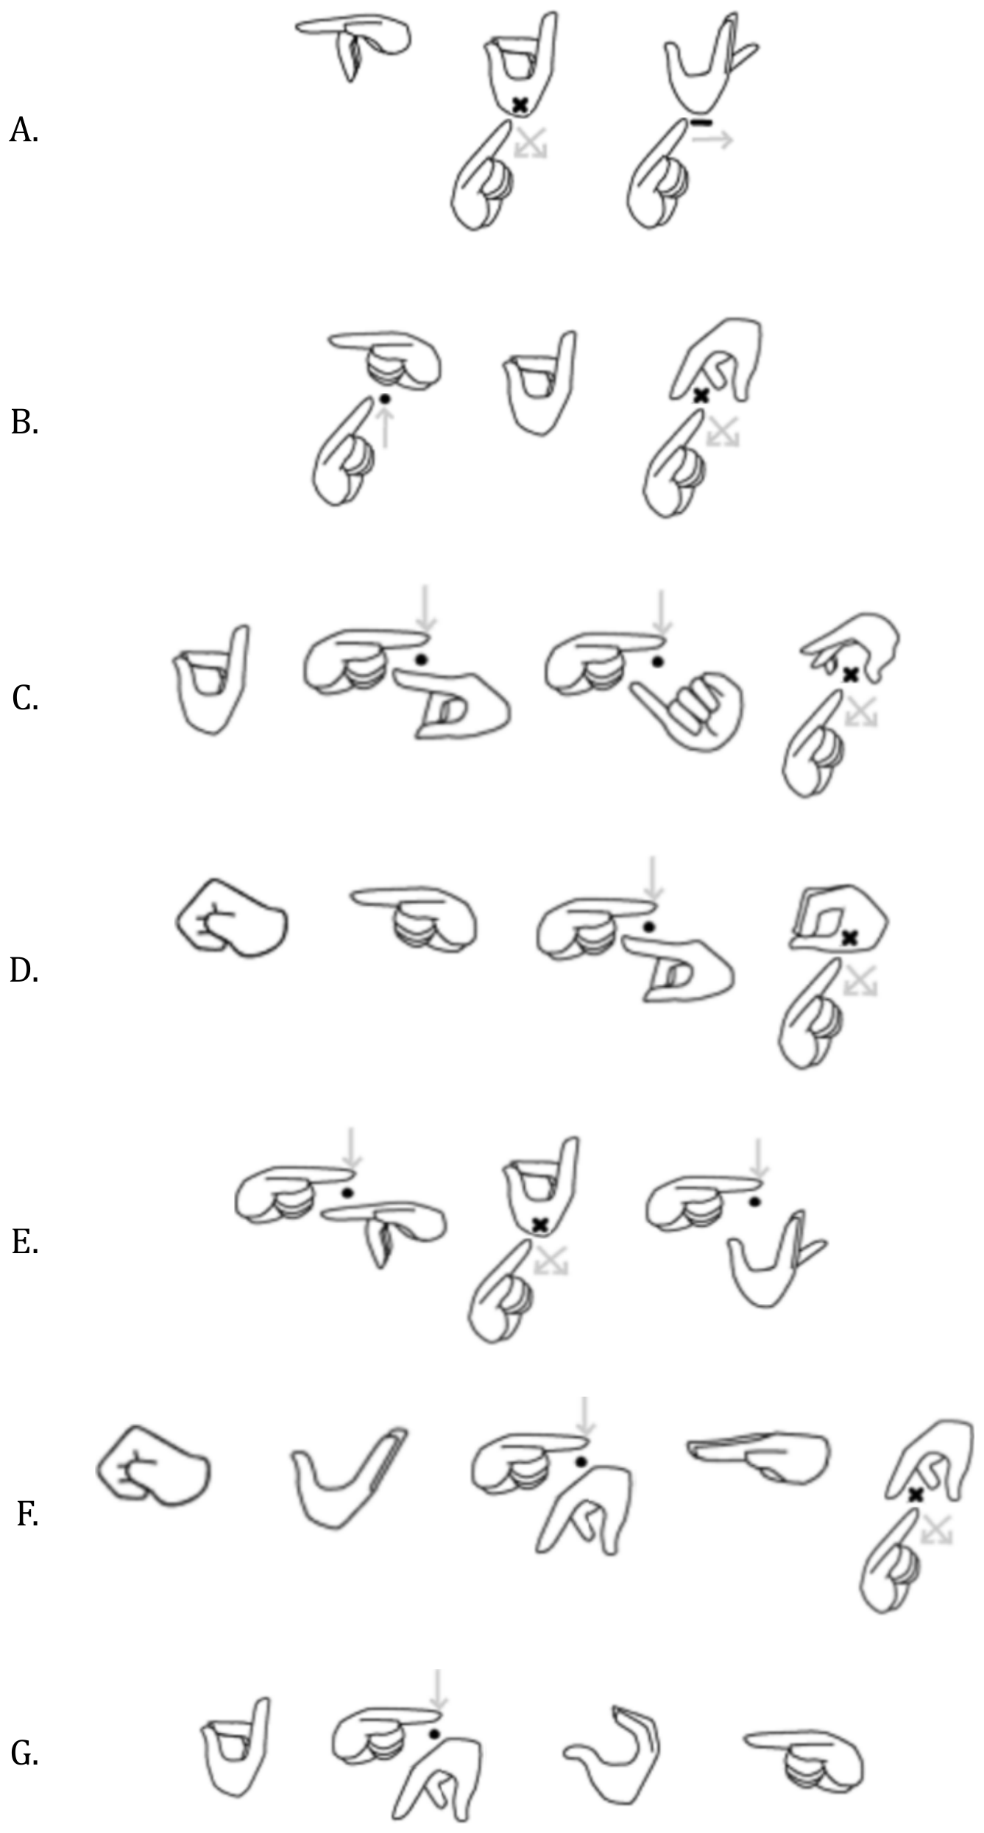
(a) Match the expressions (A)–(G) with their transcriptions in the Latin alphabet below, (1)–(7):
1. Balakid | 5. Luman
2. Bayanihan | 6. Tampo
3. Makisig | 7. Timpi
4. Maniwala
(b) Transcribe the following expressions into the Latin alphabet:
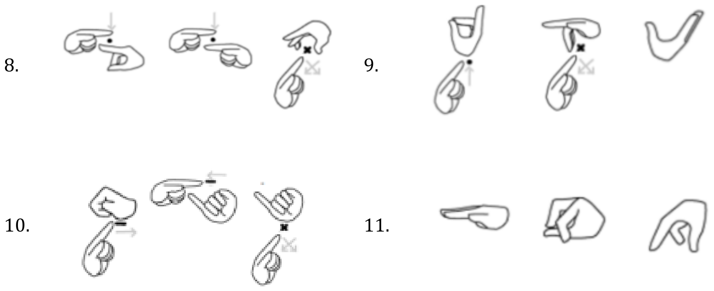
(c) Transcribe into baybayin sign language:
12. Kalinaw | 14. Perlas
13. Yugto | 15. Sumasabay
For the answers to tasks 12–15 you do not need to draw the signs. From the table below, write the numbers that identify the necessary symbols, as in the model below:
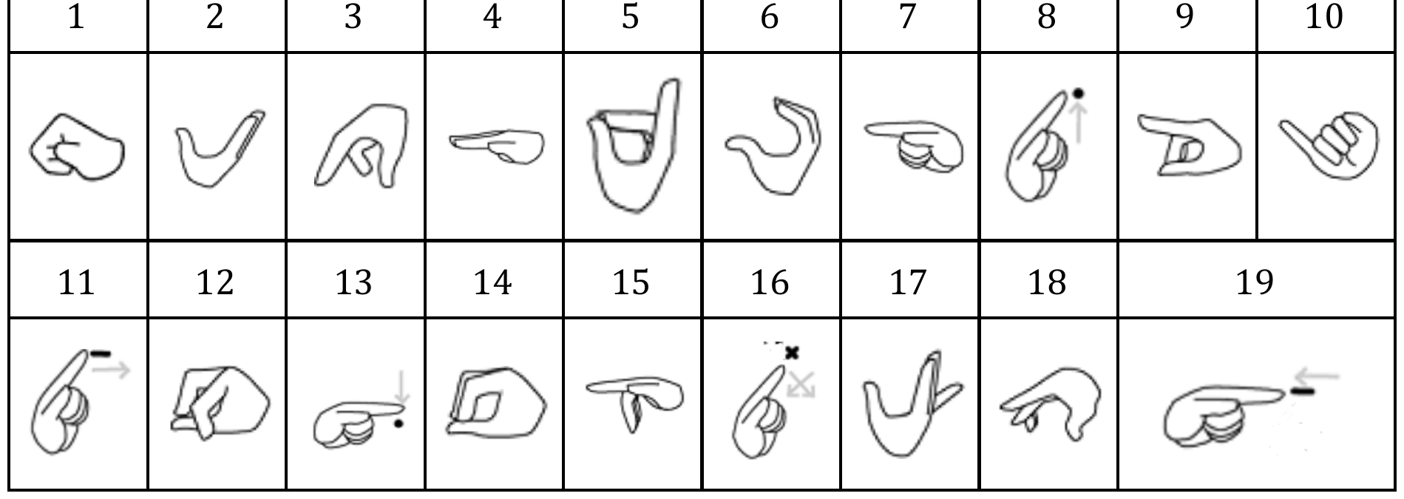
Model for the adjacent expression
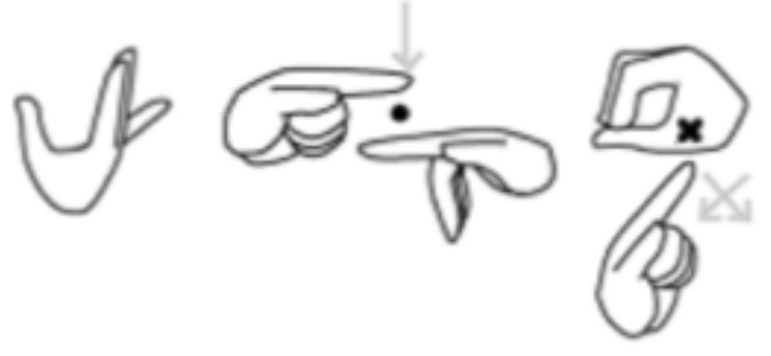 | 13  17 15 14  16
⚠ Baybayin sign language uses fingers, hand shapes, or hand movements to represent characters of the baybayin writing system of the Philippines. It was created by Tim Liwanag.
— Ioana Bouroș

PROBLEM NO. 4 (100 points)
The following sentences in the language of the adepts from the video game Chants of Sennaar are given, together with their translations into English, in random order:
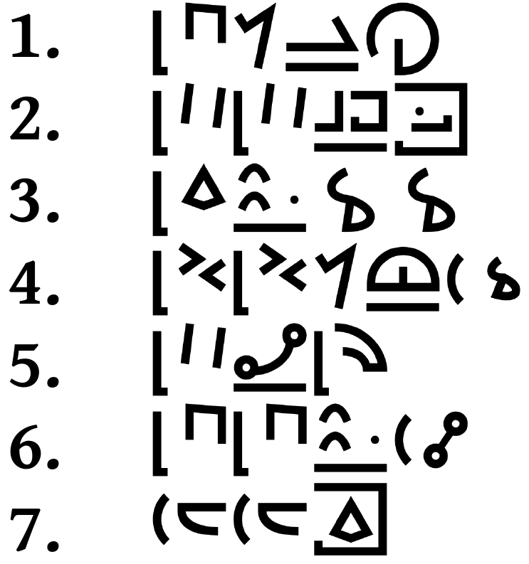 | A. The adept searches for the plants.  B. The keys are in the church.  C. I do not like the music.  D. We (without you) want the potion.  E. The warriors do not see the flowerpot.  F. You help the priest.  G. You (pl.) go to the cemetery.
(a) Determine the correct correspondences.
(b) Translate the following sentences into English:
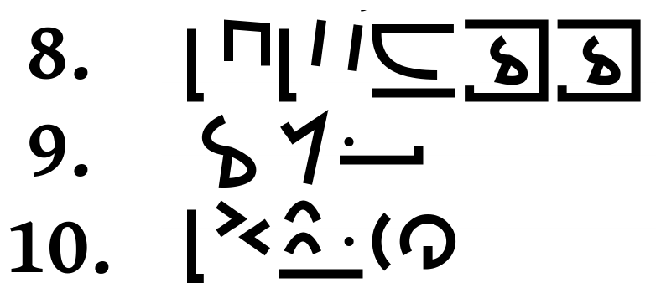
⚠ If several variants exist, write them all.
(c) Translate into the language of the adepts:
H. I see the lens.
I. The bards love the potions.
J. The warriors do not speak with the adepts.
⚠ Chants of Sennaar is a video game inspired by the myth of the Tower of Babel. The bards are one of the peoples living in the tower; their main preoccupations are theatre and music.
— Dan-Mircea Mirea
PART II · 2025 County Round (OJL) · Performance
1 February 2025 · grades 9–12 · Problems 5–7
PROBLEM NO. 5 (100 points)
The following sentences in Burushaski are given, together with their translations into English.

1. hiles iirimi. | The boy died.
2. au ghurċimi. | My father went diving.
3. hilese dasin muyeeċimi. | The boy saw the girl.
4. dasin basyulo gaarċumo. | The girl ran in the garden.
5. un ċhilulo gughurċuma. | You drowned in the water.
6. gubibi muirumo. | Your sister died.
7. ibibi un guyeeċumo. | His sister saw you.
8. ine amiṣ iltanumo. | She hit my finger.
9. une iriin ċhilulo iiluma. | You put his hand in the water.
10. mui birdiaṭe huruṭimi. | Her son sat on the ground.
11. muu malulo iwaalimi. | Her father got lost in the field.

(a) Translate into English:
12. un guwaaluma.
13. je aghurċam.
14. in malaṭe gaarċimi.
15. une hiles iyeeċuma.
16. je ċhilulo huruṭam.
17. dasine abibi multanumo.
(b) Translate into Burushaski, knowing the following verb roots:
kharan – to be late giraṭ – to dance war – to grow tired ni – to go
18. His son was late.
19. I walked on the water.
20. You danced in the garden.
21. My hand grew tired.
22. She put your finger in the ground.
23. The girl lost me.
⚠ Burushaski is a language isolate. It is spoken by about 130 thousand people in Pakistan and India. ċ, ċh, ṣ, kh, gh and ṭ are consonants.
— Elena-Tamara Ivanof and Mihai Bratu

PROBLEM NO. 6 (100 points)
In the columns below are given words in the Munster dialect of Irish, and words from the Kobon language, in which the stress is marked.

MUNSTER |  | KOBON
′a . rə . mə . kəx | tender | ′a . rəpʰ | he had left
a . mə . ′ro: . də . hə | unhappy | a . ′la . go | species of snake
ə . mə . ′da:n . ti:xt | madness | ′a . ni | one
′fo: . gə . ro: . fər | will be announced | əm . ′un | tail
′i . mʲɪ . lʲə . ka:n | navel | ga . ′li . nəŋ | species of bird
ka . ′lʲi:nʲ | girl | ha . ′ga . pe | blood
′ka . rɪgʲ | stone | ′i . lən | stick
kʲɪ . ′mja: . dən | she observes | i . ′neb | burnt
′ku: . rə . məx | careful | ki . ′a | tree
u: . ′ra: . ni: | songs | ki . dol . ′maŋ | arrow
′u: . tə . ma: . li: | bungler / clumsy person | nəm . ′bi | woman
re: . ′su:n . tə | reasonable | ′sin . də | sun
kja . nə . ′ho:rj | buyer | gi . ′ro | to tell / narrate
 |  | u . ′mob | he died
⚠ The sign “ ′ ” before a syllable indicates the stress. The sign “ . ” is used to mark the division into syllables. The sign “ : ” marks the lengthened pronunciation of the vowel.
(a) By mistake, a pupil mixed up the following words, in which the stress was marked. Help him establish, for each of them, which language it belongs to:
′a . lə . gar A) Munster B) Kobon C) either D) neither
me . ′na A) Munster B) Kobon C) either D) neither
′a . lin A) Munster B) Kobon C) either D) neither
ka . we . gam . ′bin A) Munster B) Kobon C) either D) neither
tra:n . ′ho: . nə A) Munster B) Kobon C) either D) neither
(b) Identify the stressed syllable in the following words from the Munster dialect:
1. o: . ga . nəx | young man
2. bjɪ . hu:n . ti:xt | villainy
3. a . ki . lʲi: | athletic
4. kla . gər . nəx | clanging
5. u: . də . ra:s | authority
6. a: . lɪnʲ | pretty
7. dji: . vi:nʲ | inactive
8. fo . rə . mə . du:lʲ | spiteful / envious
(c) Identify the stressed syllable in the following words from the Kobon language:
9. ə . ro | small
10. ga . le | to cry
11. si . og | species of bird
12. lu . əl | timber
13. mə . ha | two
14. mo . u | thus
15. mun . da | remains present
16. wu . lem | hole
⚠ Munster is a dialect of Irish spoken in the province of the same name by approximately 10,000 people. Kobon is a language from Papua New Guinea, spoken, likewise, by approximately 10,000 people.
— Paul Helmer

PROBLEM NO. 7 (100 points)
The following names of clans and emperors from the Qing dynasty are given in the traditional Manchu script, followed by their literal transliterations in the Latin alphabet, in random order:

1. 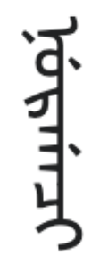 | 5. 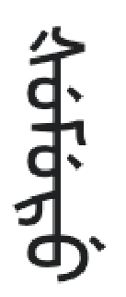 | 9. 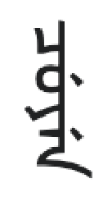
2. 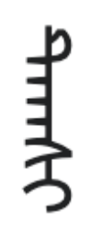 | 6. 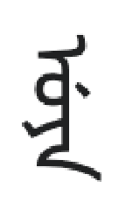 | 10. 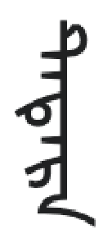
3. 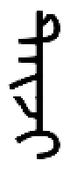 | 7. 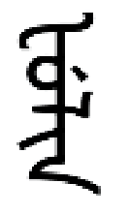 | 11. 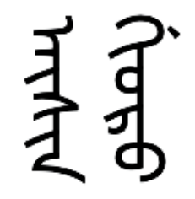
4. 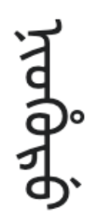 | 8. 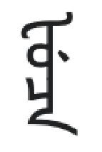 | 12. 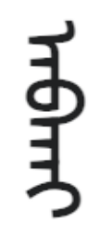

A. Niohuru | G. Tatara
B. Nurgaci | H. Cuyen
C. Uya | I. Taksi
D. Aisin-Gioro | J. Taiji
E. Abkai | K. Fuca
F. Fulin | L. Šumuru
(a) Determine the correct correspondences.
(b) Transcribe the following names from the Manchu script into the Latin alphabet.
13. 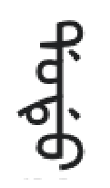 | 14. 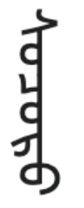 | 15. 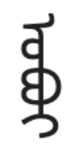
(c) Write the following proper names using the Manchu script.
P. Nara
Q. Dorgon
R. Ilibu
⚠ For writing the answers to tasks P–R, the symbols in the table on the next page may be used.

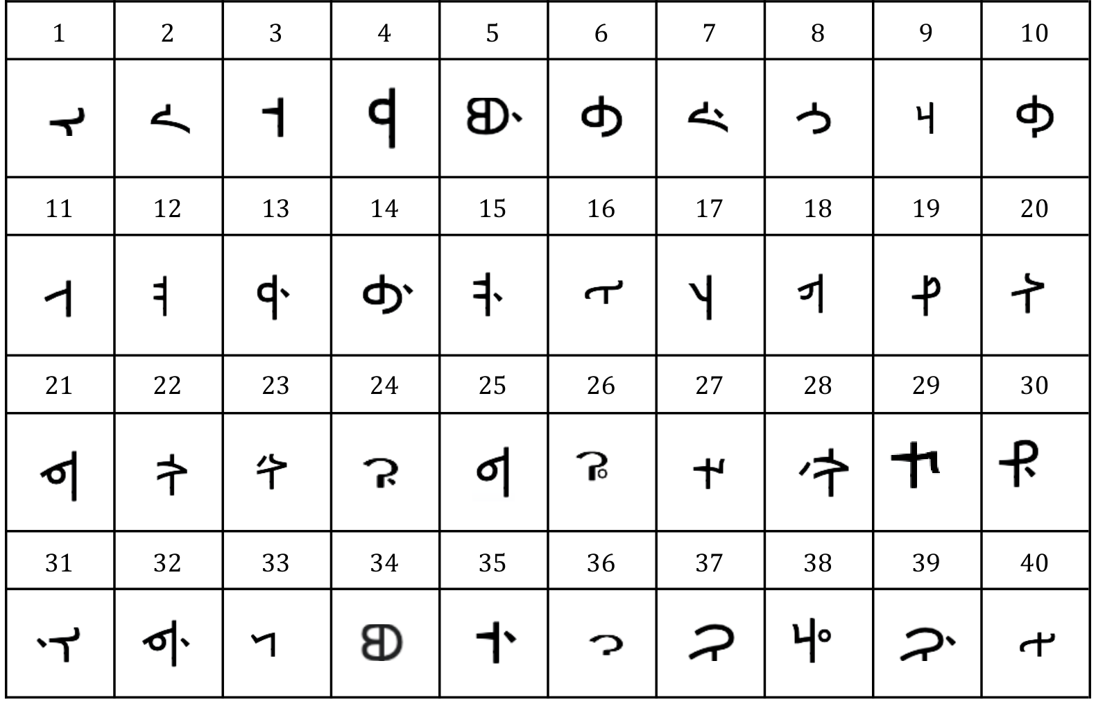
⚠ The Manchu language belongs to the Tungusic family. It was spoken by the Manchu tribes from the historical region of Manchuria in northeastern Asia. It was one of the official languages of the Qing empire, founded by the Manchus.
The group of letters “gi”, such as the one found in Gioro, represents a single sound.
— Ioana Bouroș

PART III · 2025 National Round (ONL) · Performance
28–30 March 2025 · grades 9–12 · Problems 8–10
PROBLEM NO. 8 (100 points)
The following sentences in Worora are given, together with their translations into English:

1. ŋumalala | You are handsome.
2. ŋunju kanjona inja eeja imalala | You hit the handsome man.
3. warala iwaɳdája wanji ŋanbuna | A pitiful boy found me.
4. arka warabaɭ ŋunbarwuna | They threw you.
5. daránma manja anbuna | A banksian cockatoo met us.
6. mariri ŋanbuna | A red-winged parrot hit me.
7. ŋayu wanji kuŋona wunu maruku | I found the flower.
8. arka kuɖey anbarwuna | They asked us.
9. ŋunju buju kánjona | You killed them.
10. ŋayu maɽa maŋona mana mawarba | I saw the cave.
11. ari maɽa kuɲarwuna wunu anjolu | We saw the sky.
12. ɲina waraliɲa manja kona inja warala imareya | The girl met the sick boy.
13. wunu wiyanu buju ɲimbuna ɲina waŋayiɲa ɲiniyaɲa | The fire killed the good woman.
14. ɲina maŋkáɲa warabaɭ mona mana bimbinalba | The wife threw the ashes.
15. ŋunju kuɖey ɲinjona waraliɲa ɲimbaɳdájaɲa | You asked a pitiful girl.
16. arka maɽa kubarwuna maruku | They saw a flower.

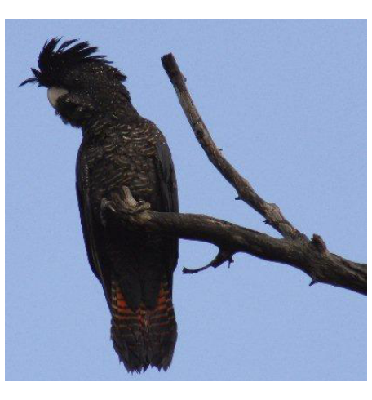  Figure 1: banksian cockatoo | 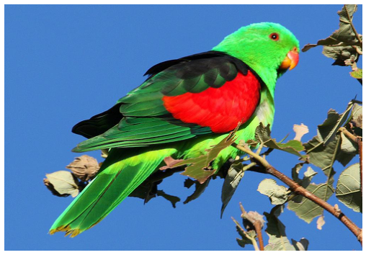  Figure 2: red-winged parrot
(a) Translate into English:
17. ŋamalala
18. ari káɲarwuna
19. eeja buju ŋunbuna
20. ŋunju wanji manjona mana bimbinalba
21. ŋayu kuɖey ɲiŋona ɲina maŋkáɲa ɲimareyaɲa
(b) Translate into Worora:
22. I met the banksian cockatoo.
23. They threw the girl.
24. You asked the red-winged parrot.
25. The good man found a handsome woman.
(c) The following sentences are translated in an unexpected way:
i. We hit you. ari ŋunbarwuna
ii. You hit us. ŋunju kánjona
How can you explain the formation of these sentences?
(d) Translate the sentence “I hit you.” into Worora.
⚠ Worora belongs to the language family of the same name. It is spoken by 8 people in northwestern Australia.
The sign ´ above a vowel marks its lengthening; j ≈ ch in Romanian chiar, ɲ ≈ ni in bani, ŋ ≈ n in cangur, y ≈ i in iarnă, r = r in ramură; ɽ, ɖ, ɭ and ɳ are pronounced like r, d, l, and n respectively, but with the tip of the tongue curled back (retroflex).
[Translator's note: the pronunciation guide is given via Romanian example words; the phonetic values (retroflex r/d/l/n, palatal ɲ, velar nasal ŋ, glide y, affricate j) are preserved.]
— Elena-Tamara Ivanof & Mihai-Alexandru Bratu

PROBLEM NO. 9 (100 points)
The following structures in Tzeltal are given, together with their translations into English:

jun sahk’ cek | → 1 skirt
oxeb yoxwinik k’ohk lima | → 43 lemons
chanlajuneb hohk’ kaslan cenek | → 14 peanuts
lajchayeb sahk’ coc | → 12 blankets
wakeb t’ol kahpe | → 6 coffee beans
juklajuneb schanwinik hohk’ ciin | → 77 potatoes
balunlajuneb k’ahs te | → 19 trees
waxakeb k’ahs lapis | → 8 pencils
bulucheb k’ohk haas | → 11 sapotes
joʼlajuneb xcha’winik k’ahs ton | → 35 bones
cheb xchaʼwinik k’ohk alcas | → 22 oranges
wakwinik t’ol tomut | → 120 eggs
(a) Each of the structures underlined above accepts one additional translation into Tzeltal. The new translations can be obtained by replacing a single word in the given Tzeltal structures with another word X. This word X is identical for all the underlined examples. What are the replaced words and what is the word X?
(b) Translate into English:
A. lajuneb
B. chaneb yoxwinik
C. waxakwinik
D. waklajuneb swakwinik
E. lajchayeb sjo’winik
F. buluchwinik
(c) Translate into Tzeltal, knowing that stone = ton, wire (of metal) = c’ahan tak’in, pair of trousers = wesil, mango = manko, sweet potato = cahal ciin, firewood = si. If two variants are possible, write them both.
G. 13 stones
H. 9 wires
I. 38 pairs of trousers
J. 51 mangoes
K. 85 sweet potatoes
L. 100 pieces of firewood
(d) Another possible translation of chaʼwinik is ‘the second man’. How would ‘the third man’ be translated into Tzeltal? Explain.
⚠ Tzeltal is a Mayan language spoken mainly in the state of Chiapas in Mexico. The number of speakers is estimated at 400,000–500,000 people.
The sapote is a sweet apple-shaped fruit. Peanuts are nuts that grow in the ground.
— Bianca-Mihaela Gănescu

PROBLEM NO. 10 (100 points)
Some words and word-combinations in Ewe are given, together with their translations into English, in random order:

1. àsì | A. to untie
2. àsí | B. to negotiate / bargain
3. àsìgbè | C. to reason
4. àsígɛ̀ | D. guitar
5. àsínù | E. marriage
6. ɖè àsì | F. ring
7. ɖè sùsú | G. hand
8. ɖè kà | H. harmonica
9. kàsàŋkú | I. price
10. kúgbè | J. writing
11. nùkú | K. husband/wife (spouse)
12. nùsàŋkú | L. amazement / wonder
13. srɔ̃̀ | M. day of death
14. srɔ̃̀ɖèɖè | N. wedding day
15. srɔ̃̀ɖègbè | O. market day
(a) Establish the correct correspondences.
(b) Translate into English:
16. àsìɖèɖè
17. ɖè fótò
18. ɖè srɔ̃̀
19. srɔ̃̀ɖèsígɛ̀
20. sùsú
(c) Translate into Ewe:
P. to take
Q. wire / thread
R. photographing / taking a photo
S. day
⚠ Ewe belongs to the Gbe group of the Volta-Niger branch of the Atlantic-Congo family. It is spoken by about 5 million people in Ghana and Togo.
ɖ and ŋ are consonants. ɛ and ɔ are vowels. The sign ´ indicates high tone. The sign ` indicates low tone.
— Mihai-Alexandru Bratu

— End of problems —
Editors (combined): Mihai-Alexandru Bratu, Matei Chirilă, Valentina Cojocaru, Nicoleta Dobrică, Bianca-Mihaela Gănescu, Diana Harambaș, Paul Helmer, Elena-Tamara Ivanof, Dan-Mircea Mirea, Vlad A. Neacșu, Bianca Negrău, Ioana Bouroș, Roxana Preda (Dincă), Karina-Adriana Stăncescu
Good luck!

