# Beeline

beeline -u “jdbc:hive2://c2n1.lab.local:10000/;principal=hive/c2n1.lab.local@KRB.LAB;ssl=true;sslTrustStore=/var/lib/cloudera-scm-server/certmanager/hosts-key-store/c2n1.lab.local/cm-auto-host_keystore.jks”

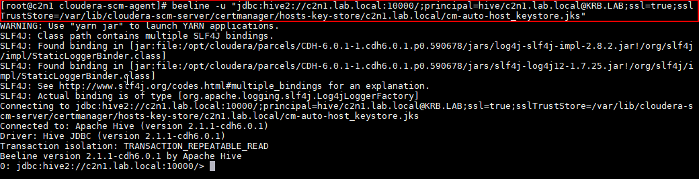

OU

> beeline

> !connect jdbc:hive2://c2n1.lab.local:10000/;principal=hive/c2n1.lab.local@KRB.LAB;ssl=true;sslTrustStore=/var/lib/cloudera-scm-server/certmanager/hosts-key-store/c2n1.lab.local/cm-auto-host_keystore.jks

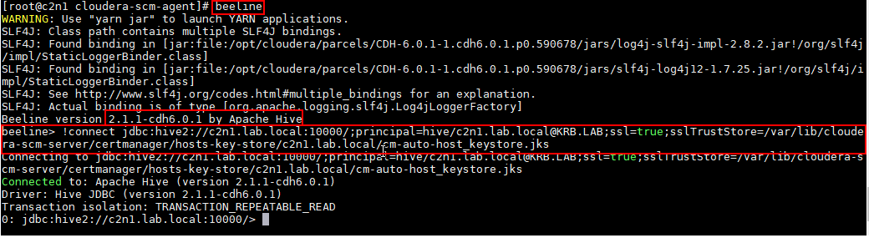

## Corrigir beeline

## 

1. cd /usr/bin
2. mv beeline beeline.bkp
3. ln -s /opt/cloudera/parcels/CDH-5.14.2-1.cdh5.15.2.p0.3/bin/beeline beeline