Fail Case Report

Summary
Total Cases | Pass | Fail
12 | 10 | 2

Section 1: Fail Cases from login_test_data.csv
TestCaseID: TC11, Username: ghost, Password: xxxx, Expected: Login successful
TestCaseID: TC12, Username: intruder, Password: passX, Expected: Login failed

Section 2: Fail Cases from browser_test_log.csv
TestCaseID: TC11, Username: ghost, Password: xxxx, Expected: Login successful, Actual: Login failed, Timestamp: 20260514_114321
TestCaseID: TC12, Username: intruder, Password: passX, Expected: Login failed, Actual: Login successful, Timestamp: 20260514_114322

Section 3: Screenshots of Fail Cases
TC11 - ghost
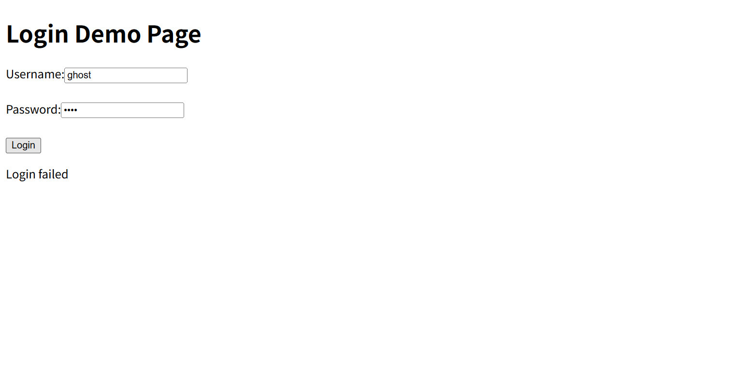
TC12 - intruder
