Final Screendump Report

TC1 – Valid login with tomsmith / SuperSecretPassword!
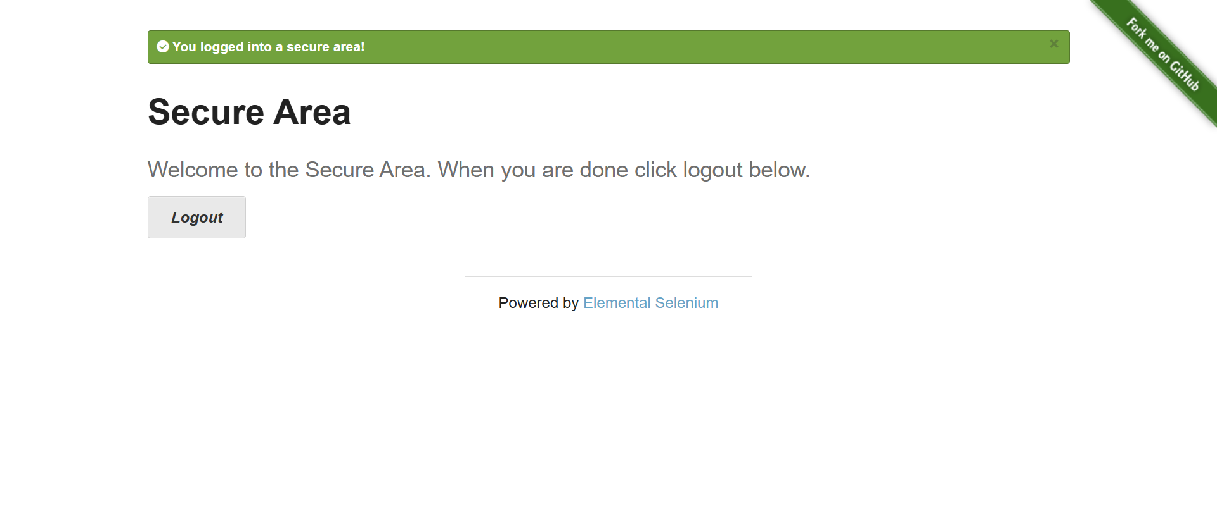
Evidence: login_success.png

TC2 – Survey submitted successfully with sample data
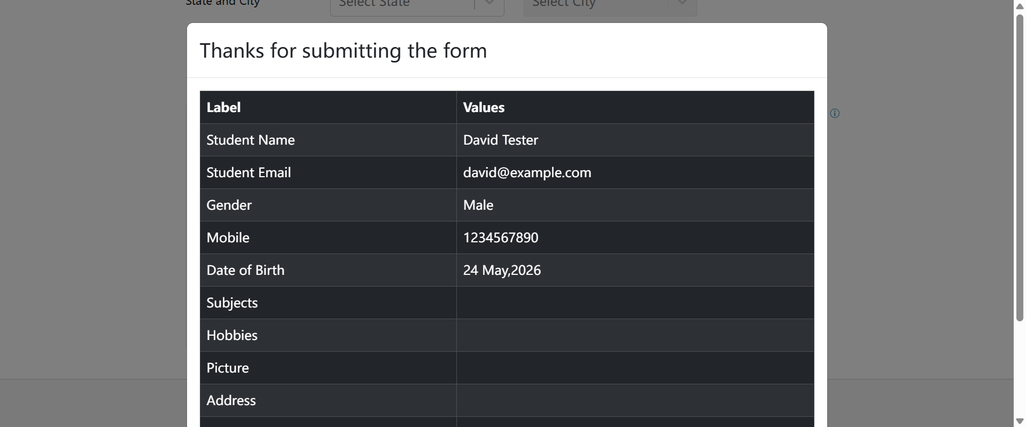
Evidence: survey_success.png

TC3 – Invalid login attempt with wronguser / wrongpass
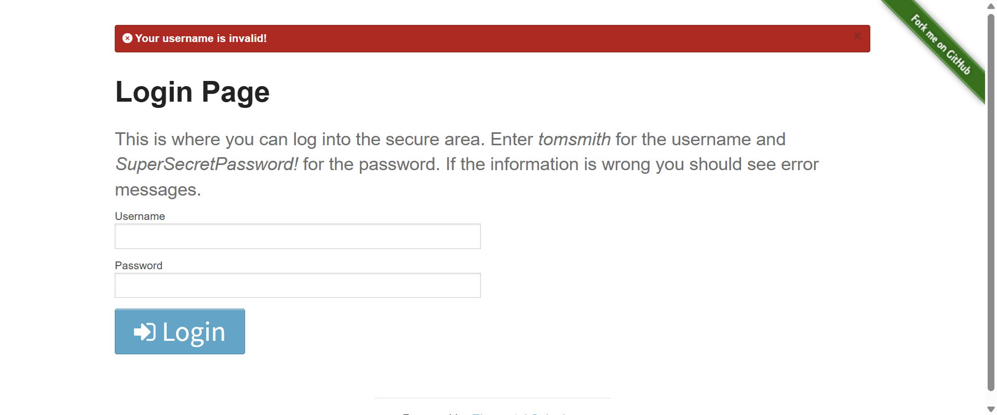
Evidence: login_invalid.png

TC4 – Invalid email format entered (abc123)

Evidence: email_invalid.png

TC5 – Invalid mobile number entered (123ABC)

Evidence: mobile_invalid.png

TC6 – Weak password entered (123)
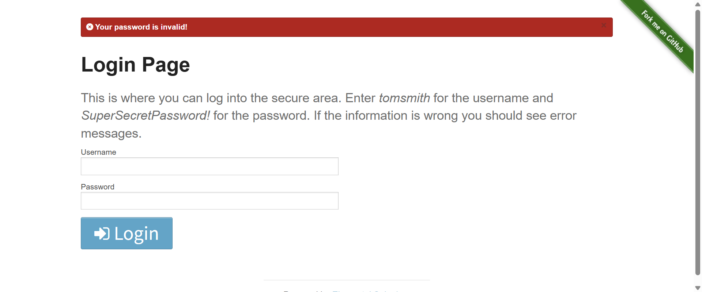
Evidence: password_invalid.png

TC7 – Session timeout after 10s idle, forced logout
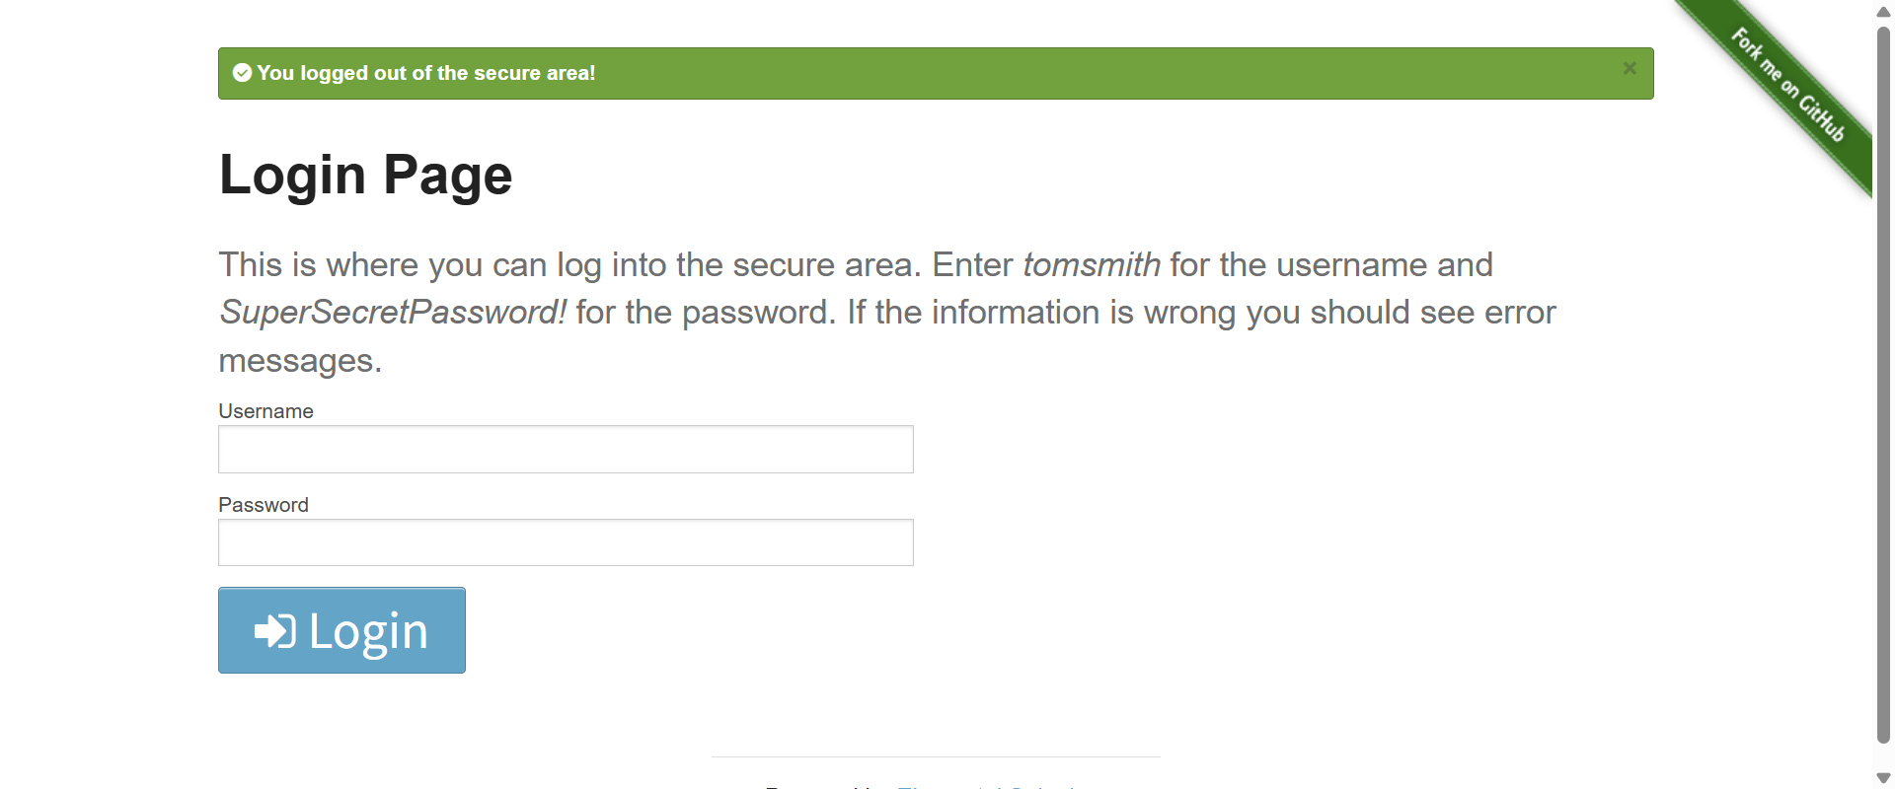
Evidence: session_timeout.png

TC8 – SQL injection attempt (' OR '1'='1) rejected

Evidence: sql_injection.png

TC9 – XSS attempt (<script>alert('XSS')</script>) rejected

Evidence: xss_prevention.png

TC10 – Boundary test with 256‑char username/password rejected

Evidence: boundary_validation.png

