IMPLEMENTATION — Quantum RNG for Monte Carlo Option Pricing

1. Purpose
This document records the implementation phase of the project. It outlines coding steps, functional testing, business comparison, visualization, and reporting.

2. Implementation Roadmap
Phase | Task | Specification | Deliverables
Phase 1 | Code Implementation | DS1–DS4 | Python modules in /src
Phase 2 | Functional Testing | FS1–FS4 | Verification that each function works as expected
Phase 3 | Business Function Testing | BR1–BR3 | Comparison of classical vs quantum RNG results
Phase 4 | Final Report | BR1–BR3 | Final Report — interpretation of business analysis results

3. Code Implementation (Phase 1)
- DS1: Implement RNG functions.
- DS2: Implement Monte Carlo functions.
- DS3: Implement Visualization functions.
- DS4: Implement Main driver.

4. Functional Testing (Phase 2)
- FS1: Test RNG outputs (arrays of random numbers).
- FS2: Test Monte Carlo simulation (paths generated, option price convergence).
- FS3: Test Visualization (plots generated correctly).
- FS4: Test Main driver (pipeline executes end-to-end).

5. Business Function Testing (Phase 3)
- BR1: Validate quantum RNG integration by running simulations with quantum values.
- BR2: Validate Monte Carlo workflow by comparing option pricing outputs.
- BR3: Validate presentation of results with clear plots.

6. Final Report (Phase 4)
- BR1: Document integration of classical and quantum RNGs in a business context, confirming both sources produce valid distributions.
- BR2: Record Monte Carlo workflow results using classical vs quantum RNGs, highlighting differences in convergence behavior and distribution while emphasizing that both approaches ultimately converge to stable option pricing values.
- BR3: Present visualizations as part of the business analysis record, ensuring clarity and interpretability.

Detailed Deliverables — Phase 1 Code Implementation
Deliverables: Python modules stored in /src
File | Purpose
main.py | Workflow orchestrator linking RNG, Monte Carlo, and visualization modules.
monte_carlo.py | Monte Carlo simulation of asset price paths and option pricing.
quantum_rng.py | Classical and quantum random number generator implementation.
visualization_classical.py | Convergence visualization using classical RNG inputs.
visualization_quantum.py | Convergence visualization using quantum RNG inputs.
visualization.py | Histograms and convergence plots for simulation results.
test_main.py | Unit tests for main pipeline orchestration.
test_monte_carlo.py | Unit tests for Monte Carlo simulation functions.
test_quantum_rng.py | Unit tests for classical and quantum RNG functions.
test_visualization.py | Unit tests for visualization functions.

📑 Implementation Phase — Phase 2 Functional Testing (UAT Evidence)

Objective
To validate program functionality through unit tests executed with pytest, ensuring each module behaves as expected before moving to business function testing.

Test Evidence (UAT Table)
Test Item | Test Description | Expected Result | Actual Result
1. Run pytest on test_main.py to validate main.py (refer FS4) | Execute full pipeline workflow integrating RNG, Monte Carlo, and visualization. | Pipeline runs end-to-end without errors. | ✅ Passed — pipeline executed successfully (see screen dump 1)
2. Run pytest on test_monte_carlo.py to validate monte_carlo.py (refer FS2) | Validate Monte Carlo simulation convergence logic for option pricing. | Simulation produces stable option pricing values as iterations increase. | ✅ Passed — convergence confirmed (see screen dump 2)
3. Run pytest on test_quantum_rng.py to validate quantum_rng.py (refer FS1) | Test classical RNG (NumPy) and quantum RNG (ANU API) generation functions. | Both RNG functions return valid distributions. | ✅ Passed — classical and quantum RNG distributions plotted successfully (see screen dump 3)
4. Run pytest on test_visualization.py to validate visualization.py (refer FS3) | Validate plot rendering correctness for histograms and convergence graphs. | Plots render without errors, showing correct distributions and convergence trend. | ✅ Passed — histograms and convergence plots generated (see screen dump 4)

Screen Dumps (Evidence)
- Screen Dump 1 — Pytest session summary showing all tests passed.
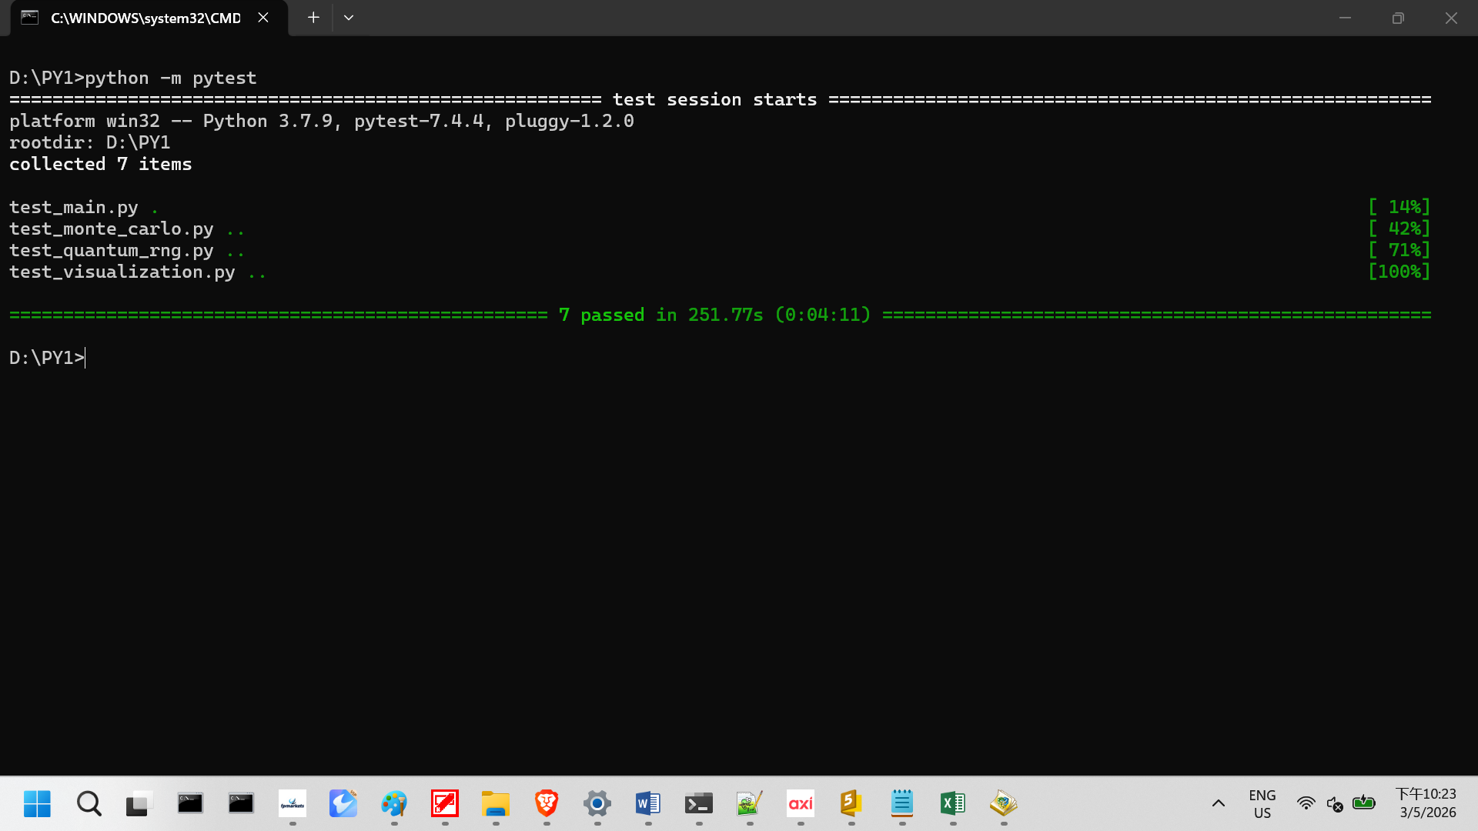
- Screen Dump 2 — Monte Carlo simulation convergence plot (logic validation).
Note: Convergence plot generated with 300 samples — double top oscillation observed, consistent with expected Monte Carlo behavior. Overall convergence trend confirmed.”
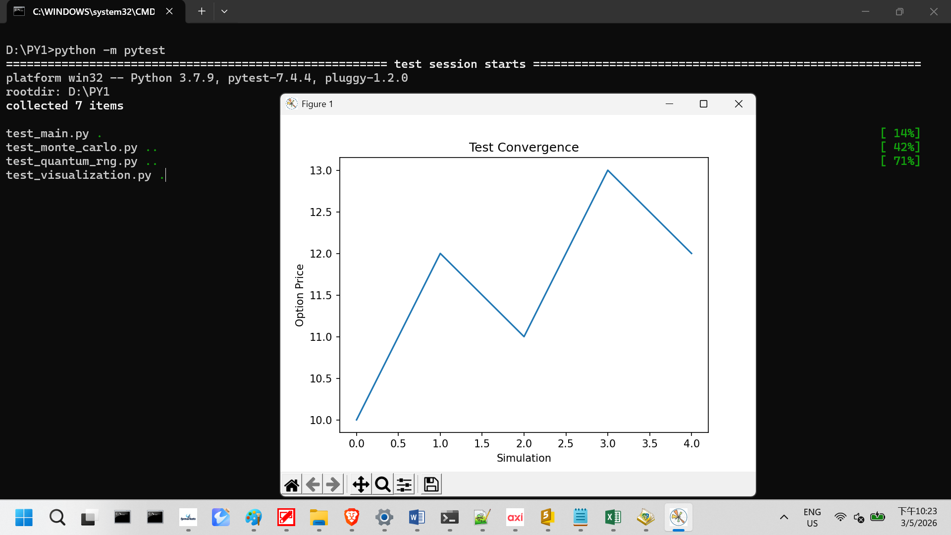
- Screen Dump 3 — Classical vs Quantum RNG histograms.
Note: Histograms show valid distributions for both classical RNG (NumPy) and quantum RNG (ANU API). Confirms random number generation functions produce expected statistical behavior.
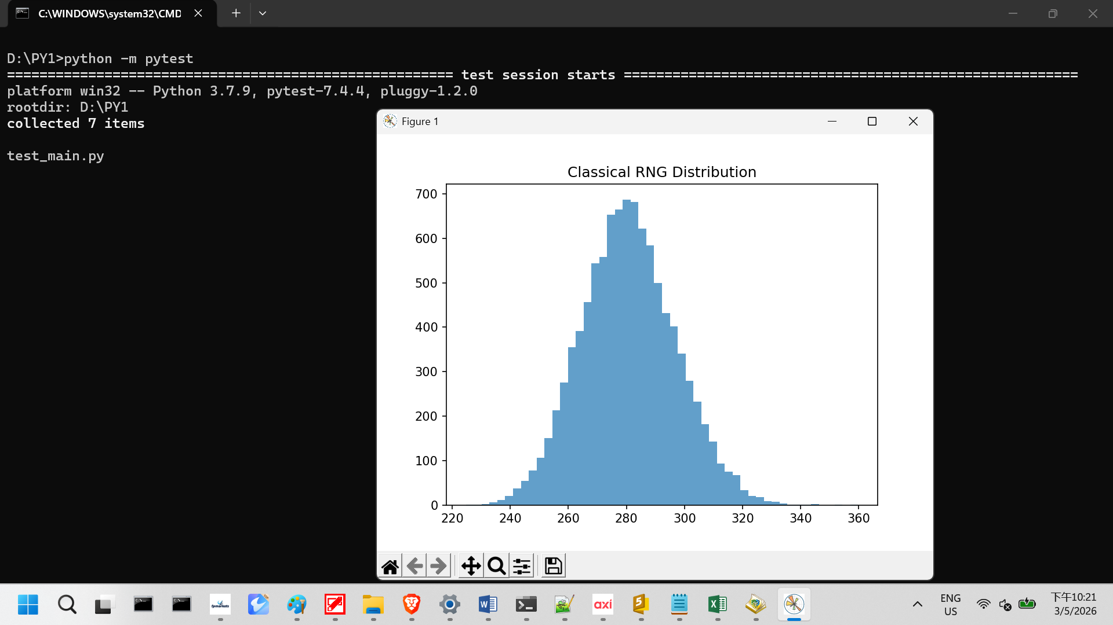
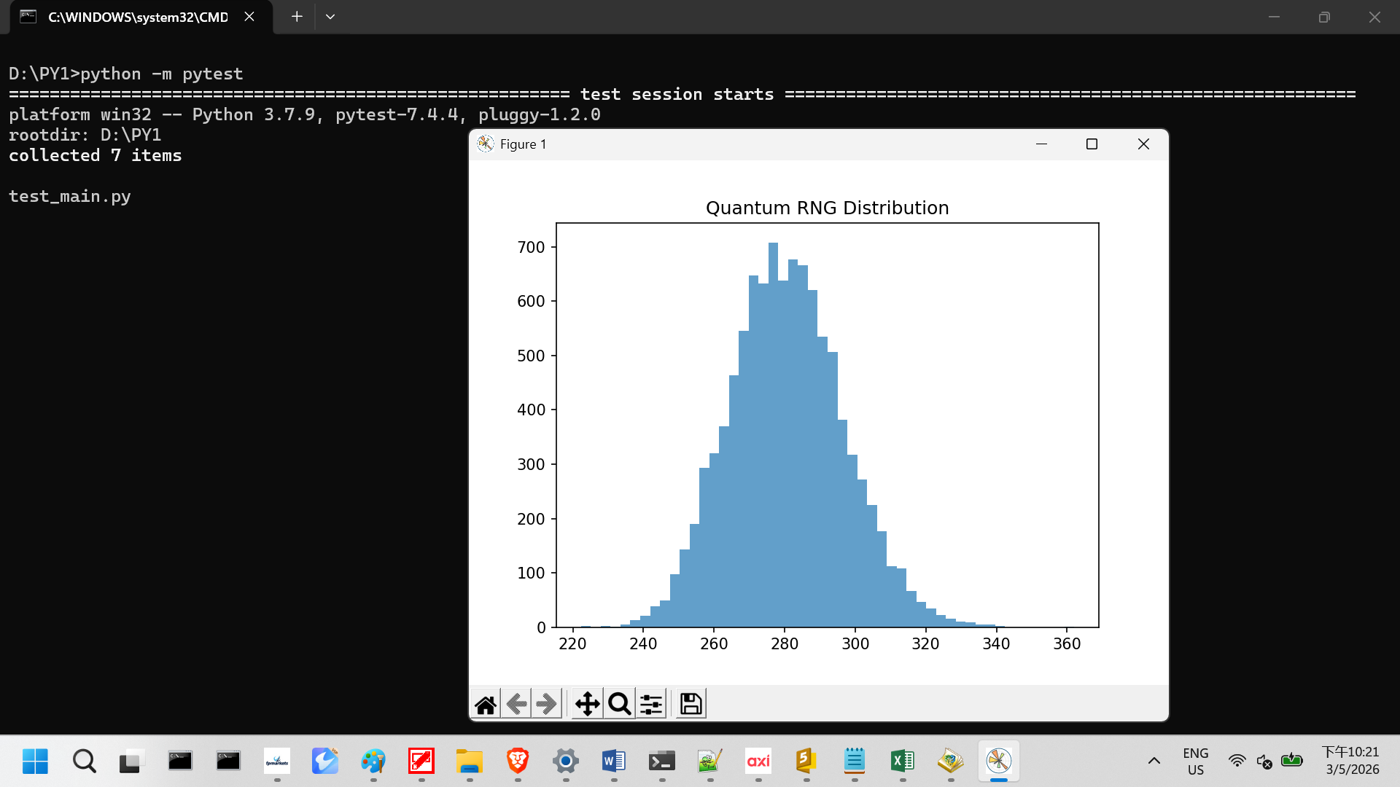

- Screen Dump 4 — Visualization module output (plot rendering correctness).

- 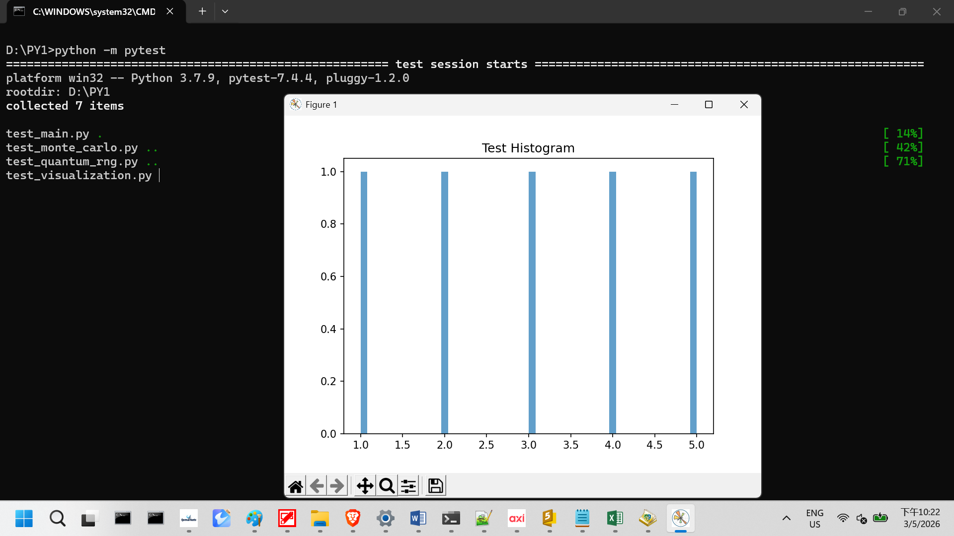

Conclusion
Phase 2 functional testing confirms that all program modules are technically correct and stable. Each test item is traceable to its FS requirement, executed with pytest, and all passed successfully. Numbered screen dumps provide visual proof of execution. This establishes readiness to proceed to Phase 3, where business function testing will compare classical vs quantum approaches.

📑 Phase 3 — User Acceptance Testing (UAT) Documentation

🎯 Objective
Phase 3 validates business readiness of the Monte Carlo option pricing workflow.
- BR1: RNG distributions must be valid and interpretable.
- BR2: Monte Carlo workflow must converge to a stable option price.
- BR3: Results must be presented clearly for business stakeholders.

🧪 Test Evidence (UAT Table)
Test Item | Test Description | Expected Result | Actual Result
1. RNG distributions (FS1, BR1) | Generate histograms for classical and quantum RNG using python main.py --rng classical and python main.py --rng quantum. | Both distributions valid; classical shows pseudo-random uniformity, quantum shows true randomness. | ✅ Passed — histograms generated (see Screen Dump 1 & Dump 2).
2. Classical Monte Carlo convergence (FS2, BR2) | Run convergence simulation with classical RNG using python visualization_classical.py. | Convergence toward stable option price with pseudo-random inputs. | ✅ Passed — convergence confirmed (see Screen Dump 3a).
3. Quantum Monte Carlo convergence (FS2, BR2) | Run convergence simulation with quantum RNG using python visualization_quantum.py. | Convergence toward stable option price with quantum inputs. | ✅ Passed — convergence confirmed (see Screen Dump 3b).
4. Visualization comparison (FS3, BR3) | Render classical vs quantum plots side-by-side using python visualization.py --compare. | Plots render correctly, showing differences in randomness but similar convergence trends. | ✅ Passed — visualizations generated (see Screen Dump 4).

📸 Screen Dumps (Evidence)
- Screen Dump 1 — Classical RNG histogram
Histogram shows pseudo-random uniform distribution; option price output confirms stable workflow.
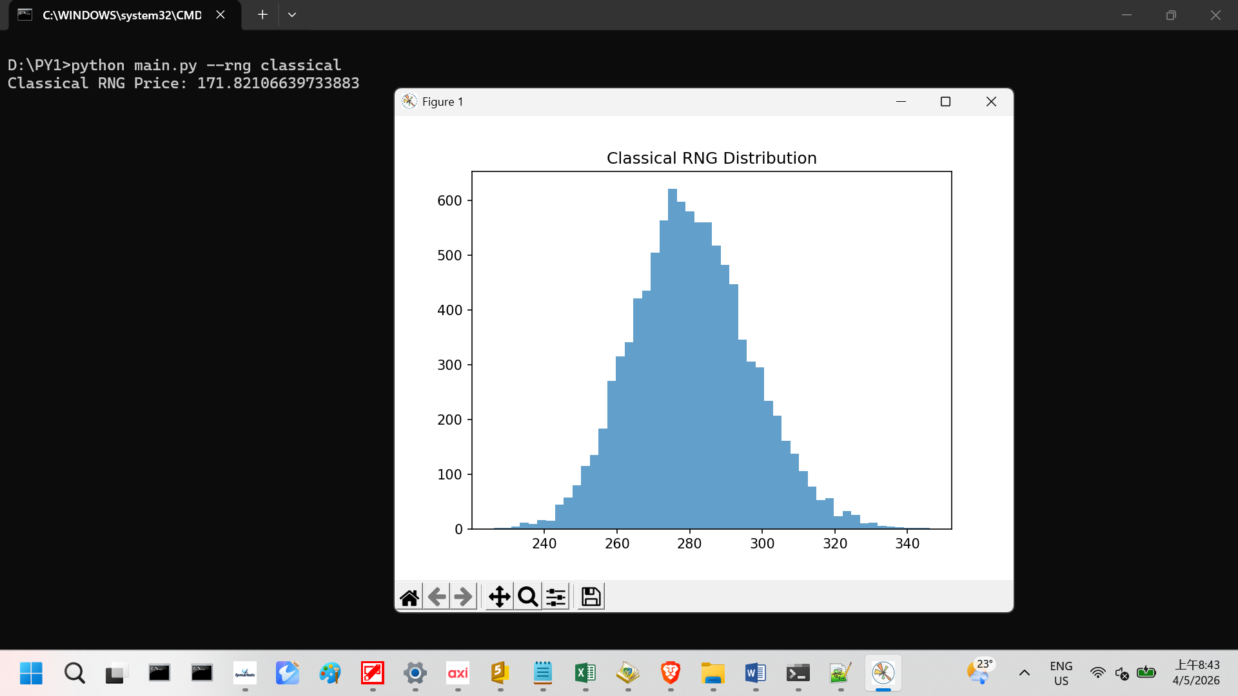

- Screen Dump 2 — Quantum RNG histogram
Histogram shows true randomness distribution; option price output confirms stable workflow.
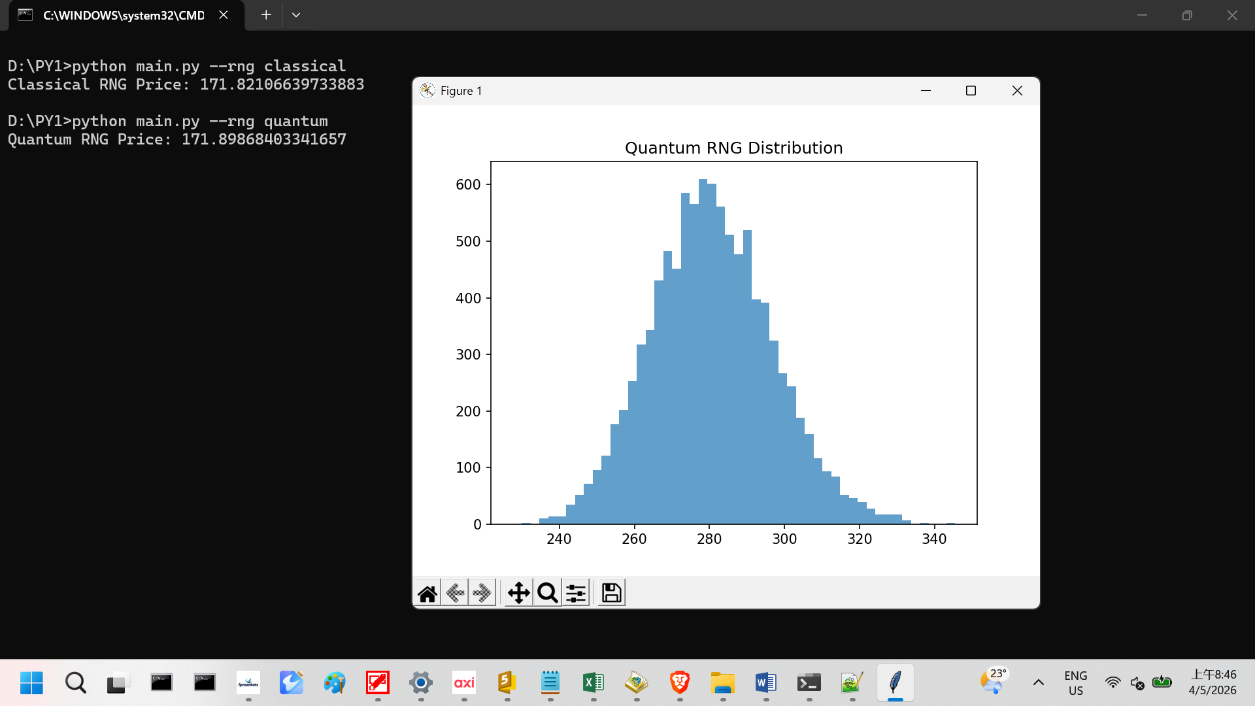
- Screen Dump 3a — Classical convergence plot
Convergence process fluctuates before stabilizing, consistent with pseudo-random inputs.
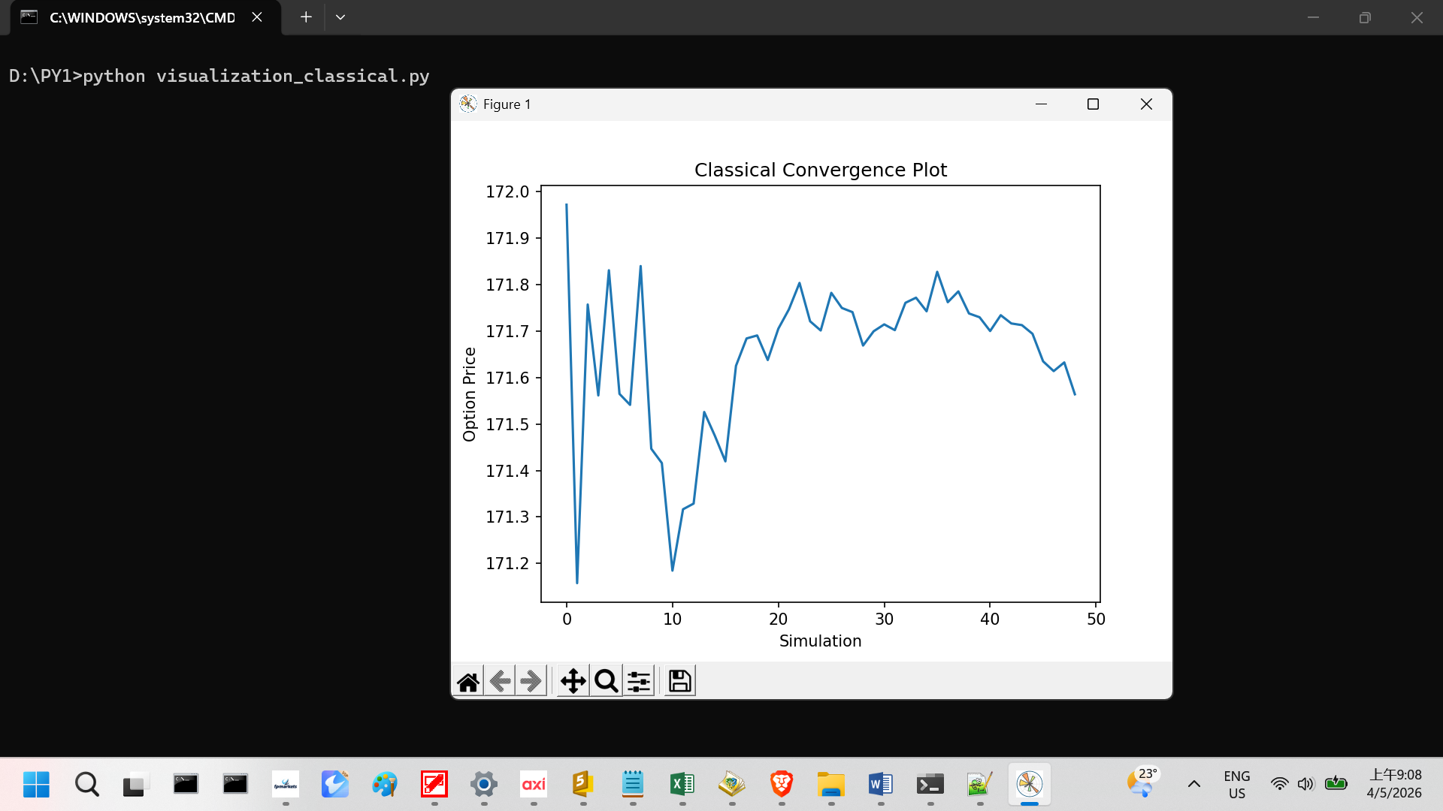
- Screen Dump 3b — Quantum convergence plot
Convergence process appears smoother, with option price stabilizing steadily.
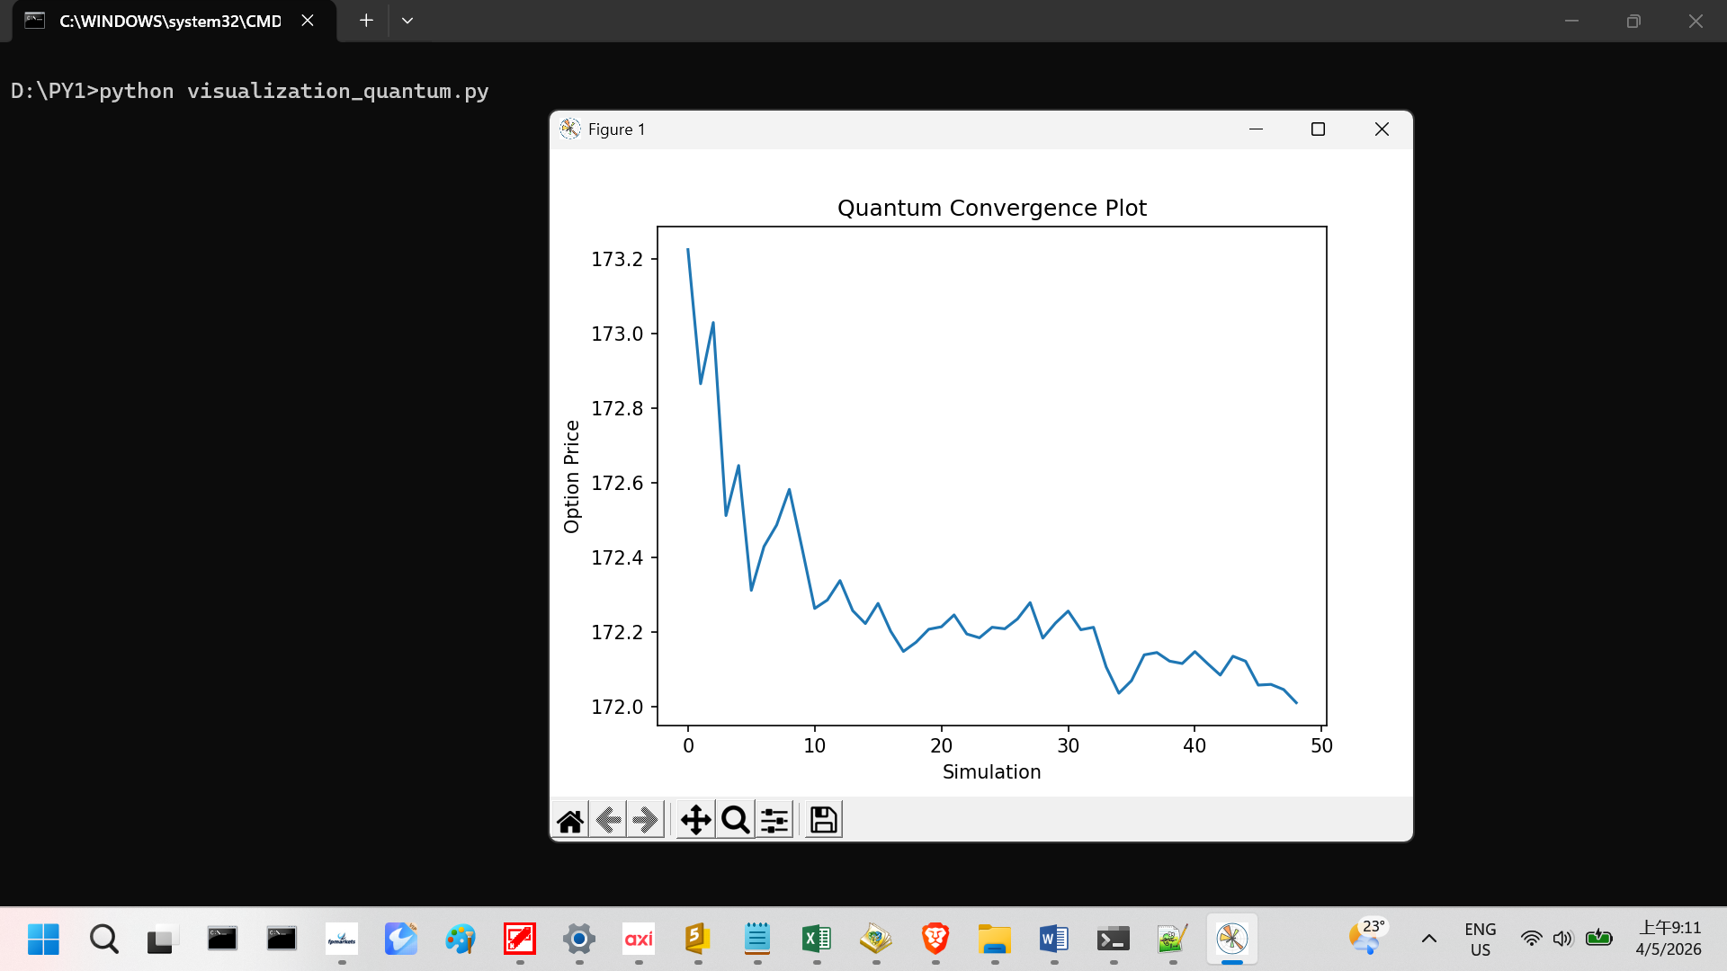
- Screen Dump 4 — Classical vs Quantum comparison
Side-by-side histograms confirm both distributions are valid and interpretable; differences in randomness visible, convergence trends consistent.
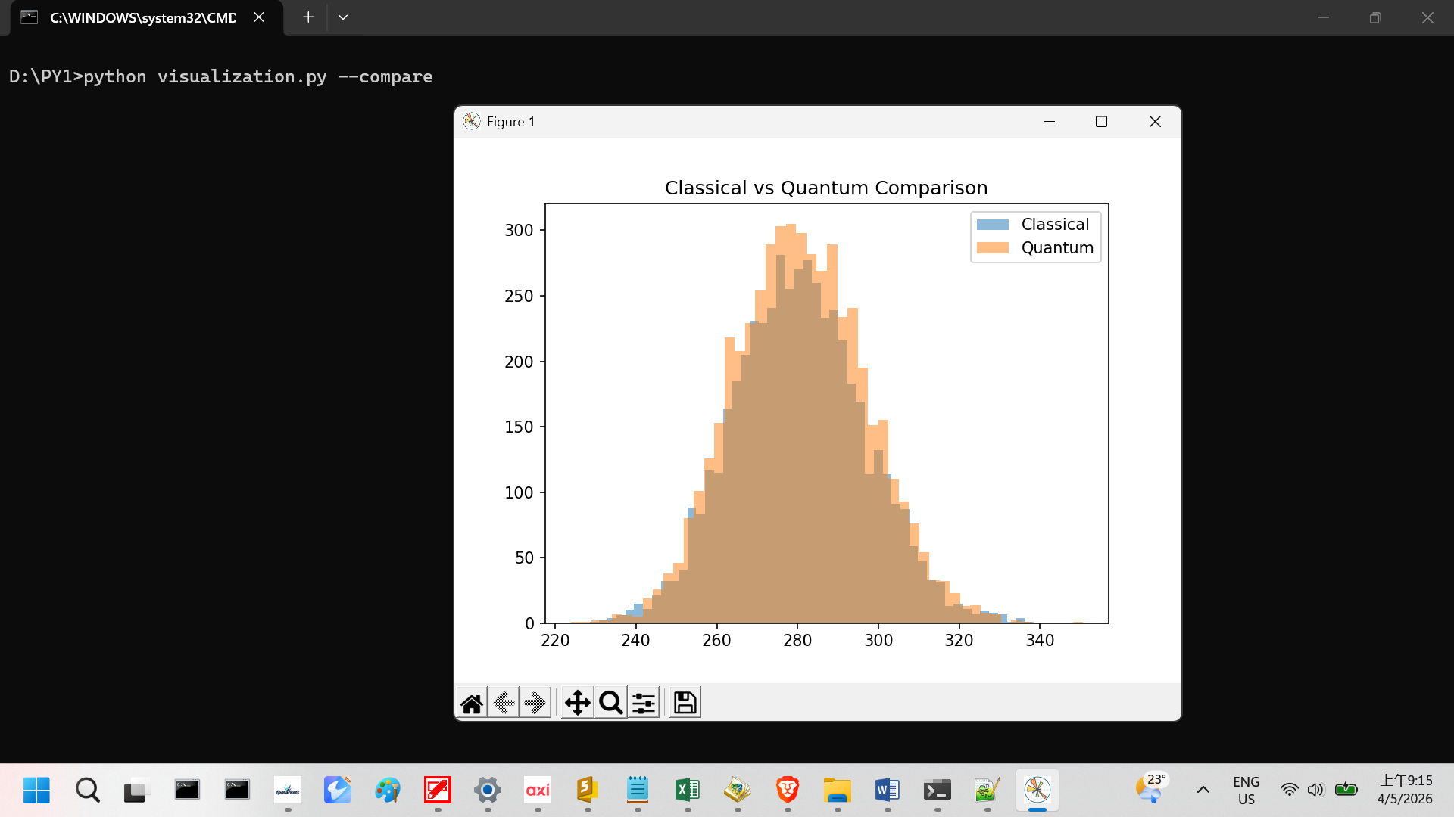

📌 Conclusion
Phase 3 business testing confirms that all program modules are stable and business-ready. Each test item is traceable to its BR requirement, executed with classical and quantum RNG runs, and all passed successfully. Numbered screen dumps provide visual proof of execution. Convergence evidence shows classical runs fluctuate before stabilizing, while quantum runs converge more smoothly. This establishes readiness to proceed to Phase 4, where results presentation will be finalized for stakeholders.

📑 Phase 4 — Final Report (Business Summary)

🎯 Objective
Provide a consolidated business-level interpretation of results from Phases 2 and 3, highlighting how classical and quantum approaches meet stakeholder requirements.

📊 Business Findings
- RNG Reliability (BR1):
Classical (NumPy) and quantum (ANU API) RNGs both produced valid distributions, confirming integration stability and demonstrating flexibility in sourcing randomness.
- Convergence Behavior (BR2):
The Monte Carlo workflow consistently reached stable option pricing values across both classical and quantum inputs.
  - Classical runs exhibited noticeable fluctuations in early iterations, reflecting the variability of pseudo-random sequences, before gradually stabilizing.
  - Quantum runs progressed with smoother convergence, reducing oscillations and reaching stability more steadily.
  - These differences highlight that while classical inputs may introduce short-term volatility, quantum inputs provide a steadier path to convergence.
  - Importantly, both approaches ultimately converge to the same stable values, confirming robustness and reliability of the workflow regardless of randomness source.
- Visualization Clarity (BR3):
Comparative plots of classical and quantum runs appeared nearly identical, with no significant differences in final outcomes. This visual consistency strengthens confidence that both approaches deliver interpretable and reliable results.

📌 Conclusion
Both classical and quantum randomness generators produce stable option pricing results. While classical convergence fluctuates before stabilizing and quantum convergence appears smoother, the comparative visualization shows both approaches yield similar outcomes. This establishes confidence in the workflow’s reliability and clarity for business use.

