Introduction
This document introduces how to install Apache, SVN and combine them both. Prepared by Arain.

Contact Me
QQ Group: 117592576
Website: http://www.svnclub.com

Soft wares will be used in the document:
1. Apache: 2.2.14
Download address:
http://archive.apache.org/dist/httpd/binaries/win32/
apache_2.2.14-win32-x86-openssl-0.9.8k.msi
2, Subversion: 1.6.6
Download address:
http://subversion.tigris.org/servlets/ProjectDocumentList?folderID=91&expandFolder=91&folderID=74
Setup-Subversion-1.6.6.msi

Apache Installation:
1. Double-click the apache installation file: apache_2.2.14-win32-x86-openssl-0.9.8k.msi until you encounter a dialog box like following picture. Input the information accordingly and click Next.
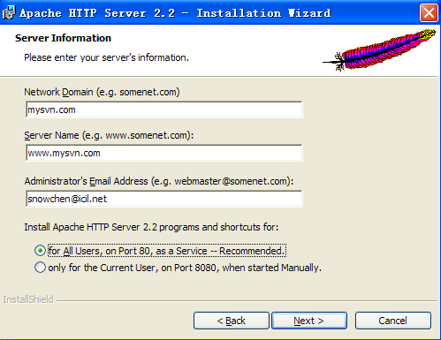

2. Finish the installation is an easy job. But a possible result is you cannot start httpd service directory (mostly say the port80 socked is occupied by other service). At this time please don’t be afraid, navigate to the apache installation path, here I used the default path: C:\Program Files\Apache Software Foundation\Apache2.2\conf , then edit the file: httpd.conf like this:

…
ServerRoot "C:/Program Files/Apache Software Foundation/Apache2.2"

#
# Listen: Allows you to bind Apache to specific IP addresses and/or
# ports, instead of the default. See also the <VirtualHost>
# directive.
#
# Change this to Listen on specific IP addresses as shown below to
# prevent Apache from glomming onto all bound IP addresses.
#
#Listen 12.34.56.78:80
Listen 8888
#
# Dynamic Shared Object (DSO) Support
#
# To be able to use the functionality of a module which was built as a DSO you
# have to place corresponding `LoadModule' lines at this location so the
# directives contained in it are actually available _before_ they are used.
# Statically compiled modules (those listed by `httpd -l') do not need
…

The default listen port is 80(occupied by other service), here I change to 8888. Then try to start httpd service manually(My Computere -> Manager -> Services and Applications -> Services -> Apache2.2).

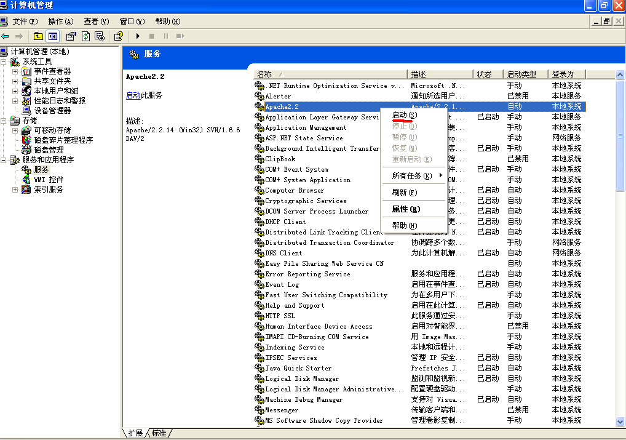

At this time, try to access: http://localhost:8888/ on the browser of your local PC and display following result means you success! What a great job you have done!


Subversion Installation:
- Double-click the SVN installation file: Setup-Subversion-1.6.6.msi and you almost needn’t do any operation and finish all the steps.
- Add bin path of SVN to system path variables to let apache find the related files and you use SVN commands everywhere, here I use the bin path: C:\Program Files\Subversion\bin. Know how to add it? If no, please try step by step by following:
  - Single-click: My Computer -> Properties -> Advanced -> Environment Variables -> System variables -> Path (Double-click to Edit it) -> Variable Value
  - In the Variable Value dialog box add the SVN bin path: C:\Program Files\Subversion\bin
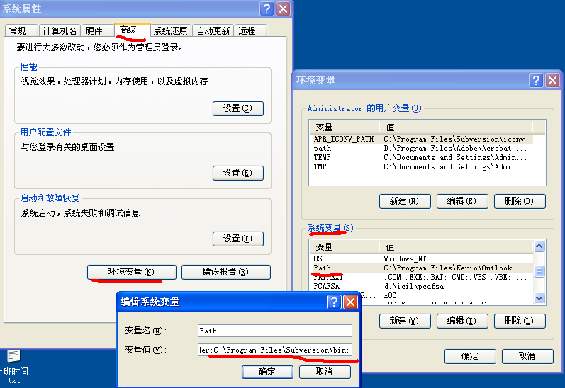

  - Add the Apache bin path to to system path variables and you can use Apache commands everywhere. Here I used: C:\Program Files\Apache Software Foundation\Apache2.2\bin. You do know how to add it, right?
  - Restart PC. This is important because if you skip it you may encounter many unknown troubles.

Apache & SVN combination
- Copy two SVN modules (mod_authz_svn.so, mod_dav_svn.so) from SVN bin directory to Apache modules directory.
SVN bin directory:
C:\Program Files\Subversion\bin
Apache modules directory:
C:\Program Files\Apache Software Foundation\Apache2.2\modules
- Modify Apache configuration file: httpd.conf (C:\Program Files\Apache Software Foundation\Apache2.2\conf). The location parts always locate at the end the file.

…
# Dynamic Shared Object (DSO) Support
#
# To be able to use the functionality of a module which was built as a DSO you
# have to place corresponding `LoadModule' lines at this location so the
# directives contained in it are actually available _before_ they are used.
# Statically compiled modules (those listed by `httpd -l') do not need
# to be loaded here.
#
# Example:
# LoadModule foo_module modules/mod_foo.so
#
LoadModule actions_module modules/mod_actions.so
LoadModule alias_module modules/mod_alias.so
LoadModule asis_module modules/mod_asis.so
LoadModule auth_basic_module modules/mod_auth_basic.so
#LoadModule auth_digest_module modules/mod_auth_digest.so
#LoadModule authn_alias_module modules/mod_authn_alias.so
#LoadModule authn_anon_module modules/mod_authn_anon.so
#LoadModule authn_dbd_module modules/mod_authn_dbd.so
#LoadModule authn_dbm_module modules/mod_authn_dbm.so
LoadModule authn_default_module modules/mod_authn_default.so
LoadModule authn_file_module modules/mod_authn_file.so
#LoadModule authnz_ldap_module modules/mod_authnz_ldap.so
#LoadModule authz_dbm_module modules/mod_authz_dbm.so
LoadModule authz_default_module modules/mod_authz_default.so
LoadModule authz_groupfile_module modules/mod_authz_groupfile.so
LoadModule authz_host_module modules/mod_authz_host.so
#LoadModule authz_owner_module modules/mod_authz_owner.so
LoadModule authz_user_module modules/mod_authz_user.so
LoadModule autoindex_module modules/mod_autoindex.so
#LoadModule cache_module modules/mod_cache.so
#LoadModule cern_meta_module modules/mod_cern_meta.so
LoadModule cgi_module modules/mod_cgi.so
#LoadModule charset_lite_module modules/mod_charset_lite.so
LoadModule dav_module modules/mod_dav.so
LoadModule dav_fs_module modules/mod_dav_fs.so
#LoadModule dav_lock_module modules/mod_dav_lock.so
#LoadModule dbd_module modules/mod_dbd.so
#LoadModule deflate_module modules/mod_deflate.so
LoadModule dir_module modules/mod_dir.so
#LoadModule disk_cache_module modules/mod_disk_cache.so
#LoadModule dumpio_module modules/mod_dumpio.so
LoadModule env_module modules/mod_env.so
#LoadModule expires_module modules/mod_expires.so
#LoadModule ext_filter_module modules/mod_ext_filter.so
#LoadModule file_cache_module modules/mod_file_cache.so
#LoadModule filter_module modules/mod_filter.so
#LoadModule headers_module modules/mod_headers.so
#LoadModule ident_module modules/mod_ident.so
#LoadModule imagemap_module modules/mod_imagemap.so
LoadModule include_module modules/mod_include.so
#LoadModule info_module modules/mod_info.so
LoadModule isapi_module modules/mod_isapi.so
#LoadModule ldap_module modules/mod_ldap.so
#LoadModule logio_module modules/mod_logio.so
LoadModule log_config_module modules/mod_log_config.so
#LoadModule log_forensic_module modules/mod_log_forensic.so
#LoadModule mem_cache_module modules/mod_mem_cache.so
LoadModule mime_module modules/mod_mime.so
#LoadModule mime_magic_module modules/mod_mime_magic.so
LoadModule negotiation_module modules/mod_negotiation.so
#LoadModule proxy_module modules/mod_proxy.so
#LoadModule proxy_ajp_module modules/mod_proxy_ajp.so
#LoadModule proxy_balancer_module modules/mod_proxy_balancer.so
#LoadModule proxy_connect_module modules/mod_proxy_connect.so
#LoadModule proxy_ftp_module modules/mod_proxy_ftp.so
#LoadModule proxy_http_module modules/mod_proxy_http.so
#LoadModule rewrite_module modules/mod_rewrite.so
LoadModule setenvif_module modules/mod_setenvif.so
#LoadModule speling_module modules/mod_speling.so
#LoadModule ssl_module modules/mod_ssl.so
#LoadModule status_module modules/mod_status.so
#LoadModule substitute_module modules/mod_substitute.so
#LoadModule unique_id_module modules/mod_unique_id.so
#LoadModule userdir_module modules/mod_userdir.so
#LoadModule usertrack_module modules/mod_usertrack.so
#LoadModule version_module modules/mod_version.so
#LoadModule vhost_alias_module modules/mod_vhost_alias.so
LoadModule dav_svn_module modules/mod_dav_svn.so
LoadModule authz_svn_module modules/mod_authz_svn.so

<IfModule !mpm_netware_module>
<IfModule !mpm_winnt_module>
…

<Location /svn/>
Dav svn
SVNParentPath "C:/svn/repository"
AuthType Basic
AuthName "ICIL SVN"
SVNListParentPath on
AuthUserFile "C:/svn/userfile.txt"
AuthzSVNAccessFile "C:/svn/accessfile.txt"
Require valid-user
</Location>

Here I simply explain some location parts options:
SVNParentPath---------Under where locate all repository
AuthUserFile------------User account file (need use apache command htpasswd to create)
AuthzSVNAccessFile—Permission setting file (create the file by hands)

- Create a SVN repository. Use svnadmin command to create a repository. After that you can find there is a folder named MyProject created on C:/svn/repository.

Note: You should first navigate to SVNParentPath: C:/svn/repository first and then run the command.

- Create SVN user account file. Cause before I set the AuthUserFile path: C:/svn/userfile.txt, I navigate to the folder on dos window and run: htpasswd –c userfile.txt username to create the file. After run the command, you can find the file has been created on C:/svn/.
Note: -c option means create the user account file, next time if you want to add another user you needn’t use this option, cause the file existed already.
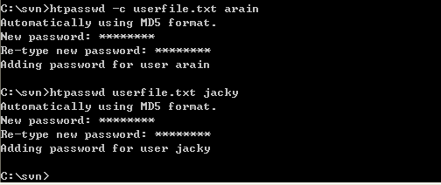

- Create permission file. Cause before I set the AuthzSVNAccessFile path: C:/svn/accessfile.txt, so you just manually create the file accessfile.txt on C:/svn/. The file contents can like this:

[/]
*=r
[test:/]
arain=rw
jacky=rw

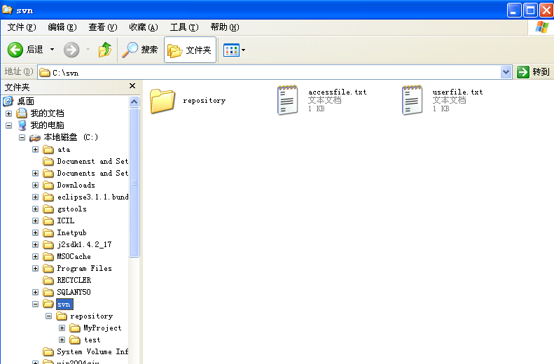

Finally, try to restart Apache service manually, you know how to do that, right (If not please review Apache Installation section again)?
Then try to access SVN repository on browser: http://localhost:8888/svn/MyProject. If you can see following pictures means you are successful! What a great great job you have done! You must be very very excited now, right? Ha ha.

