Part 2: Configure A Serverless Backend on AWS

**Author**: [David P. Lopez](http://www.DavidPLopez.com)  
**Publisher**: [UniqueSoftwareDevelopment](https://www.uniquesoftwaredev.com)

This is a continuation of our multi-part series on building a simple web application on [AWS](https://aws.amazon.com) using [AWS Lambda](https://aws.amazon.com/lambda) and the [ServerlessFramework](https://serverless.com/framework/docs/). You can review the first part of this series starting with the setup of your local environment at:

* [Part 1: How To SetUp Your local Serverless Environment](https://github.com/lopezdp/TechnicalArticles/blob/master/HowToSetUpYourLocalServerlessEnvironment.md)

You can also clone a sample of the application we will be using in this tutorial here: [Serverless-Starter-Service](https://github.com/lopezdp/ServerlessStarterService)

Please refer to this repo as you follow along with this tutorial.

The Serverless Architecture

Serverless programming and computing, or *serverless* for short, is a software architecture that enables an execution paradigm where the cloud service provider (AWS, Google Cloud, Azure) is the entity responsible for running a piece of backend logic that you write in the form of a stateless function. In our case we are using [AWS Lambda](https://aws.amazon.com/lambda). The cloud provider you choose to run your stateless function, is responsible for the execution of your code in the cloud, and will dynamically allocate the resources needed to run your backend logic, by abstracting the deployment infrastructure for you, so that you can focus on developing your product instead of auto-scaling servers. This paradigm is also known to be called *Functions As A Service or (FAAS)*, and the code will run inside of *stateless containers* that may be triggered by any number of events that can include: *cron-jobs, http requests, queuing services, database events, alerts, file uploads, etc.*

Serverless Considerations

Since the *serverless* paradigm abstracts away the need for an engineer to configure the underlying physical infrastructure typical to the deployment of a modern day application, in what is known as the new *Functions As A Service (FAAS)* reality, the following are a few considerations that should be kept in mind while we proceed through the development of our *Single Page Application*:

Stateless Computing

When we deploy a **serverless + microservice** architecture, the functions that we declare as a part of our application API, execute our application’s logic inside of stateless containers for us by our cloud service provider, or in our case [AWS](https://aws.amazon.com/). The significance of this is that our code does not run as it typically would be on a *server* that executes long after the event has completed. There is no prior execution context to serve a request to the users of your application when running [AWS Lambda](https://aws.amazon.com/lambda). Throughout the development of your serverless applications, you MUST assume that [AWS Lambda](AWS%20Lambda) will invoke your function as if it is in its first application state every time, and with no contextual data to work with, because your function will not be handling concurrent requests. Your backend is stateless, and each function should strive to return an *idempotent* response.

Serverless + Microservices

When developing a *serverless* application, we need to make sure that the application is structured in a way in which the functions we declare as part of the backend logic, are defined in the form of individual services that mimic a *microservice* based architecture so that we may better be able to reduce the size of our functions. The goal is to *loosely couple* the functionality between the services deployed as a part of the serverless backend, so that each function handles an independent piece of functionality that will provide a user with a response that does not rely on any other service.

Cold Starts  
  
Because our functions execute inside of a stateless container that our cloud service provider manages for us, in our case [AWS](https://aws.amazon.com/), there is a bit of latency associated with each http request to our serverless "backend". Our stateless infrastructure is dynamically allocated to respond to the events triggered by our application, and although the container is typically kept "alive" for a short time after completion of the [Lambda's](https://aws.amazon.com/lambda) functionality, the resources will be deallocated and will lead to slower than expected/desired responses for new requests. We refer to these situations as *Cold Starts*.

*Cold Start* durations will typically last from a couple of hundred milliseconds to up to a few seconds. The size of the functions and the runtime language used can vary the *Cold Start* duration time in [AWS Lambda](https://aws.amazon.com/lambda). It is important to understand that our serverless containers *can* remain in an Active state in [AWS Lambda](https://aws.amazon.com/lambda), after the first request to our serverless endpoint has completed its execution routine. If a subsequent request to our [Lambda](https://aws.amazon.com/lambda) is triggered by our application immediately after the completed execution of a previous request, the serverless lambda that defines our endpoint in the cloud in our stateless containers on [AWS](https://aws.amazon.com/), will respond to this next request almost immediately and with little to no latency; this is called a *Warm Start*, and this is what we want to maintain to keep our application running optimally.

The wonderful thing about working with the [ServerlessFramework](https://serverless.com/framework/docs/) library is the robust community that contributes to its development and evolution as *Serverless* becomes more of a thing. Dynamically distributing resources programmatically to deploy applications to the cloud just feels more practical from where I am sitting as an *engineer* *working quietly on the cyber front*. Take a second to bookmark this [List of plugins developed by the community for the ServerlessFramework](https://github.com/Jimdo/plugins-serverless). We are going to use the [serverless-plugin-warmup](https://github.com/FidelLimited/serverless-plugin-warmup) package on *NPM*, to make sure that our functions keep warm and purring like my dad's old 1967 Camaro. I personally had a thing for *Lane Meyer's* (John Cusack) '67 Camaro in the [1980's *Cult Classic* *Better Off Dead*](https://www.youtube.com/watch?v=jfatrAqd22c)

**I want my $2!**

[](https://github.com/lopezdp/Tech)

Configure AWS Lambda & Decrease your Application’s Latency with Warm Starts

As discussed above, we will be keeping our [Lambda's](https://aws.amazon.com/lambda) warm during the hibernation season with [serverless-plugin-warmup](https://github.com/FidelLimited/serverless-plugin-warmup). In this next section, we will walk you through each step of the installation of this plugin. Remember, you can also refer to the sample of the application we will be using in this tutorial to follow along, here: [Serverless-Starter-Service](https://github.com/lopezdp/ServerlessStarterService).

<ServerlessWarmup> eliminates *Cold Start* latency by creating a [Lambda](https://aws.amazon.com/lambda) that will schedule and invoke all the services you select from your API, at a time interval of your choice, the default is set at 5-minutes. Thereby forcing your [Lambda's](https://aws.amazon.com/lambda) to stay warm. From within the root of you serverless project directory, continue to install [ServerlessWarmup](https://github.com/FidelLimited/serverless-plugin-warmup) as follows:

* **Run:** $ npm install --save-dev serverless-plugin-warmup

Add the following line to the plugin block in your serverless.yml file that you can find in the root of your service's directory:

plugins:

- serverless-plugin-warmup

Look at what my file looks like if you need a reference point:

**serverless.yml** plugin **block**

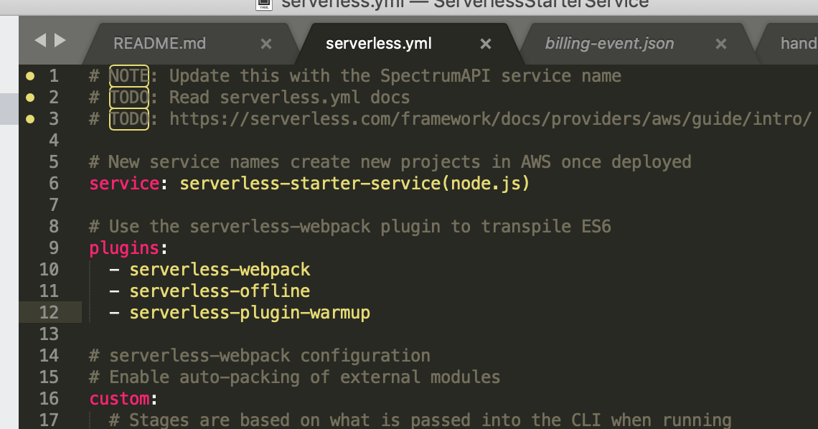

Moving along now, you will want to configure the `serverless-warmup-plugin` in the `custom:` block of your service's `serverless.yml` file. Remember, each service will always have its own `serverless.yml` file that will define the [AWS Lambda](https://aws.amazon.com/lambda) endpoints for each **serverless + microservice** implemented for each path defined in the `functions:` block of the file. There are a few configuration settings you can read more about at the `serverless-warmup` [Documentation repository](https://github.com/FidelLimited/serverless-plugin-warmup). Here we will go over what we think are the most important settings you should at least be familiar with for now. Your `custom:` block in your `serverless.yml` file should look something like this:

custom:

# Stages are based on what we pass into the CLI when running

# serverless commands. Or fallback to settings in provider section.

stage: ${opt:stage, self:provider.stage}

# Load webpack config

webpack:

webpackConfig: ./webpack.config.js

includeModules: true

# ServerlessWarmup Configuration

# See configuration Options at:

# https://github.com/FidelLimited/serverless-plugin-warmup

warmup:

enabled: true # defaults to false

folderName: '_warmup' # Name of folder generated for warmup

memorySize: 256

events:

# Run WarmUp every 60 minutes

- schedule: rate(60 minutes)

timeout: 20

Inside of our custom: block you need to declare a warmup: resource that serverless will use to create a new [Lambda](https://aws.amazon.com/lambda) function *On your Behalf* on [AWS](https://aws.amazon.com/) by the <ServerlessFramework>. Again, [Lambda](https://aws.amazon.com/lambda) is going to use the serverless-warmup-plugin to keep your **Serverless + Microservices** *warm*, and *latency-free*. The primary setting that we need to configure is enabled: true. By default, this attribute is set to false because this does have an impact on your *serverless + server* costs on <AWS>.

Warming up your [Lambda's](https://aws.amazon.com/lambda) means that they are computing for a longer time, and costing you more money. We will publish another article in the future that will show you how to determine these costs for you and your business. For now, please look at this [calculator](https://servers.lol) to help you estimate your monthly *compute* **OPEX** costs. We like this calculator at [Servers.LOL](https://servers.lol) because it gives you a tool that will let you compare your current <EC2> costs against your proposed [AWS Lambda](https://aws.amazon.com/lambda) Serverless costs.

The next property we think you need to know about is the - schedule: rate(60 minutes) attribute in the events: block. By default, the rate is set to 5-minutes. We think for the purpose of this demo application that we can leave it to once an hour to minimize our [AWS](https://aws.amazon.com) costs. You can also customize this setting on a more granular level to set it for certain times within certain days of the weeks to make sure your users can expect lower levels of latency at peak hours. For example, you can set your [Lambda](https://aws.amazon.com/lambda) to Run WarmUp every 5 minutes on Monday to Friday between 8:00 am and 5:55 pm (UTC) with this setting: - schedule: 'cron(0/5 8-17 ? * MON-FRI *)'

If you are being perceptive right now, you will notice that this serverless.yml file is really letting us complete a lot of interesting tasks quickly, and without having to think too much about the impact of the resources we are conjuring-up out of thin air. As you can see *Young Padawan*, we are slowly, but surely making our way through a concept known as **Infrastructure As Code**, and we are, albeit moderately for now, programmatically allocating and *spinning-up* the cloud-based servers we need to keep our [Lambda's](https://aws.amazon.com/lambda) warm with this [serverless-warmup-plugin](https://github.com/FidelLimited/serverless-plugin-warmup).

We will get back to **Infrastructure As Code** in a bit, but this idea of *serverless...servers*??

**Irony in the Cloud**

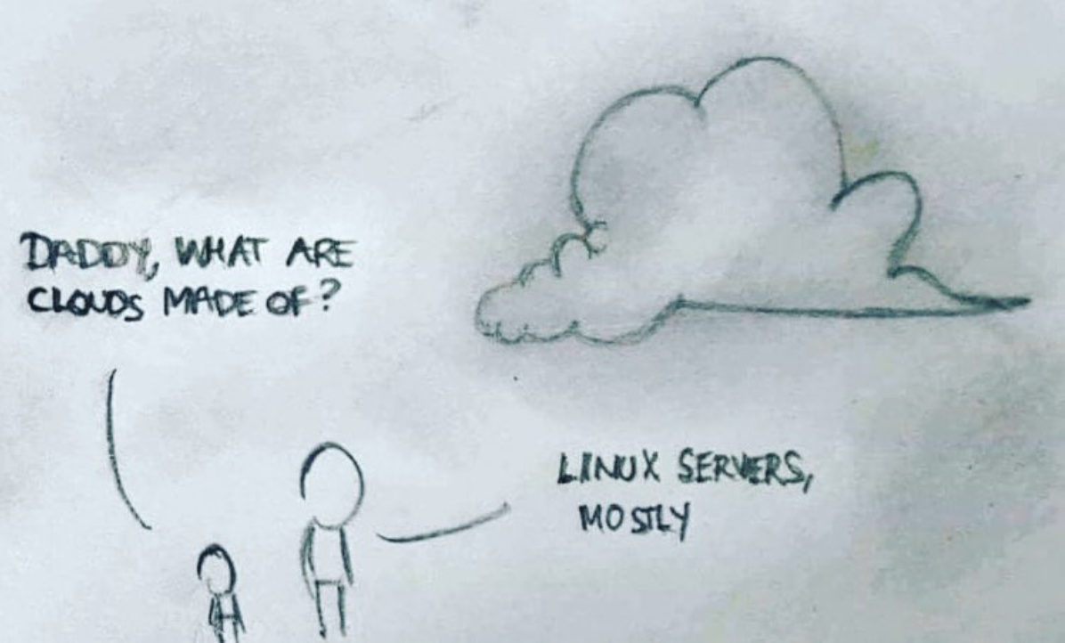

Understanding AWS [Lambda](https://aws.amazon.com/lambda)  
We really must discuss how [AWS Lambda](https://aws.amazon.com/lambda) will execute the logic within our functions to better understand, and to have a general idea about a few of the important properties that make up our [AWS FaaS](https://aws.amazon.com/lambda/) paradigm. Below are a few details you should know about how [Lambda](https://aws.amazon.com/lambda) works with you:

AWS [Lambda](https://aws.amazon.com/lambda) Specs

Lambda will support the runtime environments listed below:

* **Node.js**: v8.10 & v6.10
* **Java 8**
* **Python** v3.6 & v2.7
* **.NET Core**: v1.0.1 & v2.0
* **Go** v1.x
* **Ruby** v2.5
* **Rust**

Each [Lambda](https://aws.amazon.com/lambda) will execute and compute inside of a container with a 64-bit AWS Linux AMI. [AWS](https://aws.amazon.com) will distribute our [Lambda’s](https://aws.amazon.com/lambda) computational needs to each user according to the following system requirements:

* **Memory Allocation**: 128MB - 3008MB (Allocated in 64MB increments)
* **Ephemeral Disk Space**: 512 MB
* **Max execution time (timeout)**: 15 minutes (900s)
* **Function Environment Variables**: 4 KB
* **Function** [**Layers**](https://docs.aws.amazon.com/lambda/latest/dg/configuration-layers.html): 5 layers
* **Deployment Package Size (unzipped)**: 250 MB
* **Deployment Package Size (zipped)**: 50MB
* **Execution Threads (Processes)**: 1024

[Lambda](https://aws.amazon.com/lambda) puts the breaks on the amount of resources that you can use for compute and storage to run and store your functions on the <AWS> cloud. The following default limits are set per-region by [AWS](https://aws.amazon.com) and can be increased by special request only:

* **Concurrent Executions**: 1000
* **Function & Layer Storage**: 75 MB

The serverless design paradigm is a language agnostic approach that is meant to give engineers the ability to leverage [AWS](https://aws.amazon.com) resources and infrastructure to better scale their products, i.e. your products, to a global market place and to more quickly put your innovation into the hands of the users that need it the most.  
  
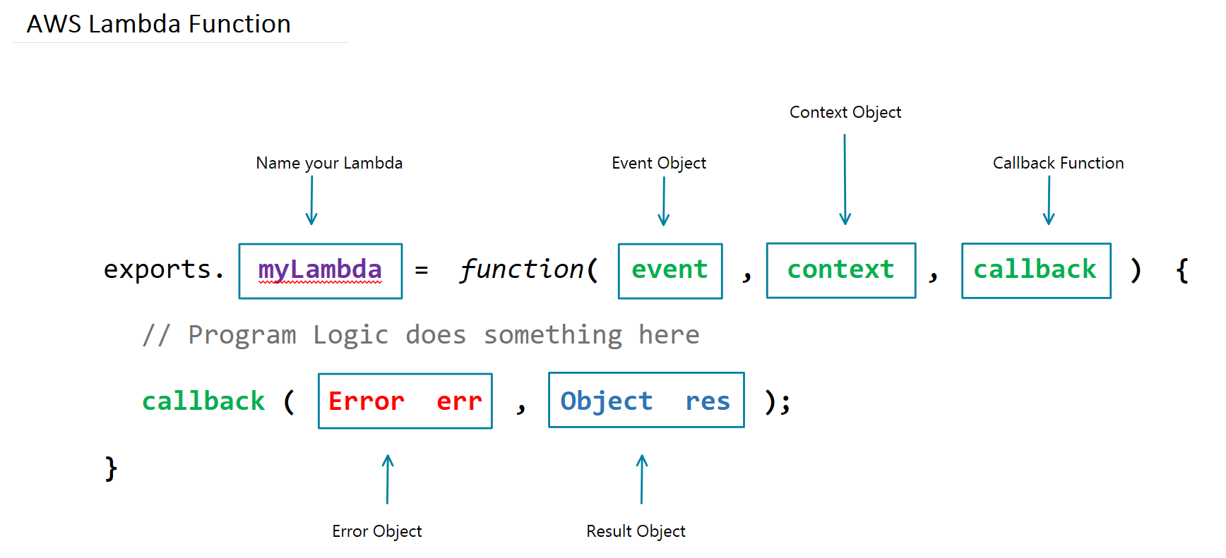

In the image, myLambda is the name of the [Lambda](https://aws.amazon.com/lambda) function written for the Node.js runtime environment shown above. The event object has all the information about the event that triggered this [Lambda](https://aws.amazon.com/lambda) for an async response, and in the case of an http-request, it will be the information you need about the specific request made to your application, and its *serverless-backend*. The context object will have information about the runtime environment that will execute our [Lambda](https://aws.amazon.com/lambda) on [AWS](https://aws.amazon.com). When [AWS](https://aws.amazon.com) completes the execution of the logic within our [Lambda](https://aws.amazon.com/lambda) function, the callback function will execute and provide you with the corresponding result or error needed to respond to the http-request.

The Stateless nature of AWS [Lambda](https://aws.amazon.com/lambda)

Because our [Lambda](https://aws.amazon.com/lambda) functions are stateless events that execute inside of containers on the cloud, all of the code that is run inside of the program's file in the container is executed and cached, while warm, and only the code in the <Lambda> function handler is run on subsequent attempts. In the example below, the let sns = new aws.SNS(); method will trigger the first time your container is instantiated on the cloud. The new aws.SNS() method and the code above it, does not execute *every time your Lambda triggers an action*. On the other hand, the myLambdaTopic handler function shown as a module export in the example, will trigger itself every time we invoke the [Lambda](https://aws.amazon.com/lambda).

let aws = require('aws-sdk');

aws.config.update({region: 'us-east-1'});

let sns = new aws.SNS();

exports.myLambdaTopic = function(event, context, callback) {

const params = {

Message: `Message Posted to Topic.`,

TopicArn: process.env.SNSTopicARN

}

let result = sns.publish(params, (err,data) => {

callback(null, '');

});

return result;

};

There is a /tmp directory inside of the 512MB of **Ephemeral Disk Space** that your **64-bit Amazon Linux AMI** gives to your [Lambda](https://aws.amazon.com/lambda) where your containers are effectively cached when it is executed from the [Lambda](https://aws.amazon.com/lambda) event that is triggered by your application. Using this directory is not a recommended approach to achieving stateful [Lambda](https://aws.amazon.com/lambda) functions. There is no way to govern what happens to the memory given for this directory because the cloud provider handles this abstraction of work. When your containers go *Cold* the Cloud Provider does not **Cache** its state or information, and you will lose everything in the /tmp directory.

Choose AWS as your Cloud Provider & Register

I am going to have to assume that you have an [AWS Account](https://aws.amazon.com) and are a registered user with [AWS](https://aws.amazon.com) for the sake of getting through this article in a reasonable amount of time. I hope that your curiosity has driven you to the wonders of the [AWS Console](https://aws.amazon.com/console/) to leave you in a state of despair, let alone paralysis. Do not be ashamed; I really believe that I am not the only person on this planet terrified by the [AWS Console](https://aws.amazon.com/console/) when first starting out as a cloud professional. The first thing that ran through my head was, "with what time am I going to figure all of this out now that I have learned how to master the art of the *reversed* *Linked-List* *interview* *question*". I terrified myself to say the least. Do not you worry though young *Silicon* *Valley* *Stallions*, we will be here to walk you through every step of each of those services. One day, we will even show you how to launch a *Machine* *Learning* application on your very own *Serverless* backend! I am just not going to show you how to register with [AWS](https://aws.amazon.com).

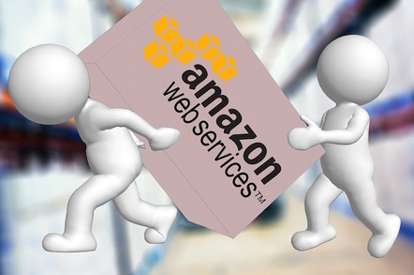

Create AWS Developer Access Keys

To deploy your application's resources using an **Infrastructure** **As** **Code** paradigm, you need to connect your development environment to AWS by authenticating your local machine with your **AWS** **Access** **Keys** that you can find within the IAM Service from your AWS Console.

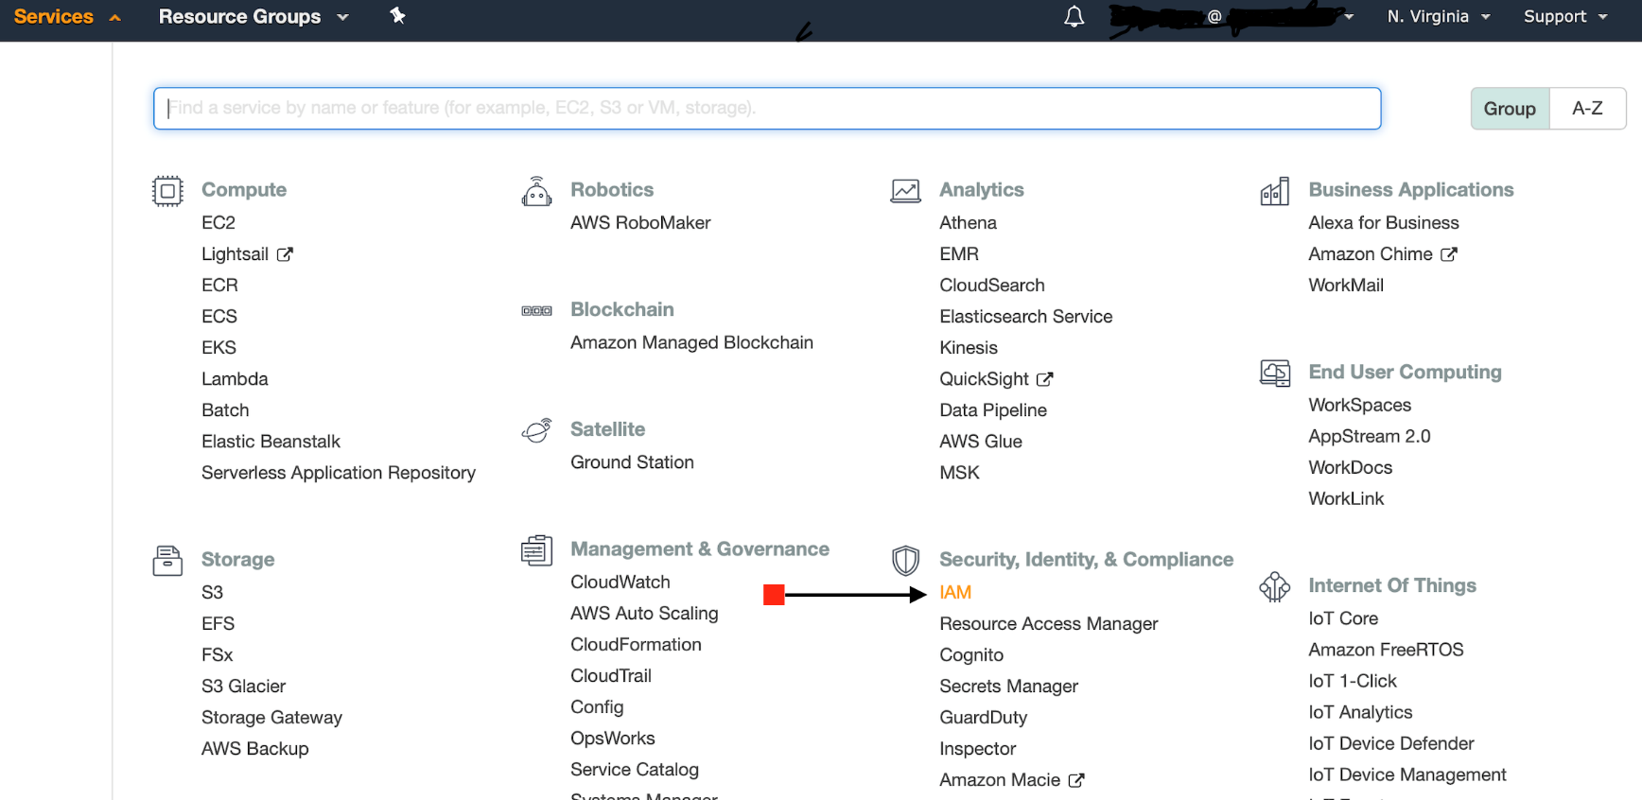

When you get into your [AWS Console](AWS%20Console), you need to click on the Services link on the top left side of the [AWS](https://aws.amazon.com) navigation bar in your browser. Your AWS Console will continue to bombard you with everything it has. Take a deep breathe, and look for the **Security, Identity, & Compliance** section inside of the Services menu. The first service in that section is the [AWS IAM](https://aws.amazon.com/iam/) service, or short for *Identity & Access Management*.

From your [IAM](https://aws.amazon.com/iam/) Dashboard continue to click on the Users button from the navigation frame on the left side of your browser, and then click on the user that you will use to create a new Access Key. When the user's information makes itself available within the browser for you, click on the tab called Security credentials and create a new Access Key as shown below.

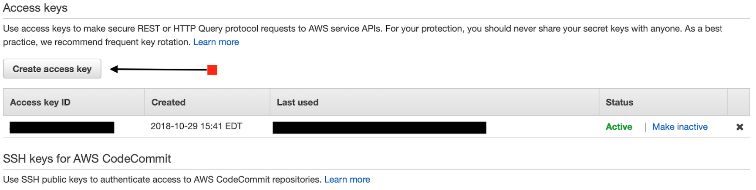

Once you create a new Access Key, both record your Secret Access Key along with your Access Key ID to configure your [AWS-CLI](https://aws.amazon.com/cli/) locally from your terminal.

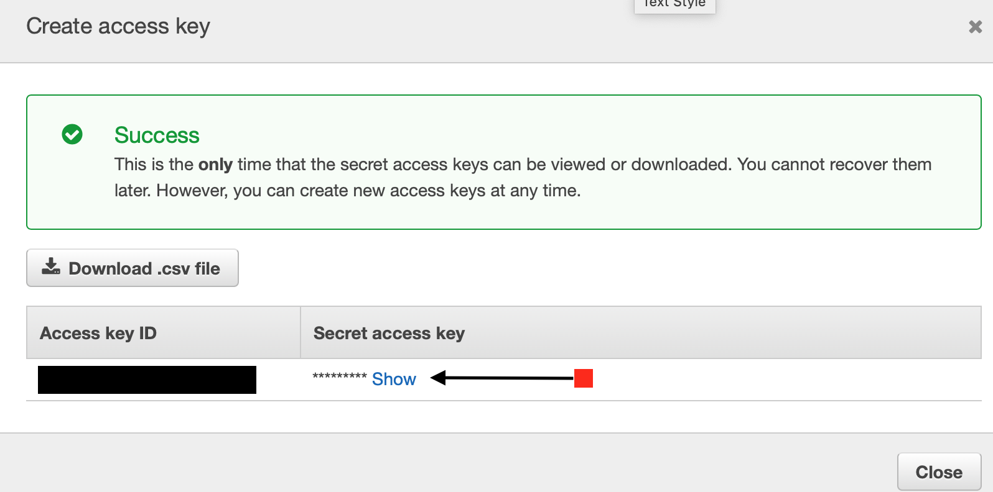

[AWS](https://aws.amazon.com) will only let you create two Access Keys per user. It is a *best practice* to change these keys often and to store them securely. [AWS](https://aws.amazon.com) will not allow you to view your Secret Access Key after you initially create it, you must be sure to record it in a safe place, as soon as you see the screen above.

Install the AWS Command Line Interface (CLI)

The demo application we are using today to discuss and teach you these skills are all part of the [Serverless Framework](https://serverless.com/framework/docs/) technology stack. The awscli needs *Python v2.7* or *Python v3.4+* and *PiP* to support our application environment. Below are links to the Python documentation repository, to help you familiarize yourself with these installations:

* [Installing Python](https://www.python.org)
* [Installing Pip](https://pypi.org/project/pip/)

With Python installed, and using Pip, install the awscli on (Linux, MacOS, or Unix) and run:

* $ sudo pip install awscli

Add your Access Key to your AWS CLI

Obtain your Access Key ID and your Secret Access Key from your AWS Console via the AWS IAM services console and run:

* $ aws configure

With the credentials obtained from your IAM userID, enter the following information into the terminal prompts:

AWS Access Key ID [****************91RX]: <paste your data here>

AWS Secret Access Key [****************ADsM]: <paste your data here>

Default region name [us-east-1]: us-east-1

Default output format [json]: json

SetUp Serverless Framework locally

To deploy our demo application with a serverless backend to handle our business logic with independent functions deployed to [AWS Lambda](https://aws.amazon.com/lambda), we will need to configure [Lambda](https://aws.amazon.com/lambda) and <APIGateway> to use the <ServerlessFramework>. The [ServerlessFramework](https://serverless.com/framework/docs/) handles the configuration of our [Lambda](https://aws.amazon.com/lambda) functions to use our code to respond to http requests triggered by [APIGateway](https://aws.amazon.com/api-gateway/). The [ServerlessFramework](https://serverless.com/framework/docs/) lets us use easy template files to programmatically describe the resources and infrastructure that we need [AWS](https://aws.amazon.com) to provision for us, and on deployment, [AWS CloudFormation](https://docs.aws.amazon.com/AWSCloudFormation/latest/UserGuide/resources-section-structure.html) does the job of instantiating the cloud based infrastructure that we call the *serverless architecture* on [AWS](https://aws.amazon.com). The serverless.yml file is the file that executes the explicit resources that we declare from within the [ServerlessFramework](https://serverless.com/framework/docs/), to tell [AWS CloudFormation](AWS%20CloudFormation) what we need from <AWS> to run our application. Please make sure to install [NPM Package Manager](https://docs.npmjs.com/getting-started/) to complete this installation:

* Install the [ServerlessFramework](https://serverless.com/framework/docs/) globally and run:
* $ npm install serverless -g`
* Create a project structure that considers the **Serverless + MicroService** approach and clone the ServerlessStarterService demo application as follows:

1. $ mkdir PayMyInvoice
2. $ cd PayMyInvoice
3. $ mkdir services
4. $ cd services

**Critical Step: Install the repo and name it accordingly**

1. $ serverless install --url https://github.com/lopezdp/ServerlessStarterService --name my-project
2. In the command above, change the generic my-project name passed as an argument and call your *serverless + microservice* whatever you want. In our case we decided to call ours invoice-log-api. We will be creating invoices and displaying a log of the invoices that our users send to their customers for payment. Try to use a logical name to describe your service when you decide upon your project's naming conventions. After using the ServerlessStarterService as a template and renaming it from your terminal, your output should look something like this:

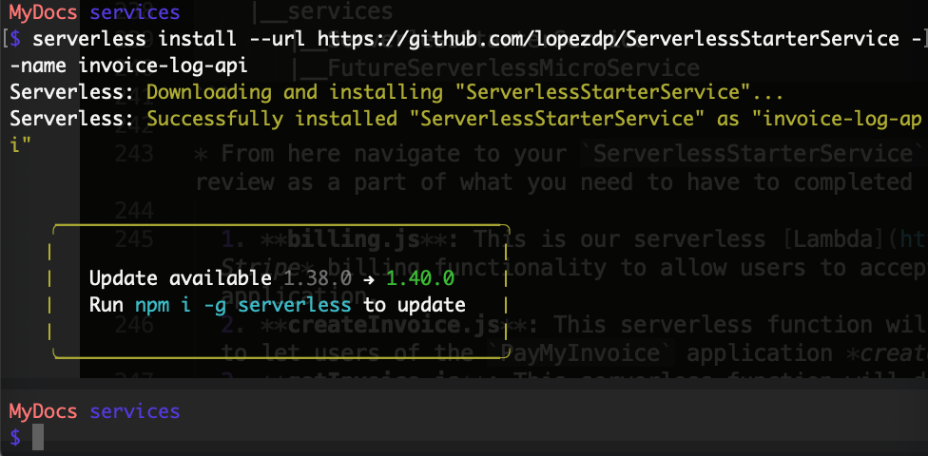

* Your project structure should now look like this after you rename your template:

PayMyInvoice

|__ services

|__ invoice-log-api (renamed from template)

|__ FutureServerlessMicroService (TBD)

* From here, navigate to your invoice-log-api project. Currently, you have a directory each for mocks and tests, a serverless.yml file and a handler.js file that was a part of the original template. We will be refactoring this directory with the files shown below, which we will review later as a part of what you need to have to complete in your local environment to deploy this demo application. For now, just take a look at what we are proposing and try to understand the logic behind each [Lambda](https://aws.amazon.com/lambda). We will implement these a bit later.

1. **billing.js**: This is our serverless [Lambda](https://aws.amazon.com/lambda) function that will deploy our *Stripe* billing functionality to allow users to accept payment for the Invoiced that they create in the application.
2. **createInvoice.js**: This serverless function will deploy the [Lambda](https://aws.amazon.com/lambda) needed to let users of the PayMyInvoice application *create new invoices* in the application.
3. **getInvoice.js**: This serverless function will deploy the [Lambda](https://aws.amazon.com/lambda) needed to let users of the PayMyInvoice application *obtain a specific invoice* stored in the application.
4. **listInvoices.js**: This serverless function will deploy the [Lambda](https://aws.amazon.com/lambda) needed to let users of the PayMyInvoice application *obtain a list* of invoices stored in the application.
5. **updateInvoice.js**: This serverless function will deploy the [Lambda](https://aws.amazon.com/lambda) needed to let users of the PayMyInvoice application *update* a specific invoice stored in the application.
6. **deleteInvoice.js**: This serverless function will deploy the [Lambda](https://aws.amazon.com/lambda) needed to let users of the PayMyInvoice application *delete* a specific invoice stored in the application.
7. **serverless.yml**: This is the configuration template used by the [ServerlessFramework](https://serverless.com/framework/docs/) to tell [AWS CloudFormation](https://docs.aws.amazon.com/AWSCloudFormation/latest/UserGuide/resources-section-structure.html) which resources we needs provisioned for our application and how to configure them on [AWS](https://aws.amazon.com).
8. /mocks: This is where we save the json files that we use in development, to mock http-request events to our serverless backend locally.

9. /resources: This is the directory that we use to organize our programmatic resources and files.

10. /tests: This is the directory where we save our Unit Tests. Typically, we will want to try to achieve at least 80% (or better) Unit Testing [coverage](https://en.wikipedia.org/wiki/Code_coverage).

* This service relies on the dependencies that we list in the package.json file found in the root of the serverless project directory.

1. **Navigate to root project directory**: $ cd ~/PATH/PayMyInvoice/service/invoice-log-api

2. **Run**: $ npm install

We will continue the review of these resources and their deployment to [AWS](https://aws.amazon.com) in the chapters that follow. For now, we must make sure you understand what is happening behind the scenes of this new **Serverless Paradigm**...

Your localhost serverless backend will now work and you can extend it for any feature you need to implement in the future. Good Luck!

Part 3: Configure Infrastructure As Code, Mock Services, & Unit Testing

* Part 3: Configure Infrastructure As Code, Mock Services, & Unit Testing