Frank Lopez
CS 499
May 23, 2026
3-2 Milestone Two: Enhancement One: Software Design and Engineering
- Briefly describe the artifact. What is it? When was it created?
The artifact I am submitting is still a work in progress as far as the enhancement is concerned. However, the original artifact is an Android mobile application, written in Java that was original created by closely following for materials for course CS 360. The foundation provided by this course allowed me to successfully recreate all back-end logic of the application in Python for my proposed enhancement plan for the application.
My new program has been completely rebuilt in python, leveraging the java application as the blueprint in foundation to successfully recreating functionality as well as implementing other improvements to flesh out the application into something much more verbose than the original project.
- Justify the inclusion of the artifact in your ePortfolio. Why did you select this item? What specific components of the artifact showcase your skills and abilities in software development? How was the artifact improved?
I feel as though I have done well in translating my original application from Java to Python using best practice for “Pythonic” writing. I leverage many sources to accomplish this, from stack overflow to geeksforgeeks to refamiliarize myself with python as best I could. I also used other resources to refamiliarize myself with SQLite which was pivotal to ensure I could make a data driven application that relied on a locally stored database created by the user.
I specifically selected this item due to how closely it is related to my everyday life and work. I currently work as an Inventory Specialist at my workplace and work with inventory items all the time with a system design by a company called Manhattan, a web-based application. The application has as many pain points as it does benefits for what my company needs. Every time we want to be able to do something related to our inventory in the form of data processing and reporting, we are constantly needing to request updates or changes to the system and our service to accomplish anything we would like. We often time joke, “I could make something better!” and I felt as though it was time to put my money where my mouth is and genuinely try. Maybe I will not get things to where I would like to get them in this final submission, but even after graduation I hope to continuing improving this application into something genuinely useful as it by nature is multipurposed and does not need to strictly track inventory but can track many things depending on the user!
Focusing on the design of the project, by leveraging tools such as Figma for visual design and the standard Python interface Tkinter to utilize the Tcl/Tk GUI toolkit, I aimed to construct an application that is aesthetically pleasing and intuitive to use on a desktop. This will allow me to completely rebuild the entire original java mobile application in Python with a GUI that will work across both MacOS and Windows OS. Although I the Tkinter library is considered dated, I needed to ensure I got fleshed out my ability to work with a more foundation library before moving on to one that is much more sophisticated to add things like animations and transitions between screens. The scope of my enhancements will be met by the final submission and I feel like it is a great foundation to present as far as my current capabilities go.
- Did you meet the course outcomes you planned to meet with this enhancement in Module One? Do you have any updates to your outcome-coverage plans?
I feel as though I am taking the right steps in fulfilling outcomes like:
“Design, develop, and deliver professional-quality oral, written, and visual communications that are coherent, technically sound, and appropriately adapted to specific audiences and contexts”
I have developed documents to support the development of the project and guide my workflow as systems were implemented:
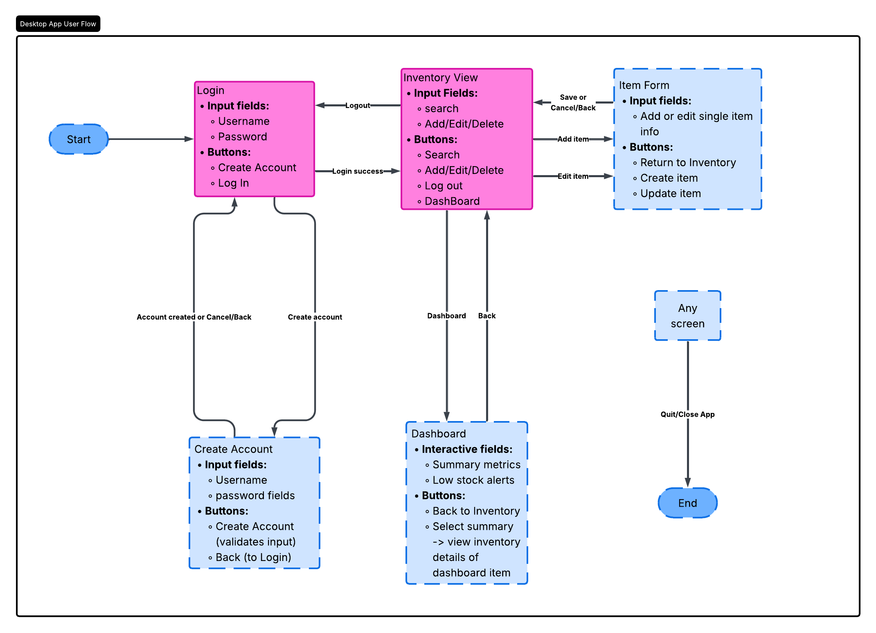
The above diagram details the expect flow while navigating from screen to screen in the application.
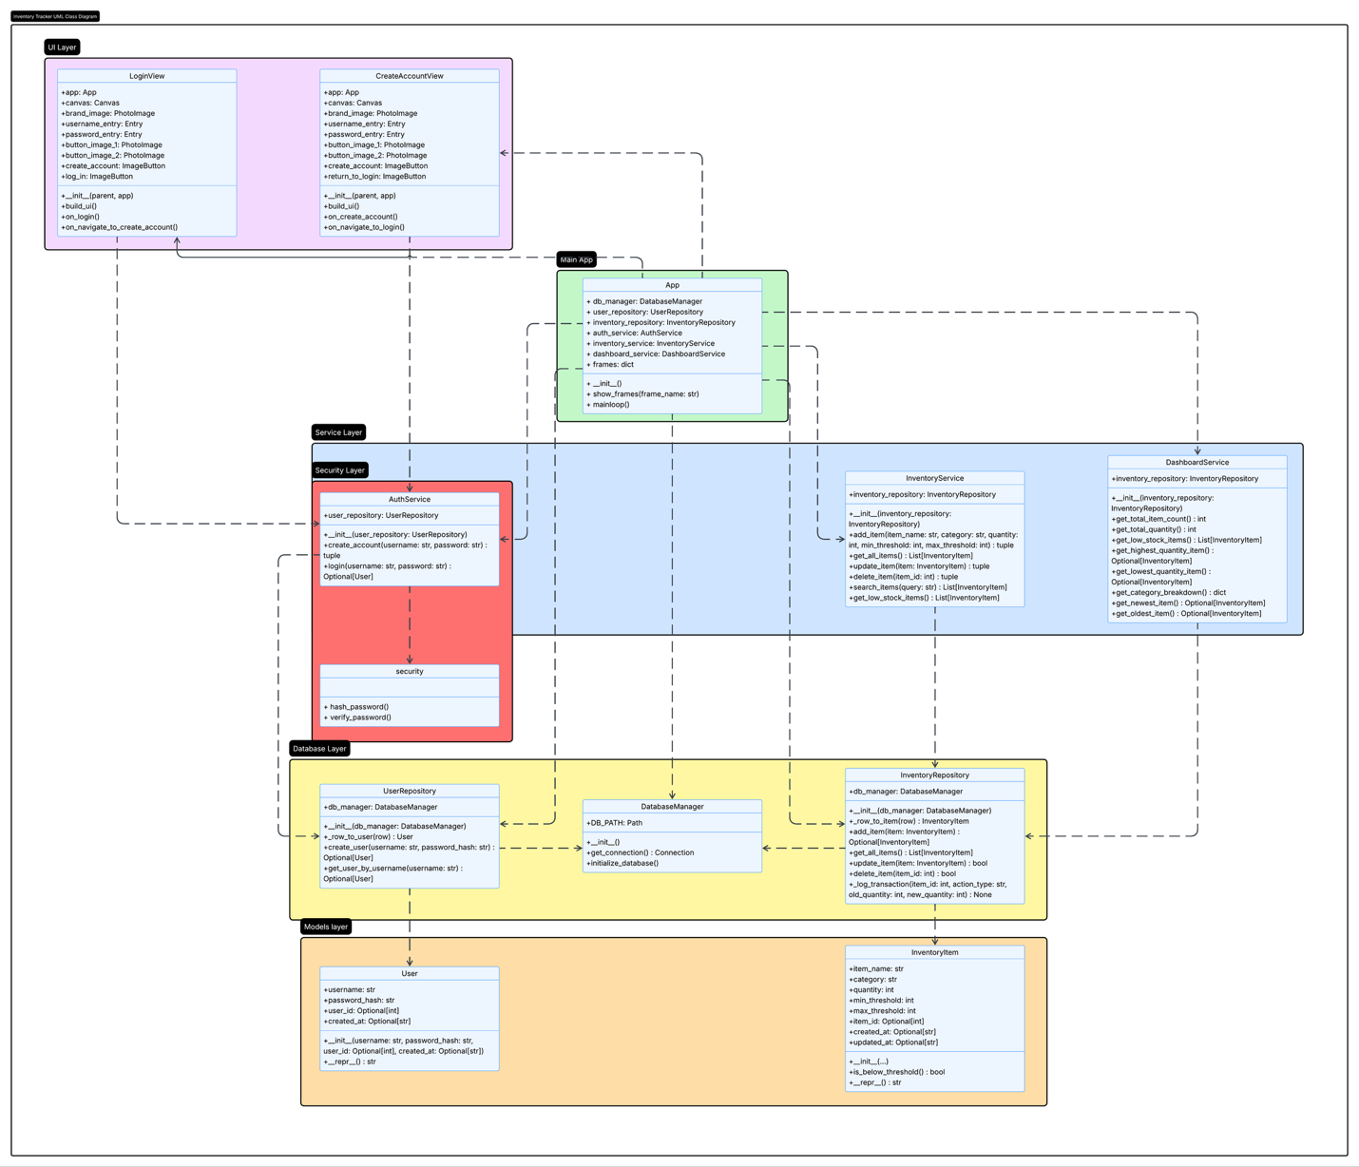
The UML diagram in comparison details how all main files/classes work together with all attributes and methods.

“Demonstrate an ability to use well-founded and innovative techniques, skills, and tools in computing practices for the purpose of implementing computer solutions that deliver value and accomplish industry-specific goals”
I feel as though I have satisfied this requirements by using tried and true libraries such as Tkinter for developing the UI of my application as well as leveraging SQLite for my local database. I am incredibly proud of the results thus far.
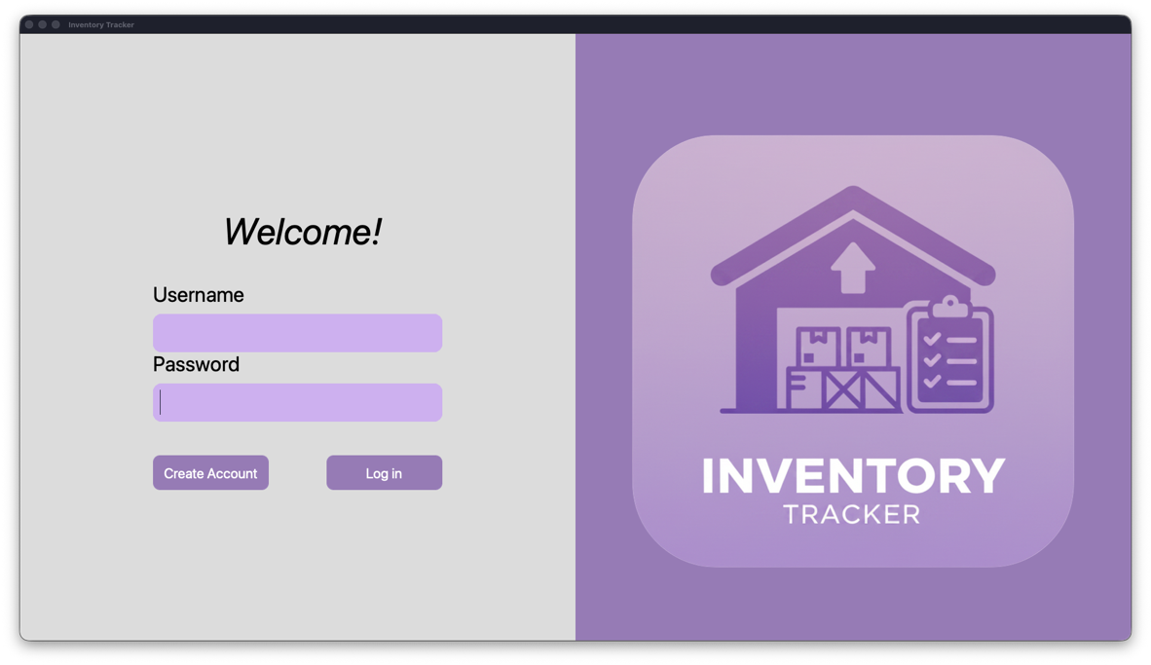
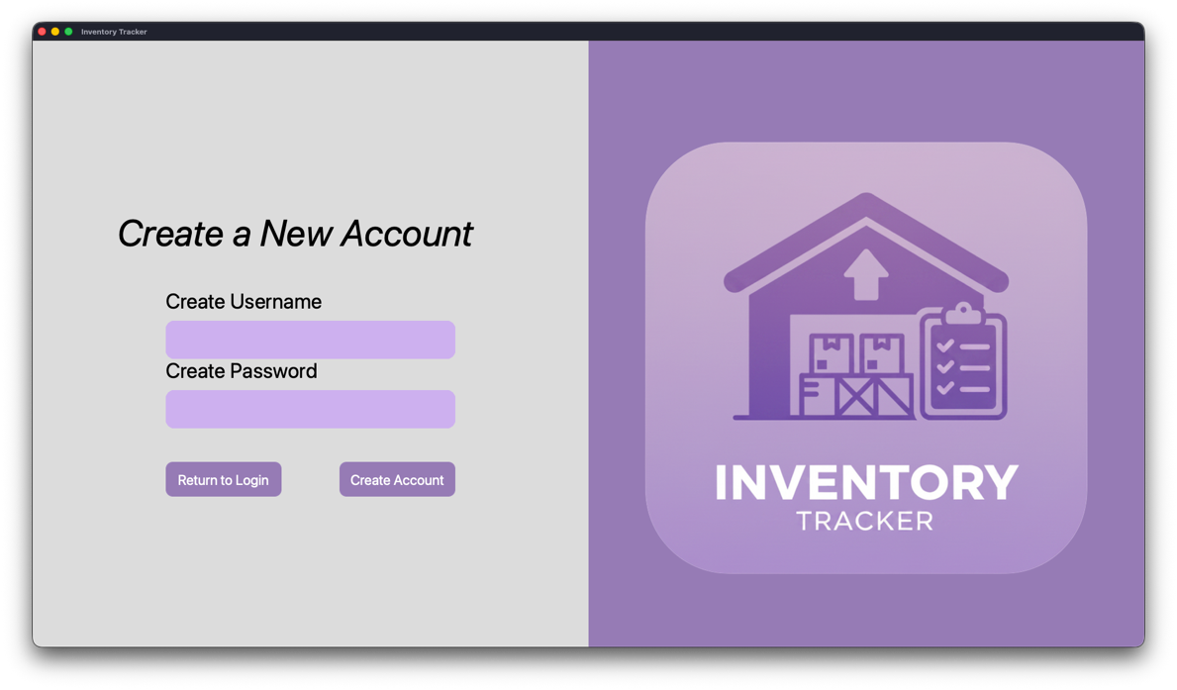
- Reflect on the process of enhancing and modifying the artifact. What did you learn as you were creating it and improving it? What challenges did you face?
I learned a great deal in desktop application development and feel as though this foundation I have built for myself is the first step in making more applications for MacOS or WindowsOS or perhaps even in pivoting to focusing more on web application development as well. More than anything I love to create things, in any shape or form, and being able to see an application like this come to life as I built each component is incredibly rewarding and satisfying. Even if it does become increasingly difficult to land a formal 9-5 job in this field, I feel as though I can always have a place in this world as a freelancer building things I love to solve problems at a smaller scale for individuals over large user bases.
- Additional notes:
Only 2/5 screens are completed for the UI frames of application. However, the majority of the backend logic of the application is complete. I think by the next milestone the application will be functionally complete, and I can then pivot to making final refinements. I unfortunately have inadvertently satisfied requirements 2 and 3 for algorithms and data structures as well as databases by translating the application first. Unfortunately, this left the UI incomplete for this week, but I hope my supporting documentation for the design of the program logic will help satisfy this week’s requirements.
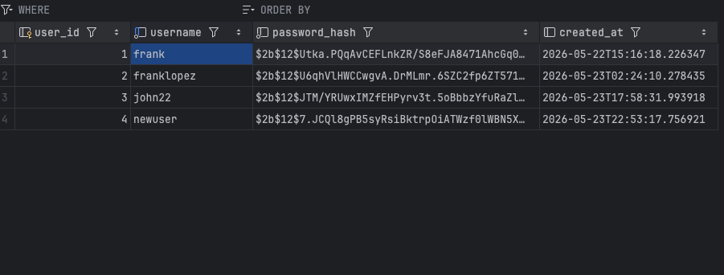
I was also very thankful to see that my database is interactable within Pycharm which is my chosen IDE for this project. One of the primary concerns in the mobile applications design was the lack of any sort of security surrounding log in and account creations. I leverage the library Bcrypt for password hashing and was happy to see it in action within the database after creating a few users when testing the log in and account creations pages. On top of secure password handling, robust validation was added for input fields to ensure account creation verifies the account does not already exist as well as password length, etc. I also managed to ensure database management was centralized into one location in the new design as many files where deeply couple in what handled database actions and what handle UI logic and flow. Now all data related logic lives independent of the UI logic which was something I set out to accomplish in the overall design of the new enhanced application. I think it is coming along quite well and I am reaping many of the benefits from this change as it makes navigating the application code much easier than the original.

