# Name: _______________________________________________________ Student Number: ____________

# Tutorial #2: Conformations of ethane (C2H6), chloroethane (C2H5Cl) and 1,2-dichloroethane (C2H4Cl2)

In class you’ve now looked at the idea of conformations – rotation about carbon-carbon bonds and the relative energetics of these conformers. This tutorial will give us the opportunity to look further at energetic differences between conformations.

We will look at different conformers and examine how the energy of the molecule changes as we rotate about a carbon-carbon single bond. As we rotate about this carbon- carbon bond we change the **dihedral angle**.

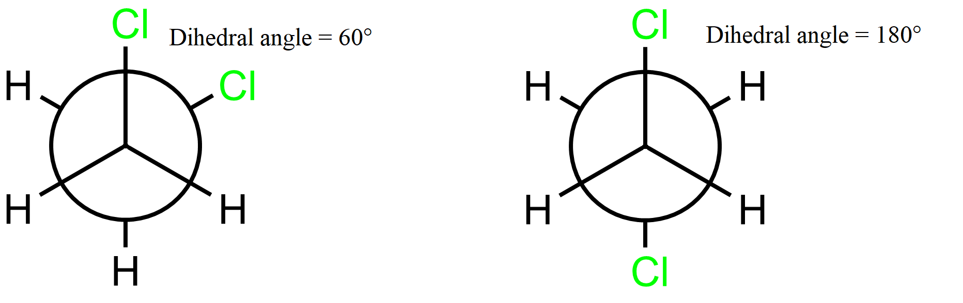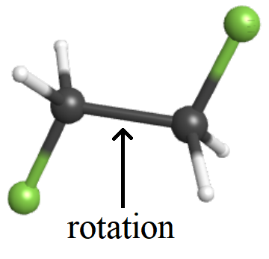

We are now going to determine the conformational energy of ethane as we change the dihedral angle within the molecule. This is another kind of **coordinate scan**.

To perform a coordinate scan, click the **adjust** button (the mouse arrow/cursor) from the left-hand tool bar. Select one of the hydrogen atoms, then hold **shift** and select the following two carbon atoms, followed by the hydrogen that is attached to the other carbon atom. Use two hydrogen atoms that are ANTI to each other. (In other words, you should select in the order H- C-C-H, with the hydrogen atoms on different carbon atoms, and use the two hydrogen atoms that are **anti** relative to each other. Click on **Adjust** then select **Scan Coordinate**.

From the Scan coordinate screen, enter a start value of **180**, a stop value of **-180**, and # steps set to **36**. **Check the Optimize Scan box**. Press **OK** to close the dialogue window. The three bonds attached to the atoms you selected should now be colored orange.

Press the right blue arrow to take you to the job options screen (If a dialogue box warns you that it is nearly symmetric, you can ignore it and press **OK**). Use the following job options:

|  |  |  |
| --- | --- | --- |
| **Calculation #4** | **Calculation #5** | **Calculation #6** |
| *Job Name:* C2H6 (scan) | *Job Name:* C2H5Cl (scan) | *Job Name:* C2H4Cl2 (scan) |
| *Calculation:* Coordinate Scan | *Calculation:* Coordinate Scan | *Calculation:* Coordinate Scan |
| *Theory:* Hartree-Fock | *Theory:* Hartree-Fock | *Theory:* Hartree-Fock |
| *Basis Set:* Routine 6-31G(d) | *Basis Set:* Routine 6-31G(d) | *Basis Set:* Routine 6-31G(d) |
| *Charge:* 0 | *Charge:* 0 | *Charge:* 0 |
| *Multiplicity:* Singlet | *Multiplicity:* Singlet | *Multiplicity:* Singlet |

The calculation may take between 3-15 minutes. While your ethane calculation is still running, repeat the process for chloroethane and 1,2 dichloroethane. Return to your data once a calculation is complete.

Once your calculation is complete, open up the job to view the resultant data and scroll down to the calculated quantities.

# Results

|  |  |
| --- | --- |
| **Molecule** | **Rotational energy barrier (kJ mol-1)** |
| Ethane |  |
| Chloroethane |  |
| 1,2-Dichloroethane |  |

|  |  |
| --- | --- |
| **Eclipsing Combination** | **Energy Cost for one Eclipsing Interaction (kJ mol-1)** |
| -H / -H |  |
| -H / -Cl |  |
| -Cl / -Cl |  |

Energy Cost for -Cl / -Cl Gauche Interaction ____________________________________ kJ/mol

Do not forget that the lowest energy conformation of 1,1,2-Trichloroethane is higher than the lowest energy conformation of 1,2-dichloroethane. Can you explain why?

_____________________________________________________________________________________________________________

Draw the most stable conformation of 1,1,2-Trichloroethane:

*Wedge‐Dash Structure Newman Projection*

Use the Eclipsing Combinations and the Gauche Interaction energies above to estimate the rotational energy barrier of 1,1,2-Trichloroethane.

____________________________________________________________________________________ kJ/mol

Compare your estimate with the 1,1,2-Trichloroethane energy barrier calculated with WebMO.

_____________________________ kJ/mol

Unit conversion needed for this tutorial: **1 Hartree = 2625.499 62 kJ mol-1**.