Globalmix Mozambique analysis

M. C. Kiti

2023-07-27

Table of contents

# 1. Background

This is a summary of results from analysis of GlobalMix data collected in Mozambique. The project had two aims: 1. quantify social contact patterns among individuals data using paper diaries 2. quantify social contact patter within households using paper diaries and wearable proximity sensors. This analysis focuses on aim 1 only.

# 2. Methods

## 2.1 Study objectives

## 2.2 Study design and site

This was a cross-sectional study conducted in Mozambique. Data were collected between April 2020 and April 2021. study will be implemented in one rural and one urban area of Mozambique. The rural area will cover the Manhiça Health and Demographic Surveillance Site (Manhiça HDSS) located in the district of Manhiça, Maputo province, while the urban area will cover the Polana Caniço HDSS located in Maputo City. The Manhiça HDSS is located in about 80 km north of Maputo City, Mozambique’s capital. It was established in 1996 and currently comprises about 201,000 individuals registered as permanent residents distributed in about 45,300 households. The Polana Caniço HDSS was established in 2018 and partly covers the third most populated urban district of KaMaxaquene in Maputo city. The urban HDSS has a population of approximately 92,000 inhabitants.

## 2.3 Sample size

We framed our sample size calculations to detect sufficient precision in the age-group of greatest interest (infants). We powered each age group to have a standard deviation consistent with the precision in the estimate of youngest age group (0-4 years) in the POLYMOD study: standard deviation = 7.65 contacts per day (95% CI 8.2-12.2 contacts per day). We chose to base our sample size calculation on the youngest age group because infants less than six months of age represent the smallest fraction of the overall population size and are traditionally the most difficult population to enroll. We then inflated the sample size by ten percent for each age group to account for participants not completing the surveys. This resulted in a sample size of 63 per age group, 630 per site, and 1260 for in total.

## 2.4 Data collection tools and procedures

Data were collected using a paper diary and an electronic diary. We defined a social contact as either 1) Physical, a 2-way face-to-face interaction between two or more individuals standing at arm’s length of each other and involving touch (skin-to-skin or over clothes) or 2) non-physical contact, a 2-way face-to-face conversation between two or more individuals standing at arm’s length of each other with no physical barrier between them.

Field staff will recruit the potential participants that were identified through the quota-based sampling via household visits. After initial contact is made, study staff will obtain written consent (via signature or thumb impression, in case the study participant is unable to read and write) and enroll the participant after providing a detailed explanation of the study. The field staff will explain that participants will have to complete two surveys over two consecutive days (each at the end of a 24-hour period to account for individual variation). Once enrolled, the field staff will randomly assign the participant two consecutive days of the week, using the enumeration code. The participant will be coached on how to complete the survey correctly one or two days before the selected day (please see the attached survey sample). Field staff will also collect information on the employment status, education level, household composition, age, birth order and gender of the participant as well as GPS data on the location of the household.13 After the completion of the two contact diary surveys, field staff will conduct an exit interview where field staff will check questionnaire for completeness and inconsistencies and make sure all required information is included. In addition, we will collect data on predictors of infectious disease transmission including information on food handling, handwashing and latrine use practices for each participant, ventilation and water source, as well as animal contact by household members. ## Data analysis

## 2.5 Ethical considerations

This study was be conducted in accordance with the protocol, current Declaration of Helsinki, current GCP Guidelines and all applicable regulatory requirements in Mozambique, including the relevant national and local regulatory bodies having jurisdiction.The investigators or appropriately delegated site study staff shall be responsible for obtaining written informed consent from each participant prior to any data collection. Individuals equal or older than 18 years of age will provide individual consent. For individuals less than 18 years old, consent will be sought from the head of household and parent/legal guardian who is above the age of 18 years. Children 12-17 years old will also be asked to provide written assent. For individuals who do not have the capacity to provide consent, this will be sought from the head of household or parent/legal guardian. If either is absent during the household visit, the subject without capacity to provide individual consent will be excluded. In accordance with GCP Guidelines, the participant shall write his or her own name and date before signing the document. For illiterate participants and minors, the process shall be in accordance with that outlined by the GCP Guidelines, i.e. the participant will make a mark, preferably a thumbprint, on the consent form and a witness will attest to the informed consent process and participant’s voluntary consent. The original document shall be filed and maintained as part of the Investigator Site records and a copy shall be provided to the participant.

# 3. Results

## 3.1 Baseline characteristics

A total of 1444 individuals participated in the study, with 725 (49% female) and 360 (0% female) participants recruited from the rural and urban sites, respectively. The figures below presents a summary the characteristics of the participants in the rural and urban site. In some age groups (<5 yrs and 40-59 yrs) we recruited more than the target. By site, there was no major difference in number of participants recruited by age, sex, and school enrollment status.

## 3.2 Participation summary by site

|  |
| --- |
| Figure 1: Participant age and sex distribution |

|  |
| --- |
| Figure 2: Literacy level |

|  |
| --- |
| Figure 3: Participant currently enrolled in school |

|  |
| --- |
| Figure 4: Participant ccupation |

## 3.3 Summary of number of contacts reported

Overall, 19927 contacts were reported with slightly above half (11782, 59%) from the rural site. In each site, 6% of the total contacts were reported with children aged <5 years (7% rural, 6% urban), with 1% of the contacts in each site happening with infants aged <6 months (148 rural, 82 urban).

The highest number of contacts were reported with children aged 10-14 yrs (26% rural, 21% urban). Overall, more contacts were reported with women (54%) with no difference between sites.

|  |
| --- |
| Note |
| Table available separately |

## 3.4 Distribution of number of contacts on both days

Data were collected over two consecutive study days. We present a summary of total number of contacts (including repeat contacts) over both study days.

Figure 5 shows the distribution of all reported contacts over the two days.

|  |
| --- |
| Note |
| Conduct statistical tests. |

|  |
| --- |
| Figure 5: **?(caption)** |

Table 1: Urban contacts

|  | Total (%) | Day 1 | Day 2 |
| --- | --- | --- | --- |
| Sex |  |  |  |
| Female | 3827 (47) | 6 (3-8) | 5 (3-8) |
| Male | 4308 (53) | 6 (4-9) | 6 (4-8) |
| 11 | NA (NA) | 5 (5-5) | 5 (5-5) |
| Age |  |  |  |
| <6mo | 475 (6) | 4 (2-5) | 3 (3-5) |
| 6-11mo | 467 (6) | 4 (2-7) | 3.5 (2-6) |
| 1-4y | 611 (8) | 4 (2-6.75) | 3 (2-7) |
| 5-9y | 779 (10) | 6 (4-9) | 6 (4-8.75) |
| 10-14y | 1055 (13) | 8 (6-10) | 7.5 (5.75-9) |
| 15-19y | 1042 (13) | 9 (6-12) | 8 (5-10) |
| 20-29y | 743 (9) | 6 (4-7.25) | 6 (4.75-8) |
| 30-39y | 805 (10) | 6 (4-9) | 6 (5-8) |
| 40-59y | 1497 (18) | 6 (4-8) | 5 (4-7) |
| 60+y | 671 (8) | 5 (3-7) | 5 (3-8) |
| Household membership |  |  |  |
| Member | 3724 (46) | 6 (4-9) | 6 (4-8) |
| Non-member | 4421 (54) | 2 (1-5) | 2 (1-5) |
| Occupation |  |  |  |
| Child | 942 (13) | 4 (2-6) | 3 (2-5) |
| Unemployed | 833 (11) | 6 (4-9) | 6 (3-9) |
| Student | 2654 (36) | 7 (5-10) | 7 (5-9) |
| Homemaker | 305 (4) | 6 (4.75-8) | 6 (5-7.25) |
| Casual laboror | 660 (9) | 5 (4-7) | 5 (4-7.25) |
| Farmer | 52 (1) | 3.5 (3-4) | 3.5 (1.5-8.5) |
| Fisherman | 0 (0) | 6 (4-8) | 6 (4-8) |
| Business person | 727 (10) | 6 (4-8) | 6 (4-8) |
| Office worker | 737 (10) | 4 (3-5.5) | 5 (2.5-6) |
| Retired | 150 (2) | 9 (8.25-10) | 9 (6-10) |
| Other | 229 (3) | 5 (2-7) | 4 (2-7) |
| Weekday/Weekend |  |  |  |
| Weekday | 5979 (74) | 6 (4-8) | 6 (3-8) |
| Weekend | 2137 (26) | 5 (3.5-8) | 5 (3-7) |
| 111 | NA (NA) | 12.5 (9.25-15.75) | 9.5 (7.25-11.75) |
| Enrolled in school |  |  |  |
| Yes | 2926 (37) | 7 (5-9) | 7 (5-9) |
| No | 4958 (63) | 5 (3-8) | 5 (3-7.5) |
| 112 | NA (NA) | 6 (4-6) | 5 (3-9) |
| Did you touch? |  |  |  |
| Yes1 | 5928 (73) | 5 (3-8) | 5 (3-8) |
| No1 | 2198 (27) | 7 (5-8) | 6 (4.75-9) |
| I don't remember | 18 (0) | 7 (6.5-7.5) | 3 (2.5-3.5) |
| Contact location |  |  |  |
| Indoors | 926 (11) | 7 (4-9) | 6 (4-8) |
| Outdoors | 2485 (31) | 5 (3-8) | 4 (2.25-7.75) |
| Both | 4734 (58) | 6 (4-8) | 5.5 (3-8) |
| Contact at home |  |  |  |
| Yes2 | 5619 (69) | 6 (4-8) | 5 (3-8) |
| No2 | 2526 (31) | 5 (3-7.5) | 5 (3-7.25) |
| Contact at work |  |  |  |
| Yes3 | 357 (4) | 9 (9-9) | 4 (3-6.75) |
| No3 | 7788 (96) | 6 (4-8) | 5 (3-8) |
| Contact at school |  |  |  |
| Yes4 | 260 (3) | 4.5 (2-8.75) | 4 (3-4) |
| No4 | 7885 (97) | 6 (4-8) | 5 (3-8) |
| Contact in other locations |  |  |  |
| Yes5 | 3051 (37) | 6 (4-8.5) | 5 (3-8) |
| No5 | 5094 (63) | 6 (4-8) | 6 (3-8) |
| Frequency of contact |  |  |  |
| Never met before | 276 (3) | 5 (1-6) | 7 (5-8) |
| Rarely | 302 (4) | 5 (4-9) | 4 (3.5-5.75) |
| Daily or almost daily | 6411 (79) | 6 (4-8) | 5.5 (3-8) |
| 1-3 times per week | 930 (11) | 4 (2.5-6.5) | 4 (3-7) |
| Once every 2 weeks | 149 (2) | 6 (4-6) | 6 (2.25-7.5) |
| Once per month | 58 (1) | 4.5 (3.75-5.25) | 4.5 (3.75-5.25) |
| Once every 3 months | 18 (0) | NA | 3 (3-3) |
| Do you know the contact? |  |  |  |
| Never met before1 | 272 (7) | 5 (1-6) | 5 (5-7) |
| <1 yr | 587 (15) | 4 (3-6.75) | 4 (3-6) |
| 1-2 yrs | 304 (8) | 6 (4-9) | 6 (4-9) |
| 3-5 yrs | 359 (9) | 4 (3-6) | 5 (3-8) |
| 6-10 yrs | 699 (17) | 6 (5-9.25) | 6 (4-8) |
| >10 yrs | 1775 (44) | 7 (4-9) | 6 (5-9) |
| 113 | NA (NA) | 2 (1-5) | 2 (1-4) |
| Contact wearing mask |  |  |  |
| Yes6 | 2170 (27) | 6 (4-8) | 5 (4-7) |
| No6 | 5956 (73) | 6 (4-9) | 6 (3-8) |
| Can't recall | 19 (0) | 5 (5-5) | 8 (7.5-8.5) |
| ARI symptoms |  |  |  |
| No symptom | 6685 (82) | 6 (3-8) | 5 (3-8) |
| >1 symptom | 1460 (18) | 6 (4-8) | 6 (4-8) |
| AGE symptoms |  |  |  |
| Yes7 | 124 (2) | 6 (4-8) | 6 (5-6.75) |
| No7 | 8021 (98) | 6 (4-8) | 5 (3-8) |

The mean (95% CI) contacts for the rural and urban sites was 16.9 (95% CI 16.1 - 17.7) and 12.2 (95% CI 11.7-12.8), respectively. The rural area reported higher number of mean contacts compared to the urban area. Additionally, we observe no difference in the median (IQR) number of contacts reported on day 1 compared to day 2 for both rural and urban sites.

|  |
| --- |
| Note |
| Additional analysis can include: 1. mean number of contacts over both days 2. mean number of contacts of unique contacts only over both days 3. mean number of unique contacts reported on both day 1 and 2 |

|  |
| --- |
| Important |
| So from here below, I only present summaries of contacts for day 1 only. |

## 3.5 Distrubution of number of contacts on day 1 only

Figure 6 shows the distribution of the contacts by rural and urban site and the corresponding mean contact rates on day 1 only. The rural mean contact rate was higher than the urban rate ()

|  |
| --- |
| Figure 6: **?(caption)** |

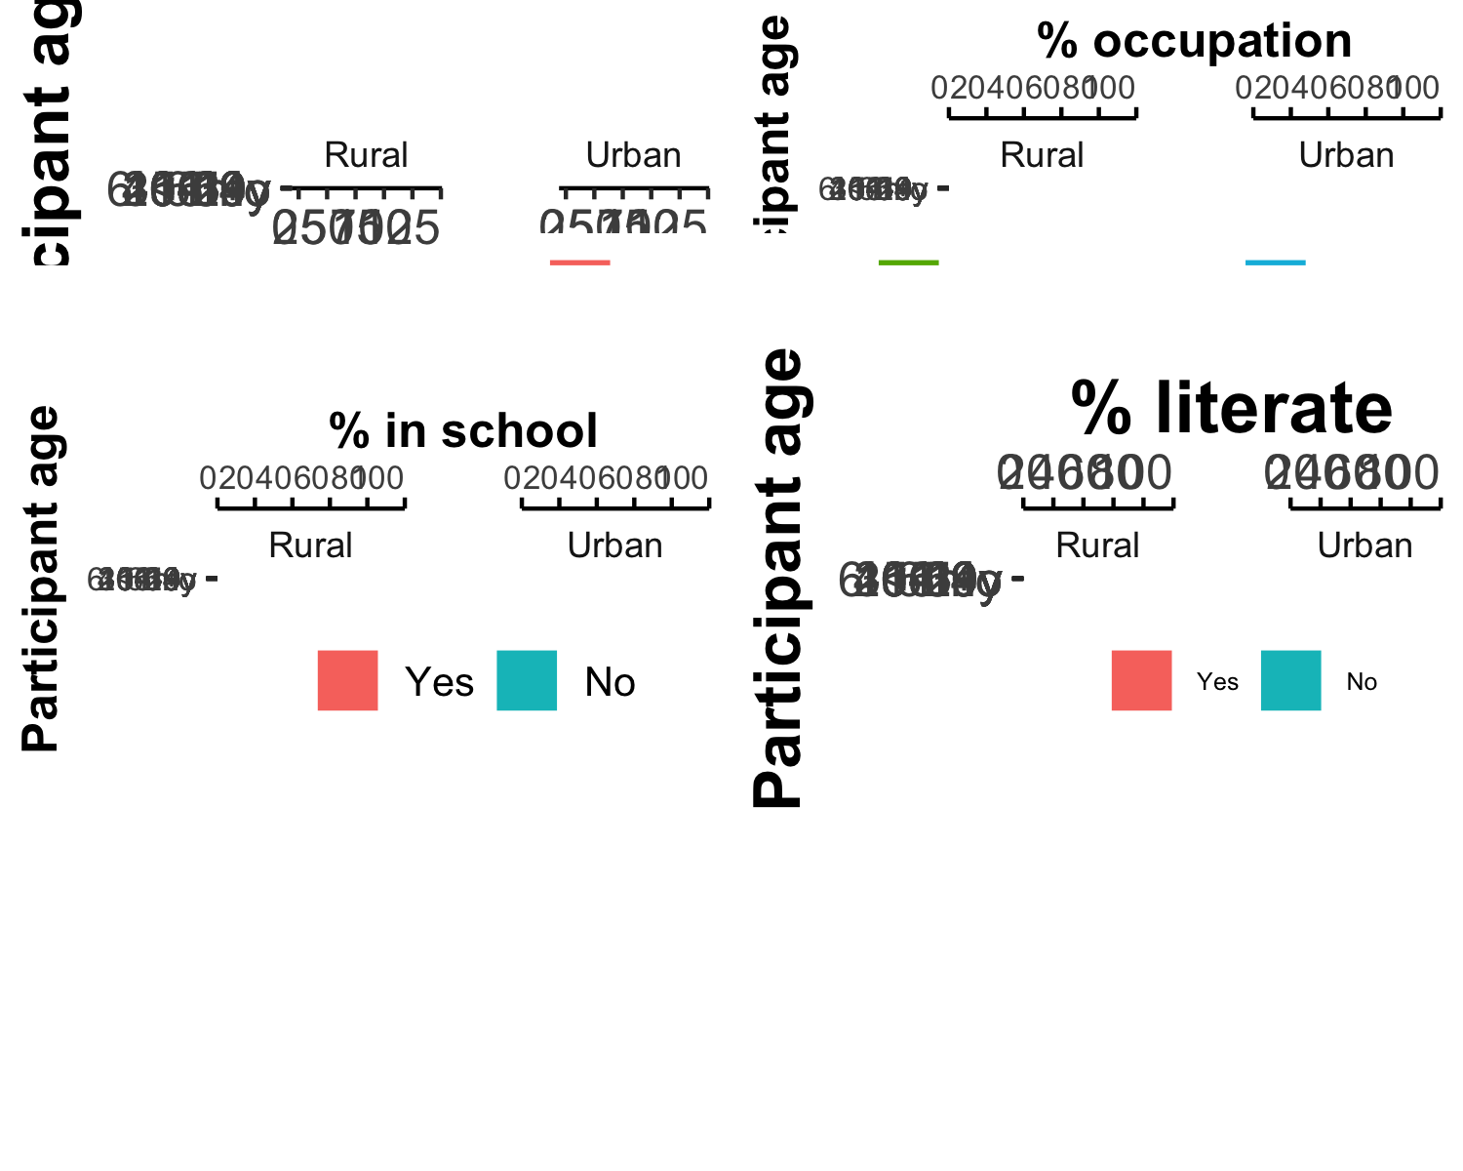

### 3.5.1 Distribution of contacts for each site site:

#### 3.5.1.1 by age

|  |
| --- |
| Figure 7: Overall distribution of contacts by rural and urban site |

#### 3.5.1.2 by sex

#### 3.5.1.3 by household membership

|  |
| --- |
| Figure 8: Distribution of contacts by household membership |

#### 3.5.1.4 by current school enrollment

|  |
| --- |
| Figure 9: Distribution of contacts by school enrollment |

#### 3.5.1.5 by day of the week

|  |
| --- |
| Figure 10: Distribution of contacts by day of the week |

#### 3.5.1.6 by weekday/ weekend

|  |
| --- |
| Figure 11: Distribution of contacts by weekday/weekend |

#### 3.5.1.7 by week of the year

|  |
| --- |
| Figure 12: Distribution of contacts by week of the year |

#### 3.5.1.8 by ARI infection status

|  |
| --- |
| Figure 13: Distribution of contacts by ARI status |

#### 3.5.1.9 by AGE infection status

|  |
| --- |
| Figure 14: Distribution of contacts by AGE infection status |

#### 3.5.1.10 by employment

### 3.5.2 Unweighted non-symmetrical contact matrices

### 3.5.3 Contact behavior

Figure 15 shows results of the question “Was the contact wearing a mask?

|  |
| --- |
| Figure 15: Mask wearing |

Figure 16 shows results of the question “What was the duration of the contact?

|  |
| --- |
| Figure 16: Duration of contact |

Figure 17 shows results of the question “Did you touch the contact?

|  |
| --- |
| Figure 17: Type of contact |

Figure 18 shows results of the question “Did the contact occur indoors or outdoors?”

|  |
| --- |
| Figure 18: Location of contact |

## 3.6 Negative binomial mixed model for crude contact rate ratio (CRR)

# 4. Proposed additional analysis

| Analysis | Status |
| --- | --- |
| Bootstrapped contact rates |  |
| Weighted contact matrices |  |
| Multivariate analysis (Negative binomial model) |  |
| Contact outlier analysis |  |
| Masking and contact reporting |  |
| Contacts vs indoor/outdoor locations |  |
| Contacts by location of contact |  |
| National policy measure timelines |  |
| Known vs unknown contacts over time |  |
| Contacts by vaccination status |  |

:{tbl-colwidths=“[30/70]”}