CSC450 – Module 7 Critical Thinking Assignment
Stevie Lopez
CSC450-1 Module 7
01/04/2026

Part 1. Program Pseudocode
START PROGRAM
DEFINE function countUp
FOR i from 0 to 20
DISPLAY "Up: I"
PAUSE for short time
END FOR
END FUNCTION
DEFINE function countDown
FOR i from 20 down to 0
DISPLAY "Down: I"
PAUSE for short time
END FOR
END FUNCTION
CREATE thread t1 to run countUp
WAIT for t1 to finish
CREATE thread t2 to run countDown
WAIT for t2 to finish
END PROGRAM
Part 2. Source Code
package module_8;
public class ConcurrencyCounters {
public static void countUp() {
for (int i = 0; i <= 20; i++) {
System.out.println("Up: " + i);
try {
Thread.sleep(100);
} catch (InterruptedException e) {
Thread.currentThread().interrupt();
return;
}
}
}
public static void countDown() {
for (int i = 20; i >= 0; i--) {
System.out.println("Down: " + i);
try {
Thread.sleep(100);
} catch (InterruptedException e) {
Thread.currentThread().interrupt();
return;
}
}
}
public static void main(String[] args) {
Thread t1 = new Thread(new Runnable() {
@Override
public void run() {
ConcurrencyCounters.countUp();
}
});
t1.start();
try {
t1.join();
} catch (InterruptedException e) {
Thread.currentThread().interrupt();
return;
}
Thread t2 = new Thread(new Runnable() {
@Override
public void run() {
ConcurrencyCounters.countDown();
}
});
t2.start();
try {
t2.join();
} catch (InterruptedException e) {
Thread.currentThread().interrupt();
}
}
}

Part 3. Execution

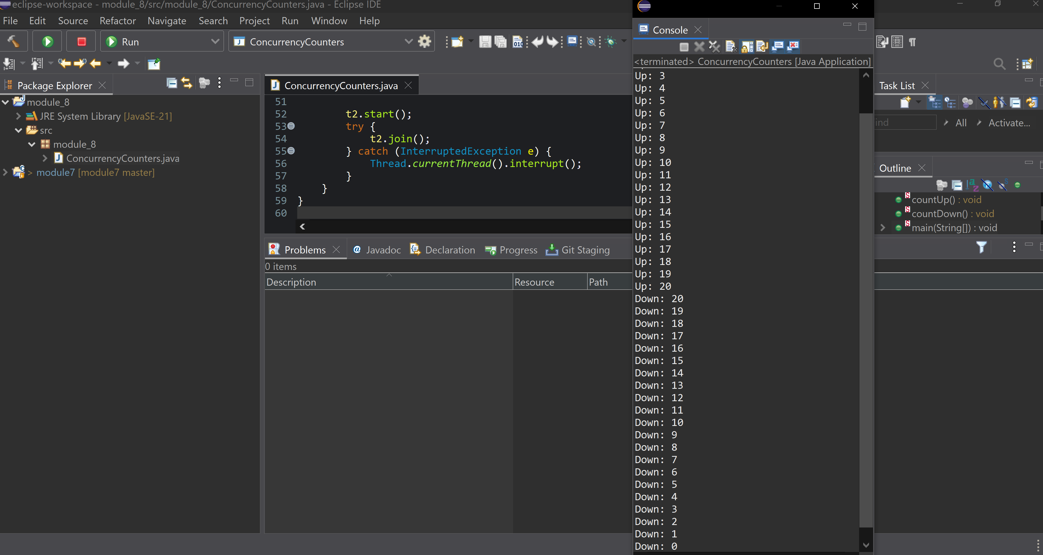

Part 4. Analysis
-Performance issues with concurrency
Threads have overhead. In this program the work is tiny (just counting to 20), so creating threads and managing them can cost more than the counting itself. Printing every number to the console is also slow and ends up being the main reason the program takes time. Since thread 1 finishes before thread 2 starts (because of join()), the program stays simple and the output is clean, but it also doesn’t get much speed benefit from using threads.
-Vulnerabilities with strings
There isn’t much string risk here because the program only prints fixed text like "Up:" and "Down:". There is no user input and no strings being built from outside data, so there’s nothing obvious to exploit. String problems usually show up when user input is printed/logged directly or used to build file paths, commands, or queries.
-Security of the data types
The counters use int and stay between 0 and 20, so overflow is not a concern. The threads also don’t share variables, which avoids race conditions. The only exception handled is InterruptedException from sleep() and join(), and the code sets the interrupt flag again so it doesn’t ignore the interruption. Since no sensitive data is used, there aren’t any major security issues in this program.

Part 5. Git Repository
https://github.com/lopstevi/module_8

