Storytelling with Data

Topic Overview
This meeting explores the importance of storytelling with data. While it is acknowledged as a crucial skill, the discussion aims to simplify the process and highlight its effectiveness in data communication.
The session will focus on how to transform data into compelling narratives to create an emotional connection with the audience and improve understanding and retention.

Core Concept Explained
The core concept revolves around structuring data narratives using the three key elements of a story: setup, conflict, and resolution. Every story follows this basic structure, making it universally applicable.
Setup establishes a baseline reality or situation. Conflict introduces change, and Resolution is the new reality resulting from that change. Without change, there is no story.
This framework allows us to analyze charts, identify potential stories within them, and rebuild them into effective storytelling devices.

Case Study Analysis
The meeting uses the Global Real Home Price Index as a case study. The index, with 2005 as the baseline, tracks home prices in different countries. Initially, the point where lines converge (2005) might suggest conflict, but this is misleading due to the index starting point.
The setup is the established baseline, prices indexed to 2005. From here, stories can be developed both backward and forward in time.
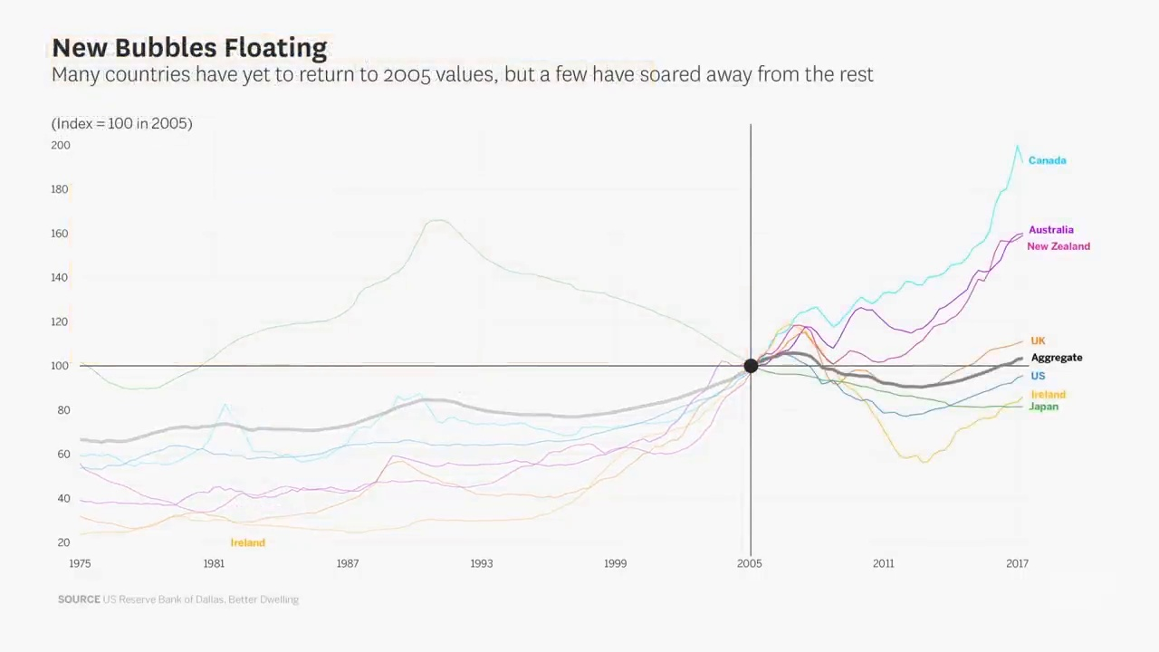
Global Real Home Price Index

Key Examples Discussed
Two primary stories are identified within the Home Price Index data. One story looks backward from 2005 and focuses on the steady increase in home prices globally, contrasting it with Japan's three-decade-long bubble.
The other story looks forward from 2005 and illustrates a housing price bubble in most places, except Japan. This bubble is followed by a market bifurcation, with Australia, Canada, and New Zealand experiencing renewed growth, while other markets fall and recover to around 2005 levels.

Interpretation of Data
The analysis highlights the importance of understanding the underlying context of the data. In the case of the Home Price Index, the index's baseline year significantly impacts the interpretation of price trends.
Proper understanding can lead to more accurate identification of setups, conflicts, and resolutions within the data, resulting in better storytelling.

Lessons Learned
Data storytelling involves actively highlighting elements of the story while eliminating distractions. This targeted approach helps keep the audience focused on the core narrative.
Chart titles should actively contribute to the storytelling, reflecting the narrative elements rather than simply providing generic descriptions.
Visually displaying a setup, conflict, and resolution together in one state helps the audience comprehend the progression of the story.
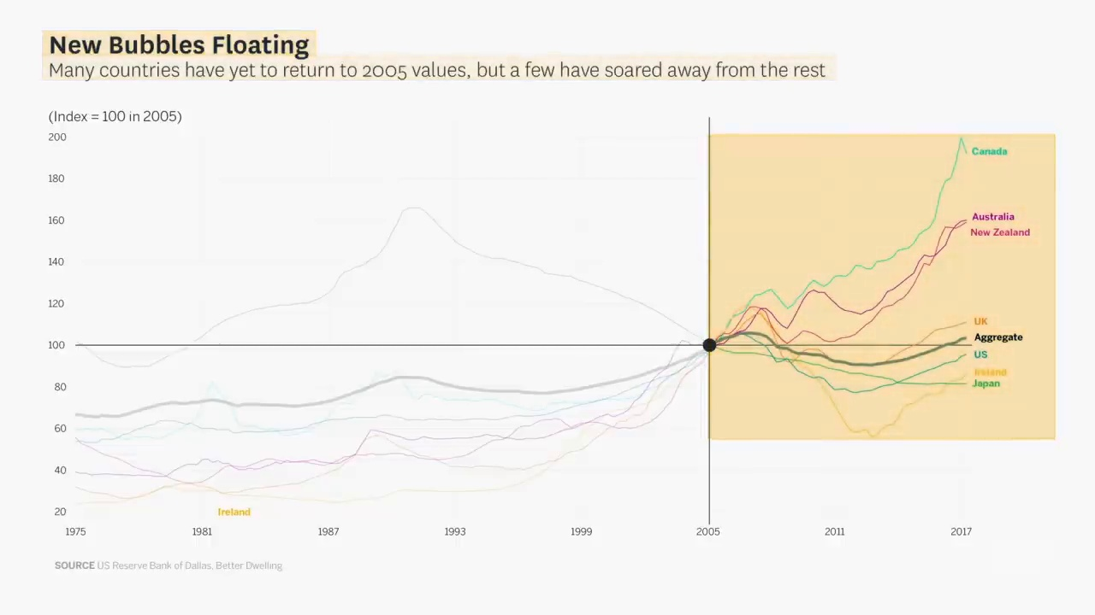
New Bubbles Floating: Market Bifurcation

Conclusion
Storytelling is a powerful communication tool that connects with the audience on an emotional level. Applying it to data allows you to convey information that resonates, leading to increased belief and understanding.
By using storytelling, information becomes not only credible but also impactful, creating a lasting impression.

