Release Notes – Verify API

2026Q4.0 Major Release – API Version - 2026Q4.0 - 2.61.0.20651-551c898

Available from 15th Oct 2026

Contents
Local API Notice 3
Case Resolutions 3
Details of Resolved Cases 4
Installation Instructions 7

Local API Notice
In the 2025Q4.0 release we have fixed 4 cases which improve the Verify API.

Case Resolutions
Details of the customer case resolutions are detailed below. If you would like more details on these cases, please contact LoqateSupport@gbgplc.com or your Customer Success Manager for further information.

Case Number | Change Description | Country
Enhancement | Introduced a new server option, PreserveInputValue. When it is set to yes, true or 1, the user’s input values will be preserved in the output result. It does not remove, change or add words. | All
CAS-180138-T2N3L3 | Improved match score calculation. | All
CAS-179697-C5Z3F1 | Improved matching of premise number in alphanumeric grid address format against reference data. | All
GBG | Improved the retrieval of AdministrativeAreaISO2 in Enhance process. | All

Details of Resolved Cases
Case Number | Change Description | Category | Country | Example Address
Enhancement | Introduce a new server option, PreserveInputValue. When it is set to yes, true or 1, the user’s input values will be preserved in the output result. It does not remove, change or add words. | API | All | - Address1= "Butler Dr Orlando", Administrative= "Florida", PostalCode="32888", Country="United State"
Default Image |  |  | Option True Image
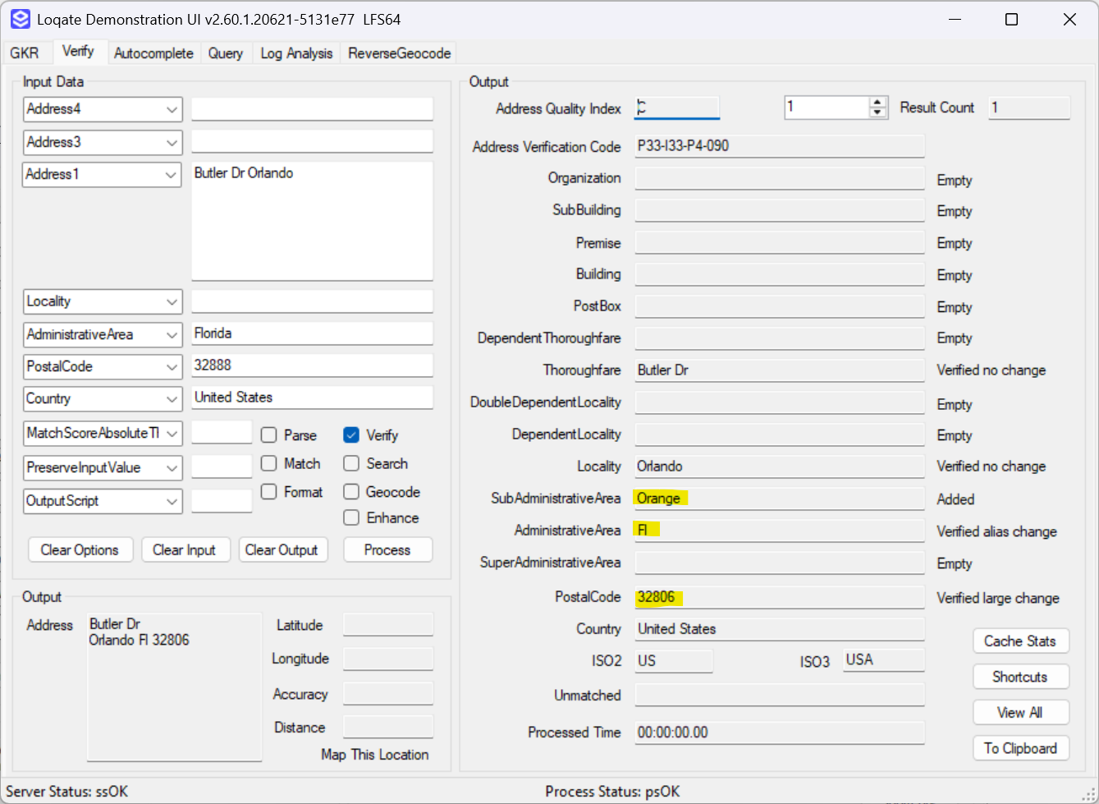 |  |  | 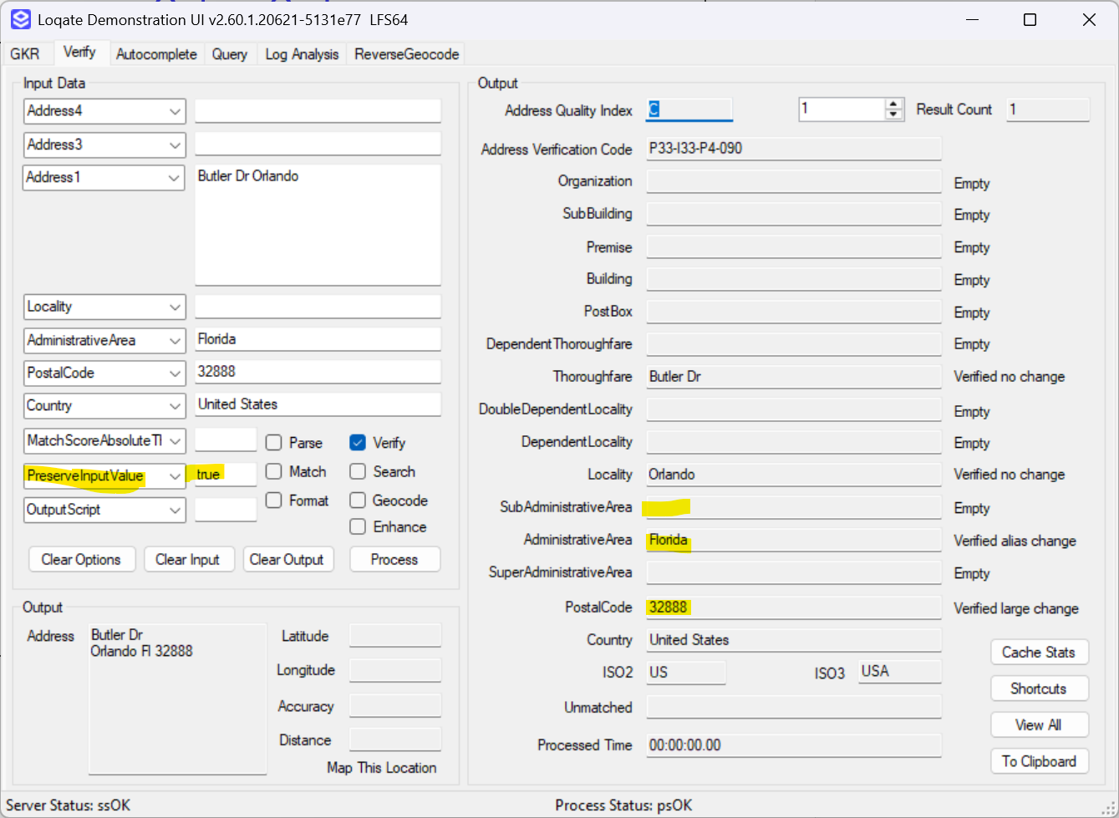

Case Number | Change Description | Category | Country | Example Address
CAS-180138-T2N3L3 | Improved match score calculation | API | All | - Address1= "1 CASTLE STREET COURT CASTLE STREET FRASERBURGH AB34 9FF", Country="GBR"
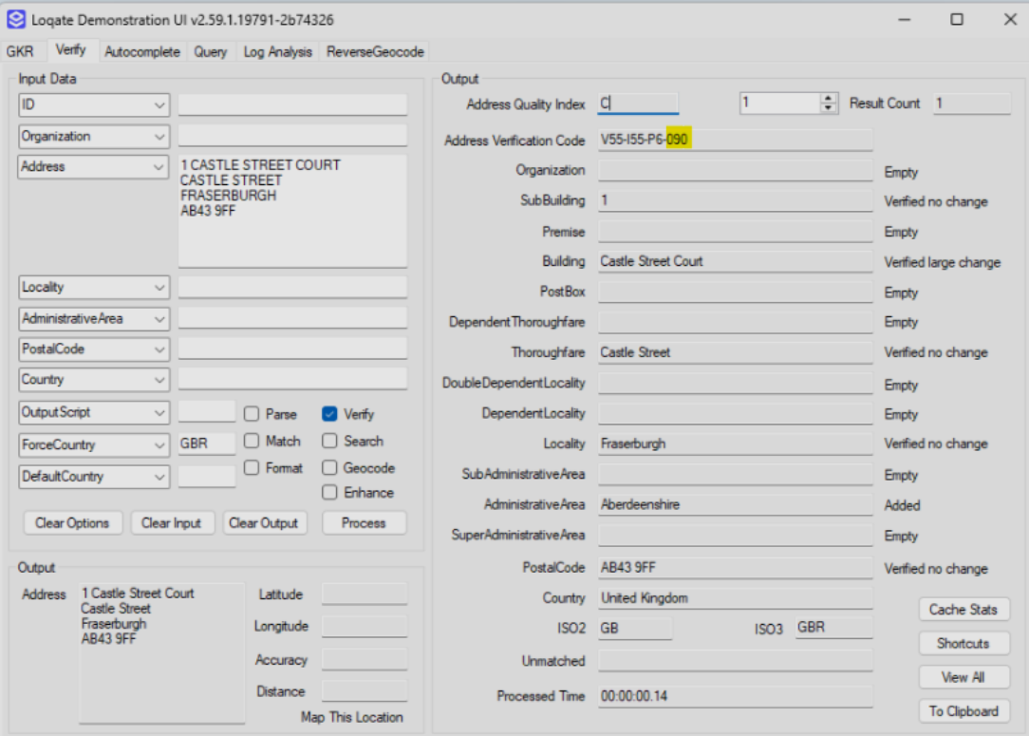 |  |  | 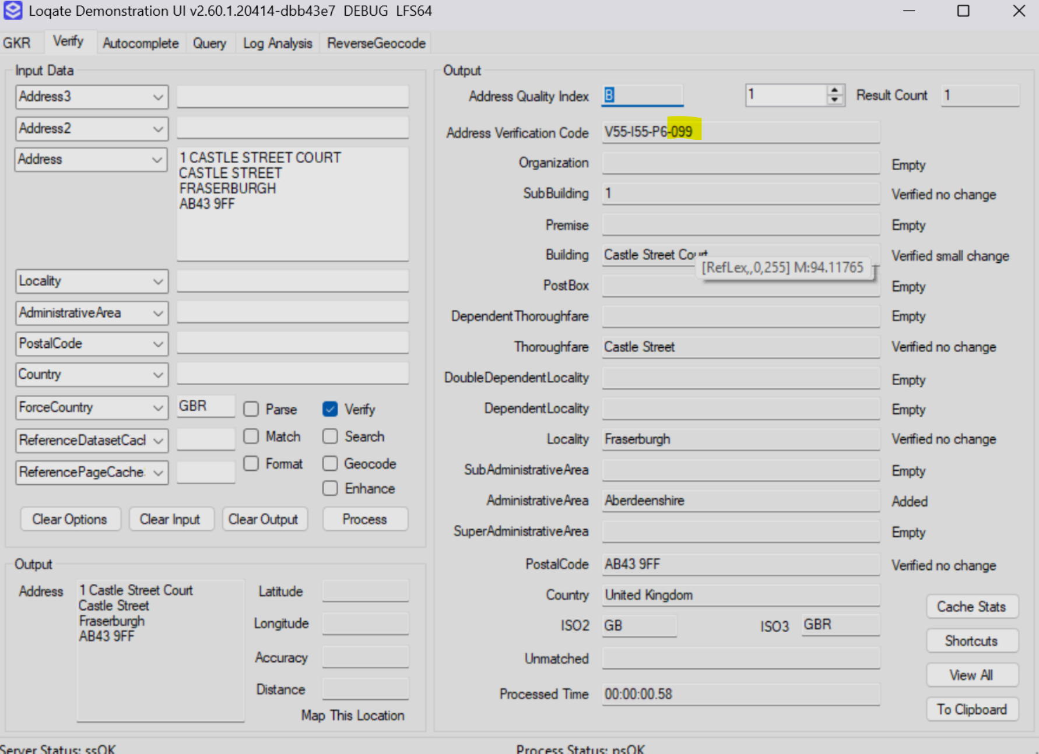

Case Number | Change Description | Category | Country | Example Address
CAS-179697-C5Z3F1 | Improved matching of premise number in alphanumeric grid address format against reference data. | API | All | - Address1= "W165N11084 Kings Ct Germantown",  AdministrativeArea=”WI”, PostalCode=”53022-4092”, Country="US"
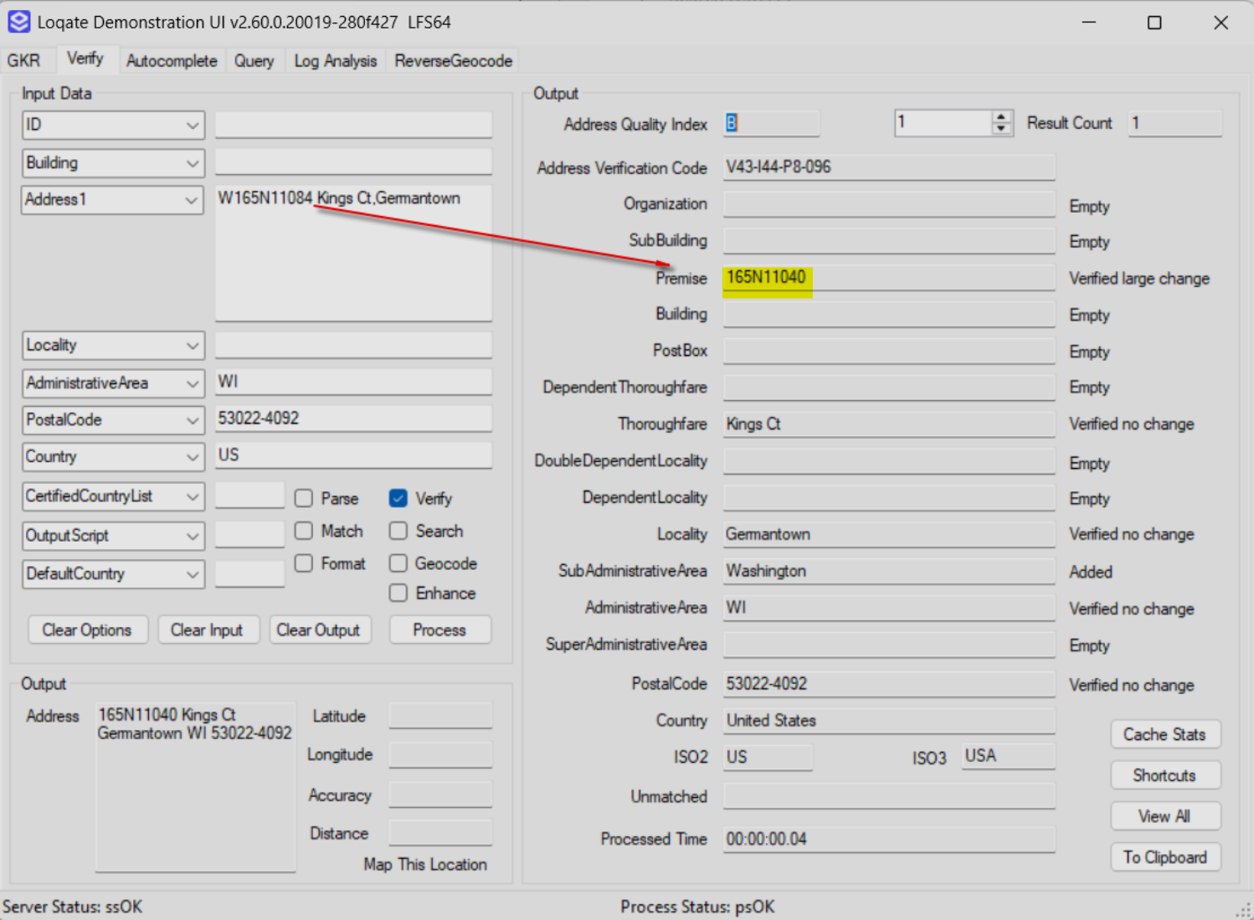 |  |  | 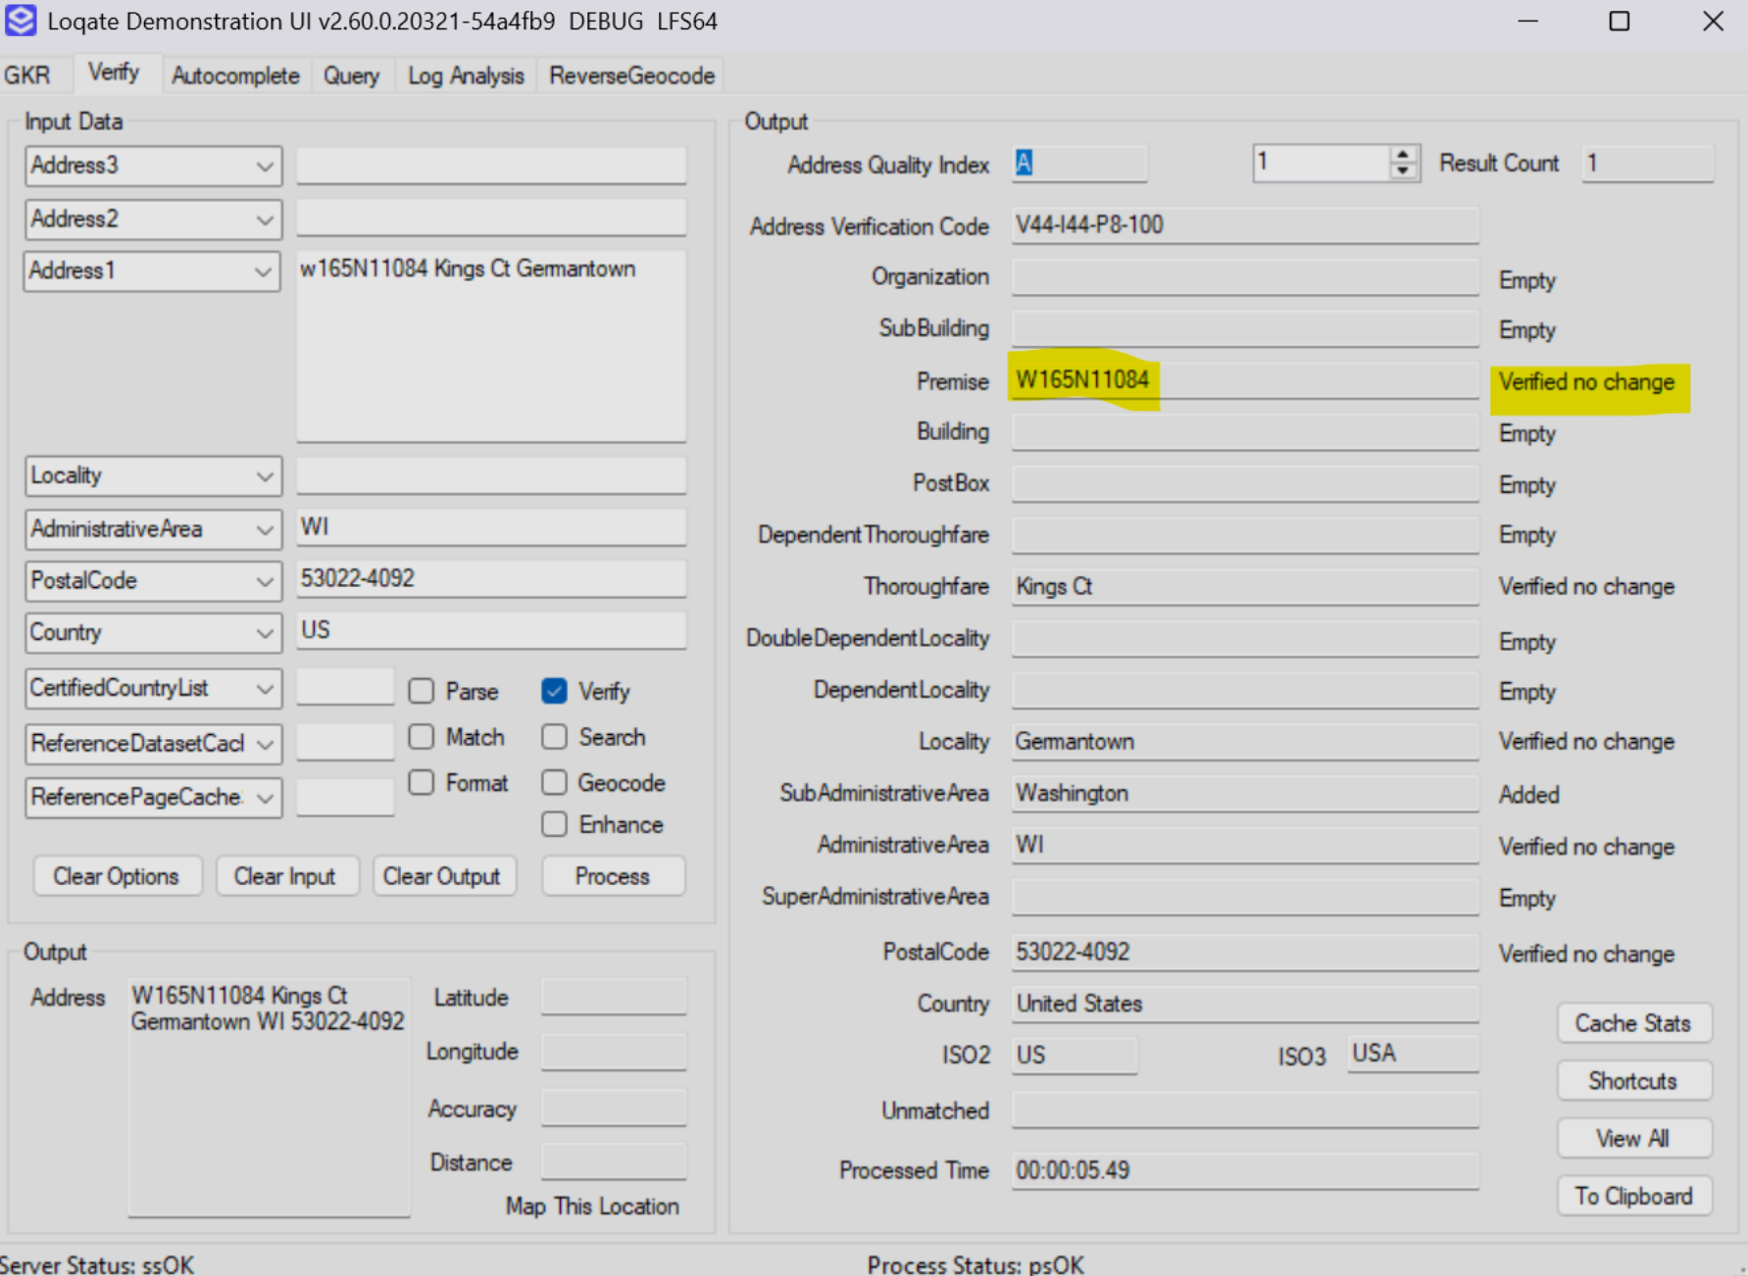

Case Number | Change Description | Category | Country | Example Address
GBG | Improved the retrieval of AdministrativeAreaISO2 in Enhance process. | API | All | - Address1= "TASOLUK MERKEZ MAH. 107 SK. NO. 4 TASOLUKE ARNAVUTKOY - ISTANBUL TURKEY", Locality="ISTANBUL", Country="TUR"
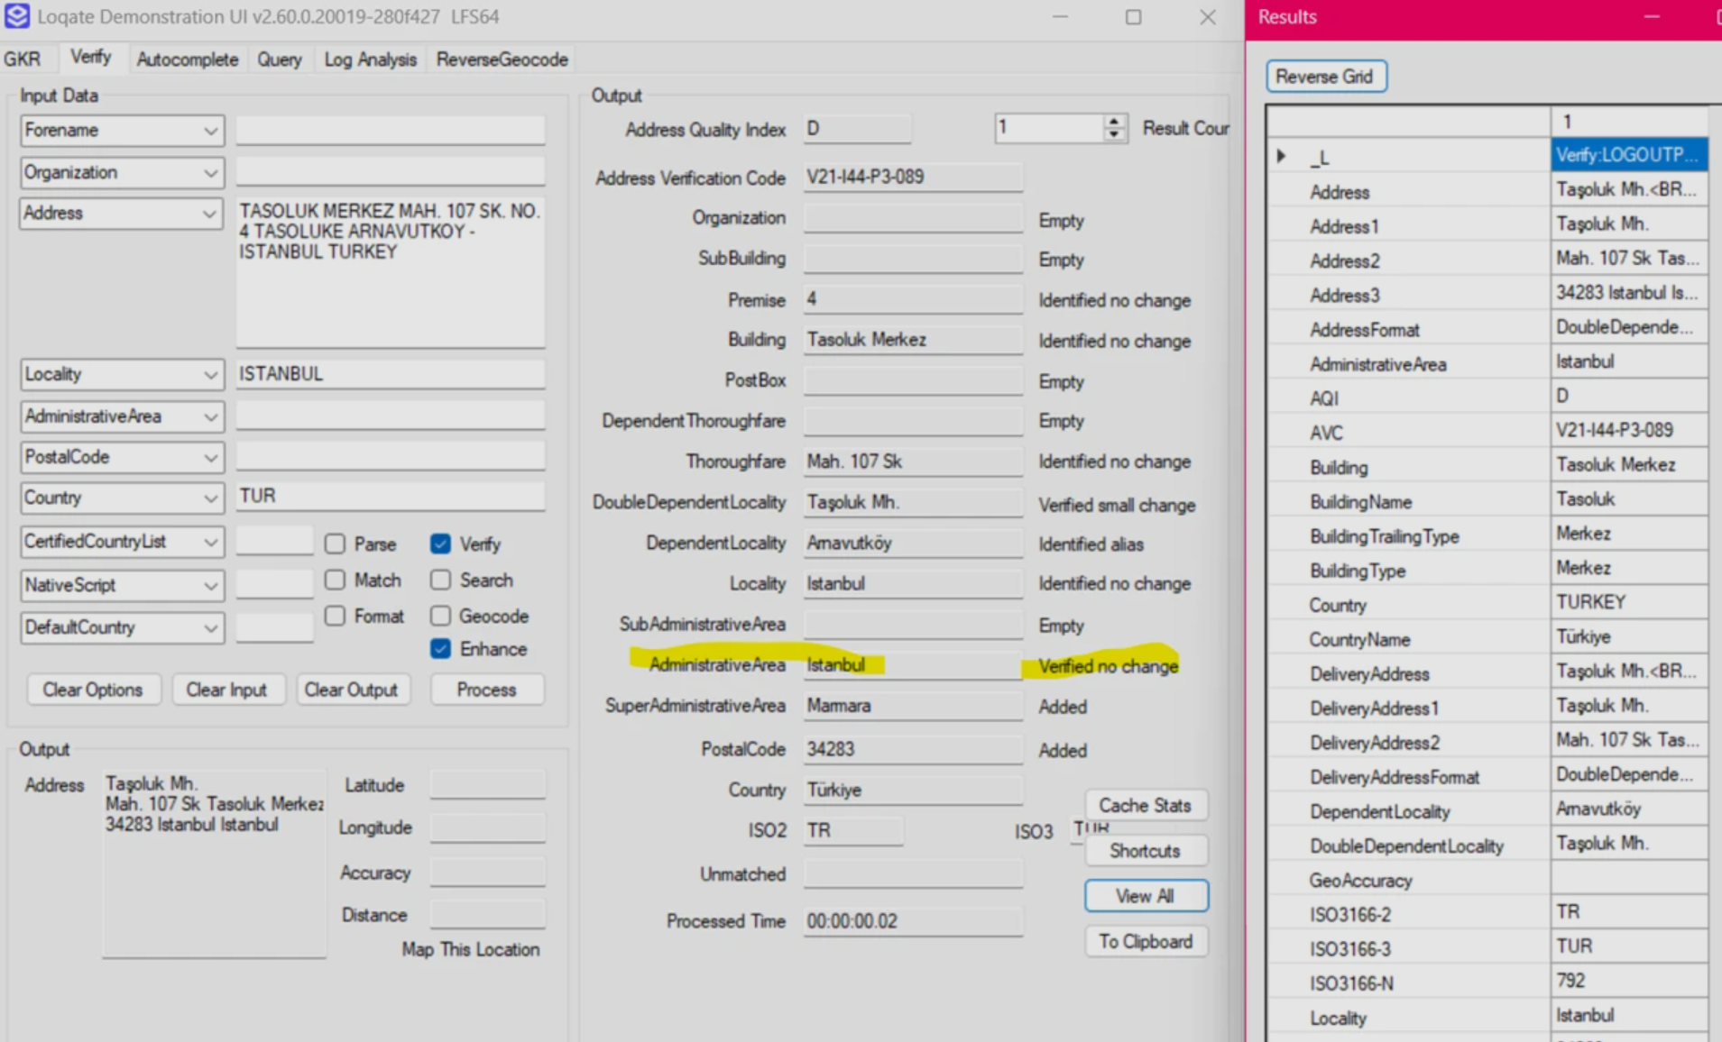 |  |  | 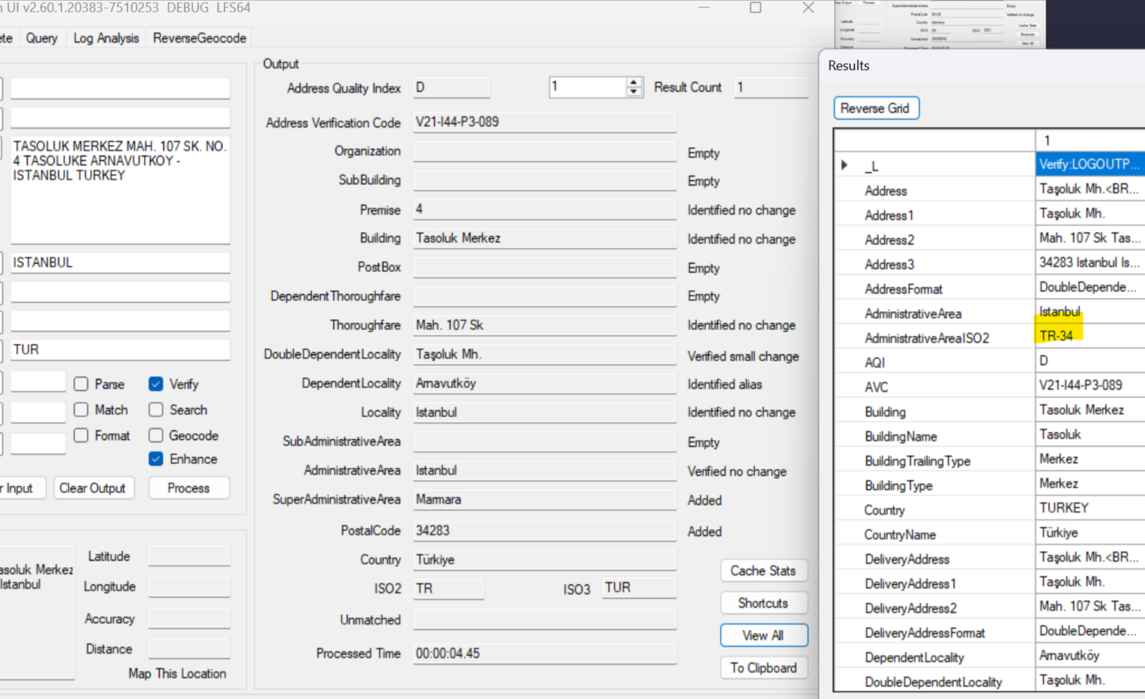

Installation Instructions
Please remember to update both the program files and the reference data and please install these to a new fresh folder location. The improvements are tied to the data in the Global Knowledge Repository and the Local API. When updating the data, it is recommended to use a new data folder each time to ensure the latest dataset is installed properly.

If you need any assistance with the upgrade of the Local API or the data update process, please contact GBG Loqate Support.

The setup wizard for the Local API can be obtained from our SFTP server. Please contact your account manager to retrieve the SFTP information. If you do not know who your account manager is please contact GBG Loqate Support.

