Language mapping, stage 01: what changed between 28 September and 9 October 2026-
Preprocessing, references, bad lists, trials, the preprocessing audit, and the three patients whose triggers were checked (PAT_3780, PAT_3975, EL031). Written 9 October 2026 from the git history, the 140 audit (outputs/03_ERSP/audit_140.tsv), the Stage 01 per-patient table and the probe scripts of the two Claude sessions. Every number is from a file that still exists; the figures are the ones made at the time, plus three summary figures drawn from existing tables (trials, muscle, band reliability).

Summary
- One tree, one procedure: every published cube now comes from one tree, 03_ERSP, run with the same settings for all 30 patients (interp notch, MAD 3.5 trial rejection, bad-listed contacts dropped before the reference). The frozen 04_* trees were archived on 7 October.
- The reference is only as good as its worst contact: a single broken white-matter contact in the reference mean injects its lines and noise into every contact of a patient. Found and fixed for EL048 (aH_L1, 10x), PAT_3965 (cmd12, 43x) and EL033 (PHG_R4, 9x); the earlier PlaT_L4 of EL045 was the sam e thing. All three patients were rerun; two of EL033's contacts that had been removed on the noisy cubes came back.
- Bad lists: 141 contacts were bad-listed between 28 September and 7 October across 18 patients, each with a dated reason in the config; the Stage 01 tab shows them per patient.
- Trials: of 4,740 recorded trials, 3,777 (80 %) enter the ERSPs; 963 are removed by the trial filters, 438 of them for a wrong answer. Three patients lose more than half of a block (EL043, EL046 reading, EL031 audio).
- Preprocessing audit: 42 contacts in 11 patients carry speech muscle in the response half (a rise at 250-400 Hz as large as at 70-150 Hz); the 300-ms single-trial baseline paints a +-0.34 dB random offset on every row; one 128-ms window cannot resolve rows below 12 Hz and makes rows above 170 Hz copies of high gamma. Trial windows, baseline position, the MAD rule and dB averaging were checked and are fine.
- PAT_3780: its trial tables were 180.0 s early. No channel of the recording is a photodiode on its own; the envelope of X1 minus the envelope of X2 is (Lora's recipe), and every trial was recovered from it. At the corrected onsets the superior temporal contacts answer the spoken words (|t| up to 12), at the old ones nothing did. Rerun on 7 October; five contacts bad-listed.
- PAT_3975: its 2023 photodiode tables are right: the raw difference E1 - E2 steps at every one of its 150 trials and 22 / 11 / 17 channels show evoked responses at the current onsets.
- EL031: added to the pipeline (three one-block EDF recordings joined, triggers from DC6 per file, 51 / 23 / 53 trials, Lookup anatomy), run once with a whole-recording CAR, and excluded from the cohort the same day: the audio block stopped after 23 trials with the patient asleep and 8 survive the filters.
- Still open: cache v14 without PAT_3780's old windows and the clustering chain on it; PAT_3780's TPG3 / FAS1 and EL040's CinG_R13 still to be looked at in the raw; EL031's recon; the reading-block broadband effect of PAT_3780 to be re-judged on the corrected cubes.

Key numbers
what | value | where
patients run in 03_ERSP | 30 (31 with EL031) | audit_140.tsv
recorded / used / removed trials | 4,740 / 3,777 / 963 (20.3 %) | audit_140.tsv, PerTrial/Report/*_IQR.tsv
removed for a wrong answer | 438 | *_IQR.tsv, n_dropped_accuracy
contacts bad-listed 28 Sep - 7 Oct | 141 in 18 patients | functions/config.py, bad_channels_manual
reference contacts found broken | 4 (EL045 PlaT_L4, EL048 aH_L1, PAT_3965 cmd12, EL033 PHG_R4) | Stage 01 tab, FOUND
speech-muscle contacts in the cohort | 42 in 11 patients | audit_cohort/emg.tsv
PAT_3780 trial-window error | 180.0 s (log + 149.57 s instead of log - 30.43 s) | pat_3780_build_triggers.py
EL031 trials recovered | 51 picture / 23 audio / 53 reading | el031_build_triggers.py

1. Timeline
Grouped by day from the commit history of lorafanda/Analysis_LoraFanda (main). Site-only commits (the cluster-visualizer bundles of 28 September) are left out.
date | what landed
28 Sep | EL045 third rerun: the 59.94 Hz screen comb notched as a second comb; +-5 Hz width floor at 350 Hz for EL037 and EL045 (trial-locked residue the +-1 Hz test missed). Bad lists: EL037 pH_R12 (+33 dB floor) and seven more by Lora; EL043 sSMG8-10; EL045 PlaT_L2-4 / PlanTL4 / A_R8 and the 350 Hz stripe shaft A_L2-4 / STG_L1-2. Patient metadata (centre, task language); FIG C.0 cohort figure.
29 Sep | 140: bad-listed contacts drop BEFORE the reference and the notch (they used to be removed after); trial z-score test tree and per-trial z on the HFA figures; EL051 and EL052 reference contacts checked one against the other (EL051 3 WM contacts, EL052 on its FreeSurfer recon).
30 Sep | One output tree 03_ERSP for everyone (HG renamed HFA), MAD 3.5 trial rejection for every patient, PAT_3415 depth contacts only, notch half-width capped at 3 Hz, the cohort tag in every run, TABLE C.0 (every patient and why it is or is not in the cohort). Full rerun of the cohort (19:27-22:17).
2 Oct | Stage 01 tab: the procedure step by step, each step cited to the function that does it, and the per-patient table (reference, removed contacts and why, findings, owed). PerTrial/ folder per patient (HFA rasters, Signal traces in uV, trial scores, Report/). The photodiode stays as a figures-only channel; 143 removes the non-neural leftovers. Bad lists of the visual review (PAT_3975 ictal shafts, PAT_3455, PAT_3390, EL040, EL038, EL035 notch residue, EL033 14 contacts, EL045 13 more). THE REFERENCE FINDING: EL048 aH_L1, PAT_3965 cmd12, EL033 PHG_R4; EL048 rerun the same evening.
5 Oct | EL033: pH_R7 and aH_R12 back (their stripes were PHG_R4's); PAT_3965 and EL033 rerun with the reference contacts out.
5-6 Oct | Preprocessing audit (muscle, baseline banding, spectral resolution; what is fine). Counters to cNMF built (not in this report).
7 Oct | PAT_3780: reading-block finding, no photodiode found, the envelope recipe, 180-s error, pat_3780_build_triggers.py, bad list, rerun. EL031 onboarding (el031_build_triggers.py, RAW_CONCAT with a shaft rename, Lookup anatomy). Cleanup by the other session: 60 GB archived, the 04_* trees leave git, everything reads 03_ERSP. 140: EL depth patients with non-Bern names keep their shafts by prefix.
8 Oct | collect_trials skips a manual trigger table instead of stopping; EL031 run (whole-recording CAR).
9 Oct | EL031 excluded from the cohort as a whole patient; PAT_3975 photodiode checked and confirmed.

2. Pipeline changes (140 and its helpers)
- Order of operations. before 29 September a bad-listed contact was removed after the reference had been computed, so a broken contact on the list still polluted the white-matter mean. Since then the list is applied first, then the reference, then the notch. This is what made the EL048 / PAT_3965 / EL033 fixes a one-line change each.
- Notch. the spectrum-interpolation notch is the method for everyone since 24 September (the IIR notch dug holes: after_db negative for every IIR patient). Its half-width is capped at 3 Hz (30 Sep) with per-patient floors of +-5 Hz at 350 Hz for EL037 and EL045, where a trial-locked residue sat 0.7-1.2 dB below the neighbouring rows while the +-1 Hz PSD test passed. EL045 gets a second comb at 59.94 Hz (the screen refresh; 20 of its 23 unexplained peaks), EL048 one at 16.667 Hz (railway traction).
- Output tree. a single tree, outputs/03_ERSP/<patient>/LM/, holds cubes, halves, CLEAN images, QC figures and PerTrial/ (HFA rasters, Signal traces, trial scores, Report/ with the IQR table, the QC figures, the notch audit and the unexplained peaks). The frozen 04_* trees were archived on 7 October and every reader uses 03_ERSP only.
- Trial rejection. MAD 3.5 on the high-gamma score, per channel and trial, for every patient (was a mixture of rules); the per-trial z is printed on the HFA figures; the trial z test tree of 29 September was the evidence.
- Signal figures. twin of the HFA raster with the cleaned signal as traces at one uV scale for the cohort (200 uV per row), so a saturated or flat trial is visible as such.
- Stage 01 tab. the per-patient table (reference, removed contacts and why, findings, owed) is generated from the config and the audit, so a contact name that is not in the config fails the build. The 'listed but not recorded' column of 141 was dropped: meaningless since the list is applied before the ERSP stage.
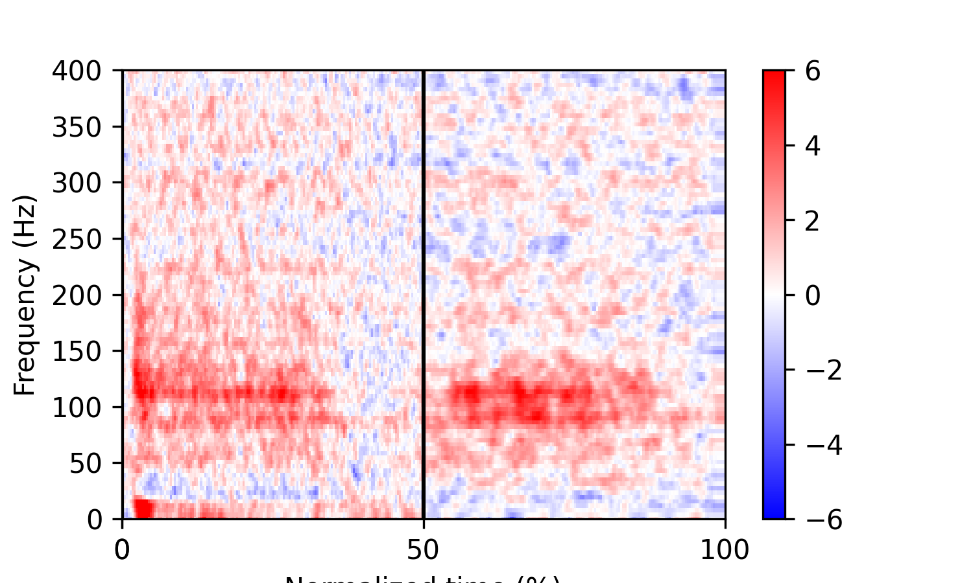
FIG 2.1 - the ERSP as 140 writes it: one contact, one block, 0-400 Hz x 300 warped bins (stimulus half, then response half), dB re the single-trial baseline.
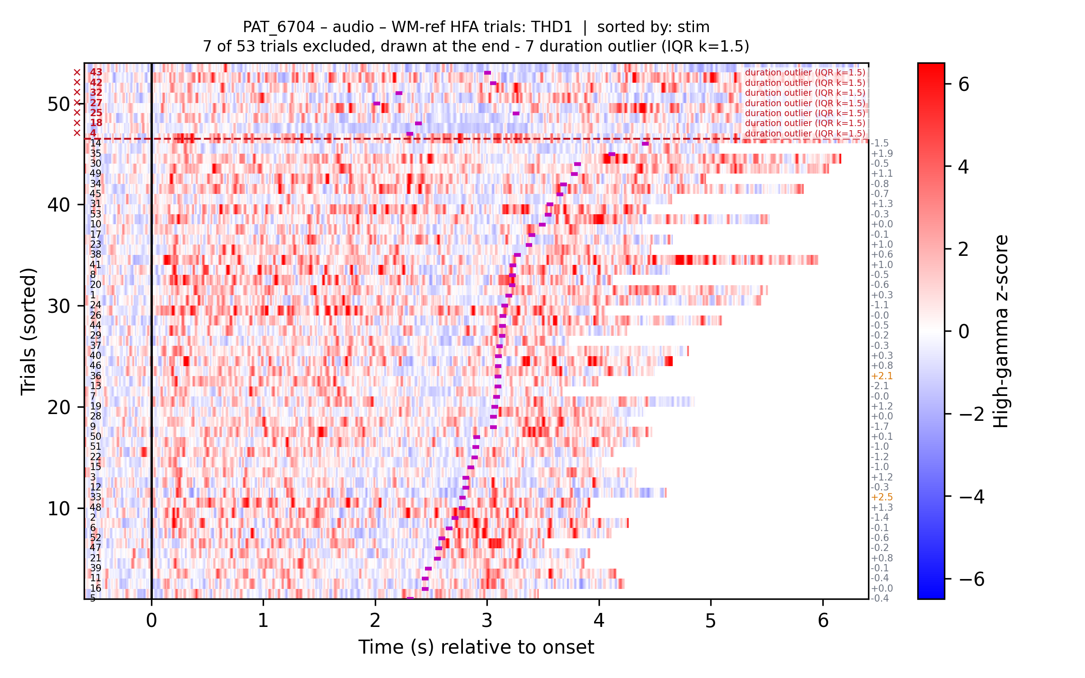
FIG 2.2 - the per-trial HFA raster of the same contact: trials sorted by stimulus duration, excluded trials drawn at the top with their reason, the per-trial z printed at the right.

3. The reference contacts
The white-matter reference is the mean of a patient's white-matter contacts (3 to 48 of them). Subtracted from every contact, anything that lives in one reference contact only appears on all the others at 1/n of its amplitude, with the opposite sign, and at (n-1)/n on the contact itself. A line that is identical in amplitude and phase on every contact of a patient is therefore the reference's own, and the one contact that carries it n-1 times larger with the sign flipped is the culprit. That is the per-contact check written on 2 October (s1_ref figure below); it was run on the whole cohort as a screen.
patient | contact | what it did | fixed
EL045 | PlaT_L4 (1 of 5) | 70-150 Hz floor 11 dB above the patient; once out, the 59.94 Hz screen comb became visible on four shafts and was notched | 28 Sep rerun
EL048 | aH_L1 (1 of 11) | 3230 uV SD in the raw file against 60-75; every line 50-400 Hz stood at the same amplitude and phase on the 69 other contacts and at 10.0x, sign flipped, on aH_L1: the 200 / 300 Hz ERSP bands, the 400 Hz band the notch never tests, the 84.5 / 115.5 Hz pair, the 12.5 Hz comb of the audio block | 2 Oct rerun; rows within +-0.2 dB, floor -2 to -4 dB
PAT_3965 | cmd12 (1 of 44) | 356 uV SD against a median of 73; carried 99-101 % of the shared line at 43x; 1.1-1.9 dB of every contact's floor. Simulated without it: lines 17-26 dB -> 1-3 dB, 130 notched bands -> 49-52 | 5 Oct rerun
EL033 | PHG_R4 (1 of 10) | 60-390 Hz floor 18 / 15 / 8 dB above the median contact (audio / picture / reading); 98-102 % of the shared line at 9.0x; 26 of 56 notched bands > 3 dB above the floor in audio, none without it | 5 Oct rerun; pH_R7 and aH_R12 back
EL043 | pIns2 (1 of 28) | 80-93 % of the shared line, but ordinary broadband; without it the lines sit 6-12 dB lower before the notch and the ERSP rows do not change | left in
EL040 | CinG_R13 (1 of 9) | 10 dB above the median contact at 12-30 Hz, ~12 % of every contact's beta power | not checked further

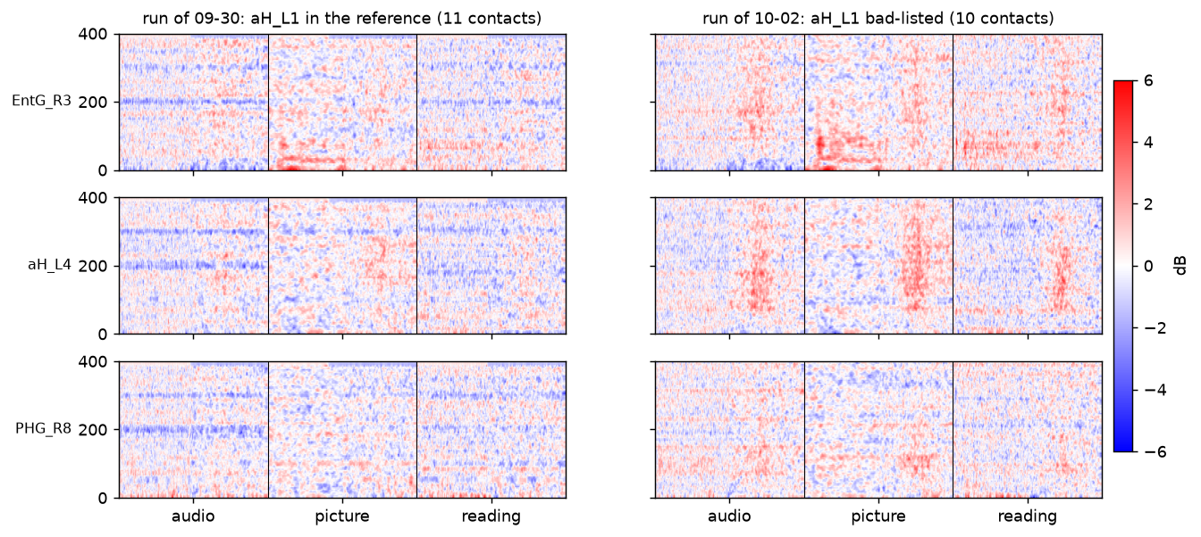
FIG 3.1 - the reference check on EL048 (2 October): the shared line on every contact and aH_L1 carrying it at 10x with the sign flipped.
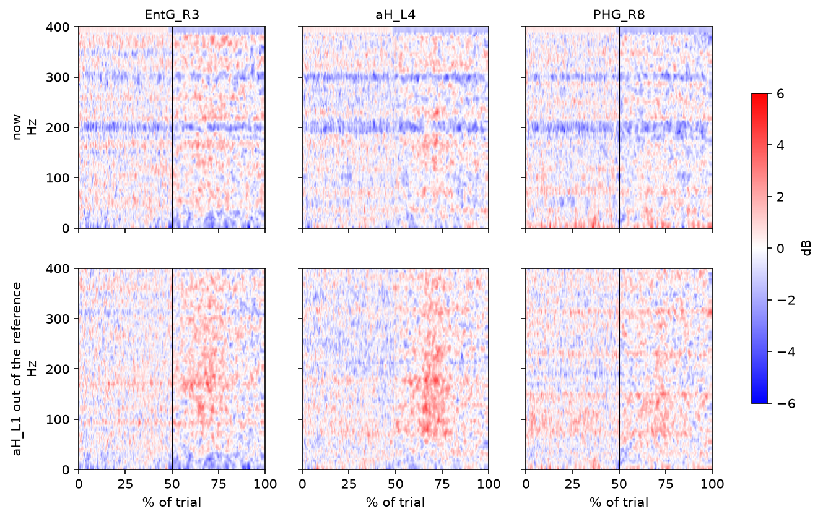
FIG 3.2 - EL048, audio block: the simulation of the fix before the rerun (reference without aH_L1).
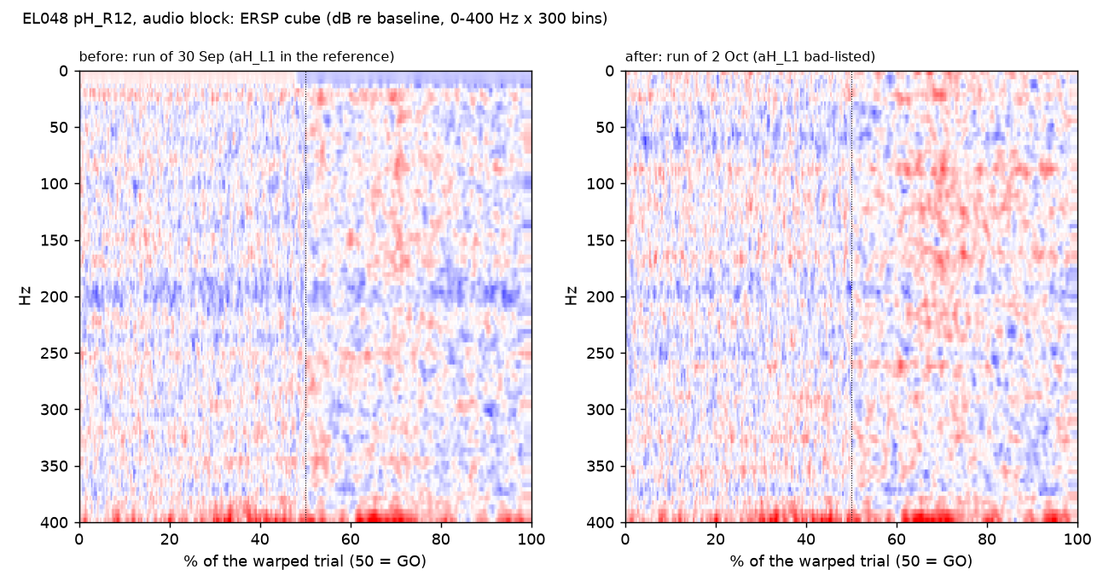
FIG 3.3 - EL048 pH_R12, audio, before and after: the run of 30 September with aH_L1 in the reference, and the run of 2 October without it.
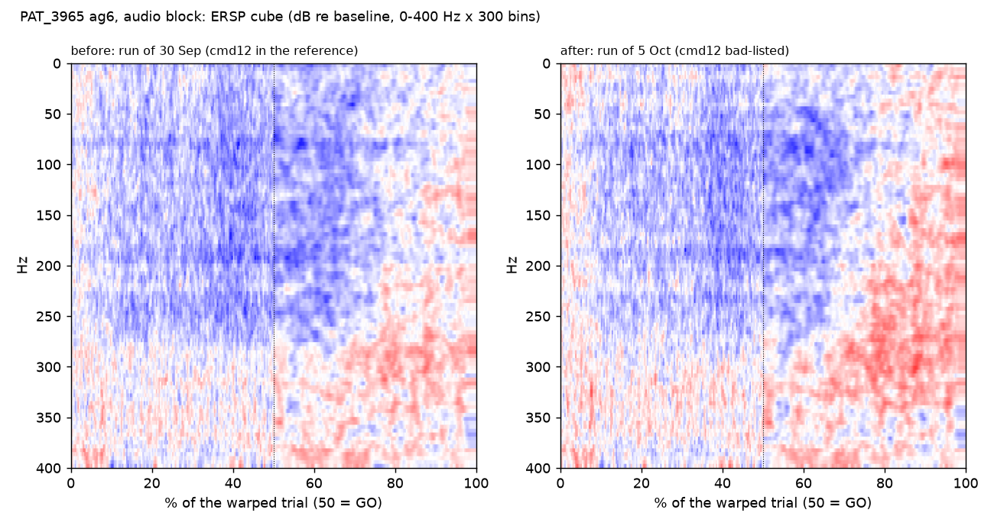
FIG 3.4 - PAT_3965 ag6, audio, before (30 September, cmd12 in the reference) and after (5 October).
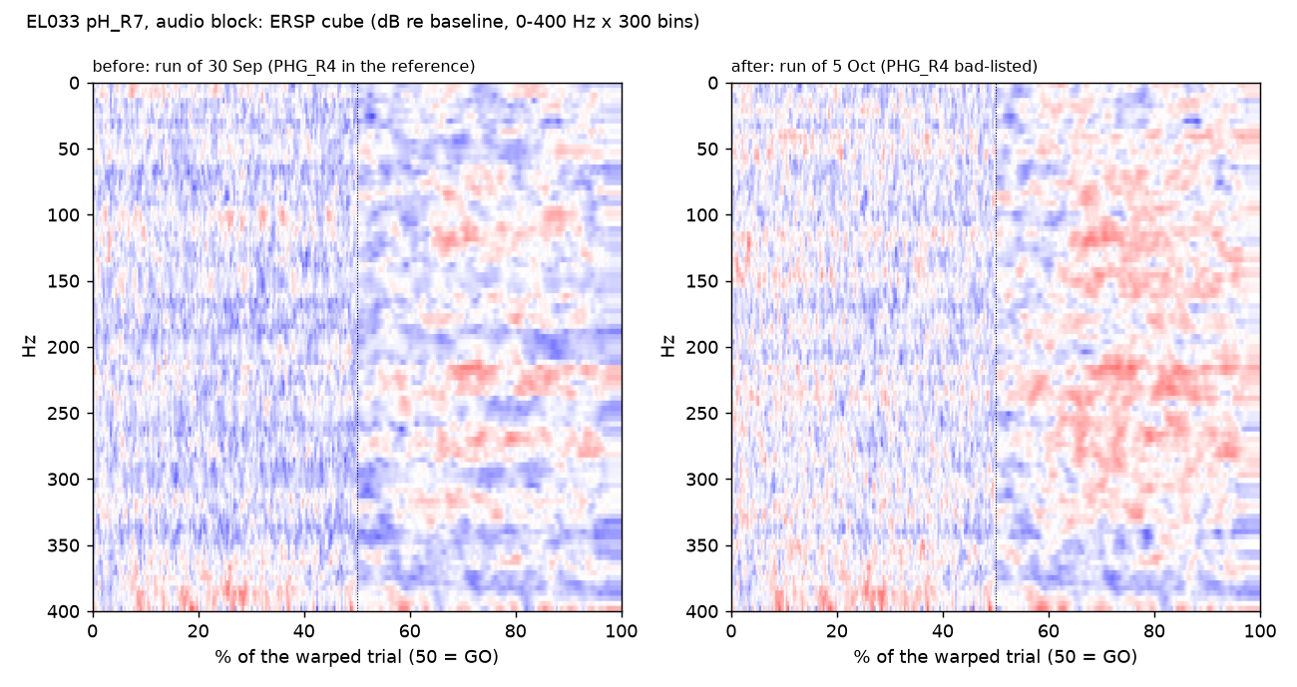
FIG 3.5 - EL033 pH_R7, audio: one of the two contacts that had been removed on 2 October for its stripes and came back on 5 October once PHG_R4 left the reference.
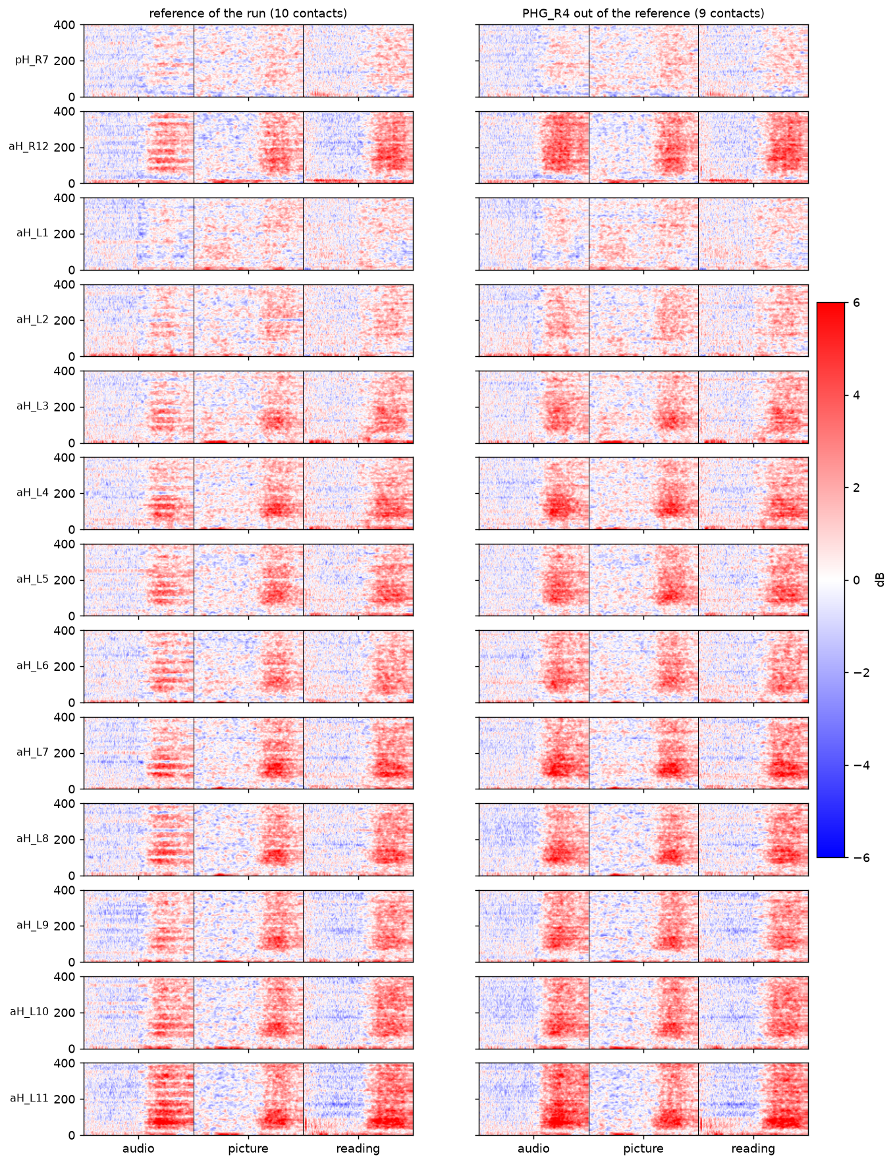
FIG 3.6 - EL033: the 13 contacts removed on 2 October, recomputed without PHG_R4 in the reference (simulation). The horizontal notch stripes go from all of them; the aH_L shaft stays out for other reasons.

4. Bad lists since 28 September
Every entry carries its date and reason in functions/config.py; the Stage 01 tab prints them per patient. Reasons fall in five kinds: a broken reference contact (section 3), a dead or saturated contact, a shaft the notch could not clean, ictal activity on visual review, and contacts outside the brain in the anatomy workbook.
date | patient | contacts | reason
28 Sep | EL037 | pH_R12; aI_L2-5, A_L4, pI_L14, CinG_L2 | 70-150 Hz floor +33 / +31 / +7 dB (dead in two blocks); the seven by Lora after the rerun
28 Sep | EL043 | sSMG8-10 | 12-70 Hz floor 10-14 dB above the patient in every condition; saturated trials in the raster
28 Sep | EL045 | PlaT_L2-4, PlanTL4, A_R8; A_L2-4, STG_L1-2 | 70-150 Hz floor 7-15 dB above the patient (PlaT_L4 a reference contact); the deepest 350 Hz stripe (-1.7 dB rows)
29 Sep | EL051, EL052, PAT_1327 | VIM_1-11, aH_R13; ANT_R14, aH_R12-13, pH_L12-13, Pul_R16; FOD7 | Lora's review; Pul_R16 a white-matter candidate with a 100-350 Hz smear
30 Sep | PAT_3415 | HLG1-18 | the whole shaft 25-28 dB above the other depth contacts at 70-150 Hz (a connector, not tissue)
2 Oct | EL033 | pH_R7, aH_R12, aH_L1-12; PHG_R4 | visual review of striped ERSPs (judged on cubes that carried PHG_R4's noise); the reference contact itself
2 Oct | EL035 | CinG_R1/3/5/7, aI_R1-7 | the two shafts whose notch left a line > 3 dB at 250 / 350 Hz
2 Oct | EL038, EL040, PAT_3390, PAT_3455 | pH_R1-2, LinG_R5-6, A_L1; aH_R13, pPVH_L2; PHG12; HAD9-10 | visual review of the 03_ERSP tree; removed from the tree without a rerun
2 Oct | EL045 | TTG_L4/7/8, A_L1/5/6, EntG_L5-11 | visual review
2 Oct | EL048 | aH_L1; pH_R13 | the reference contact; a dead contact (2362 uV SD)
2 Oct | PAT_3965 | cmd12; cmd11, y1, y2 (measured) | the reference contact; 60-390 Hz floor 22-23 dB above the median channel
2 Oct | PAT_3975 | PHD1-6, HAG1-3, HAD1-4, FOD1 | ictal activity (Lora); none is a reference contact
5 Oct | EL033 | pH_R7, aH_R12 BACK | their stripes were PHG_R4's; the aH_L shaft and PHG_R4 stay out
7 Oct | PAT_3780 | FAP9; HAG1, HAG2, TPG1, TPG2 | dead channel; 5-13 dB above the patient median at 30-150 Hz with a 30-100 Hz hump (HAG1/2), 6-8 dB (TPG1/2). First review of this patient
7 Oct | EL031 | latSFG8, SPL9-12 | outside the brain in the Lookup workbook

5. Trials
Per patient and block, 140 reads the trial table, keeps the correct answers, keeps trials whose post-stimulus window lies between 0.2 and 10 s and within 1.5 IQR of the block's distribution, and then drops, per channel, the trials whose high-gamma score is more than 3.5 MAD from the channel's median. The counts below are the audit's trials_in and trials_used of the current 03_ERSP runs; the wrong-answer column comes from each patient's IQR report.
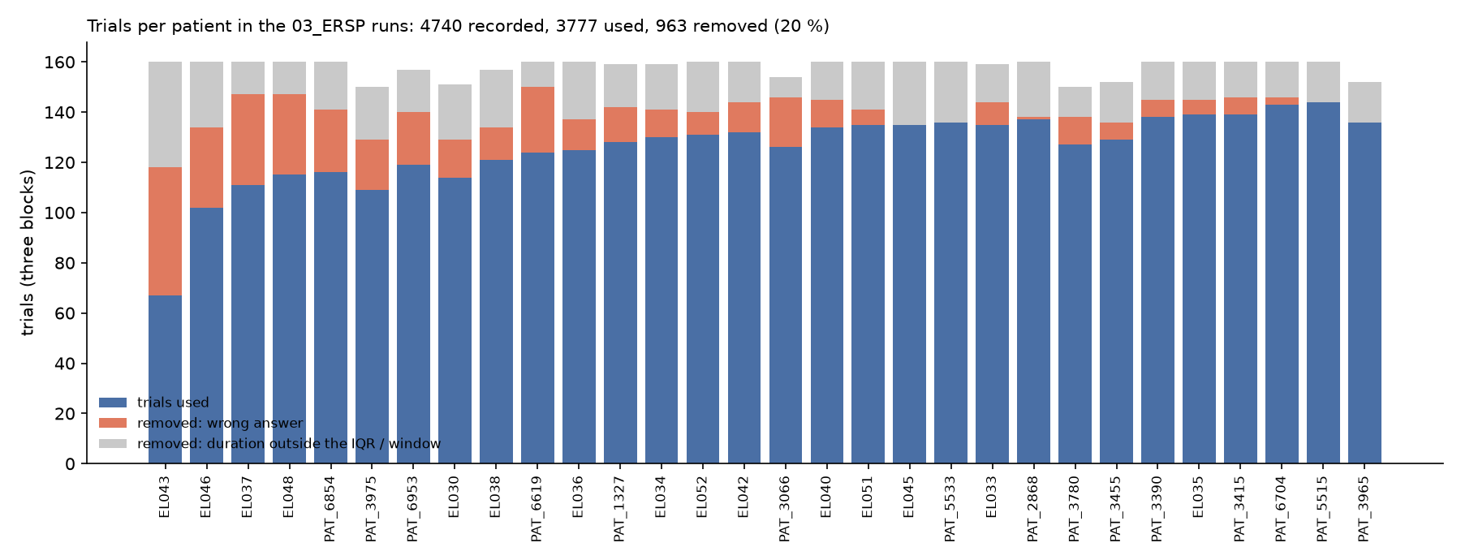
FIG 5.1 - trials recorded, used and removed per patient (three blocks together), sorted by the number removed. EL031 is the run of 9 October.
patient | audio in / used | picture in / used | reading in / used | removed | of which wrong answer
EL030 | 53 / 39 | 54 / 44 | 44 / 31 | 37 | 15
EL033 | 53 / 48 | 53 / 45 | 53 / 42 | 24 | 9
EL034 | 53 / 44 | 53 / 45 | 53 / 41 | 29 | 11
EL035 | 53 / 45 | 54 / 50 | 53 / 44 | 21 | 6
EL036 | 53 / 45 | 54 / 45 | 53 / 35 | 35 | 12
EL037 | 53 / 33 | 54 / 39 | 53 / 39 | 49 | 36
EL038 | 53 / 28 | 51 / 51 | 53 / 42 | 36 | 13
EL040 | 53 / 48 | 54 / 47 | 53 / 39 | 26 | 11
EL042 | 53 / 46 | 54 / 44 | 53 / 42 | 28 | 12
EL043 | 53 / 22 | 54 / 25 | 53 / 20 | 93 | 51
EL045 | 53 / 44 | 54 / 46 | 53 / 45 | 25 | 0
EL046 | 53 / 36 | 54 / 43 | 53 / 23 | 58 | 32
EL048 | 53 / 39 | 54 / 42 | 53 / 34 | 45 | 32
EL051 | 53 / 47 | 54 / 47 | 53 / 41 | 25 | 6
EL052 | 53 / 42 | 54 / 47 | 53 / 42 | 29 | 9
PAT_1327 | 52 / 34 | 54 / 51 | 53 / 43 | 31 | 14
PAT_2868 | 53 / 40 | 54 / 46 | 53 / 51 | 23 | 1
PAT_3066 | 50 / 32 | 54 / 50 | 50 / 44 | 28 | 20
PAT_3390 | 53 / 46 | 54 / 49 | 53 / 43 | 22 | 7
PAT_3415 | 53 / 45 | 54 / 49 | 53 / 45 | 21 | 7
PAT_3455 | 48 / 42 | 53 / 47 | 51 / 40 | 23 | 7
PAT_3780 | 50 / 39 | 51 / 46 | 49 / 42 | 23 | 11
PAT_3965 | 50 / 45 | 51 / 48 | 51 / 43 | 16 | 0
PAT_3975 | 50 / 40 | 50 / 40 | 50 / 29 | 41 | 20
PAT_5515 | 53 / 49 | 54 / 47 | 53 / 48 | 16 | 0
PAT_5533 | 53 / 46 | 54 / 44 | 53 / 46 | 24 | 0
PAT_6619 | 53 / 36 | 54 / 42 | 53 / 46 | 36 | 26
PAT_6704 | 53 / 46 | 54 / 51 | 53 / 46 | 17 | 3
PAT_6854 | 53 / 41 | 54 / 47 | 53 / 28 | 44 | 25
PAT_6953 | 53 / 39 | 51 / 42 | 53 / 38 | 38 | 21
TOTAL | 1572 / 1226 | 1601 / 1359 | 1567 / 1192 | 963 | 438

Where the losses are: reading loses the most (401 trials), audio 358, picture 246. EL043 (93 removed) and EL046 (58) lose more than half of a block to wrong answers; EL038's audio block lost 25 to the trigger drift that the rebuilt tables of 24 September partly recovered; PAT_3975's reading block loses 21, 17 of them wrong answers. The per-channel MAD rule removes on average 2 % of channel-trials (PAT_3780: 316 of 14,732) and never a whole trial.
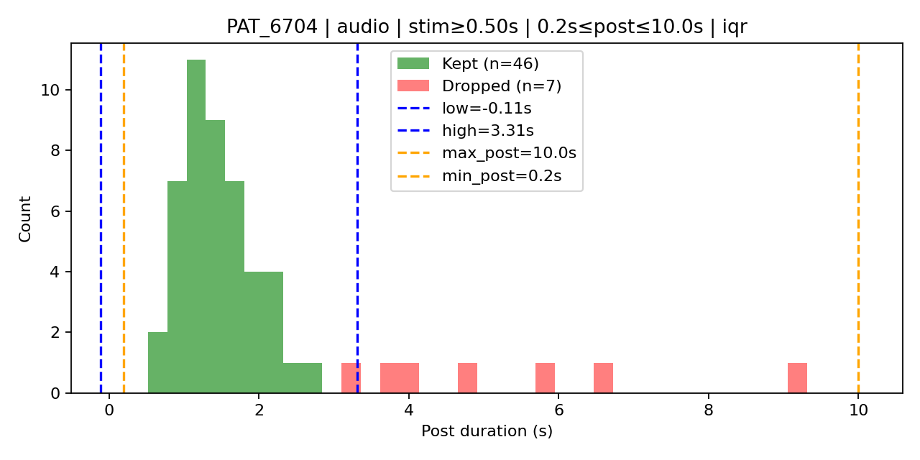
FIG 5.2 - the post-stimulus window filter on one patient's audio block: the IQR band and the trials outside it.
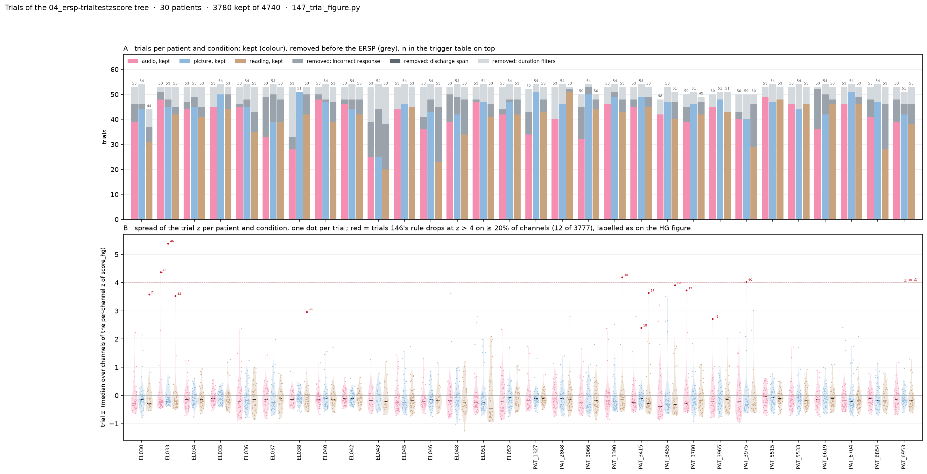
FIG 5.3 - the trial z-score test of 29-30 September: how many trials each rule keeps per patient, which settled the MAD 3.5 rule for everyone.
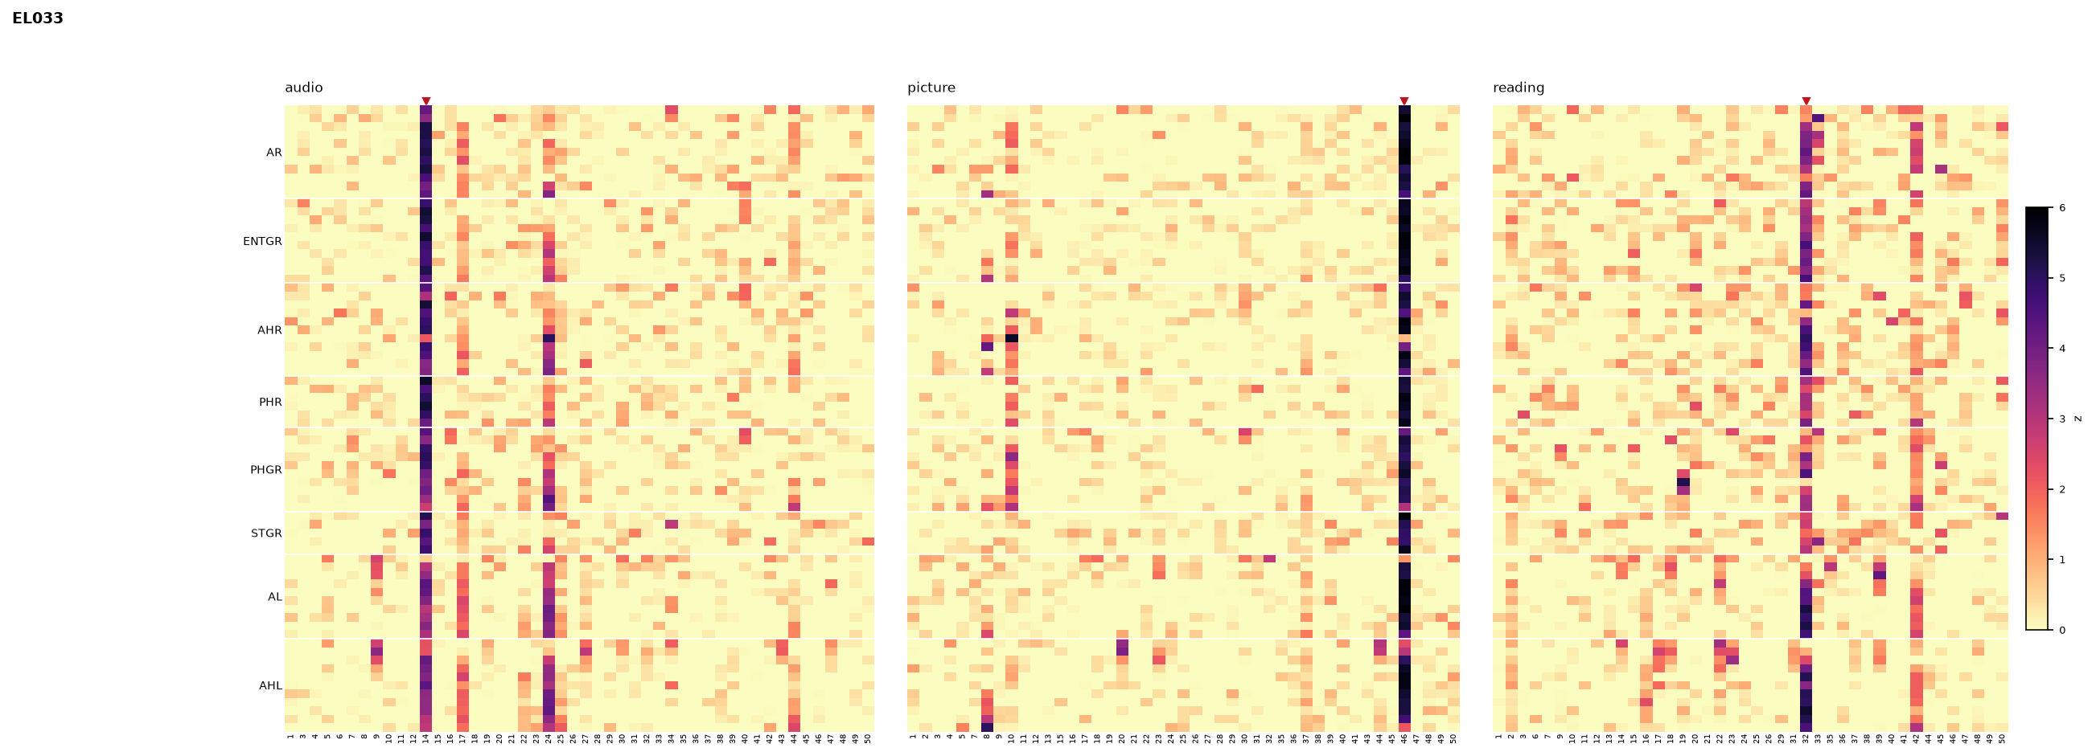
FIG 5.4 - the same test as a heat map for EL033: trial x channel z of the high-gamma score.
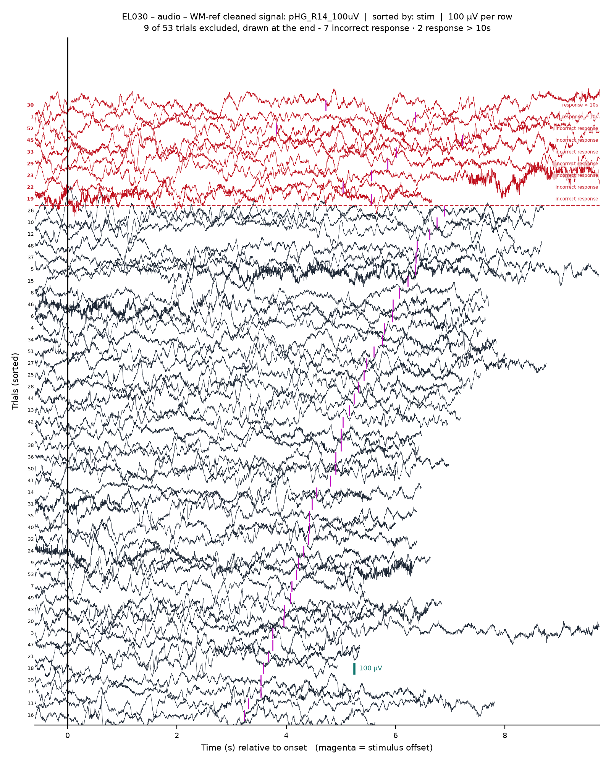
FIG 5.5 - a Signal figure (2 October): the cleaned signal of one contact, trial by trial, at a fixed uV scale, the twin of the HFA raster.

6. Preprocessing audit (5-6 October)
Asked for as a critical review of the pipeline's assumptions, measured on the v13 cohort (1,460 electrodes, 30 patients) from the cubes and their odd / even halves. What was found wrong, what was found fine.

Found
- Speech muscle. a response-half rise at 70-150 Hz of at least 1.5 dB whose 250-400 Hz rise is at least 0.75 dB and 40 % of it marks 42 contacts in 11 patients (EL030 and EL033 8 each, PAT_6953 6, PAT_1327 5). They sit in the v13 cohort and are 42 of its 100 strongest responders; they climb toward the outermost contacts and are coherent across shafts at 250-400 Hz. Cortical high gamma does neither.
- Baseline banding. the per-trial dB baseline is the mean of three 100-ms frames in (-0.4, -0.1) s. Its noise paints a random offset per frequency row of 0.34 dB SD (0.48 in a half), uncorrelated between the halves (r = 0.01). Any band average inherits it.
- Spectral resolution. one 128-ms Hann window for 0-400 Hz resolves about 12 Hz: rows below 12 Hz are one cell (adjacent rows r 0.72-0.91) and rows above 170 Hz are copies of high gamma (r 0.7-0.95 in responsive contacts) plus muscle.

Checked and fine
- The trial window. trial_end = stimulus offset + the log's response window, a constant 1.1-1.8 s before the next onset.
- The baseline position. high gamma in the baseline frames sits within +-0.4 dB of rest.
- The MAD rejection. removing the MAD-flagged channel-trials changes the average by 0.00 dB.
- dB averaging. averaging in dB across trials, as done, and averaging in power then converting differ by less than the banding.
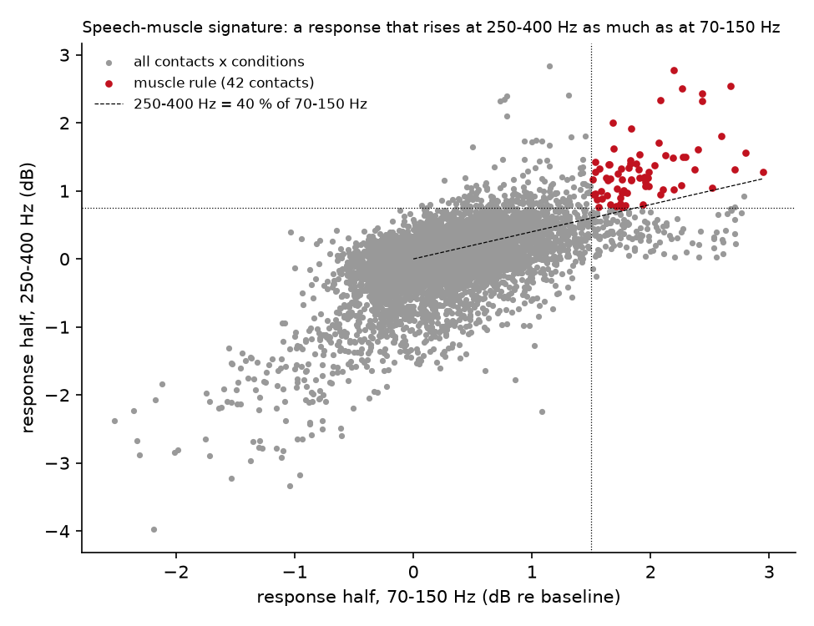
FIG 6.1 - the muscle rule on every contact x condition of the cohort (9,021 points): response-half rise at 70-150 Hz against 250-400 Hz; the 42 flagged contacts in red.
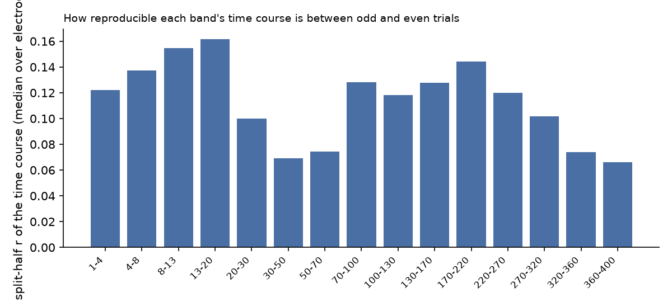
FIG 6.2 - split-half reliability of each band's time course per electrode (median over the cohort): low everywhere, and the 30-70 Hz and 320-400 Hz bands lowest; 13-170 Hz is the range with no unresolved rows and no high-gamma copies.
Consequence for stage 02: the clustering counters built the same week work on bands 13-170 Hz x 30 bins and drop the muscle-flagged electrodes; the split-half reproducibility of the electrode distance matrix is 0.65 on that set against 0.62 on concat_hg and 0.59 on the 15-band set. (The counters themselves are not part of this report.)

7. PAT_3780: the trial windows were three minutes off

How it surfaced
The counter runs of 7 October put all 48 cohort electrodes of PAT_3780 into one cluster, driven by a reading-block pattern: a trial-locked broadband rise of about 1 dB from 13 to 400 Hz on FAP, FLA, FLP, FMP, TPG and HAG, in every reading trial, absent in the other blocks. Before interpreting it the trial timing was checked, starting with the photodiode.

What the recording holds
- No photodiode on any channel. X1 and X2 are the same 50-Hz carrier pinned at the +-3200 uV rails 94 % of the time; X3-X10 are flat, the four MKR channels a 1-Hz test wave, the TRC trigger tables empty. Alone, as X1 - X2, or as any pair of the ten X inputs they show nothing at the trials.
- The old tables. the prep0 tables of October 2025 were the stimulus log's onsets minus 30.43 s, from a manual table of September 2025 whose constant nothing in the file could have anchored.
- No response locked to them. at the old onsets no evoked potential appeared in any of 135 WM-referenced contacts, no stimulus-locked high gamma, no speech-locked high gamma; sliding the onsets by any constant within +-150 s did not help, nor did splitting the blocks into thirds.
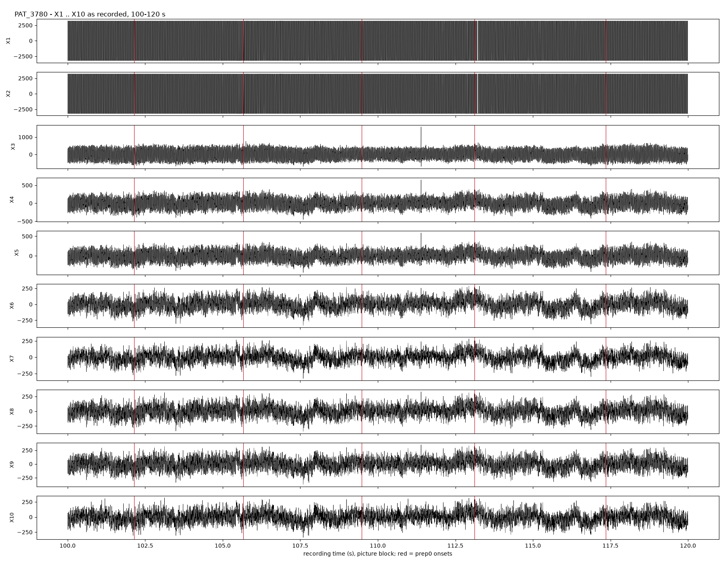
FIG 7.1 - the ten X inputs over 20 s of the picture block (red = the old onsets): X1 and X2 saturated, the others noise.
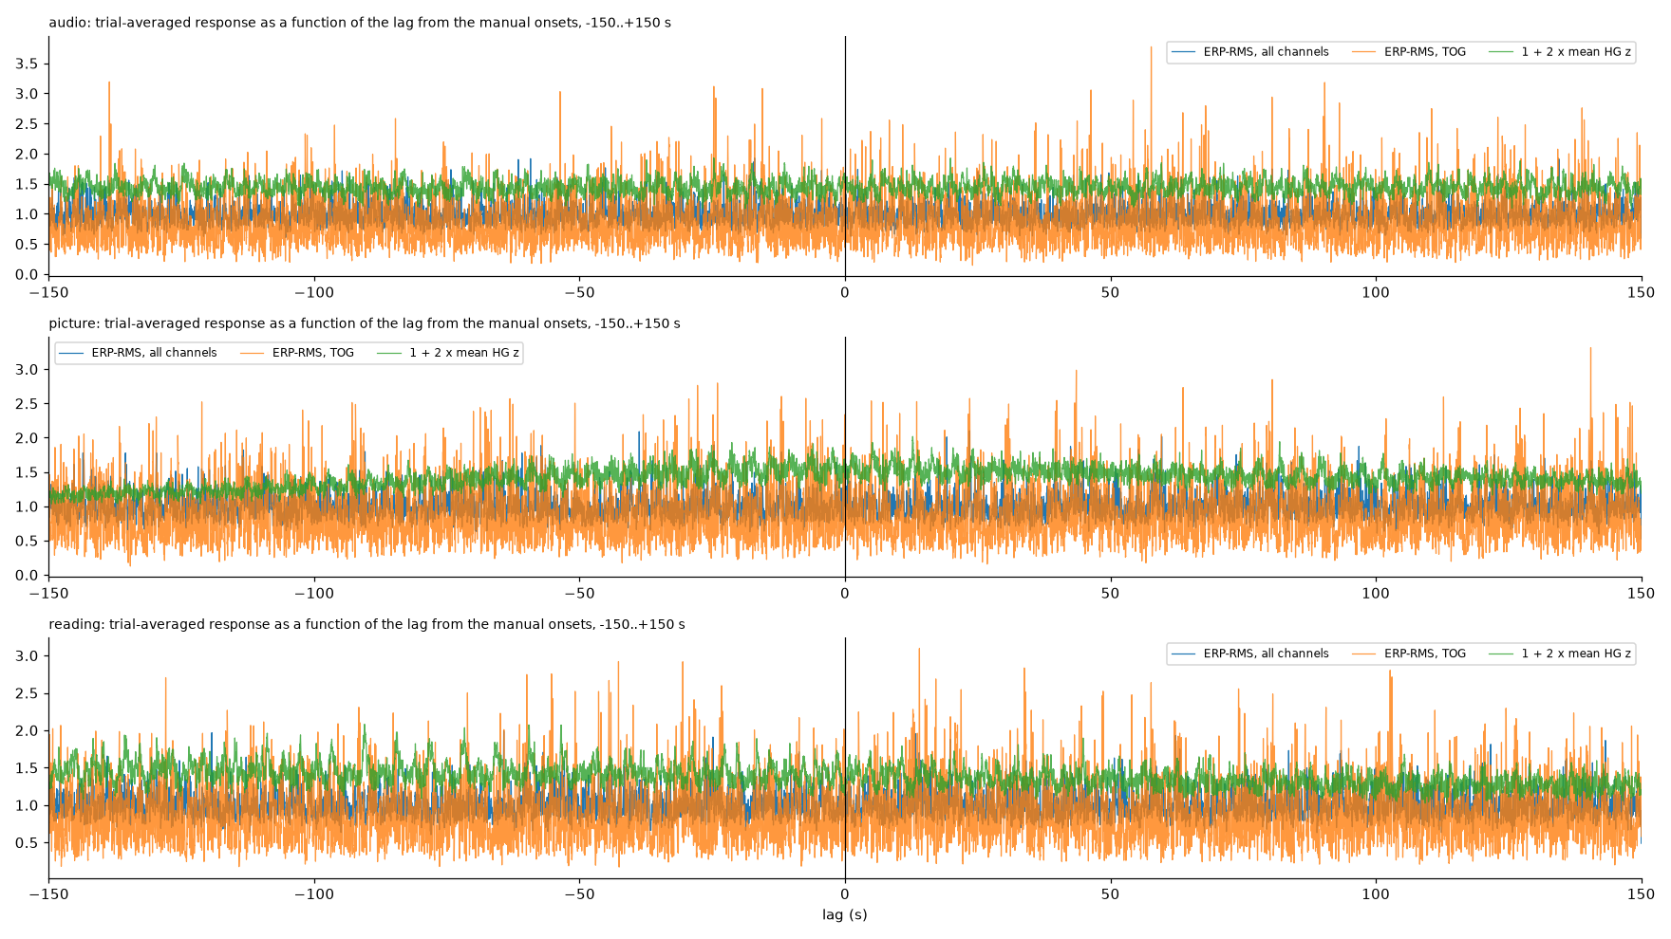
FIG 7.2 - the evoked response as a function of a constant shift of the old onsets, -150 to +150 s: no lag produces one.

The recipe that works
Take the envelope of X1 and of X2 separately (Hilbert amplitude of the carrier), subtract, low-pass at 20 Hz. The difference is flat outside the task and steps by 10-20 uV at every screen change: down at stimulus onset, up at offset, with the design's own durations (1.02 / 3.09 / 3.51 s). The log maps onto those edges with +149.57 s, not -30.43 s: the old windows were 180.0 s early. Per trial the diode and the log agree within +-10-20 ms, with a few picture trials where the screen was 50-160 ms late.
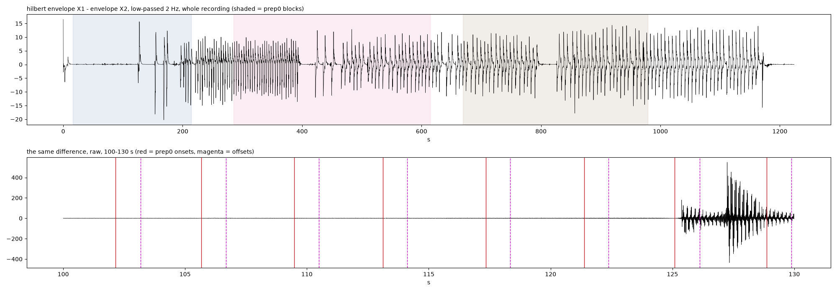
FIG 7.3 - envelope(X1) - envelope(X2) over the whole recording (top; the shaded spans are the OLD blocks) and raw over 100-130 s (bottom): the task starts where the old tables had their first block already running.
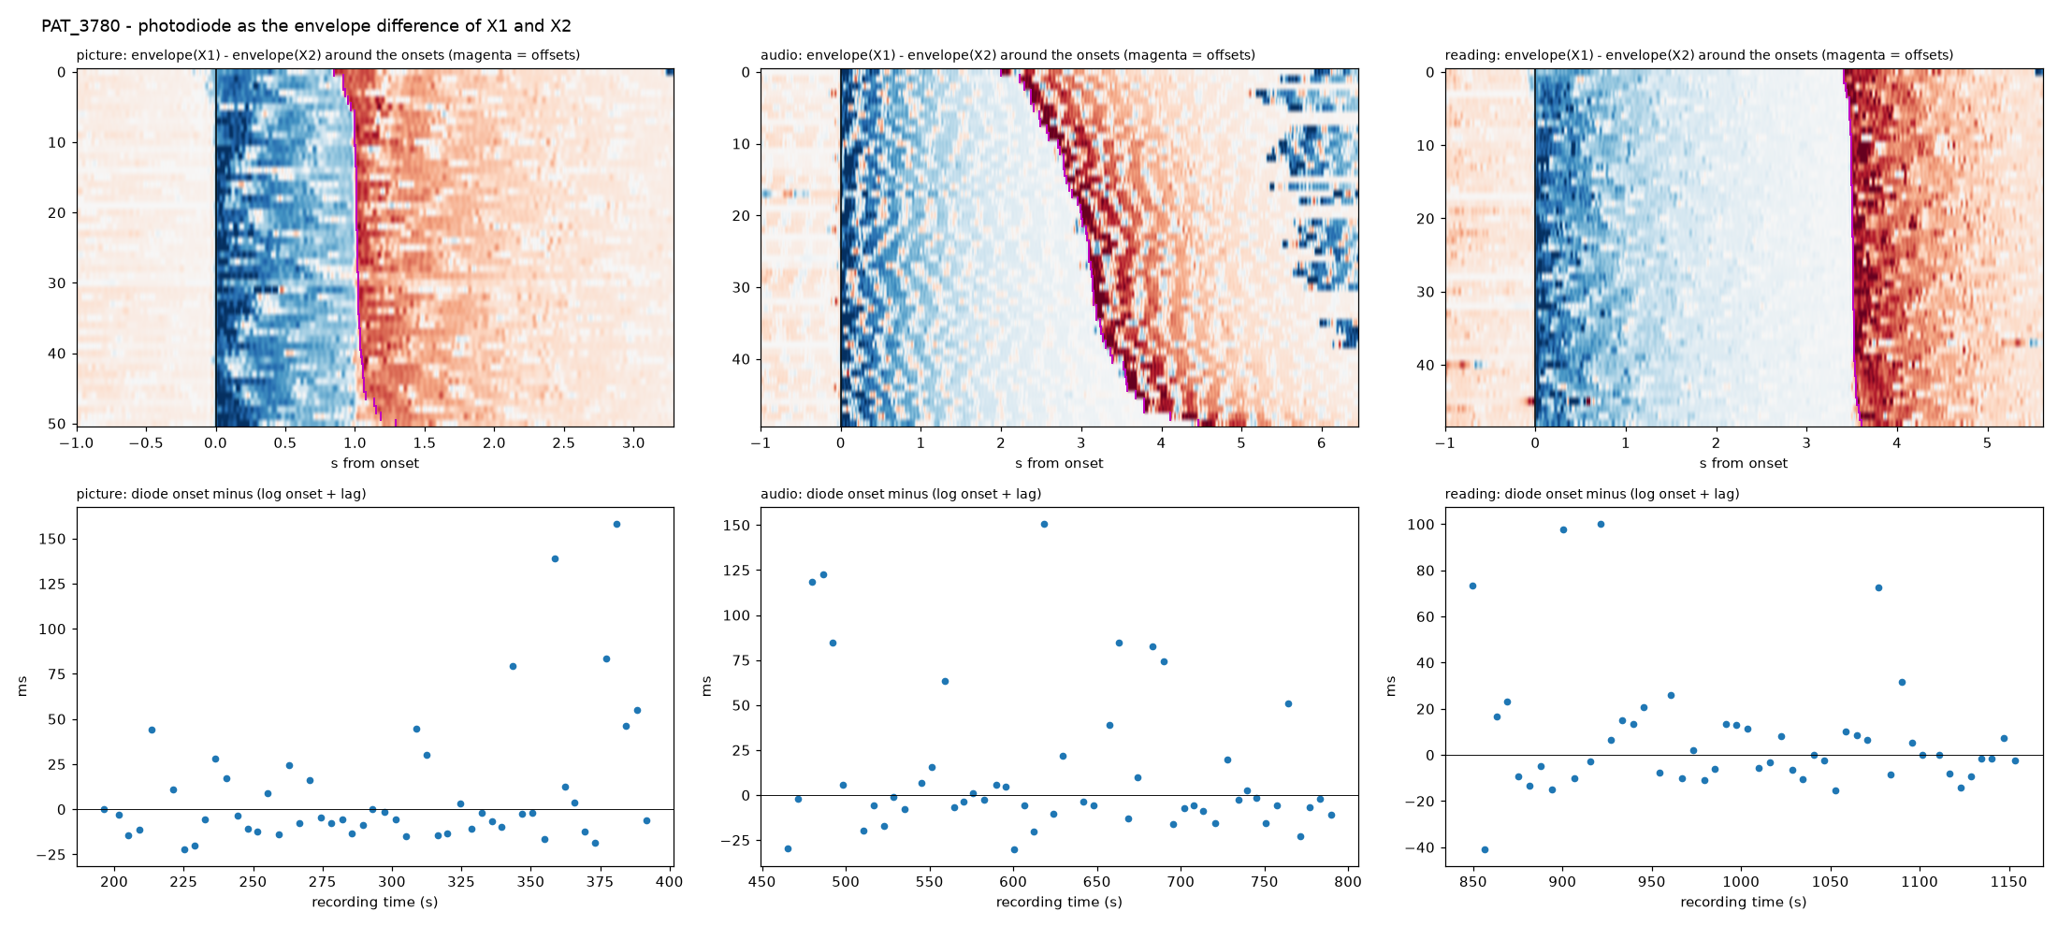
FIG 7.4 - the builder's check: the envelope difference around every recovered onset (magenta = recovered offsets) and the per-trial residual of the diode edge against the log, per block.

Confirmation
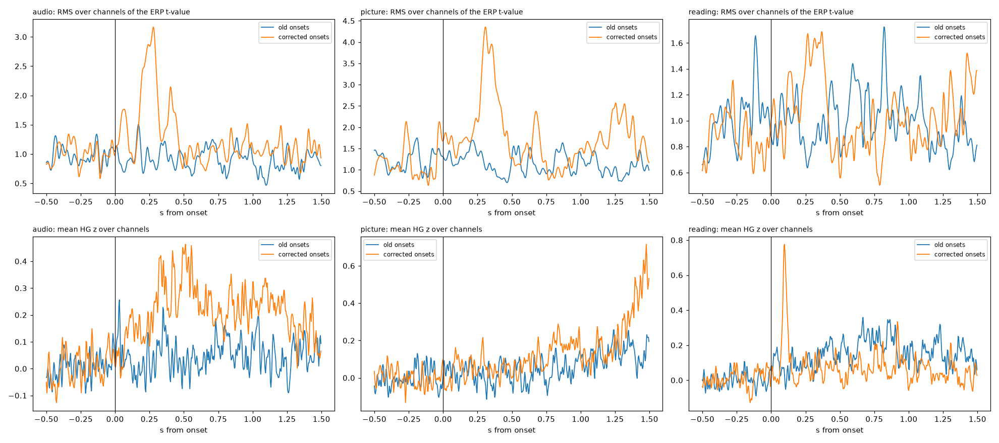
FIG 7.5 - RMS over channels of the evoked-potential t-value and the mean high-gamma z at the old onsets (blue) and the corrected ones (orange).
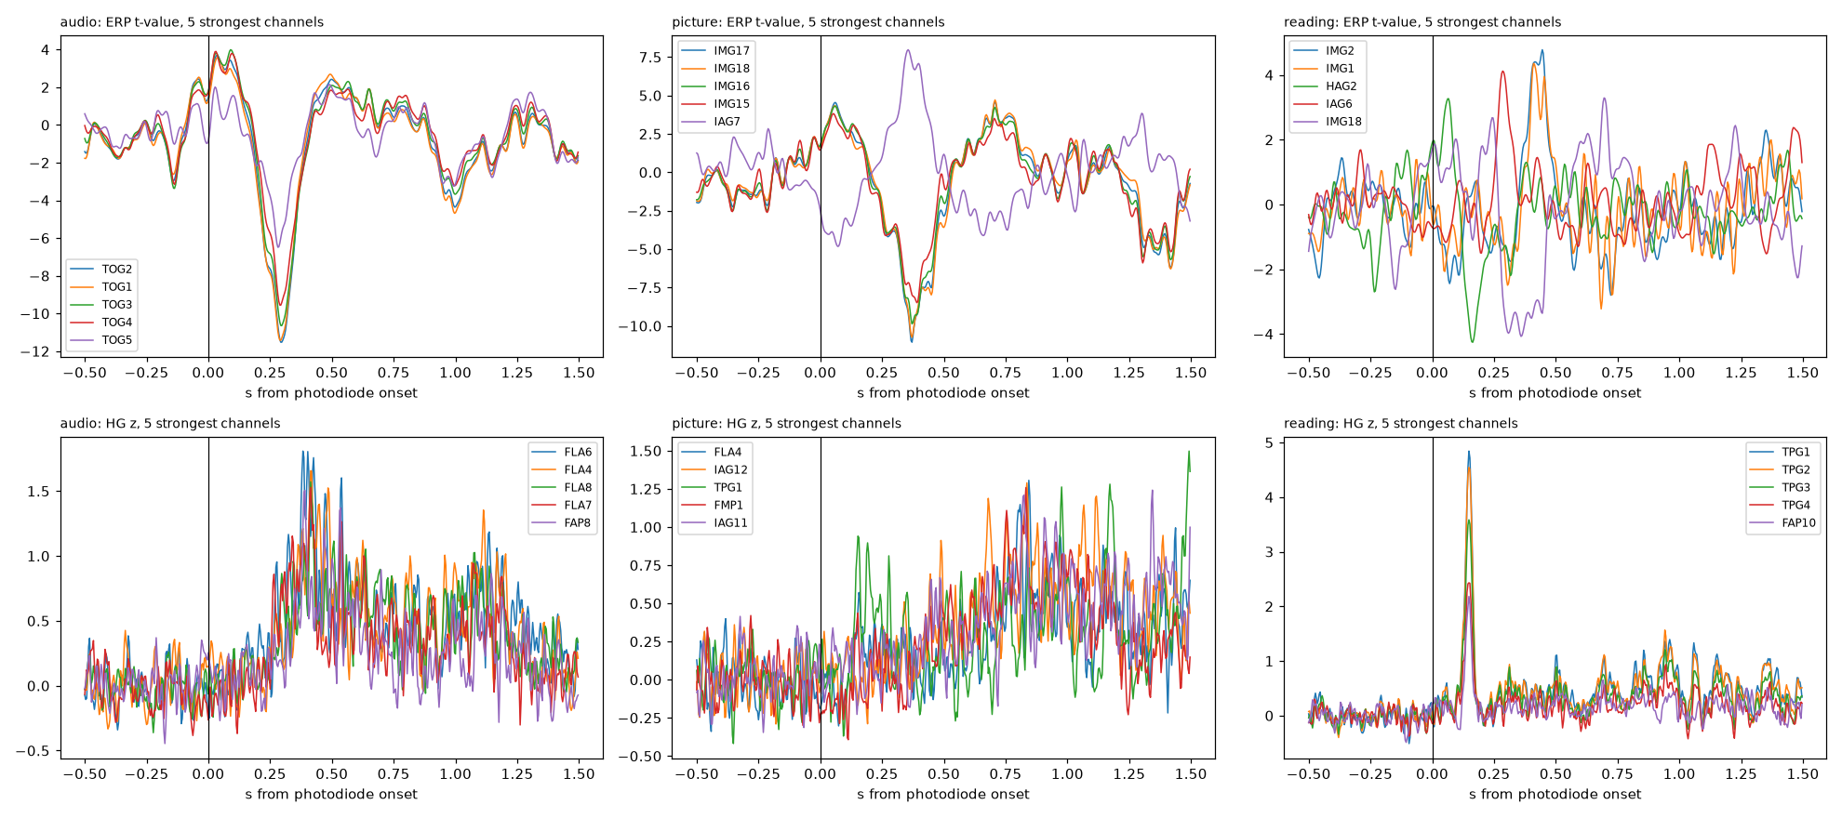
FIG 7.6 - at the photodiode onsets: audio answered by the superior temporal contacts TOG1-5 (|t| up to 11.5 at 210 ms), picture by 43 channels (IMG, IAG), reading by a high-gamma burst on TPG1-4 at 150 ms.
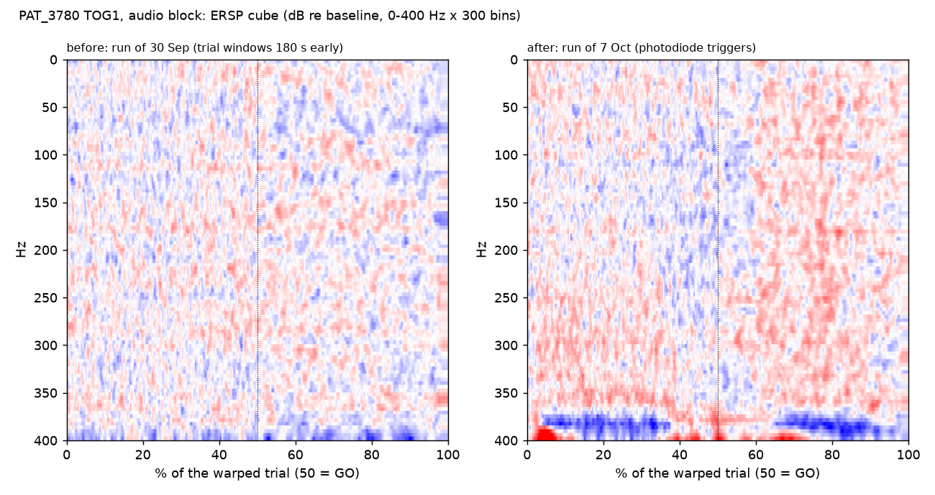
FIG 7.7 - TOG1, audio: the cube of 30 September (windows three minutes early) and of 7 October (photodiode triggers).
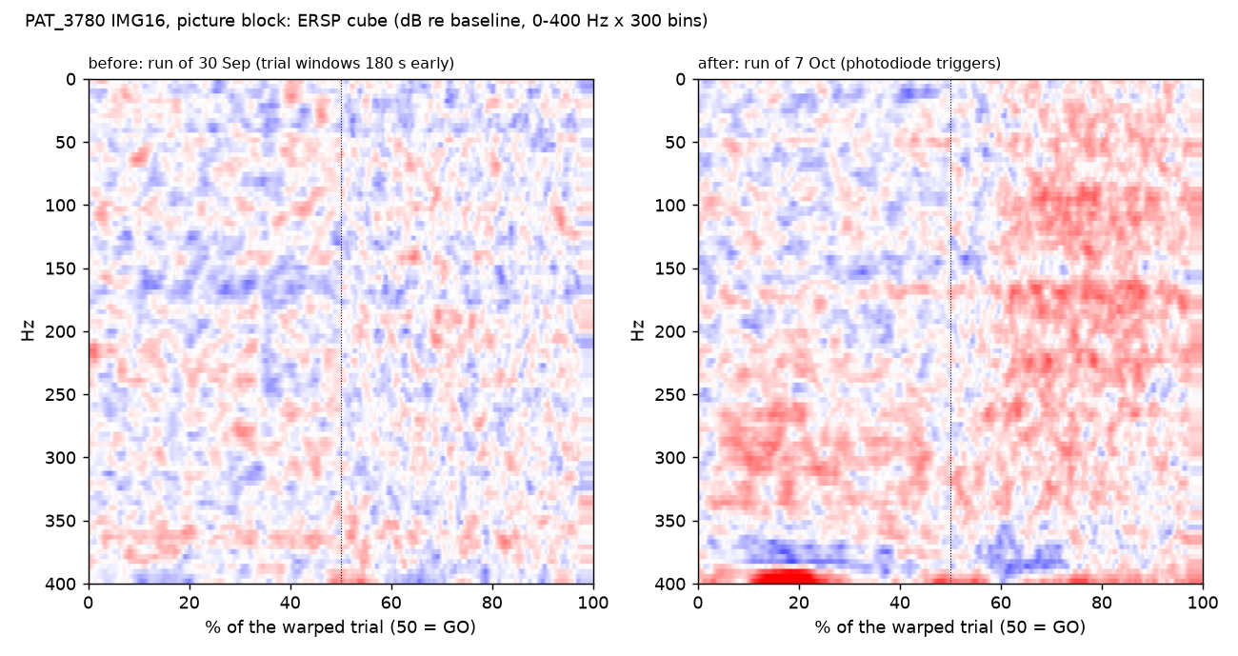
FIG 7.8 - IMG16, picture: the same before and after.

What changed in the tree
- pat_3780_build_triggers.py writes the three prep0 tables from the diode edges (149 of 150 offsets from the diode, one from the design), moves the 2025 tables to prep0/archive and draws the check figure. Run on 7 October; 140 rerun the same evening (39 / 46 / 42 trials used, as before: the filters work on the log's durations and answers, which did not change).
- Bad list: FAP9 (a dead channel; the old 'example' entry), HAG1 and HAG2 (10.5 / 5.4 dB above the patient median at 70-150 Hz, 13.5 / 8.2 at 30-70, a 30-100 Hz hump), TPG1 and TPG2 (7.6 / 5.7 dB). TPG3 and FAS1 (4 dB) are noted as candidates for a look at the raw. None is a reference contact.
- Consequence: the reading-block broadband effect, the muscle flags and the counter clusters of this patient were all computed on the wrong windows and are void until recomputed; the five contacts' old cubes are orphans for 142.

8. PAT_3975: checked, correct
The other HUG patient on a manual trigger table. Its E1 and E2 are the same saturated pair, but here the raw difference E1 - E2, low-passed at 20 Hz, is a clean diode: a -7 mV step at every one of the 150 prep0 onsets and a +7 to +13 mV step at every offset, with no jitter against the tables. The tables are byte-identical to photodiode detections made in April and May 2023 (the log + 208.69 s, 7-8 ms per-trial scatter).
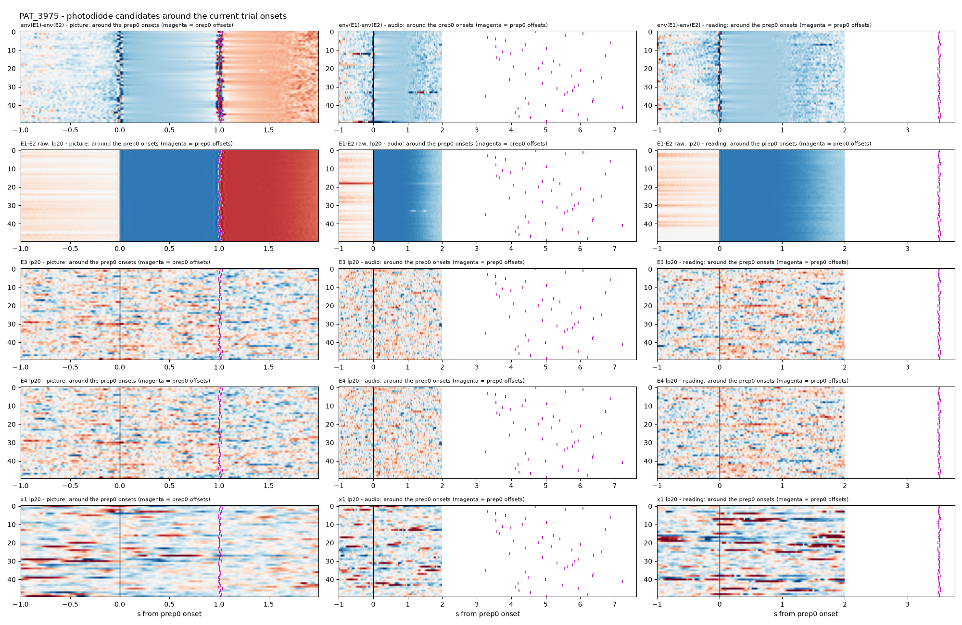
FIG 8.1 - PAT_3975's candidates around the current onsets: the envelope difference (top row), the raw difference (second row, the diode), E3, E4 and x1 (nothing).
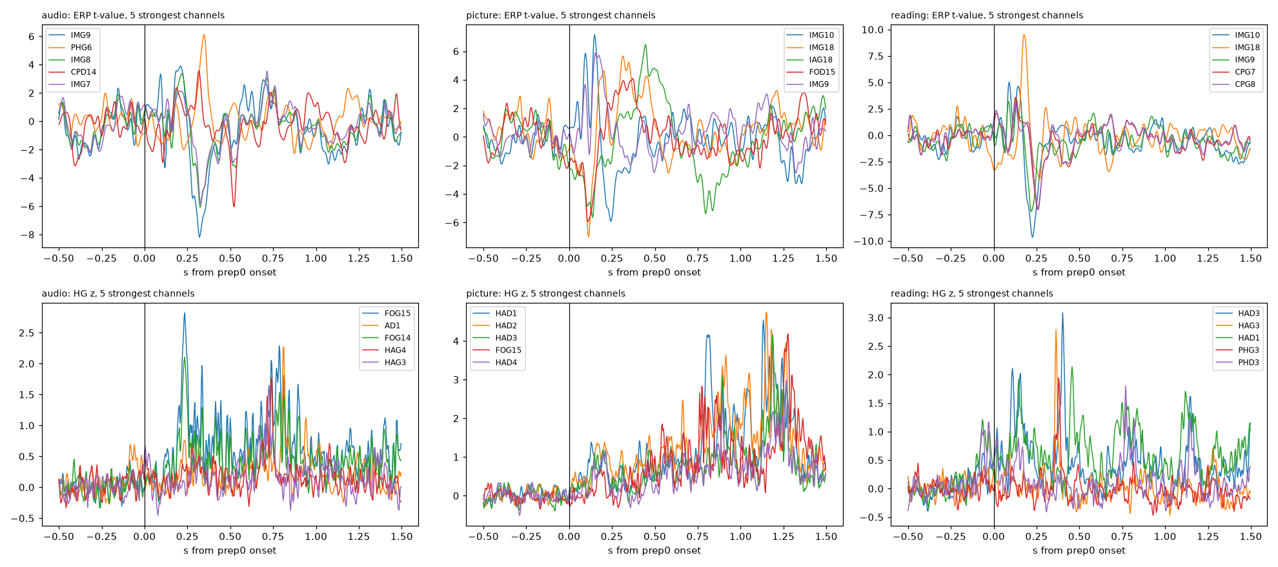
FIG 8.2 - evoked responses at the current onsets: 22 / 11 / 17 channels above |t| = 5 at 90-320 ms (IMG, CPG, PHG), and high gamma in the hippocampal and insular contacts.

9. EL031: added, run, excluded
A Bern patient of March 2024, recorded in three one-block EDF files (pictures 19 March 09:29, audio 19 March 10:45, sentence 20 March 14:22), three events logs, a proper photodiode on DC6. Camille's readme: the first three picture trials were training without photodiode; the audio block stopped after about 20 trials with the patient asleep.
session | pulses | log rows | kept | dropped
pictures | 54 x 1 s | 54 picture | 51 | 3 training rows (two without a pulse, one with a 42-s response); two pulses before the run belong to no row
audio | 23 x 3.2-6.8 s | 23 audio + 6 picture | 23 (20 correct) | 6 picture strays, 5 sub-0.4-s blips
sentence | 53 x 3.5 s | 53 reading + 3 picture + 1 audio | 53 (35 correct) | the 4 strays

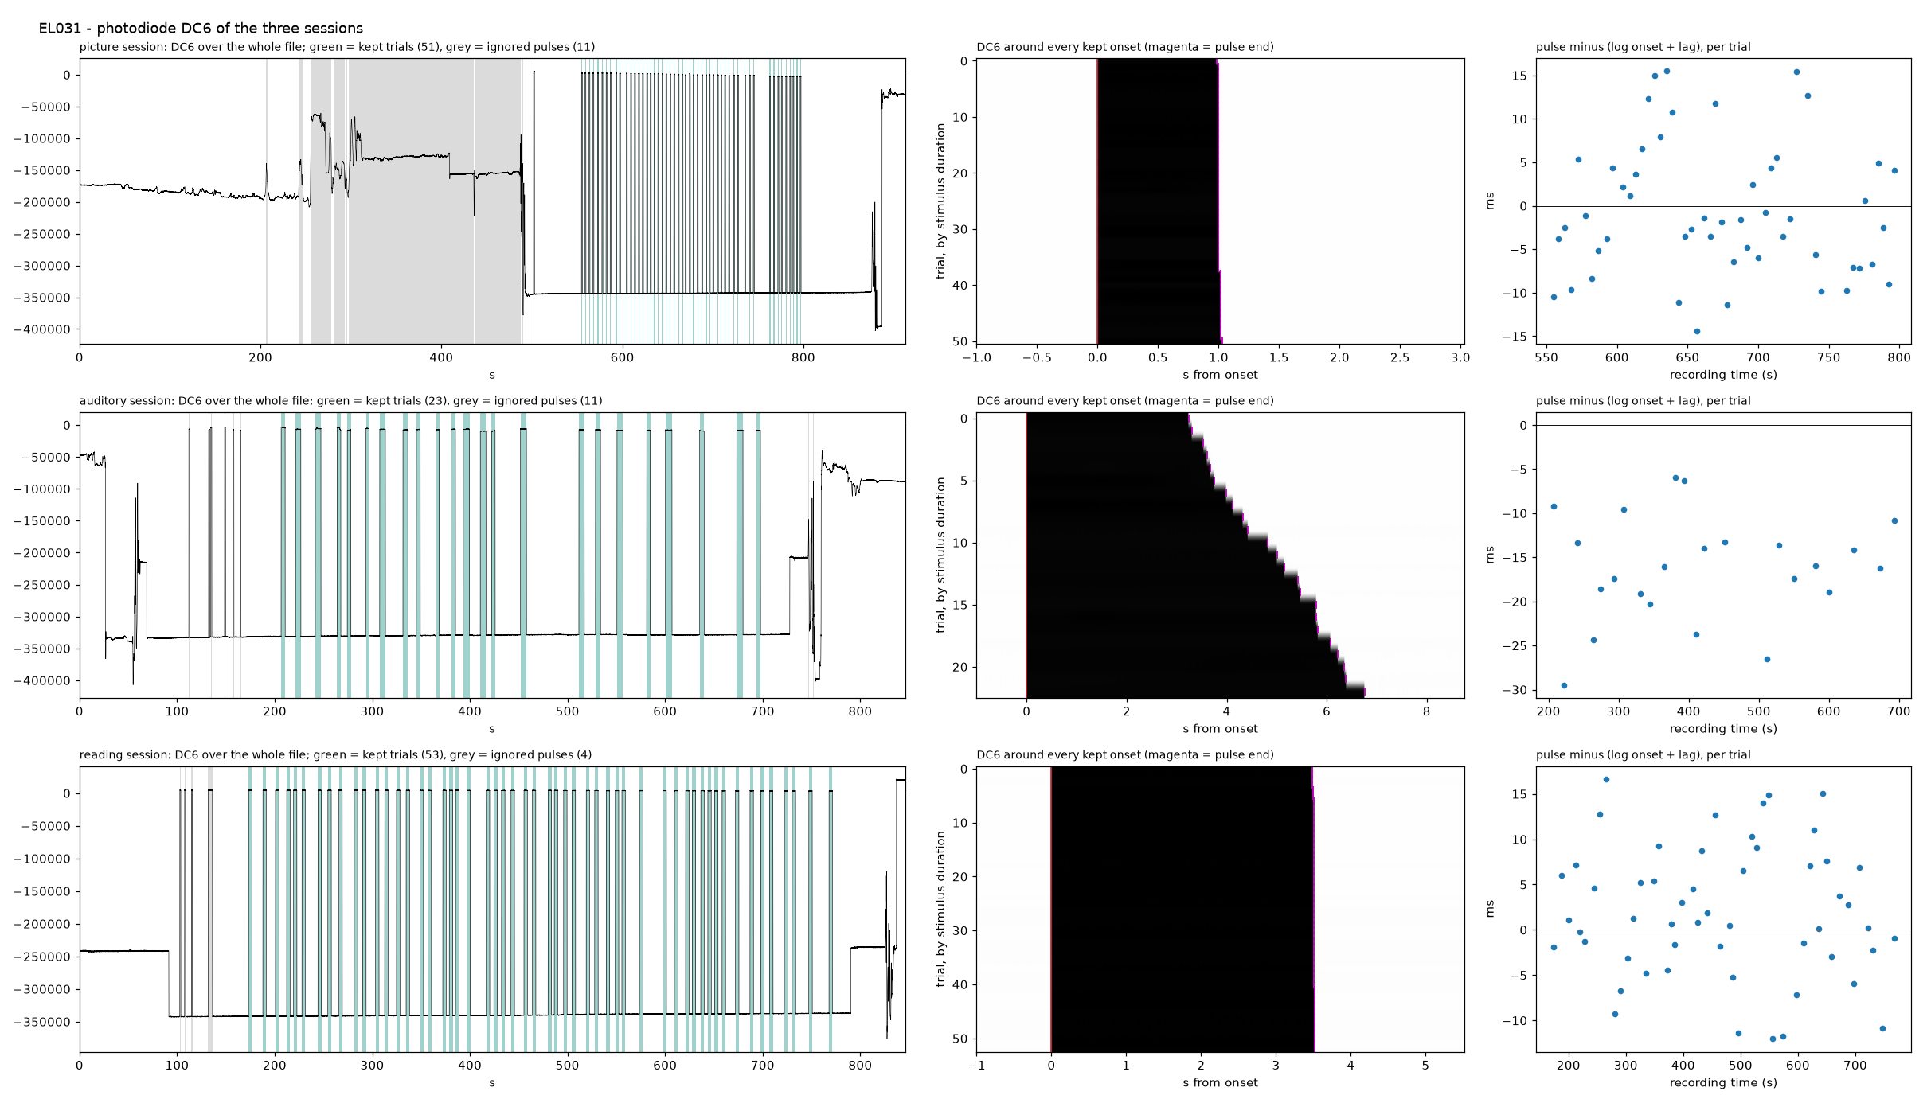
FIG 9.1 - DC6 per session: the whole trace with kept trials in green and ignored pulses in grey, the raster around every kept onset, the per-trial residual against the log (+-30 ms).
- cfg.RAW_CONCAT joins the three files in block order; a new RAW_CONCAT_RENAME folds the 20 March file's antSUP1-8 back to antSFG1-8 (the other files and the anatomy say antSFG), applied in both loaders.
- el031_build_triggers.py reads DC6 per file, fits each log's lag, keeps the block's own trials, writes the manual triggers on the joined axis and a merged events table that 140 --pd turns into the per-condition tables.
- Anatomy by the workbook route: no BIDS electrodes table; Electrodes/Lookup.xlsx gives the 48 lead contacts with MNI, 8 white matter, 5 outside the brain (bad-listed).
- Two pipeline fixes it needed: the EL name filter kept only names with an underscore or a dash and threw out all of EL031's contacts; EL_DEPTH_KEEP_PREFIXES names its five shafts. collect_trials now skips a manual trigger table instead of stopping.
Run on 9 October with a whole-recording CAR (43 contacts) as a first look. The trial filters kept 47 of 51 picture, 8 of 23 audio and 27 of 53 reading trials: the response windows of the audio and reading logs run to 52 and 19 s. With eight audio trials the patient cannot carry a three-condition cohort, so EL031 was added to lf_concat.DEFAULT_EXCLUDE_PATIENTS the same day, with the reason in the site roster. Its 03_ERSP run stays for a look.

10. Open items
- Stage 02: cache v14 without PAT_3780's old windows, then the clustering chain and the counters on it.
- Raw-signal looks still owed: TPG3 and FAS1 of PAT_3780 (4 dB above the median), CinG_R13 of EL040 (beta), and the FLA slow deflections of PAT_3780 (eye-movement-like, densest in the picture block).
- Re-judge: the reading-block broadband rise of PAT_3780 must be re-judged on the corrected cubes before it is called muscle; the reading condition is sentence completion with a 3.5-s display.
- Anatomy: the recon of EL031 if it is ever to come back; PAT_3415's whole-patient decision noted as pending in the roster.
- Housekeeping: the 140 audit column for EL031 says 'not run' until 141 is run again; 142 --delete for PAT_3780's orphan cubes after 141.

Intracranial electrodes are placed for clinical reasons, so no patient is recorded everywhere and no two patients are recorded in the exact same places. This matters for any test that asks whether a result survives when one patient is removed: taking a patient out does not remove a random sample of cortex, it removes a particular set of regions, depending on the clinical need of that patients seizures. A region recorded in two patients loses half its support when one leaves; a region recorded in twenty barely changes. The iEEG guidelines state the problem directly — whether a finding can be shown to generalise “depends on whether that particular cortical location is frequently targeted by intracranial surgery” — but treat it as a constraint on how many patients a study needs, not as something to adjust for afterwards (Mercier et al., 2022). Where the field does correct for it, it does so in one of three ways, all applied before the statistic rather than to it. First, set a coverage floor and analyse only well-sampled regions: Kochi et al. (2026) restrict their analysis to regions sampled in more than 20 patients with more than 70 electrodes each, and state that their result is a population-level claim rather than a per-patient one. Second, split patients by how well sampled they are and report them separately: Conrad et al. (2020) resample contacts within each patient to give that patient a confidence interval, and propose using the spread to separate patients whose networks are adequately sampled from those whose are not; they also show that removing contiguous contacts damages a result more than removing the same number at random, which is why a null built by shuffling single electrodes is too easy. Third, repeat the whole analysis on a second cohort with different coverage: Yu et al. (2025) re-run their clustering after adding 23 patients with right-hemisphere electrodes and recover the same five response networks. None of these studies weights a cross-validation fold by how much coverage a patient contributes, and we do not either. In our cohort 12% of electrodes have no other patient’s electrode within 6 mm and 3% within 10 mm, so for those sites a leave-one-patient-out test measures extrapolation rather than generalisation; we report this as a bound on the generalisation estimate rather than correcting for it.

We examined this directly rather than assuming it. For every electrode in the clustered cohort we counted how many other patients have an electrode within 6 mm and within 10 mm, and mapped the same count onto the cortical surface (Figure A). The cohort is a temporal-lobe cohort: at 6 mm the median electrode has only 2 other patients near it, 22% have none at all, and 56% of the cortical surface is unsampled; at 10 mm the median rises to 5 other patients, 8% of electrodes remain isolated and 31% of the surface is still unsampled. Both medial walls, the frontal pole and superior parietal cortex are empty at either radius, while bilateral lateral and ventral temporal cortex reaches 15–22 patients. We then asked whether this predicts which patients fail the generalisation test (Figure B). Across the 29 patients, how well a patient’s electrodes are shared with the rest of the cohort does predict how accurately that patient is placed by a model fitted without them, in the expected direction, but weakly: Spearman ρ = +0.36 (p = 0.055), falling to ρ = +0.29 (p = 0.13) once the number of electrodes a patient contributes is held constant. The stronger and clearer predictor is that electrode count itself: ρ = −0.52 (p = 0.004), and ρ = −0.47 to −0.58 (p ≤ 0.01) once coverage is held constant. The two are statistically independent of each other (ρ = −0.14, p = 0.49), so these are separate effects rather than one variable in two guises. A patient who contributes more of the data shapes the full-cohort solution more, and is correspondingly harder to recover without — EL046, the most isolated patient in the cohort, is nonetheless placed correctly 94% of the time, while PAT_3975, the next most isolated and the largest of the two, is placed 63% of the time. We therefore report sparse and uneven coverage as a bound on the generalisation estimate, not as its explanation, and follow the practice of the field in applying no correction to the statistic itself.